PDHPE

Early Stage 1: Child Protection Education

# Resources

# Keeping myself safe

## Contents

Images of different types of families 2

See, think, wonder template 5

Visual representation of a support network 6

Body parts images 10

Cards: Body parts 12

Worksheet: Body outlines 13

Cards: Yes, sometimes, no and uncertain 15

Cards: Feelings and emotions 16

Body signals images 19

Wanted and unwanted touch images 21

Images of toys 23

Cards: No-go-tell scenarios 24

No-go-tell images 29

Copyright register 30

## Images of different types of families

|  |  |
| --- | --- |
| A portrait of five family members. The mother and father are the main carers of three adopted children from different cultural backgrounds. Their two sons are five and one years old and their daughter is one year old. | An extended family portrait of five members at the university graduation of their eldest daughter. The mother, father and grandmother share the care of two younger children, a 14-year-old boy and a nine-year-old girl. |
| A portrait of seven family members The mother and father are from different cultural backgrounds and are the main carers of their five children, four-year-old twin daughters, a newborn daughter and two sons aged 10 years and 8 years old. | A portrait of four family members with their pets, a miniature poodle and fluffy white cat. The mother and father are the main carers of their two daughters. One daughter is a late teenager the younger is a girl of 12 years. |
| A portrait of four family members and their pet blue heeler dog. A single mother is the main carer of three children, a 17-year-old daughter sitting in a wheelchair, a 14-year-old son and a seven-year-old son. | A portrait of a stepfamily. A divorced mother and father stand either side of their 16-year-old daughter at her 16th birthday. The birthday girl holds the tie of a pink helium balloon with the words ‘sweet 16’. Her 12-year-old brother stands on the other side their mother. Their father and his partner stand behind and their three-year-old daughter who stands on a chair holding the tie of a pink helium balloon with the words ‘sweet 16’. |
| A portrait of three family members and their pet border collie dog. The mother is sitting in a wheelchair beside the father. In front is their five-year-old son and their pet dog. | A portrait of three family members. Two fathers stand besides each other. In front of them, standing on a chair and holding the tie of a pink-helium balloon, is their five-year-old daughter. |
| A portrait of five family members. The grandmother and grandfather are the main carers of three granddaughters. The eldest granddaughter is a late teenager, the middle granddaughter is 11 years old and the youngest is seven years old. | A portrait of four family members. Two mothers are the main carers of their 10-year-old son and two-month-old baby daughter. |
| A wedding portrait of a multicultural couple and their extended family. The bride’s mother, father and teenaged sister and brother pose with their grandfather. The groom’s large family of brothers and sisters, uncles and aunts and cousins pose alongside his mother, father and grandmother. | |

## See, think, wonder template

Three rows of containing one image and space for writing thoughts.
Row 1: Icon of an eye within a pink circle is positioned above the words ‘See. What do you see?
Row 2: Icon of a quizzical stylised face within a pink circle is positioned above the words ‘Think. What do you think is going on? The face has a hand scratching its chin and a thought bubble above.
Row 3: Icon of a question mark within a pink circle is positioned above the words ‘Wonder. What does it make you wonder?

## Visual representation of a support network

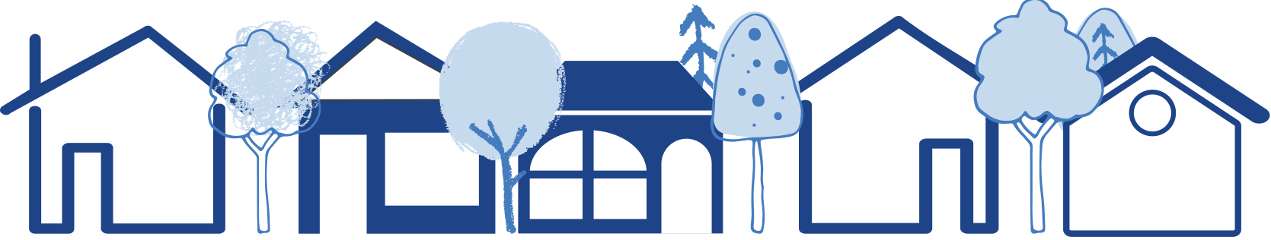

A line illustration of large flower with four red-lined petals and a blue centre. The petals represent four people identified as the student’s network of trusted people. The blue centre represents adults in the student’s home.

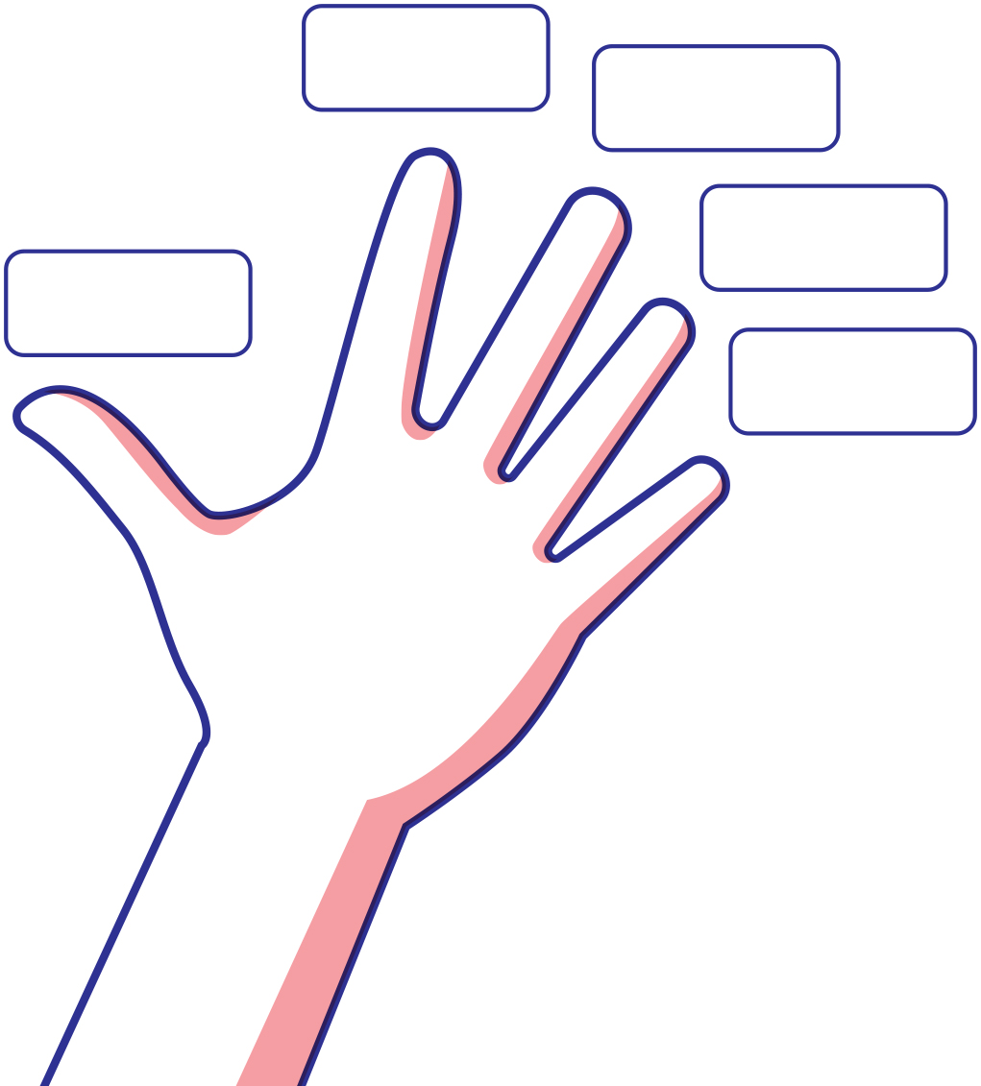

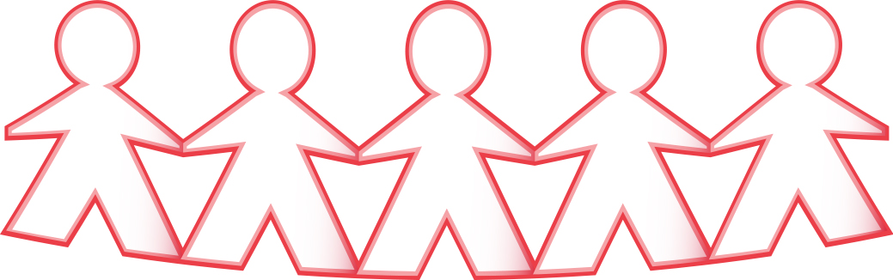

## Body parts images

|  |  |  |
| --- | --- | --- |
| Close-up of two arms, from the shoulder to the hands, belonging to a girl and a boy running on grass. | Close up of a teenage boy’s ear. | A close up of a girl with her arms folded in front and showing her elbows. |
| Arms | Ear | Elbows |
| A close up of a pair of brown smiling eyes belonging to a young girl. | A close up of a young girl’s face showing her eyes, nose and mouth. | A close up of a teenage girl in a crouch position with her heels touching and her toes bent outwards to the side. |
| Eyes | Face | Feet |
| A close up of a young person’s hand showing four fingers covered in red, yellow and black paint. | A close up of three different teenager’s hands held high in the air and silhouetted against the sky. | A close up of a girl’s head showing her blowing bubbles. |
| Fingers | Hands | Head |
| A close up of a young soccer player balancing a ball on top of his knee. | A close-up of two pairs of girl’s legs running next to each other on the grass. | A close up of a young girl’s mouth showing her lips in a smile. |
| Knee | Legs | Lips |
| A close up of a young girl’s mouth open wide showing her teeth and her tongue. | A close up of a young girl's nose showing the bridge and nostrils. | A close up of a teenage girl in a leotard showing her shoulder. |
| Mouth | Nose | Shoulder |
| A close up of a girl’s foot showing her toes peeping through her sandles. |  |
| Toes |  |

41

## Cards: Body parts

|  |  |  |
| --- | --- | --- |
| arms | ear | neck |
| elbows | eyes | thighs |
| face | feet | nipples |
| fingers | hands | breasts |
| head | knee | bottom |
| legs | lips | testicles |
| mouth | nose | penis |
| shoulder | toes | vagina |

## Worksheet: Body outlines

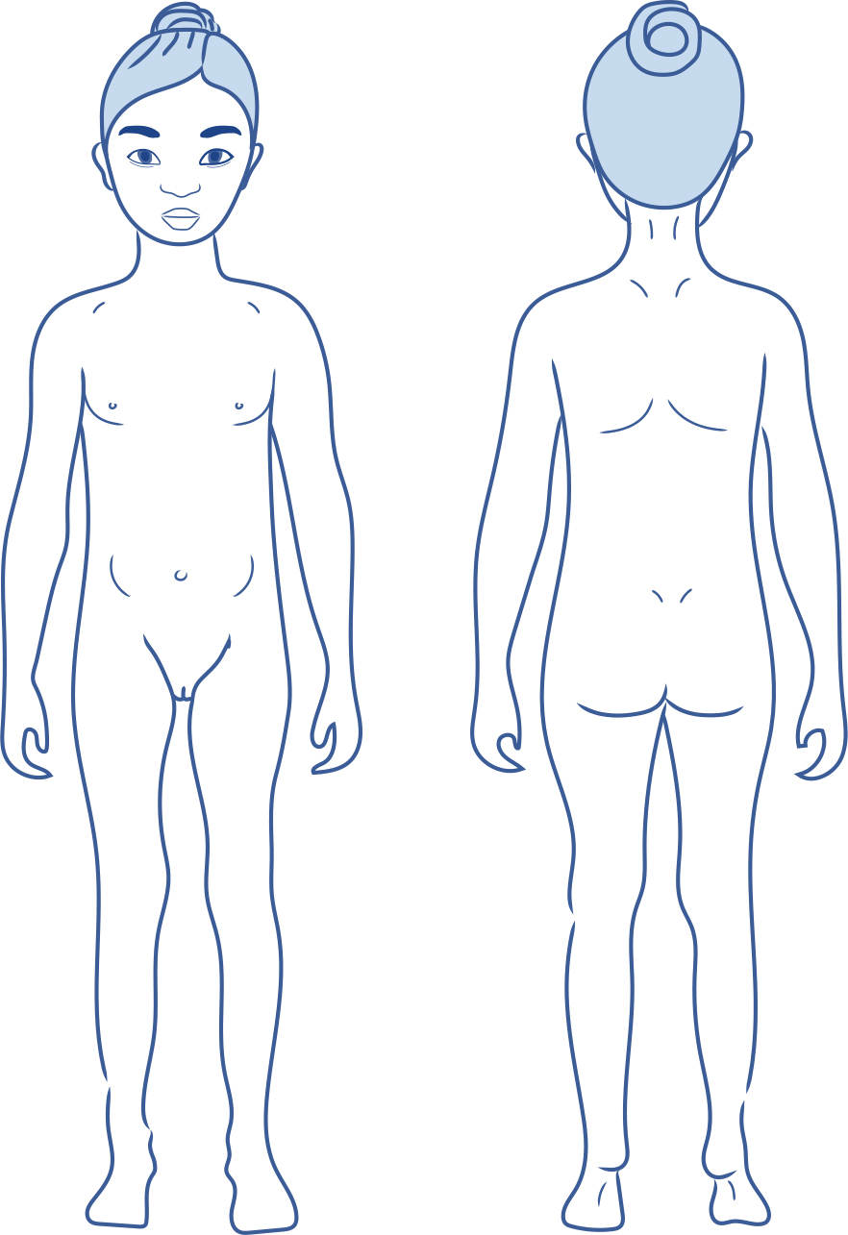

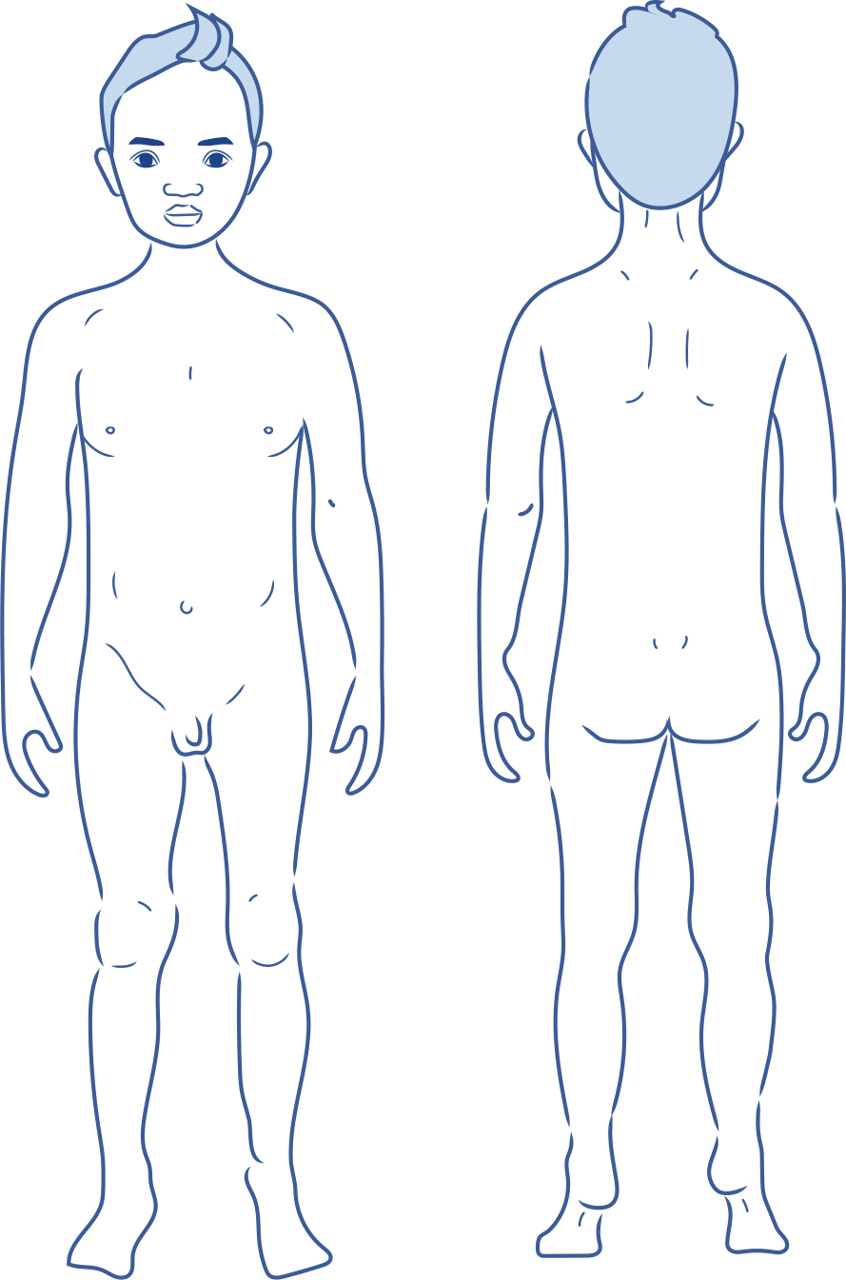

## Cards: Yes, sometimes, no and uncertain

|  |  |
| --- | --- |
| A mid shot of a girl and boy holding each other around the shoulders, smiling, with their heads tilted toward each other, and both giving a thumbs up sign.1 | A mid shot of a young girl with long hair wearing a beanie, with her arms at shoulder level. Her right hand is touching her right cheek giving a thumbs-down sign and her left hand is near her left ear giving a thumbs up sign. 2 |
| Yes | Sometimes |
| A mid shot of a girl with a determined expression on her face. Her head slightly tilted to the right, holding her right hand to the right side of her forehead with a thumbs down sign.3 | A boy faces sideways with an expression of uncertainty on his face. His left hand is ruffling the back of his head and his right hand is in his trouser pocket.4 |
| No | Uncertain |

## Cards: Feelings and emotions

### No feelings

|  |  |  |
| --- | --- | --- |
| A young girl looking annoyed. Her left hand on her left hip and her right arm at shoulder height is bent at the elbow, and she is pointing up with her pointer finger.5 | **An older boy looking confused. His head is tilted to the left and he is scratching his hair with his left fingers.**6 | A head shot of a teenage girl. Her eyes are tightly closed and her mouth is opened wide with her tongue sticking all the way out in disgust.7 |
| Angry | Confused | Disgusted |
| ­A girl stiffly holds her hands up and opened out either side of her face. Her eyes and mouth are wide open with fright.8 | A young girl with a frustrated expression on her face. She is scratching both sides of her head with her fingers.9 | A boy looking down with a grumpy expression. His shoulders are hunched, and his arms are crossed across his chest.10 |
| Frightened, afraid, scared | Frustrated | Grumpy |
| A sad young girl with her eyes closed and her head tilted to the left resting her forehead on the fist of her left hand.11 | A left-sided view of a sad, young girl sitting on her own against a post. with her arms around her knees 12 | A young, nervous girl looking down and biting the nails of her right fingers.13 |
| Hurt | Lonely | Nervous |
| A shocked young boy with raised eyebrows and wide-opened eyes, pressing the palms of his hands tightly against his opened mouth.14 | A sad, young boy with his eyes closed and his head tilted to the right, resting the right side of his face on the back of his right hand.15 | A concerned, young girl with her head tilted to the right, resting the right side of her face on the palm of her right hand. Her eyes are downcast.16 |
| Shocked | Unhappy, sad | Worried |

### Yes feelings

|  |  |  |
| --- | --- | --- |
| A face of a teenage girl. Her head is titled slightly to the right. She is looking directly at you with calm eyes and a wide, peaceful smile.17 | A mid shot of a boy with a huge smile on his face jumping up with excitement. His arms are raised above his head and his fingers are spread wide.18 | The head and shoulders shot of a happy-faced girl with a big smile and eyes looking confidently at you.19 |
| Peaceful, calm | Excited | Happy |
| A girl and an older woman enjoying a loving hug. The girl has a peaceful smile on her face.20 | A boy, head slightly tinted to the left, smiling with pride, and giving a thumbs-up sign with his left hand.21 | The head and shoulders of a smiling girl with her head tilted to her right. Her arms are folded across her chest and she is clutching the ends of her twisted long hair in each hand.22 |
| Loved, safe | Proud | Shy |
| A close-up on the faces of a girl and boy looking at you. Their eyes and mouth are opened wide with surprise.23 |  |  |
| Surprised |  |  |

## Body signals images

|  |  |
| --- | --- |
| A mid-shot of a nervous teenage girl with both arms bent at the elbows, her hands placed at her shoulders with fingers crossed on both her hands. Superimposed over her belly is a view inside her stomach with colourful flying butterflies to indicate she is nervous.49 | A mid shot profile of a young boy with his mouth opened grasping for air. Symbols of swirls and arrows describe his inhaled and exhaled breath as fast.50 |
| Butterflies in your tummy | Quick breathing |
| A mid shot of a teenage girl with her eyes and mouth squeezed closed in pain. She clutches her hands over her heart.51 | A full length shot of a young boy standing with his hands on his head and his eyes and mouth wide open. Squiggle lines near his knees indicate that he is shaking at the knees. 52 |
| Racing heart | Shaky knees |
| A mid shot of a young girl with a sad expression on her face, wearing a beanie and a scarf. Her arms are crossed tightly over her chest and her shoulders are hunched. Squiggly lines down the side of her upper arms indicate that she is shivering with cold. 53 | A mid shot of a young boy looking down with a sad expression on his face, his left hand is pressed against his tummy and his right arm is straight beside him. Superimposed over his belly is a view inside his stomach which is full of colourful wriggling worms indicating unrest. 54 |
| Cold-shivery body | Squirmy tummy |
| A head and shoulders shot of a young boy holding his right hand up with lots of droplets of water in his palm.55 | A young girl gazes upwards pressing her hand against her tilted forehead. Her forehead is flushed red indicating pain.56 |
| Sweaty hands | Warm body |

## Wanted and unwanted touch images

|  |  |
| --- | --- |
| A young girl with a broad smile on her face is kissed on the cheek by an adult woman.  45 | A young girl with a broad smile on her face is kissed on the cheek by an unknown adult person whose body has been outlined in a dotted line and filled in grey with a large black question mark in the middle.  45 |
| Wanted kissing | Unwanted kissing |
| A mid shot of a young girl walking on the street holding hands with an adult man. 46 | The front view of a young girl walking on the street holding hands with an unknown adult person whose body has been outlined in a dotted line and filled in grey with a large black question mark in the middle.  46 |
| Wanted holding hands | Unwanted holding hands |
| A young boy sitting next to an adult man and looking up at him with his eyes wide and his mouth closed in a thin line. The man has his arm around the boy’s shoulders in a hug and is holding the boy’s hand and looking into the boy’s eyes.  47 | A young boy sitting next to an unknown adult and looking up at them with his eyes wide and his mouth closed in a thin line. The unknown adult’s body has been outlined in a dotted line and filled in grey with a large black question mark in the middle. The unknown adult has their arm around the boy’s shoulders in a hug and is holding the boy’s hand.  47 |
| Wanted hug | Unwanted hug |
| A young boy sitting on the floor across from an adult man. Their legs are crossed, and the boy’s right foot is touching the man’s left foot. The man has his hands on the boy’s knees tickling him. The boy is leaning back away from the man grimacing with his face tilted down.  48 | A young boy sitting across from an unknown adult whose body has been outlined in a dotted line and filled in grey with a large black question mark in the middle. This person’s hands are on the boy’s knees tickling him. The boy is leaning back away from the adult grimacing with his face tilted down.  48 |
| Wanted tickling | Unwanted tickling |

## Images of toys

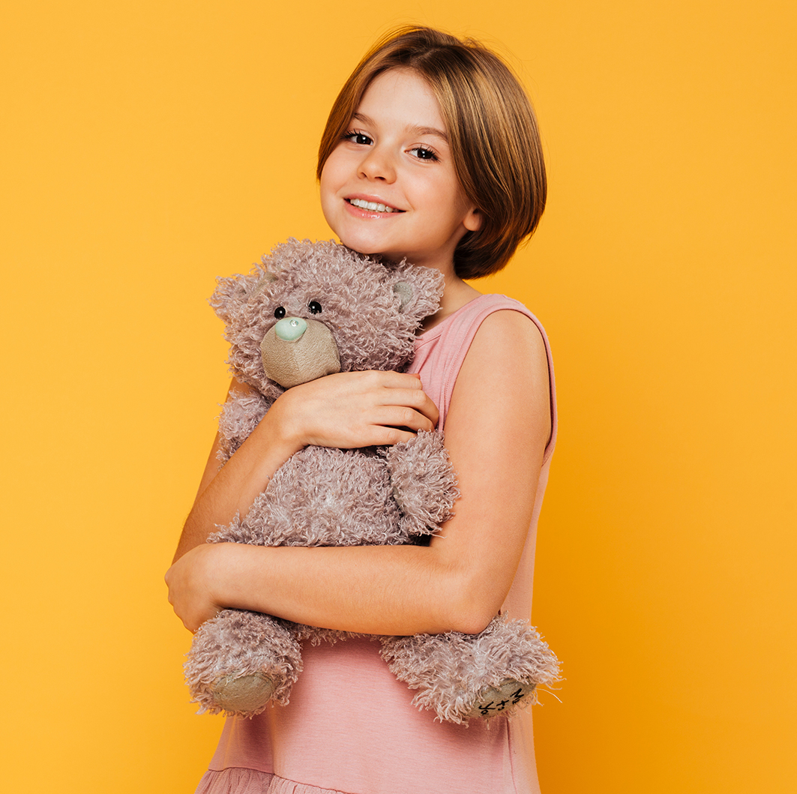57

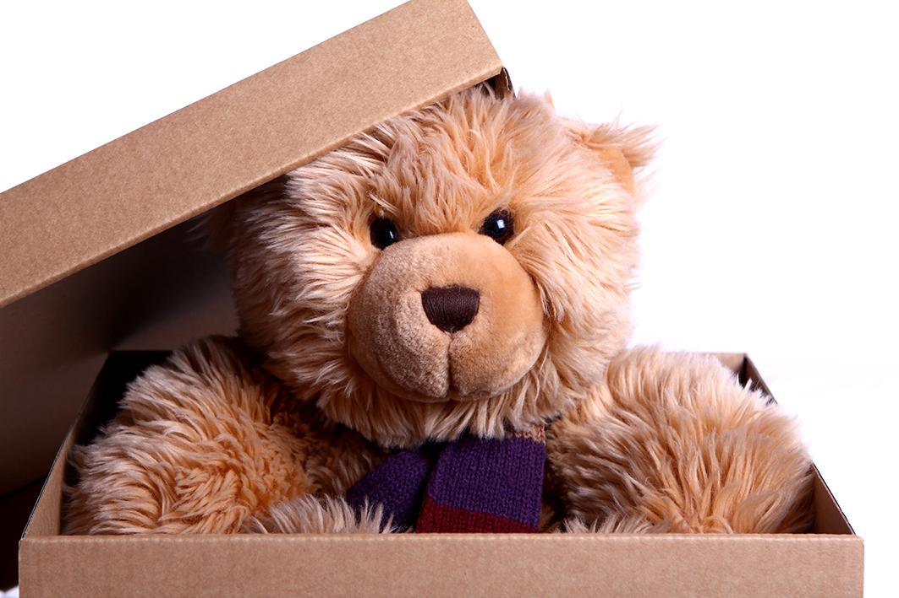 58

## Cards: No-go-tell scenarios

|  |  |
| --- | --- |
| Four children are sitting in their seats at the movies. A young girl in the nearest seat looking at you and smiling with her hand placed on the side of her mouth. A large box of popcorn is on her armrest tray. Next to her is an older girl with a drink in her armrest tray. She and the other two children (a boy and a girl) are looking at the movie screen and smiling.  24 | A young boy sits in the dark holding a small torch alight at chest level. Light is reflecting below and above his mouth, under his nose, and under his eyebrows.  25 |
| Going to the movies | Being in the dark |
| A group of two adults and two young children sitting on a picnic rug. The man and older child are smiling and looking at the younger child whose right arm is extended towards the opened mouth of the woman, offering her something to eat. 26 | A three frame scene. In the bottom frame a profile view of a young boy wearing earphones, sitting at a computer with two screens, playing an online game. In the top left frame is a back view of a man wearing earphones sitting at a computer. There is a question mark on his back. The top right frame has a silhouetted back view of a person also wearing earphones facing a computer screen. There is a question mark symbol on the back of his head.  27 |
| Having a picnic with family | Playing a game online with people  you don’t know |
| A mid shot of a man in the foreground and a full side profile of a bull in an enclosed paddock in the background. The bull is looking at the man. The man has his back to the bull, with a partly clenched fist up to his mouth, a frown on his forehead and his eyes are opened wide with fear.  28 | A mid shot of a young boy standing in the foreground of a shopping centre. Both his arms are bent at the elbows with his hands covering his face up to his eyes.  29 |
| Being in a paddock with a bull | Lost in a shopping centre |
| A young boy wearing a backpack with a water bottle is sitting on the ground in the bush. His legs are crossed and resting his head on his knees which are pulled up to his chest. His right arm is crossed over his right knee, covering his face, and holding his left arm near the elbow. His left hand is hanging opened across his right shin. His hat and a walking pole are lying on the ground in front of him.  30 | A young boy sits alone on a bus top bench leaning against a billboard. He has the hood of his jacket pulled over the baseball cap he is wearing. His feet are crossed, and his hands are resting on his lap. He has a sad expression on his face.  31 |
| Lost in the bush | Missing the bus home |
| A long shot of three teenaged girls with backpacks walking behind each other through a narrow creek in the bush. The girl in the middle is looking up and pointing ahead towards something. The other two girls are looking in the direction that she is pointing.  32 | A close up head and shoulders shot of a young boy lying on the grass on his stomach propped up on his elbows with his nose touching the nose of a grey rabbit which is also lying on the grass on its stomach propped up on its elbows.  33 |
| Going on a bush walk | Playing with a pet |
| A close up of two young boys lying on their stomach under a blanket reading from an ebook tablet. The light from the tablet reflects on their faces.  34 | A group of teenagers riding in the front car of a roller coaster at the peak of the hill. One of the girls in the front has her hand stretched up in the air with her fingers spread out. The girl beside her has her arms opened straight from her shoulders and bent at the elbows with her hands opened wide, one hand halfway across the face of the girl next to her. Both girls have their mouths wide open.  35 |
| Reading a book at night with a torch | Riding on a roller coaster |
| A head and shoulder shot of a man looking at a large grey camouflaged-patterned snake in the top right foreground. The man is covering his face with his hands with a gap between the first and middle fingers of his left hand through which he is looking up at a snake with a wide opened eye.  36 | A long shot looking up at a young child swinging high on a swing in a park. The top of the swing structure and two trees are visible.  37 |
| Seeing a snake | Swinging on the swings at the park |
| A head and shoulder shot of a young boy with a huge spider web with a spider in the middle of the web. The boy is looking at the spider with his eyes and mouth wide opened, his arms bent at the elbows, and his hands opened in front of him in a defensive poise.  38 | Three schoolboys are walking (shoulder to shoulder) and laughing. They hold take-away drinks in their hands. The first two boys are looking directly at each other and the third boy is looking towards them.  39 |
| Walking into a spider web | Walking to school with friends |
| Two young girls sitting on a couch watching a TV with a bowl of popcorn between them. The girl on the right is pointing the remote towards the TV and the girl on the left has her hand to her mouth eating popcorn.  40 |  |
| Watching television at home |  |

## No-go-tell images

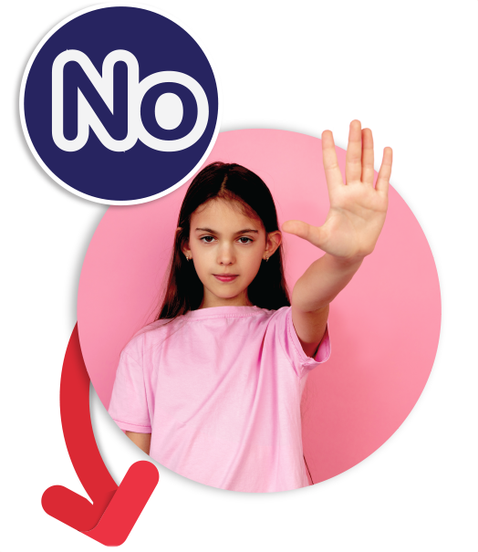42

43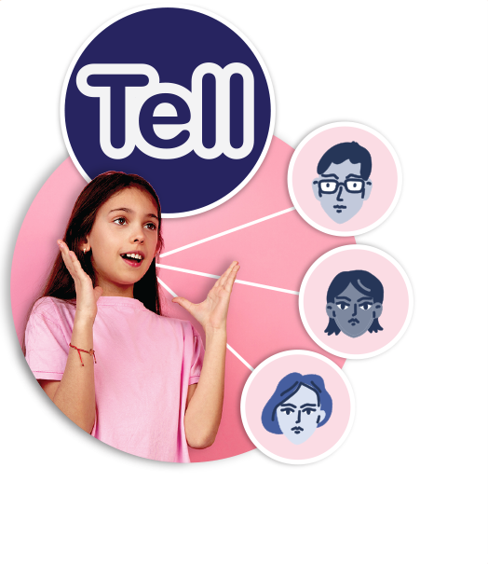44

## Copyright register

1. Yes boy and girl: Children photo created by freepik – www.freepik.com
2. Sometimes girl: Camera photo created by drobotdean – www.freepik.com
3. Don’t like it girl: Background photo created by freepik – www.freepik.com
4. Uncertain boy: Children photo created by freepik – www.freepik.com
5. Angry: Education photo created by freepik – [www.freepik.com](http://www.freepik.com)
6. Confused: People photo created by cookie_studio – [www.freepik.com](http://www.freepik.com)
7. Disgusted: Woman photo created by cookie_studio – [www.freepik.com](http://www.freepik.com)
8. Frightened: Kids photo created by freepik – www.freepik.com
9. Frustrated: Girl photo created by freepik – [www.freepik.com](http://www.freepik.com)
10. Grumpy: Designed by Freepik – [www.freepik.com](http://www.freepik.com)
11. Sad/hurt: Girl photo created by freepik – [www.freepik.com](http://www.freepik.com)
12. Lonely: People photo created by jcomp – [www.freepik.com](http://www.freepik.com)
13. Nervous: Designed by pressfoto – [www.freepik.com](http://www.freepik.com)
14. Shocked Designed by Freepik – [www.freepik.com](http://www.freepik.com)
15. Unhappy: Designed by jcomp – [www.freepik.com](http://www.freepik.com)
16. Worried: Designed by jcomp – [www.freepik.com](http://www.freepik.com)
17. Peaceful/calm: Woman photo created by cookie_studio – [www.freepik.com](http://www.freepik.com)
18. Excited: People photo created by jcomp – [www.freepik.com](http://www.freepik.com)
19. Happy: For websites: Designed by Asier_Relampagoestudio – [www.freepik.com](http://www.freepik.com)
20. Loved/safe: Family photo created by master1305 – [www.freepik.com](http://www.freepik.com)
21. Proud: Designed by jcomp – [www.freepik.com](http://www.freepik.com)
22. Shy: For websites: Designed by cookie_studio – [www.freepik.com](http://www.freepik.com)
23. Surprised: People photo created by drobotdean – [www.freepik.com](http://www.freepik.com)
24. Kids at movies: Designed by serhii – www.freepik.com
25. Being in dark: Image by FotoRieth from Pixabay
26. Family picnic: People photo created by freepik – www.freepik.com
27. Playing online with strangers: Profile of boy with monitors: Image by ExplorerBob from Pixabay  
    Back view of guy: Image by 11333328 from Pixabay  
    Shadowed guy: Image by Tomasz Mikołajczyk from Pixabay
28. Bull in paddock: Tree photo created by freepik – www.freepik.com  
    Guy scared: Business photo created by drobotdean – www.freepik.com
29. Lost in shopping centre: Boy: Background photo created by freepik – www.freepik.com  
    Shopping centre background: Background photo created by mrsiraphol – www.freepik.com
30. Lost in bush: Green photo created by rawpixel.com – [www.freepik.com](http://www.freepik.com)
31. Missing the bus: Image by Виктория Бородинова (Victoria_Borodinova) from Pixabay
32. Bushwalking: People photo created by freepik – [www.freepik.com](http://www.freepik.com)
33. Playing with a pet: People photo created by freepik – [www.freepik.com](http://www.freepik.com)
34. Reading a book with torch: People photo created by photoroyalty – [www.freepik.com](http://www.freepik.com)
35. Roller coaster: Image by Jose Aitor Pons Buigues from Pixabay
36. Seeing a snake: Snake: Nature photo created by brgfx – [www.freepik.com](http://www.freepik.com)  
    Shocked man: Background photo created by freepik – [www.freepik.com](http://www.freepik.com)
37. Park swings: Image by jrwhip from Pixabay
38. Spiders web: boy: Kids photo created by freepik – www.freepik.com  
    Spider’s web: Image by Stockvault Non-Commercial License: <https://www.stockvault.net/terms-of-use>
39. Walking with friends: School photo created by pressfoto – [www.freepik.com](http://www.freepik.com)
40. Watching TV: Food photo created by nensuria – www.freepik.com
41. Body parts: Kids photo created by freepik – www.freepik.com
42. No girl: People photo created by master1305 – www.freepik.com
43. Go footprints: Background vector created by macrovector_official – [www.freepik.com](http://www.freepik.com)
44. Tell girl: People photo created by master1305 – www.freepik.com  
    Trusted people headshots: People vector created by freepik – www.freepik.com
45. Kiss: Family photo created by freepik – www.freepik.com
46. Holding hands: People photo created by freepik – www.freepik.com
47. Hug: Designed by Freepik – www.freepik.com
48. Tickle: Love photo created by freepik – www.freepik.com
49. Butterflies in your tummy butterflies: Background photo created by freepik – www.freepik.com  
    Butterflies in your tummy girl: Woman vector created by freepik – www.freepik.com
50. Quick breathing boy: Food photo created by diana.grytsku – [www.freepik.com](http://www.freepik.com)
51. Racing heart girl: People photo created by wayhomestudio – [www.freepik.com](http://www.freepik.com)
52. Shaky knees: Shaky knees boy: Cute photo created by drobotdean – www.freepik.com
53. Cold shivery body girl: Winter photo created by freepik – www.freepik.com
54. Squirmy tummy boy: Background photo created by freepik – www.freepik.com  
    Worms: Food photo created by freepik – www.freepik.com
55. Sweaty hands boy: School photo created by jcomp – www.freepik.com  
    Droplets: Water vector created by pch.vector – www.freepik.com
56. Warm body girl: Designed by jcomp – www.freepik.com
57. Girl hugging bear: Love photo created by drobotdean – www.freepik.com
58. Teddy bear in box: Christmas photo created by Racool_studio – www.freepik.com