What do we need in life?
Suggested duration: 60 minutes
This is one activity in a sequence designed to investigate the issue of violence and extremism with a focus on the skills required to objectively consider these issues within a context of positive relationships, identity, rights and responsibilities and intercultural understanding.
The activities seek to empower students with the skills to critically analyse situations, attitudes and behaviours that influence health, safety and wellbeing in different contexts, including countering violence and extremism.
Students will develop their skills to recognise and respond appropriately to situations, which may be harmful to self and others. The activities introduce a broad range of scenarios involving violence through which students:
- understand the difference between violence and violent extremism
- analyse their own attitudes towards violence
- learn to identify warning signs and safely engage in upstander behaviour or exercise self-control
- strengthen skills in asserting oneself respectfully.
In exploring violence and extremism, the following key questions have been considered:
- what is violence and extremism? What does violence and extremism look like?
- could our assumptions about violence and extremism be false?
- what motivates individuals to act violently?
- what are the consequences of violence and extremism?
- how can we change attitudes and behaviours in relation to violence and extremism?
The knowledge and understanding developed through responding to these key questions can be validly explored through a range of violence related scenarios. These scenarios aim to equip students with the skills they need to critically analyse potentially harmful situations and act safely and timely to promote health, safety and wellbeing.
The activity sequence includes five lessons.
- Why violence?
- Where do you stand on violence?
- What do we need in life?
- The boss of me
- Stitch in time.

Activity focus
This activity leads students to analyse their needs in life, arrange them in a hierarchy of what needs need to be met first, before others. This activity is useful before working on the activity Why violence? but it also works as a standalone activity.

Course outcomes
1.1 Assess personal strengths and skills to achieve positive outcomes in a range of challenging and changing situations.
1.2 Critically evaluate services and resources to identify sources of reliable information and support.
1.3 Build positive thinking, self-belief and a sense of empowerment to take action to promote meaningful futures for self and others.
5.1 Critically analyse situations, attitudes and behaviours that influence independence, health, safety and wellbeing in different contexts.

What do we want students to know, understand or be able to do?
- Understand their own needs in life.
- Analyse the motivation behind their own attitudes and behaviours.
- Recognise that we behave in response to feelings and needs.
- Propose effective strategies for satisfying needs.
- Evaluate the efficacy of strategies employed to satisfy needs.
- Describe their future acknowledging the satisfaction of needs to create meaning in their lives.

Suggested content
Learning context | Content
Independence  Focus: Building self-concepts and independence | Personal values and beliefs  - self concepts  Self management  - responsibility for self and actions  - strategies for future success
Mental health and wellbeing  Focus: Developing self-efficacy and mental fitness | Building resilience  - acknowledging controllable factors  - recognising achievements and successes  - seeking, accessing and accepting help and support  - overcoming adversity  Self-awareness and self-regulation  - perspective taking  - holistic view of life  Positive wellbeing  - establishing meaning and purpose for life

Resources for preparation
- Whiteboard, markers, butcher’s paper and markers or online tools such as Mindmeister, Coggle, and Popplet to brainstorm
- Hierarchy of Human Needs pyramid handout

Teaching notes
These activities lead students to analyse their needs in life, arrange them in a hierarchy of what needs need to be satisfied first, before others. This activity provides a base and leads into the activity Why anger? but it also works as a standalone activity.
Students are asked to critically evaluate Maslow’s Hierarchy of Needs and propose theories for the similarities and differences between Maslow’s Hierarchy and their own. A recommended reading for the teacher facilitating this discussion is:
McLeod, S. A. (2014). Maslow's Hierarchy of Needs. Retrieved from: simplypsychology.org/maslow

Creating a safe and supportive learning environment
There are a number of strategies that can be used to create a supportive learning environment which enables students to feel safe to learn and ask questions. They include:
- making students aware at the beginning of Life Ready sessions that disclosing personal information that indicates they may be at risk of harm will be reported to the school principal in all instances. This includes personal disclosures related to instances of abuse, drug use, neglect or sexual activity under the legal age of consent.
- being aware that some parts of Life Ready can be confronting and sensitive for some students.
- enabling students to withdraw if they find issues personally confronting to protect them from making harmful disclosures. Equally, it is important to be prepared for issues that arise as a result of a student making a public disclosure in the classroom.
More information on creating a safe and supportive learning environment can be found on the Life Ready website.

Evaluating resources before use
Preview and evaluate all strategies, resources and teaching and learning approaches in full before use with students to determine suitability for student learning needs, stage of development and local school context. Consider the age, maturity, cultural background, sexuality, gender, sex, health and other characteristics of students in your care. Apply professional judgements to all strategies, teaching and learning approaches and resources including audiovisual materials (e.g. videos, media clips and YouTube), interactive web-based content (e.g. games, quizzes and websites) and texts.
Use the resource review flowchart to decide about the suitability of teaching and learning resources.
Materials should be reviewed in full and endorsed by the school principal before use in NSW government schools.

Communication with parents and caregivers
Some aspects of Life Ready may be viewed as sensitive or controversial, such as learning about abuse, child protection, drugs, respectful relationships, sexual health, sexuality and violence. Inform parents and carers, prior to the occasion, of the specific details of the Life Ready program, so that parents and caregivers have time to exercise their rights of withdrawing their child from a particular session. In this regard, a parents or caregiver’s wish must be respected.
Establishing how parents and caregivers will be informed about programs and involved in consultation is a school-based decision. Where parents and caregivers indicate they wish to withdraw their child from a program it is useful to negotiate which parts of the Life Ready program they are concerned about. A sample information letter is available on the Life Ready website.

Learning experiences

Activity one – What do I need in life? (15 minutes)
This activity builds on student understanding of needs and wants from 7-10 PDHPE. If required, discuss the difference between needs and wants to ensure students can differentiate between the two and use this information in the following activities.
This activity requires equipment for students to mind map: whiteboard and markers, butcher’s paper and markers or online tools such as Mindmeister, Coggle, and Popplet.
- Students work in groups of no more than 4 people. Students will discuss in groups, but each will create their individual mind map.
- Students draw a representation of themselves in the middle of the mind map.
- As a group, students discuss the essentials they need or appreciate in their life and would find life difficult without. Students add the items that resonate with them personally to the first level of their mind map, around their self-representation. Essentials might include:
  - adequate standard of living – warmth, shelter, food, drink, clothing
  - health, education, employment
  - sense of self-worth, capability and identity
  - sense of recognition and belonging
  - sense of justice
  - sense of welfare, safety and security.

Activity two – Grouping the needs (10 minutes)
Facilitating teachers will need to have read the recommended reading before commencing this activity. McLeod, S. A. (2014). Maslow's Hierarchy of Needs. Retrieved from simplypsychology.org/maslow
- As a whole group, discuss each of the human needs, and provide examples of needs that would belong to each group.
- Students return to their groups to discuss the human need headings that each of their essentials relate to. Individual students record the human needs in the next level of their mind map.
- Human needs:
  - physiological needs
  - safety needs
  - belonging/Love
  - esteem
  - cognitive needs
  - aesthetic needs
  - self-actualisation
  - transcendence

Activity three – The heirachy of human needs (10 minutes)
- A student reads the following explanation to the whole group: “Maslow was an American psychologist who proposed a theory of human motivation – that people are motivated to work through stages of development to meet their needs. His work is today commonly represented as a pyramid. The most basic human needs are at the bottom half. Maslow proposes these need to be met before the individual will strongly desire the higher needs.”
- Students take a Hierarchy of Human Needs pyramid handout, and considering their own needs in the mind map, label the pyramid from bottom to top using the needs identified by Maslow, in order of the most basic needs that will need to be satisfied, before satisfying others.

Activity four – What if our needs are not met? (10 minutes)
- Students label, on the left side of their pyramid, how they feel when their needs are not satisfied.
- As a group, discuss how those feelings, and the desire to satisfy needs can sometimes make people behave in a way that does not functionally satisfy the need long term, or it may have the opposite effect. For example, some people feel the need to increase the own self-esteem by putting down others, so that they feel more powerful.

Activity five – Fulfilling the needs (10 minutes)
- Explain to students that understanding our needs and having hope and vision for how we might satisfy these needs equips us for a fulfilling future.
- Students brainstorm different activities that could satisfy each of the human needs. Students label, on the right side of their pyramid, a description of their future selves taking action to satisfy each level of need, e.g. volunteering for a charity might satisfy belonging or transcendence.

Activity six – Critically evaluate the hierarchy of needs (10 minutes)
- Students form groups to compare their pyramid to Maslow’s pyramid. Discuss the similarities and differences as a group.
- Where students identify differences, students propose reasons for the differences.
- Share these reasons as a whole group and record a list.
- As a whole group, evaluate the effectiveness of the hierarchy in helping us understand our own motivations behind behaviour.
  - How does identifying the motivation behind our behaviour help us understand why we behave the way we do?
  - How could you apply this thinking in life?
  - What strategies do we use as individuals and communities (e.g. young people as a community) to access what we need to satisfy needs?
  - Evaluate the efficacy of these strategies in accessing what we need to satisfy needs.

Heirachy of human needs
Activity: Label the most basic needs at the bottom, with your higher needs at the top.
Activity: Label, on the right side of your pyramid, a description of your future selves taking action to satisfy each level of need, e.g. volunteering for a charity.

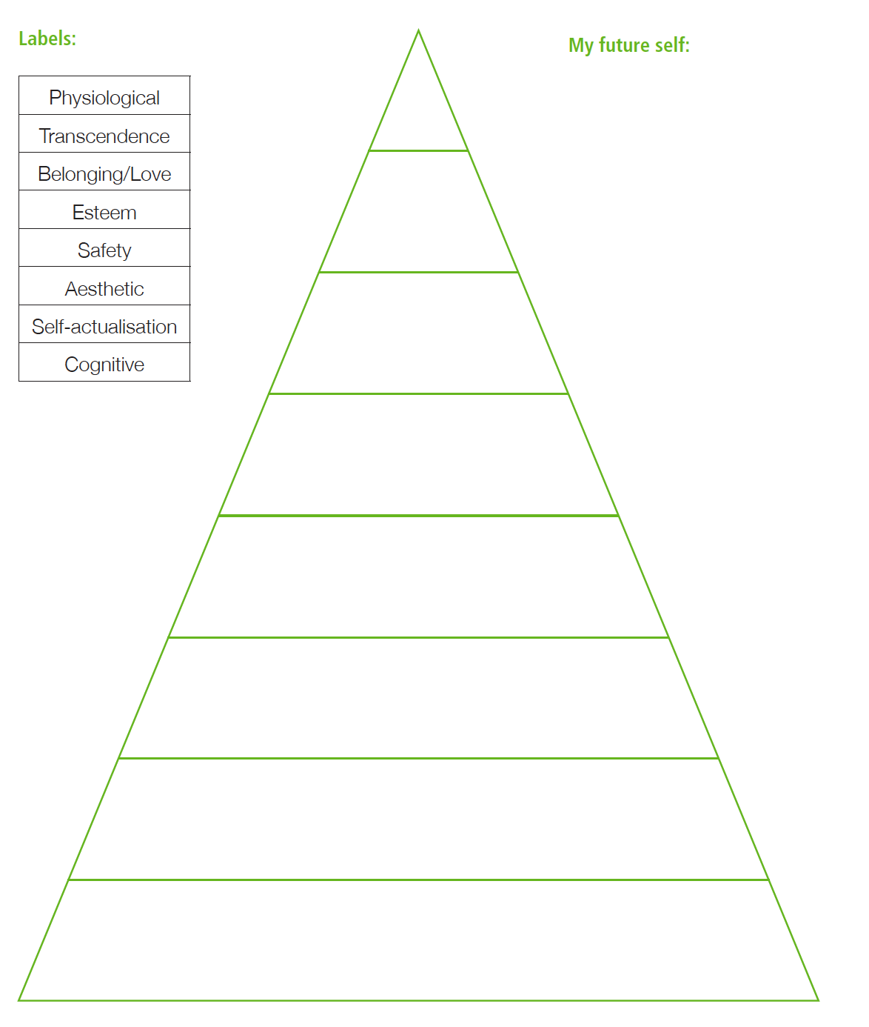

Teacher notes – Violence and extremism
Violence has been defined by the World Health Organization as “the intentional use of physical force or power, threatened or actual, against oneself, another person, or against a group or community, that either results in or has a high likelihood of resulting in injury, death, psychological harm, maldevelopment or deprivation”.
For the purpose of the Life Ready course and the following activities, violence includes domestic and family violence, relationship violence, assault, sexual assault, rape, underage or forced marriage, trafficking or coercion, harmful traditional or cultural practices including female genital mutilation or honour killings. Violent extremism is using violence to achieve goals on behalf of a group. Life Ready activities are not designed to explore the issues around state sanctioned violence, war, the use of the death penalty or violence as a sport. These examples of violence are outside the scope of the Life Ready course.
It is important for students to learn about violence and consider their own attitudes and the attitudes of others towards violence in our community. Childhood and adolescence is an important time for developing and maintaining respectful, non-violent relationships and learning to assert a non- violent stance.
In Australia only a very small proportion of the population supports the use of violence to try to achieve ideological, religious or political goals. Combatting violence is the responsibility of the whole community and is most effective as part of a whole school approach. The Australian Government Living Safe Together website and toolkit provides information for schools to assist in building understanding of extremism and the radicalisation process and how to respond if they are concerned about a student or member of the community.
The development of a school ethos and culture that models respectful practices and is consistent in dealing with incidents of violence is as important a teaching tool as the formal curriculum.

Key messages

Domestic and family violence is a gendered crime.
- Females make up the majority of victims and males the majority of offenders.
- Although the research shows that males are the main perpetrators of violence against both men and women, most men and boys are not abusive in their relationships.
- Some men’s violence may give all men a bad name.
- Males can play a key role in helping stop violence, particularly against women.

Violence is a choice
- The use of violence is a choice: those who use violence choose where and when they do the violence; and, how they use the violence.
- Violence as a choice does not necessarily mean a considered choice. It should be noted that some individuals may react violently in specific situations, such as when their life is threatened or they act in self-defence.
- In some situations, an individual’s response may be affected by poor impulse control resulting from experiences of abuse or trauma or as a result of mental illness, clinical behaviour disorders, health conditions or disability. The teaching and learning activities provided do not seek to judge these actions.
- The activities aim to address violence broadly without specific reference to individual cases or specialised instances of violence, where an individual requires specialised counselling and support.

Violence can be learned and unlearned
- Research shows that violence, particularly violence against women is the product of learned attitudes and norms, and social inequalities.
- Just as violence-supportive attitudes can be learned, they can be unlearned.
- Communities and governments can change the social conditions that feed violence, replacing them with social conditions that encourage respect and non-violence.

There is no simple profile of a violent offender or extremist
- People who demonstrate violent behaviours, engage in acts of violent extremism or join violent extremist groups come from all kind of backgrounds and have various motivations.
- Teachers should avoid discussions that promote stereotypical views or exclusion of particular individuals or groups in society.

Education about violence, extremism and radicalisation is the responsibility of the community
- All forms of violence and extremism use fear and intimidation to change a situation rather than through respectful and peaceful means.
- It is our community and our responsibility.
- Australia’s diversity has given rise to a rich culture with a strong commitment to political and personal freedoms, respect for human rights and the rule of law.
- Regardless of their background or motivation, individuals who are prepared to commit or support violence against individuals or the community threaten our shared values.
- Community initiatives designed to address factors that can lead to violence and extremism and help at- risk individuals, can play an important part in strengthening our communities.

Additional resources
Australian Government, Living Safe Together Toolkit livingsafetogether.gov.au/informationadvice/Pages/what-is-radicalisation/what-is-radicalisation.aspx
Domestic Violence NSW domesticviolence.nsw.gov.au
White Ribbon – Australia’s campaign to stop violence against women whiteribbon.org.au/schools
Building Respectful Relationships: Stepping Out Against Gender Based Violence (Vic DoE) education.vic.gov.au/school/teachers/health/Pages/respectrel.aspx
Domestic Violence Resource Centre Victoria dvrcv.org.au

World Health Organisation, Global campaign for violence prevention; last viewed 15 Feb 2016 who.int/violenceprevention/approach/definition/en/
Australian Government, livingsafetogether.gov.au/informationadvice/Pages/what-is-radicalisation/what-is-radicalisation.aspx

