A stitch in time
Suggested duration: 50 minutes
This is one activity in a sequence designed to investigate the issue of violence and extremism with a focus on the skills required to objectively consider these issues within a context of positive relationships, identity, rights and responsibilities and intercultural understanding.
The activities seek to empower students with the skills to critically analyse situations, attitudes and behaviours that influence health, safety and wellbeing in different contexts, including countering violence and extremism.
Students will develop their skills to recognise and respond appropriately to situations, which may be harmful to self and others. The activities introduce a broad range of scenarios involving violence through which students:
- understand the difference between violence and violent extremism
- analyse their own attitudes towards violence
- learn to identify warning signs and safely engage in upstander behaviour or exercise self-control
- strengthen skills in asserting oneself respectfully.

In exploring violence and extremism, the following key questions have been considered:
- what is violence and extremism? What does violence and extremism look like?
- could our assumptions about violence and extremism be false?
- what motivates individuals to act violently?
- what are the consequences of violence and extremism?
- how can we change attitudes and behaviours in relation to violence and extremism?
The knowledge and understanding developed through responding to these key questions can be validly explored through a range of violence related scenarios. These scenarios aim to equip students with the skills they need to critically analyse potentially harmful situations and act safely and timely to promote health, safety and wellbeing.

The activity sequence includes five lessons.
- Why violence?
- Where do you stand on violence?
- What do we need in life?
- The boss of me
- Stitch in time.

Activity focus
This activity aims to explore the issues surrounding violence as a choice. Students investigate how and when people can intervene in situations and the consequences of their actions. This activity has been designed to build on the activity Identifying strengths, skills and strategies.

Course outcomes
1.1 Assess personal strengths and skills to achieve positive outcomes in a range of challenging and changing situations.
5.1 Critically analyse situations, attitudes and behaviours that influence independence, health, safety and wellbeing in different contextsds
5.2 Recognise and respond appropriately to situations which may be limiting or harmful to self and others.
6.1 Assess, adapt and apply skills to develop and maintain respectful relationships and successfully participate in education, work and community contexts.
6.2 Demonstrate behaviours that model positive values, beliefs and attitudes and promote inclusion and equity for self and others.
7.2 Demonstrate the capacity to seek help for self and others.

What do we want students to know, understand or be able to do?
- Evaluate the suitability and effectiveness of a range of skills and strategies designed to assist young people to recognise and respond appropriately to situations of violence.
- Assess and apply personal strengths and skills to avoid potentially harmful situations in relation to abuse and violence.
- Practice applying relationship skills in different violence related situations, e.g. refusal skills, communication skills and help seeking skills.
- Demonstrate an ability to select the most appropriate and timely strategy to use in different violent situations to achieve a positive outcome for self and others.

Suggested content
Learning context | Content
Independence  Focus: Building self-concepts and independence | Personal values and beliefs  - influence of values, attitudes and beliefs on decisions and actions in various contexts  - recognising and assessing strengths, aspirations and potential
Relationships  Focus: Developing and maintaining respectful relationships | Establishing and managing relationships  - applying relationship skills, e.g. effective communication, active listening, conflict resolution, assertiveness, negotiation, mediation  - understanding rights and responsibilities in different relationships  - bullying and harassment  Applying relationship skills in differing contexts  - appropriate expression of thoughts, emotions and opinions  - refusal skills in different contexts and situations, e.g. negotiating consent, drug and alcohol related situations
Relationships  Focus: Promoting safety, equality and respect in relationships | Valuing and advocating for the rights of self and others  - changing perspectives and challenging stereotypes  - respecting others  - asserting a stance on a situation or decision  - challenging discrimination based on race, sex, age, disability, religion, culture, gender and sexuality  - upstander behaviour (online and offline)  Challenging and changing attitudes and beliefs about power, assault and relationship violence  - promoting equality and respect in relationships  - preventing relationship violence and sexual assault  - challenging and changing attitudes to violence, including domestic violence

Resources for preparation
- Strengths, skills and strategies student handout (1 copy per student printed)
- Scenarios - printed and stuck on the walls around the room
- Pens and 2 different colour sticky notes required for each group
- “Red flags” heading is written on board or poster, ready to be displayed just before activity three
- Who can help cards printed for each group

Teaching notes
This activity encourages students to recognise how timely intervention can prevent situations escalating into acts of violence. Violence can include domestic and family violence, relationship violence, assault, sexual assault, rape, trafficking or coercion, harmful traditional or cultural practices including or honour killings. Respectful relationships are characterised by non-violence, equity, mutual respect and trust. A range of scenarios, which include violence, have been included in these activities. The purpose of introducing the scenarios is to empower students to recognise appropriate times for intervention.
Teachers should encourage students to focus on intervention strategies.
Teachers should be aware that the issues discussed in these activities may be confronting for some students. It is important to establish a safe and effective classroom environment, where ground rules are clearly communicated so students feel safe to learn and ask questions. It is essential that students are encouraged to listen to and respect the values, beliefs and opinions of others. It is important to enable students to withdraw if they find issues personally confronting and to protect them from making harmful disclosures.
Students should be made aware at the beginning of this activity, and other activities through Life Ready, that disclosures that indicate they may be at risk of harm will be reported to the school principal in all instances. This includes personal disclosures related to instances of abuse, violence, illegal activity or sexual activity under the legal age of consent.
It is important that students are familiar with the appropriate places they can seek help. The Teacher Fact sheet – Sources of help provides more information about some of the services available to students and the broader community.

Creating a safe and supportive learning environment
There are a number of strategies that can be used to create a supportive learning environment which enables students to feel safe to learn and ask questions. They include:
- Making students aware at the beginning of Life Ready sessions that disclosing personal information that indicates they may be at risk of harm will be reported to the school principal in all instances. This includes personal disclosures related to instances of abuse, drug use, neglect or sexual activity under the legal age of consent.
- Being aware that some parts of Life Ready can be confronting and sensitive for some students.
- Enabling students to withdraw if they find issues personally confronting to protect them from making harmful disclosures. Equally, it is important to be prepared for issues that arise as a result of a student making a public disclosure in the classroom.
More information on creating a safe and supportive learning environment can be found on the Life Ready website.

Evaluating resources before use
Preview and evaluate all strategies, resources and teaching and learning approaches in full before use with students to determine suitability for student learning needs, stage of development and local school context. Consider the age, maturity, cultural background, sexuality, gender, sex, health and other characteristics of students in your care. Apply professional judgements to all strategies, teaching and learning approaches and resources including audiovisual materials (e.g. videos, media clips and YouTube), interactive web-based content (e.g. games, quizzes and websites) and texts.
Use the resource review flowchart to decide about the suitability of teaching and learning resources.
Materials should be reviewed in full and endorsed by the school principal before use in NSW government schools.

Communication with parents and caregivers
Some aspects of Life Ready may be viewed as sensitive or controversial, such as learning about abuse, child protection, drugs, respectful relationships, sexual health, sexuality and violence. Inform parents and carers, prior to the occasion, of the specific details of the Life Ready program, so that parents and caregivers have time to exercise their rights of withdrawing their child from a particular session. In this regard, a parents or caregiver’s wish must be respected.
Establishing how parents and caregivers will be informed about programs and involved in consultation is a school-based decision. Where parents and caregivers indicate they wish to withdraw their child from a program it is useful to negotiate which parts of the Life Ready program they are concerned about. A sample information letter is available on the Life Ready website.

Learning experiences

Activity one – What could you do next? (10 minutes)
- As a group, revise the strengths, skills and strategies that people can use in difficult, challenging or awkward situations, such as those which may escalate into violence. Ideas can be found in the Student handout - Strengths, skills and strategies.
- Students work in small groups to read a scenario and record their responses to: “What could you do next?”
- Individually, students analyse their own strengths and skills to decide on a strategy they could implement in response to the situation. Students record their individual response to the situation on a sticky note and place it on the wall below the corresponding scenario.

Activity two – What might be the consequence? (10 minutes)
- Groups move in a clockwise direction to the next scenario.
- Students read both the scenario and the suggested strategies from previous group.
- As a group or in pairs, students brainstorm possible negative and positive consequences for each of the suggested strategies.
- Students rearrange the strategies to rank them in order of what they think with have the greatest chance of positive outcomes. Group discussion will be required. There may be some strategies which do not have a group consensus. Groups should note any strategies which generated more discussion and objection within the group than others.

Activity three – A stitch in time (20 minutes)
- As a whole group, students finish the idiom: “A stitch in time…” (saves nine).
  - As a group, discuss the meaning of this idiom.
  - Note: The idea is that if you sew a stitch in a hole as soon as it first appears, it will save the hole growing larger to the point where it will take 9 stitches to mend the hole.
- Students discuss how this idea could be applied to the scenario they examined in activity one.
- Students work in the same small group to examine the same scenario they read in activity one.
  - Students read the possible consequences that another group has recorded in activity 2 to the strategies suggested in activity 1. As a group, discuss whether the group agrees or disagrees with the outcomes and provide reasons?
  - Students read the scenario again. As a group, discuss if there is a point in the scenario, where action could have been taken sooner? Draw a red line to indicate a point where someone could intervene.
  - “Red flags” warn people of potential danger. Students discuss in pairs or as a group if students feel comfortable, what they have witnessed in the scenario that would make them want to raise the “red flag”.
  - One member of the group adds the behaviour they have witnessed to the “red flag” poster displayed in the room.
  - Students reflect on their own strengths and skills and record suggested intervention strategies that could be implemented at the “red flag” stage. Place these on post it notes with the scenario.
- Student groups rotate clockwise. Groups review the intervention strategies recorded and record possible consequences of each early intervention strategy. Groups rank the early intervention strategies in order of what they think with have the greatest chance of positive outcomes. Group discussion will be required. There may be some strategies which do not have a group consensus. Groups should note any strategies which generated more discussion and objection within the group than others.
- Students regroup as a whole class. Invite each group to present:
  - the scenario
  - the number one ranked suggested “What could you do next?” strategy and the possible consequences
  - the “red flag” moment
  - the number one ranked intervention strategy and the possible outcomes.
- Ask each group to explain whether group consensus was achieved for both the “what could you do next strategy” and intervention strategy. What discussions were had as a group? What influenced people’s thoughts and decisions when discussing the strategies and their ranking?
  - Did some strategies provide positive outcomes for some people involved in the situation and not others? Did this influence their ranking?
  - Were some strategies more difficult to put in place or achieve than others? Did this influence their ranking?
  - Did some strategies require more skill or more complex skills than others? Did this influence their ranking?
- As a group, discuss the positive benefits of taking action as soon as the “red flags” appear.

Activity four – Who can help? (10 minutes)
- Groups are provided with a set of Who can help cards.
- Share some of the “red flag” behaviours displayed on the board with the whole group. Students match the Who can help cards with the red flag behaviours.
- Students discuss in their groups:
  - how could the organisation or service provide help? What type of help would it provide, e.g. legal help, safety, counselling and support, protection, housing or shelter, information?
  - would this service provide all the help required or would other services be required?
  - assess how likely young people would be to access this service? What would make this service more accessible or increase the likelihood of young people accessing this service?
  - what other services are young people aware of to offer help in this situation?

Handout - Strengths, skills and strategies
Sometimes, young people might find themselves in a situation where they are not comfortable. It is important for young people to have a range of strengths, skills and strategies that can be used in different situations to remain safe and increase the chance of a positive outcome.

Adapted from:
National Drug and Alcohol Research Centre 2014, Illegal drugs – what you need to know, University of NSW, Sydney.
NSW Department of Education and Training 2004, Personal Safety Plans
State of Victoria Department of Education and Early Childhood Development 2013, Get Ready – Research based education addressing drugs and youth: Year 9 Teacher Manual, Victoria.

Strategies
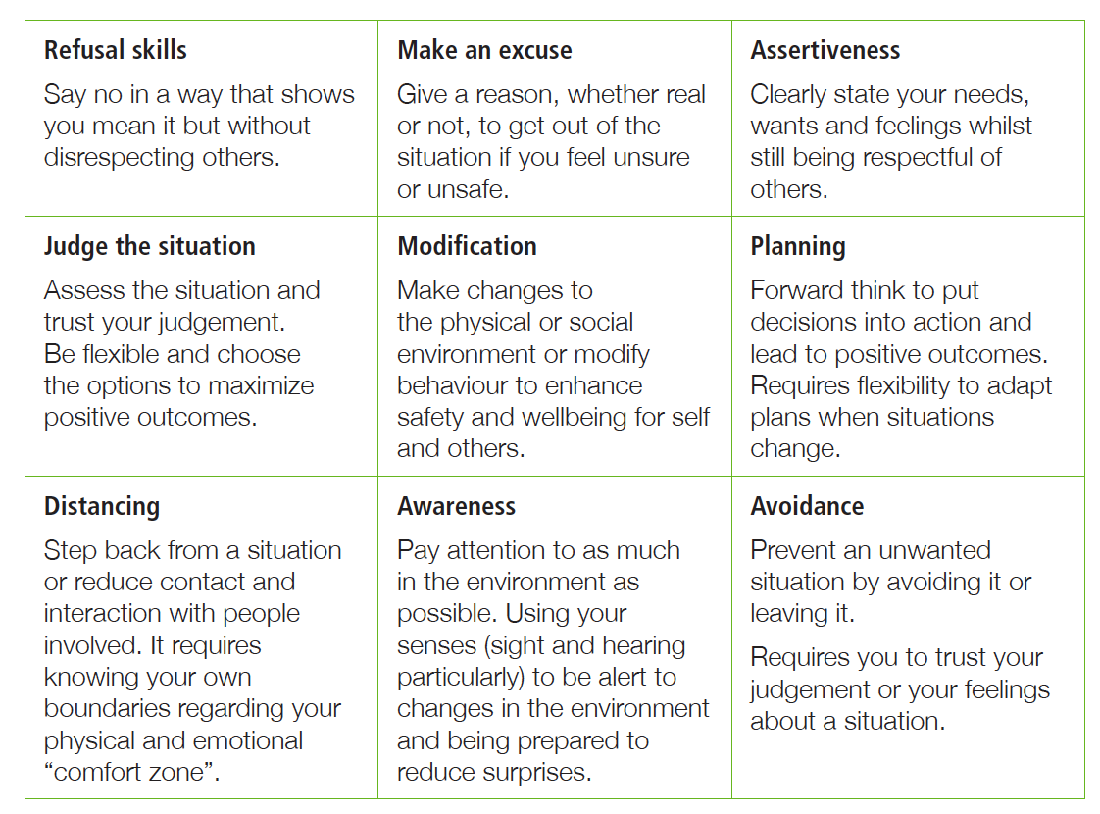

Strengths

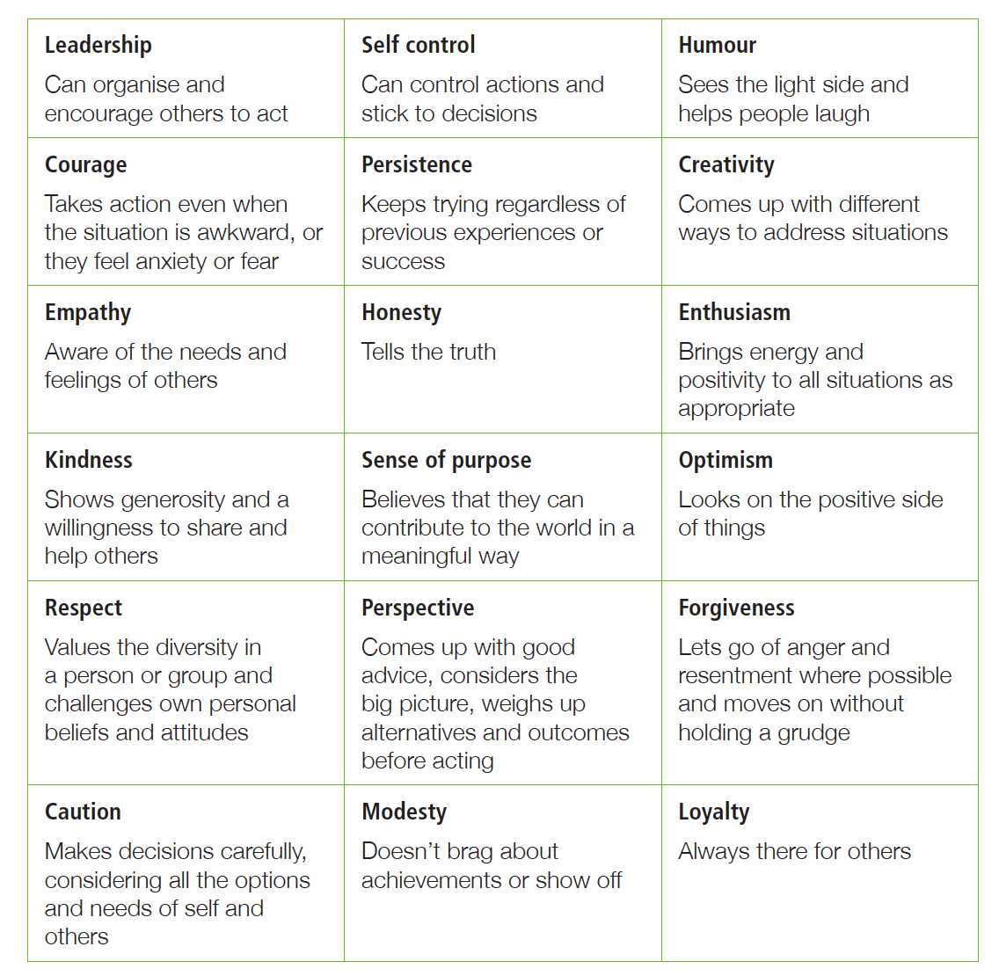

Knowledge and skills
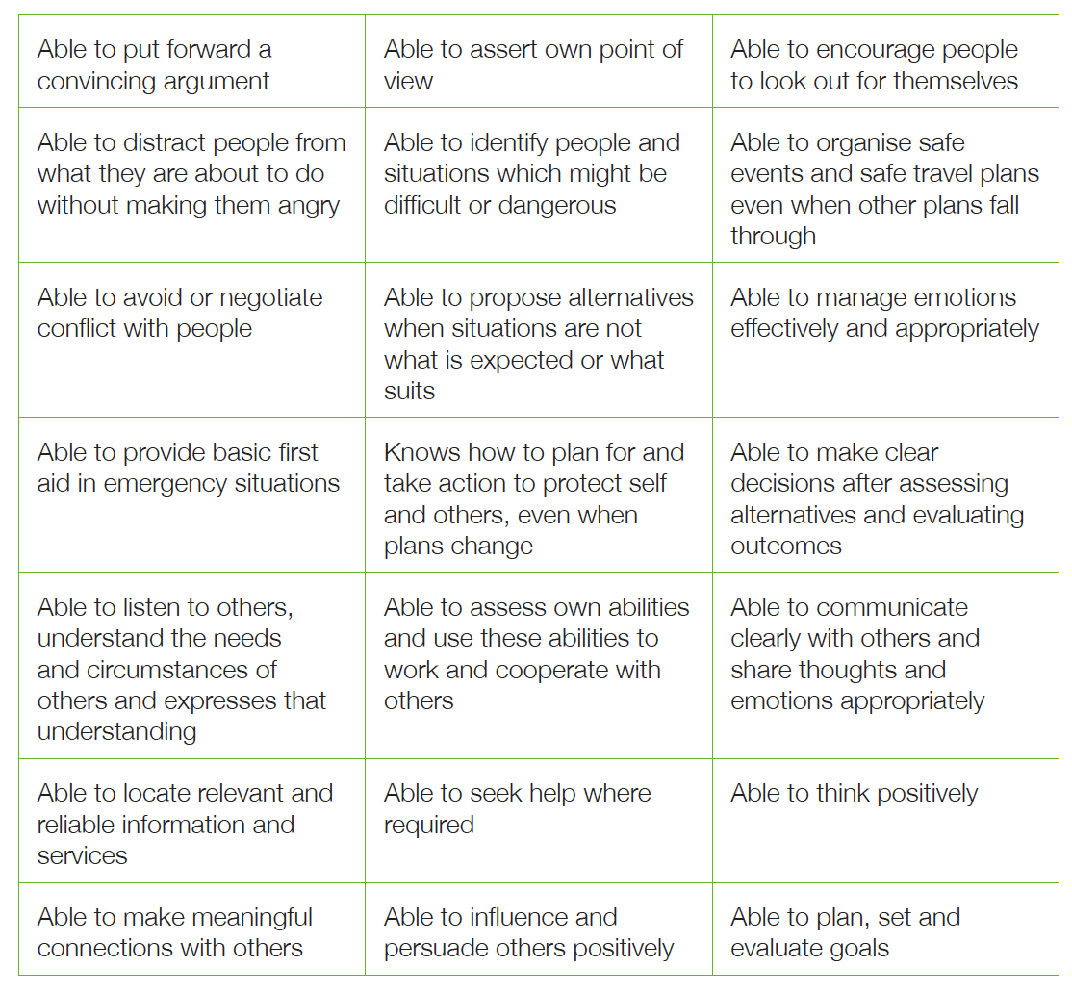

Scenarios
Jake spends a lot of time playing online games after school. More and more, you notice that Jake is reluctant to come out with you and your other friends. He is always making excuses to not leave his room and gets aggressive when you visit, swearing at you to leave. You feel his views are different from the values he used to believe in. You’ve heard rumours that he is making radical comments on public forums. Jake didn’t turned up at school today, and you can’t make contact with him online either.
You work at the local fast food restaurant part time. You notice that every Monday night, there is a group of young men that gather in the car park for hours after dark. For the last few weeks, the numbers have been growing and the group is becoming rowdier. When you turn up to work tonight, you see three men walking down the road towards the group, carrying heavy implements. You hurry inside to begin your shift. A short time later you hear loud shouts and the sound of someone being repeatedly bashed.
You receive an invitation on Facebook to attend a rally against a temple being built in your local area. The group page has many articles and photos linking the religion with alleged violence. The comments on the page are full of hate and some of your friends have added really racist comments. Large numbers of people have gathered at the rally outside the local council. They crowd become increasingly angry, as they feel their views are not being heard by the council. When the Mayor arrives, many people in the crowd launch objects at the Mayor.
You heard two female Year 9 students yelling at one another across the street on your way to school this morning. At recess you notice a crowd of students gather quickly. You look over and see one student shove the other to the ground, and then she begins to repeatedly hit the other student. More and more students run over. One student brings their phone out to film the incident and some Year 11 male students are encouraging the student to keep hitting.
Your friend, Susi, has always loved animals. Lately she has started putting pressure on you to stop using certain products because they test on animals. When she hears a circus that has animal acts is coming to town, she insists you come and stand outside the entrance to protest against the animals being kept in cages. That evening, her yelling at families bringing young children to the circle becomes increasingly heated. When one father tells her to be quiet as he passes her to enter the venue, Susi pushes the man with the placard she had been waving.

Who can help?

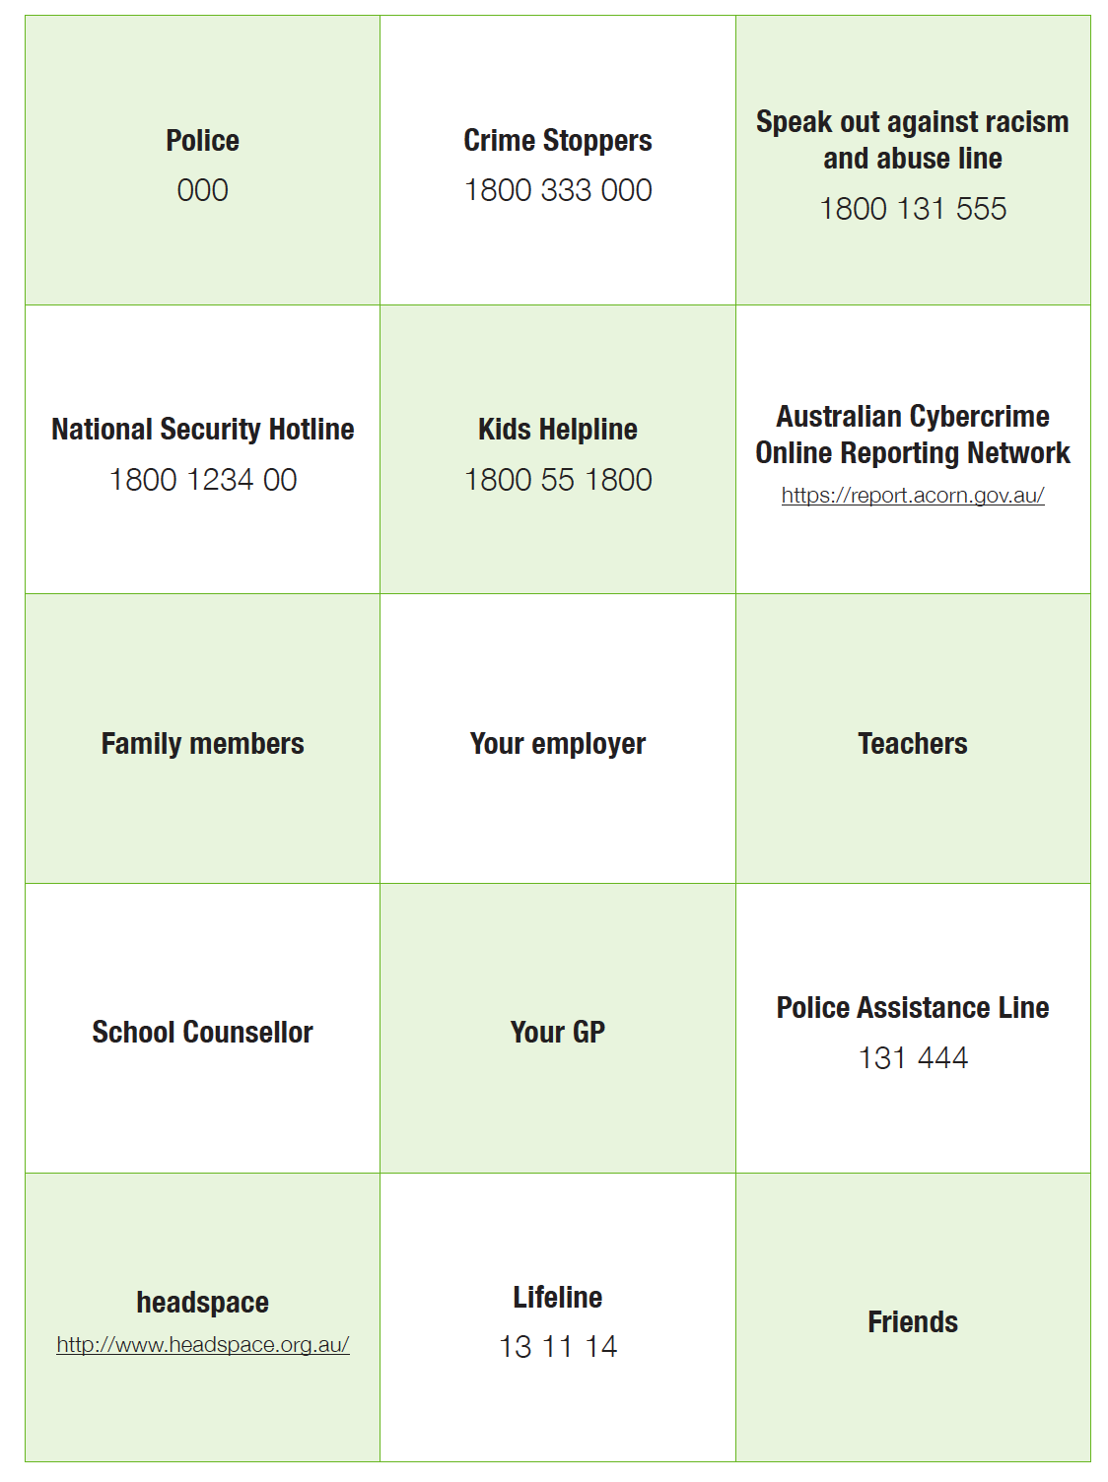

Teacher Fact Sheet – Sources of Help
There are a range of services available for young people to access to seek help and report instances of abuse or violence. These include but are not limited to:
- Police – Emergency 000
- Kids Help Line (1800 55 1800) – a free and confidential, telephone counselling service for 5 to 25 year olds in Australia. kidshelp.com.au
- Headspace – the National Youth Mental Health Foundation, helping young people with general health, mental health and counselling, education, employment and other services and alcohol and other drug services. www.headspace.org.au
- Lifeline – provides all Australians experiencing a personal crisis with access to online, phone and face-to-face crisis support and suicide prevention services.
- Crime Stoppers (1800 333 000) – Crime Stoppers collects information, which may help Police solve a crime. People can leave information anonymously.
- Police Assistance Line (131 444) – For victims of crime, other than life threatening or time critical emergency situations. 24 hours a day, seven days a week.
- Speak Out Hotline (1800 131 555) – Support for someone who has experienced harassment, intimidation or hateful insults or threats. Speak Out against racism and abuse.
- National Security Hotline (1800 123 400) – Single point of contact for the public to report possible signs of terrorism. It also provides information to callers on a wide range of national security matters. 24 hours a day, seven days a week.
- Australian Cybercrime Online Reporting Network (ACORN) – A national online system that allows the public to securely report instances of cybercrime. report.acorn.gov.au

Teacher notes – Violence and extremism
Violence has been defined by the World Health Organization as “the intentional use of physical force or power, threatened or actual, against oneself, another person, or against a group or community, that either results in or has a high likelihood of resulting in injury, death, psychological harm, maldevelopment or deprivation”.
For the purpose of the Life Ready course and the following activities, violence includes domestic and family violence, relationship violence, assault, sexual assault, rape, underage or forced marriage, trafficking or coercion, harmful traditional or cultural practices including female genital mutilation or honour killings. Violent extremism is using violence to achieve goals on behalf of a group. Life Ready activities are not designed to explore the issues around state sanctioned violence, war, the use of the death penalty or violence as a sport. These examples of violence are outside the scope of the Life Ready course.
It is important for students to learn about violence and consider their own attitudes and the attitudes of others towards violence in our community. Childhood and adolescence is an important time for developing and maintaining respectful, non-violent relationships and learning to assert a non- violent stance.
In Australia only a very small proportion of the population supports the use of violence to try to achieve ideological, religious or political goals. Combatting violence is the responsibility of the whole community and is most effective as part of a whole school approach. The Australian Government Living Safe Together website and toolkit provides information for schools to assist in building understanding of extremism and the radicalisation process and how to respond if they are concerned about a student or member of the community.
The development of a school ethos and culture that models respectful practices and is consistent in dealing with incidents of violence is as important a teaching tool as the formal curriculum.

Key messages

Domestic and family violence is a gendered crime.
- Females make up the majority of victims and males the majority of offenders.
- Although the research shows that males are the main perpetrators of violence against both men and women, most men and boys are not abusive in their relationships.
- Some men’s violence may give all men a bad name.
- Males can play a key role in helping stop violence, particularly against women.

Violence is a choice
- The use of violence is a choice: those who use violence choose where and when they do the violence; and, how they use the violence.
- Violence as a choice does not necessarily mean a considered choice. It should be noted that some individuals may react violently in specific situations, such as when their life is threatened or they act in self-defence.
- In some situations, an individual’s response may be affected by poor impulse control resulting from experiences of abuse or trauma or as a result of mental illness, clinical behaviour disorders, health conditions or disability. The teaching and learning activities provided do not seek to judge these actions.
- The activities aim to address violence broadly without specific reference to individual cases or specialised instances of violence, where an individual requires specialised counselling and support.

Violence can be learned and unlearned
- Research shows that violence, particularly violence against women is the product of learned attitudes and norms, and social inequalities.
- Just as violence-supportive attitudes can be learned, they can be unlearned.
- Communities and governments can change the social conditions that feed violence, replacing them with social conditions that encourage respect and non-violence.

There is no simple profile of a violent offender or extremist
- People who demonstrate violent behaviours, engage in acts of violent extremism or join violent extremist groups come from all kind of backgrounds and have various motivations.
- Teachers should avoid discussions that promote stereotypical views or exclusion of particular individuals or groups in society.

Education about violence, extremism and radicalisation is the responsibility of the community
- All forms of violence and extremism use fear and intimidation to change a situation rather than through respectful and peaceful means.
- It is our community and our responsibility.
- Australia’s diversity has given rise to a rich culture with a strong commitment to political and personal freedoms, respect for human rights and the rule of law.
- Regardless of their background or motivation, individuals who are prepared to commit or support violence against individuals or the community threaten our shared values.
- Community initiatives designed to address factors that can lead to violence and extremism and help at- risk individuals, can play an important part in strengthening our communities.

Additional resources
Australian Government, Living Safe Together Toolkit www.livingsafetogether.gov.au/informationadvice/Pages/what-is-radicalisation/what-is-radicalisation.aspx
Domestic Violence NSW domesticviolence.nsw.gov.au
White Ribbon – Australia’s campaign to stop violence against women www.whiteribbon.org.au
Building Respectful Relationships: Stepping Out Against Gender Based Violence (Vic DoE) www.education.vic.gov.au/school
Domestic Violence Resource Centre Victoria dvrcv.org.au

World Health Organisation, Global campaign for violence prevention; last viewed 15 Feb 2016 www.who.int/violenceprevention/approach/definition/en
Australian Government, www.livingsafetogether.gov.au/informationadvice

