Student workbook - How can we solve problems when moving?
Name:
Class:

Overview of lessons 3 and 4
You will:
- predict the outcome of their throws by considering how space and effort influence the accuracy of their throws (lessons 3-4)
- adapt throwing skills to improve accuracy and control across different contexts (lessons 3-4)
- test alternative ways to solve the throwing challenges (lessons 3-4)
- explain which approach was most successful and why (lessons 3-4)
- select and use equipment appropriate for their learning environment (lessons 3-4).

Resources
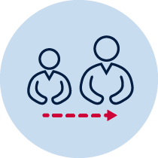
Help from an adult
A soft object to throw (for example, soft ball, pair of socks, soft toy, scrunched-up paper)
3 objects or landmarks to create targets for objects to hit (for example, bucket, a long piece of string laid in a circle, an ‘X’ formed by two pieces of tape/material, a t-shirt laid on the ground, a chair/bench, a wall, a tree)
Refer to ‘Throlf’ game card for suggestions of what this activity could look like. (Sport Australia, 2019. Playing for life) Images are included in this student book for reference.

Lesson 3 – Obstacle golf – testing alternatives
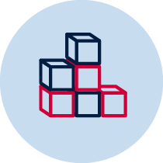
3.1 Create 3 targets that you can safely throw a soft object towards. Choose a ‘starting point’ where you will throw the object from. Place each target at different distances from the ’starting point’.
3.2 Choose or create at least one object that will act as an obstacle for each target. The obstacle needs to be placed between the ’starting point’ and the target.
3.3 Discuss the following predictive questions with your teacher or parent/caregiver before beginning each attempt. Record your answers in Table 1 below.
  - How will you attempt to avoid the obstacle so you can hit the target in as few throws as possible?
Describe at least two different approaches you will try for each target and explain how you will use the space and adapt the amount of force applied.
Examples include
- throw the object high and hard so it can drop down over the obstacle and only roll a short distance from the target
- throw the object low and apply spin so the throwing object moves around the obstacle
- deliberately throw the object softly to land it before the obstacle so I can take my second throw closer to the target and avoid the obstacle more easily.

Table 1 – testing alternatives to solve the throwing challenge
Target | Explain how you will attempt to avoid the obstacle
Target 1 – alternative 1
Target 1 – alternative 2
Target 2 – alternative 1
Target 2 – alternative 2
Target 3 – alternative 1
Target 3 – alternative 2
3.4 Throw the object towards the target. You should aim to hit the target. Pick up the object from where it landed and throw the object again until the target has been hit.
Table 2 – Obstacle golf examples
Obstacle golf examples
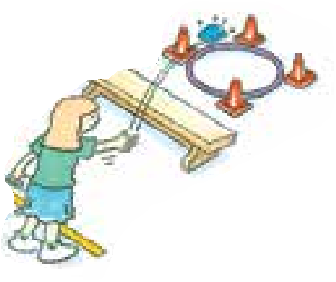  Sport Australia 2019, Playing for life | 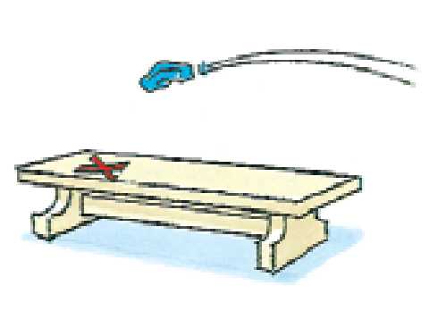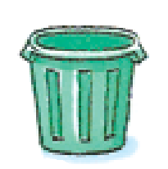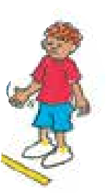 | 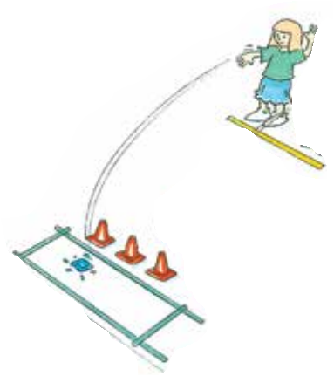

3.5 Record how many throws it took to hit the target. Repeat the challenge 5 times for each of the 3 targets
Table 3 Obstacle golf results
How many throws did you it take to hit the target? | Attempt 1 | Attempt 2 | Attempt 3 | Attempt 4 | Attempt 5
Target 1 – alternative 1
Target 2 – alternative 2
Target 2 – alternative 1
Target 2 – alternative 2
Target 3 – alternative 1
Target 3 – alternative 2
3.6 Discuss the following reflective questions with your teacher or parent/caregiver after completing all attempts. Record your answers.
Which alternative was most successful? Why?
______________________________________________________________________________________________________________________________________________________________________________________________________________
Which alternative was least successful? Why?
Explain how you could adjust this alternative to throw your object accurately and avoid the obstacle?
_______________________________________________________________________________________________________________________________________________________________________________________________________________
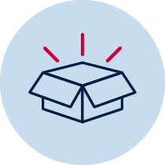 Resources
- A soft object to throw (for example, soft ball, pair of socks, soft toy, scrunched-up paper).
An object or landmark to create a target for the object to hit (for example, bucket, a long piece of string laid in a circle, an ‘X’ formed by two pieces of tape/material, a t-shirt laid on the ground, a chair/bench, a wall, a tree).
Items that can be used as obstacles (for example a small stool, a bucket, toys)

Lesson 4 – Obstacle golf – testing alternatives with your opposite hand
4.1 Create 3 new targets that you can safely throw a soft object towards. Where possible, students should create new targets from the previous lesson. Choose a ‘starting point’ where you will throw the object from. Place each target at different distances from the ’starting point’.
4.2 Choose or create at least one object that will act as an obstacle for each target. The obstacle needs to be placed between the ’starting point’ and the target.
You will complete all challenges by throwing your object with your opposite hand. This is the hand that you usually don’t use to throw or prefer to use.
4.3 Discuss the following predictive questions with your teacher or parent/caregiver before beginning each attempt. Record your answers in Table 4 below.
  - How will you attempt to avoid the obstacle so you can hit the target in as few throws as possible?
How will this be different when using your opposite hand compared to your preferred hand?
Describe at least two different approaches you will try for each target and explain how you will use the space and adapt the amount of force applied.
For example, throw the object high and hard so it can drop down over the obstacle and only roll a short distance from the target; or throw the object low and apply spin so the throwing object moves around the obstacle; or deliberately throw the object softly to land it before the obstacle so I can take my second throw closer to the target and avoid the obstacle more easily.
Table 4 – testing alternatives to solve the throwing challenge with your opposite hand
Target | Explain how you will attempt to avoid the obstacle
Target 1 – alternative 1
Target 1 – alternative 2
Target 2 – alternative 1
Target 2 – alternative 2
Target 3 – alternative 1
Target 3 – alternative 2
4.4 Throw the object towards the target with your opposite hand. You should aim to hit the target. Pick up the object from where it landed and throw the object again until the target has been hit.
Table 5 – Obstacle golf examples
Obstacle golf examples
Sport Australia 2019, Playing for life
4.5 Record how many throws it took to hit the target using your opposite hand. Repeat the challenge 5 times for each of the 3 targets
Table 6 Obstacle golf results
How many throws did you it take to hit the target? | Attempt 1 | Attempt 2 | Attempt 3 | Attempt 4 | Attempt 5
Target 1 – alternative 1
Target 2 – alternative 2
Target 2 – alternative 1
Target 2 – alternative 2
Target 3 – alternative 1
Target 3 – alternative 2
4.6 Discuss the following reflective questions with your teacher or parent/caregiver after completing all attempts. Record your answers
Which alternative was most successful? Why?
__________________________________________________________________________________________________________________________________________________________________________________________________________________
Which alternative was least successful? Why?
Explain how you could adjust this alternative to throw your object accurately and avoid the obstacle?
________________________________________________________________________________________________________________________________________________________________________________________________________________________
What was the biggest challenge when using your opposite hand? Why? Explain how you tried to overcome any difficulties related to using your opposite hand.
________________________________________________________________________________________________________________________________________________________________________________________________________________________

Resources
- A soft object to throw (for example, soft ball, pair of socks, soft toy, scrunched-up paper).
An object or landmark to create a target for the object to hit (for example, bucket, a long piece of string laid in a circle, an ‘X’ formed by two pieces of tape/material, a t-shirt laid on the ground, a chair/bench, a wall, a tree).
Items that can be used as obstacles (for example a small stool, a bucket, toys)

