How can I build positive relationships others?
Student workbook PDHPE Stage 1
Name:
Class:

Overview of lessons 1 and 2
You will
- Explore and identify emotions and their effects on others (lessons 1–2).
- Identify your own strengths and how they lead to successful outcomes (lesson 2).

Resources

Lesson 1-2
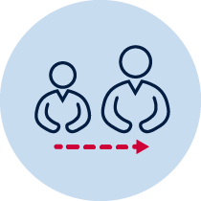
- Help from an adult
- Lead pencil/coloured pencils or crayon
- Mirror

Lesson 1 – Facial expressions
During this activity students will identify and explore emotions. Students:
- Discuss with your teacher or parent/caregiver the following questions:
  - What are emotions?
  - What are facial expressions?
  - What do facial expressions do?
- Identify the different emotions in the table on the next page.

- In the table on the next page, draw a line to match the emotion picture with an event.

Table 1 Facial expressions
Emotions | Match the emotion | The event
Happy |  | Family member in hospital
Confused |  | Getting a surprise
Worried |  | Trying to answer a really hard question at school
Proud |  | Pet passes away
Surprised |  | Struggling to tie your shoelaces for the first time
Sad |  | Your friend breaks your favourite toy
Frustrated |  | Playing games at a birthday party
Angry |  | Win an award at school
Excited |  | See a huge spider on the wall
Scared |  | Going to a party
Images used from www.freepik.com

Lesson 2 – How others feel

Activity 1
During this activity students will identify and explore their own and other people’s emotions. Students:
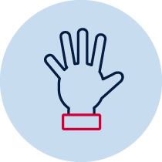
- Practice making facial expressions in the mirror to experience what others see. Expressions to be made – happy, sad, proud, angry, excited, worried. Students can use the emotion icons from Table 1 on the sheet here to assist.
- Read 'the situation’ and practice ‘Your facial expression’ in the mirror.
Draw or write how the person/people would feel if they saw the facial expression.

Table 2 How others feel
The situation | Your facial expression | How would these people feel when they see your facial expression?
Scoring the winning goal. | Excited | My team -
Getting an award at school. | Proud | My teacher -
Hurting my knee badly in the playground. | Sad | My friends -
I don’t get to play with my toy. | Angry | My mum or dad -
Images used from https://www.sparklebox.co.uk
Lesson 2 – My strengths, my successes

Activity 2
In this activity students identify their own strengths and how they lead to successful outcomes. Students:
- Discuss the question: ”What is a strength?” with your teacher or parent/caregiver:
- Brainstorm a list of their own strengths.

- Complete the activity below by identifying how your strengths have led to success.
Table 3 My strengths, my successes
Strength | How has your strength lead to you being successful?
Example: Kicking | Example: Enjoying playing soccer. Scoring goals in soccer
Example: Reading | Example: Being able to read and understand stories. Reading stories to my friends

