How can I keep myself and others safe?
PDHPE student workbook lesson 1-2
Name:
Class:

Overview – Lessons 1 and 2
Students will:
- Explain who or what influences their understanding of what makes a situation safe or unsafe (lesson 1)
- proposes protective strategies to help keep themselves and others safe at home, school and in the community (lesson 1)
- distinguishes contextual factors that influences health, safety and wellbeing which are controllable and uncontrollable (lesson 1)
- identify a network of adults that can help keep them safe and provide support (lesson 2)
- propose ways they can support their peers (lesson 2)

Resources

Lesson 1-2
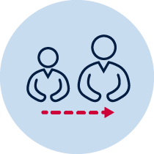
- help from an adult
- pen or pencil

Lesson 1 – Safe and unsafe
During this activity you will recognise that your choices and decisions help keep you and others healthy and safe. You will identify controllable and uncontrollable factors that influence your safety. You will also identify a personal network of trusted adults and how they support your health and safety.
1.1Discuss with your teacher or parent/caregiver who or what influences you when deciding if something is safe or unsafe. Explain your response.
__________________________________________________________________
__________________________________________________________________
__________________________________________________________________
__________________________________________________________________
1.2 Discuss with your teacher or parent/caregiver safe and unsafe situation you may identify in the home environment. Select one unsafe situation and explain how you would make it safer.
The example I have chosen is –_________________________________________
__________________________________________________________________
__________________________________________________________________
__________________________________________________________________
Discuss with your teacher or parent/caregiver safe and unsafe situation you may identify in the school environment. Select one unsafe situation and explain how you would make it safer.
The example I have chosen is –_________________________________________
__________________________________________________________________
__________________________________________________________________
__________________________________________________________________
Discuss with your teacher or parent/caregiver safe and unsafe situation you may identify in the community. Select one unsafe situation and explain how you would make it safer.
The example I have chosen is –_________________________________________
__________________________________________________________________
__________________________________________________________________
__________________________________________________________________
1.3 Explain why you may think some of these actions/activities are safe, while another person may think they are unsafe? Consider who or what may be influencing you and other people.
__________________________________________________________________
__________________________________________________________________
__________________________________________________________________
1.4 There are many factors that can influence a person’s safety. These factors can be defined under two categories; controllable and uncontrollable. Controllable influences are when your decisions can directly affect your safety, uncontrollable influences are when other people’s decisions or environmental factors directly affect your safety.
Discuss the following;
- identify one controllable and one uncontrollable influence
For example
Action/behaviour | Controllable influence | Uncontrollable influence
Crossing the road | Where I cross the road, when I cross and who I cross with. | The speed of the cars on the road and if they follow the road rules
- explain how the uncontrollable influence may need to be considered when making decisions that keep us safe.
For example, cars are expected to stop at traffic lights or pedestrian crossings. Using these clearly marked crossings will provide a safer environment to cross the road.

Select three actions/behaviours and complete each table and question.
Action/behaviour 1 – at home
Action/behaviour | Controllable influence | Uncontrollable influence
Explain how the uncontrollable influence may need to be considered when making decisions that keep us safe.
__________________________________________________________________
__________________________________________________________________
__________________________________________________________________
Action/behaviour 2 – at school
Action/behaviour | Controllable influence | Uncontrollable influence
Explain how the uncontrollable influence may need to be considered when making decisions that keep us safe.
__________________________________________________________________
__________________________________________________________________
__________________________________________________________________

Action/behaviour 3 – in the community
Action/behaviour | Controllable influence | Uncontrollable influence
Explain how the uncontrollable influence may need to be considered when making decisions that keep us safe.
__________________________________________________________________
__________________________________________________________________
__________________________________________________________________
1.5 Think about the previous activities to select the most appropriate box that reflects your level of understanding. Place a tick inside the box you have selected.
Success criteria | I need help to learn to | I am still learning to | I have learned to
explain who or what influences my understanding of what makes a situation safe or unsafe
propose protective strategies to help keep myself and others safe at home, school and in the community
identify controllable and uncontrollable factors and how they influence my safety.

Lesson 2 – Support networks
2.1 Discuss with your teacher or parent/caregiver some of the controllable and uncontrollable factors you identified in the previous lesson.
Name one person who could help you in a situation where there are many uncontrollable factors.
2.2Identify who is in your network of trusted adults that can help support you to stay safe. Use the template below to list people from your network of trusted adults from the following areas.
- self (centre circle)
- parents/ carers ( next larger circle)
- extended family & Friends
- local community
- government/state.
Concentric circle – network of adults

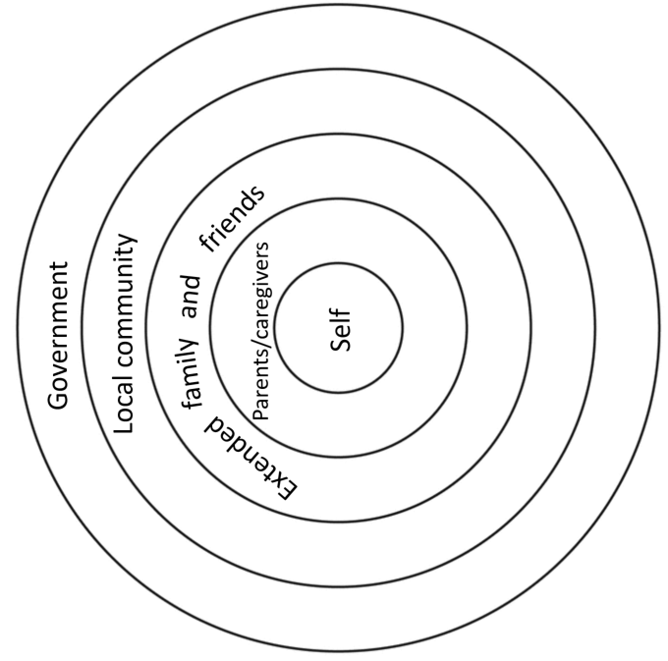

2.3 Explain how these people support you? Consider why some people/groups are closer to you at the centre of the circle and others are further away. How does the relationship influence the type of support provided to keep you safe?
Parent/caregiver –
__________________________________________________________________
__________________________________________________________________
Extended family and friends
__________________________________________________________________
__________________________________________________________________
Local community
__________________________________________________________________
__________________________________________________________________
Government
__________________________________________________________________
__________________________________________________________________
2.4Explain why someone else may have different people in their network?
__________________________________________________________________
__________________________________________________________________
2.5 Discuss with your teacher or parent/caregiver the following: You are aware of a range of people who support you to make safe choices. How do you support your friends/family to make safe choices?

2.6Read the following scenarios and explain the support you would provide.
Table 1 Scenarios
Scenario | What support would you provide?
Your cousin is diving in shallow water. What would you suggest to keep your cousin safe?

Your little brother or sister is hungry and wants something hot to eat for lunch but you’re home alone. What would you do to keep everyone safe?

You are going on a bike ride with your siblings. What would you suggest to keep yourself and them safe?
You are talking to your best friend online and she tells you she is home alone and someone is knocking on the door. She has a quick look but doesn’t recognise the person.
What would you do to keep everyone safe?
You are outside with your friend but have forgotten your sunscreen. What would you do to keep everyone safe?

2.7Consider the following questions and reflect on your learning.
Table 2 Self-reflection
Self-reflection
Important things I have learned.
How will this help me in the future?
Things I still want to know.

