NESA exemplar question solutions

N2.1 Networks
Solutions for questions from the NESA topic guidance related to networks.

- Model the following house plan as a network, showing doors (doorways) as edges and the rooms as vertices.
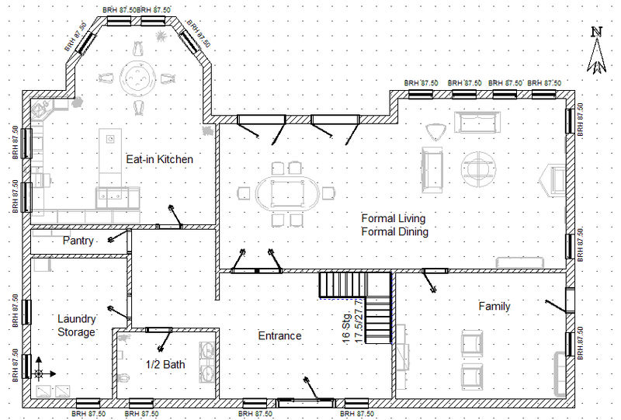

Solution:
Note: In the first solution an additional ‘room’ has been included to represent the outside. This allows all doors to be represented as edges.
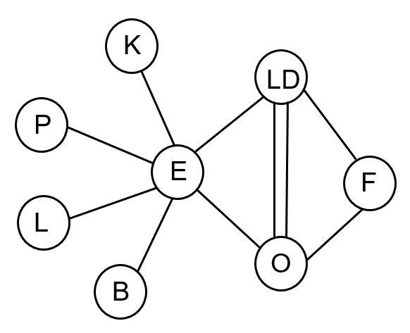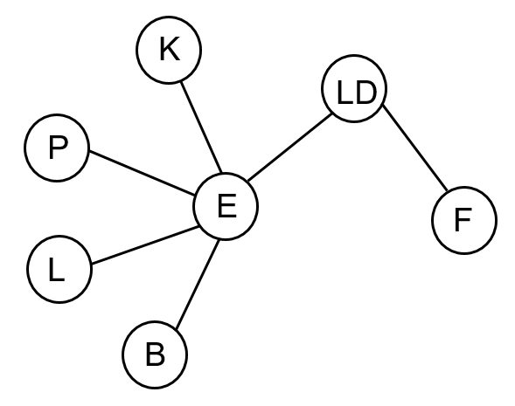

- Draw a network diagram to illustrate the following table:
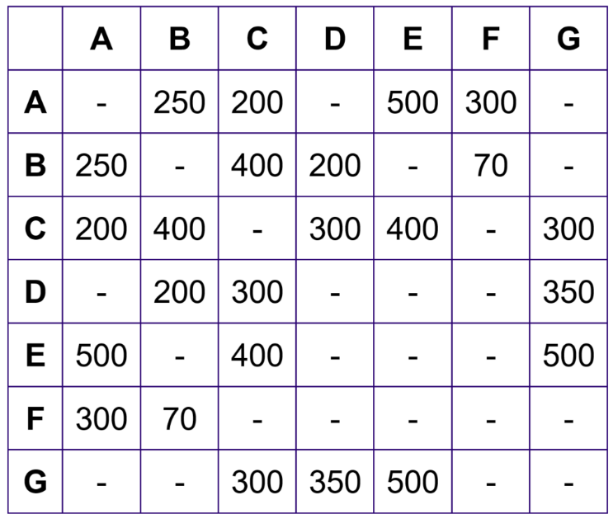

Solution:
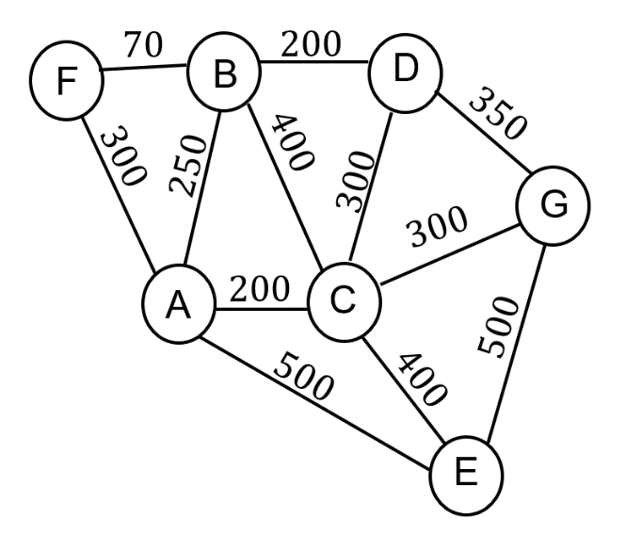

N2.2 Shortest paths
Solutions for questions from the NESA topic guidance related to shortest paths.

- For the following network:
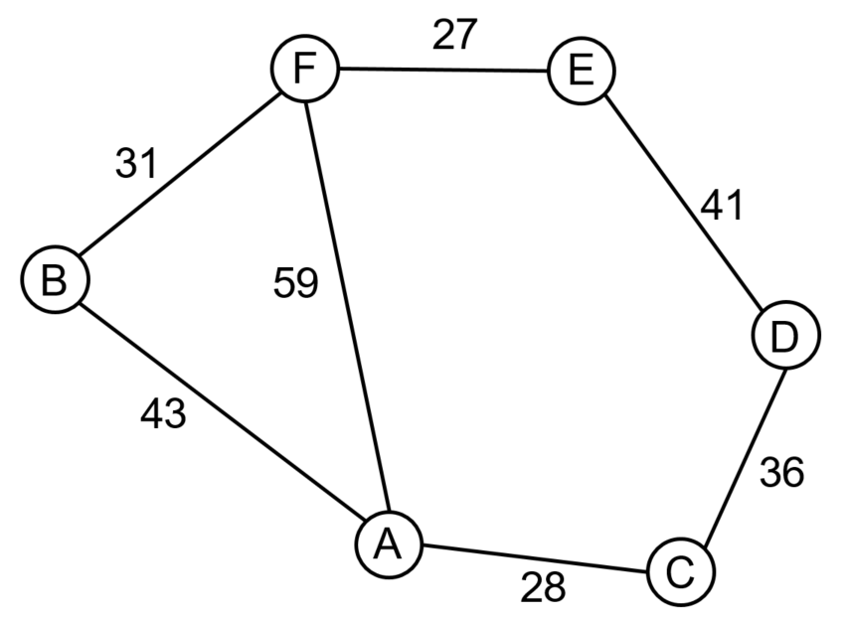
- Find all possible spanning trees

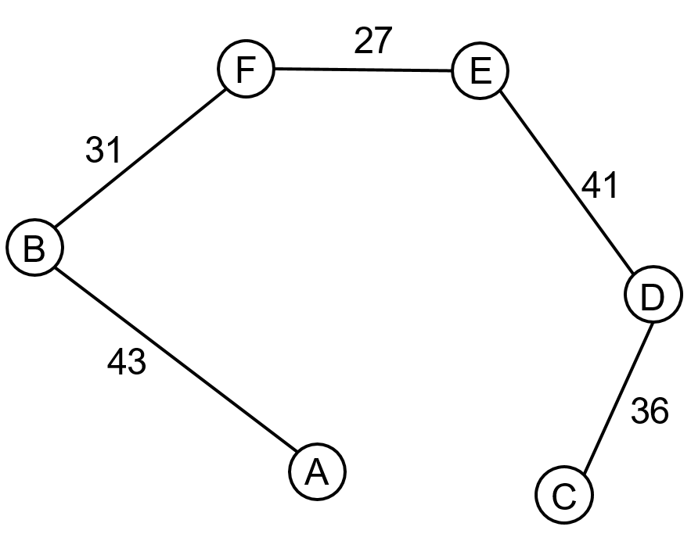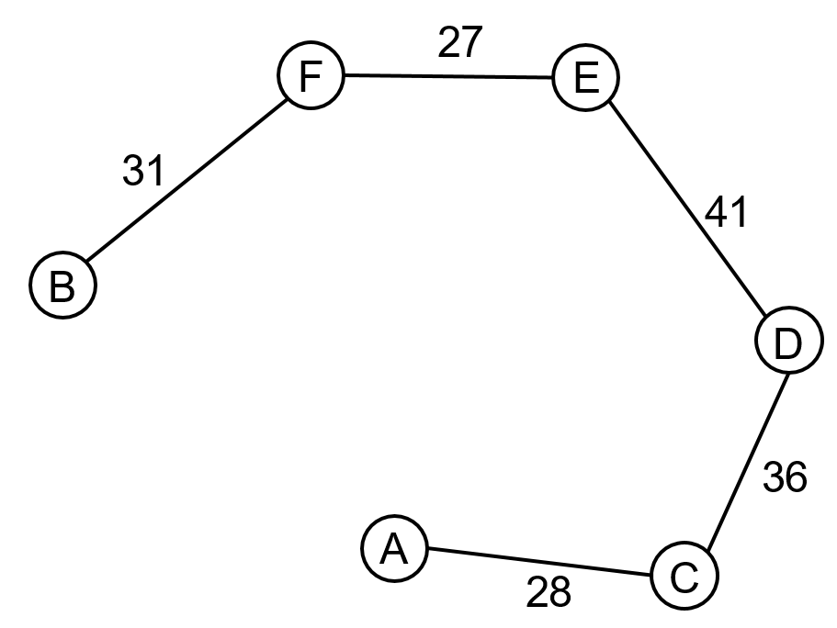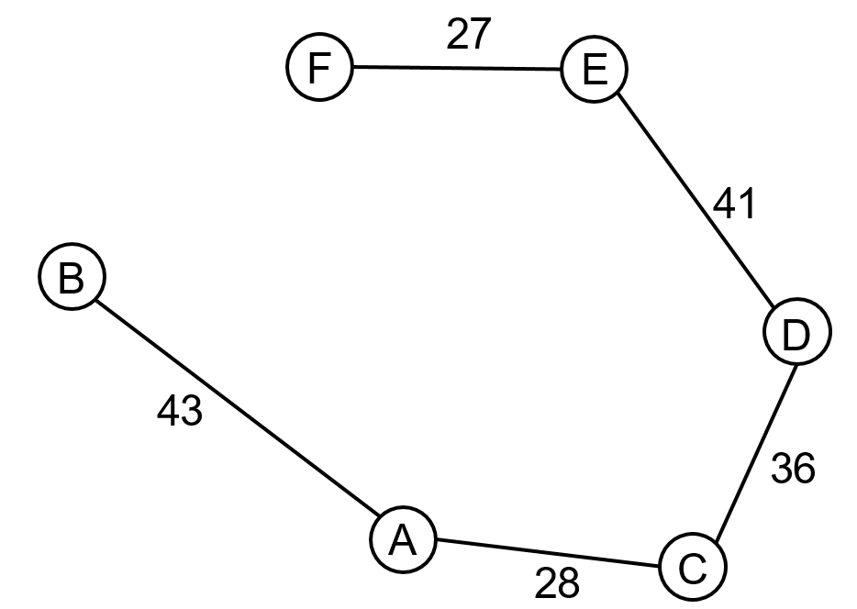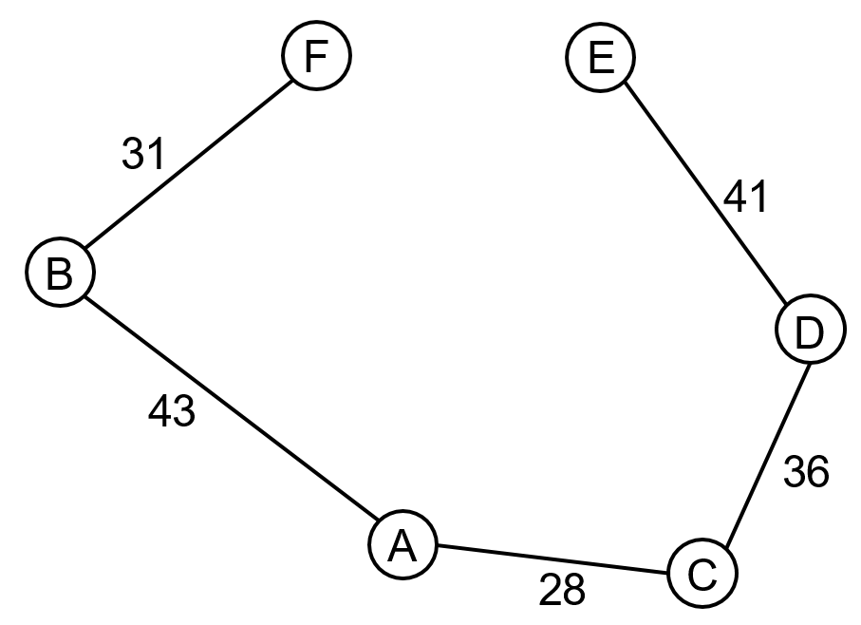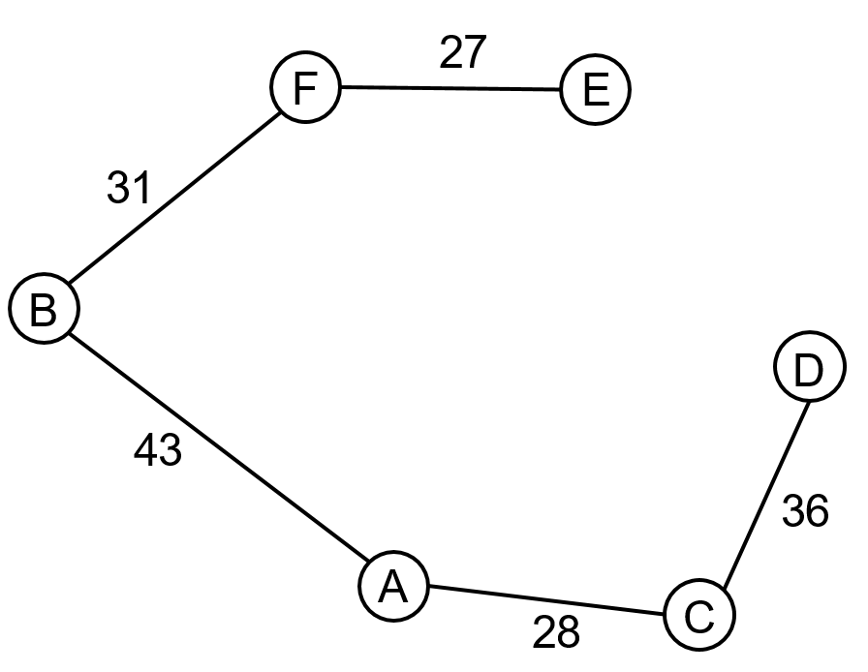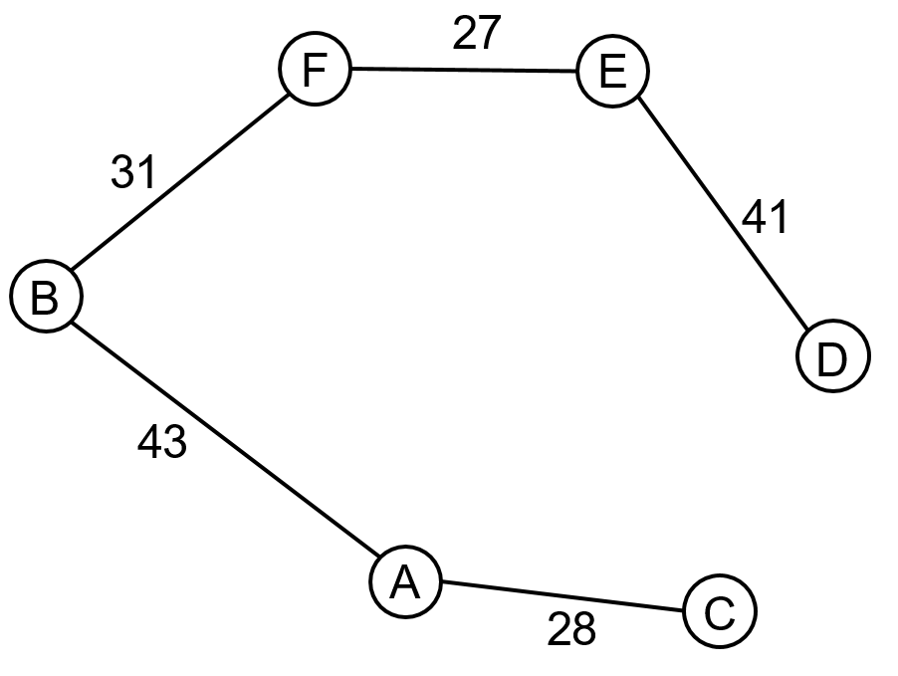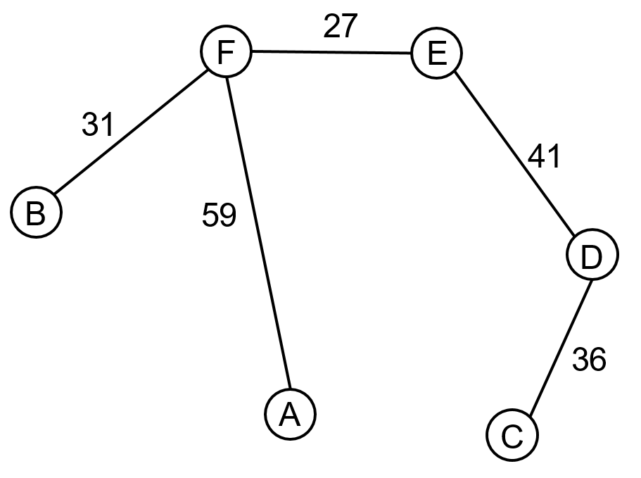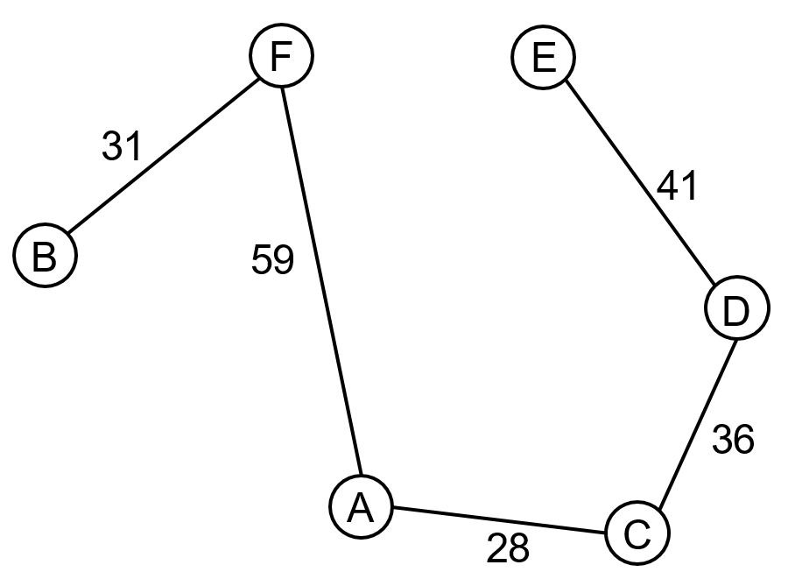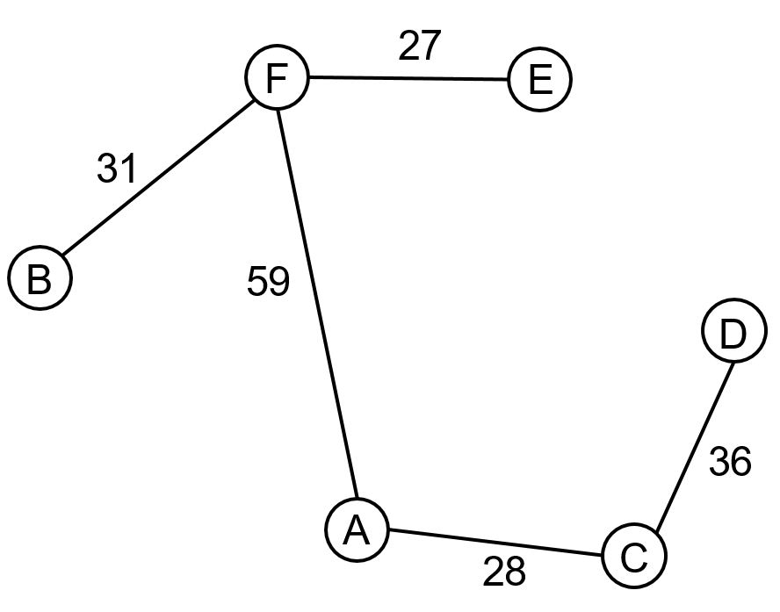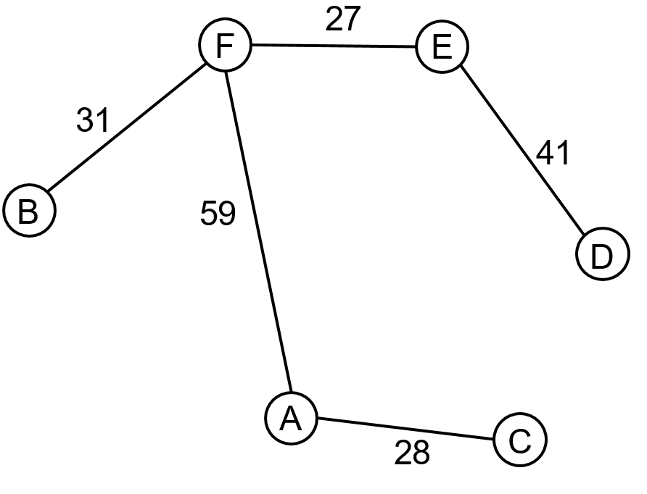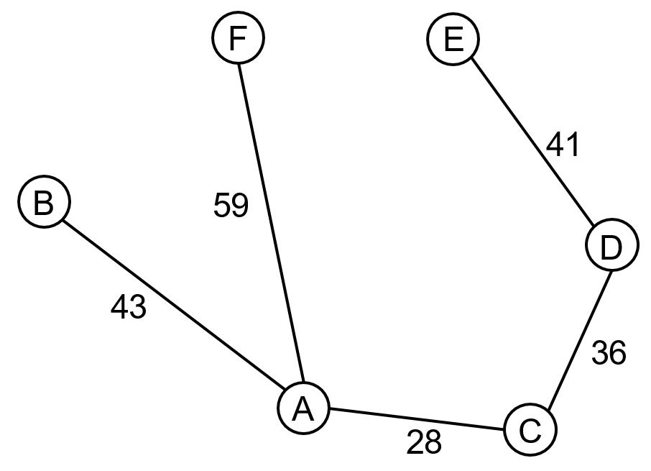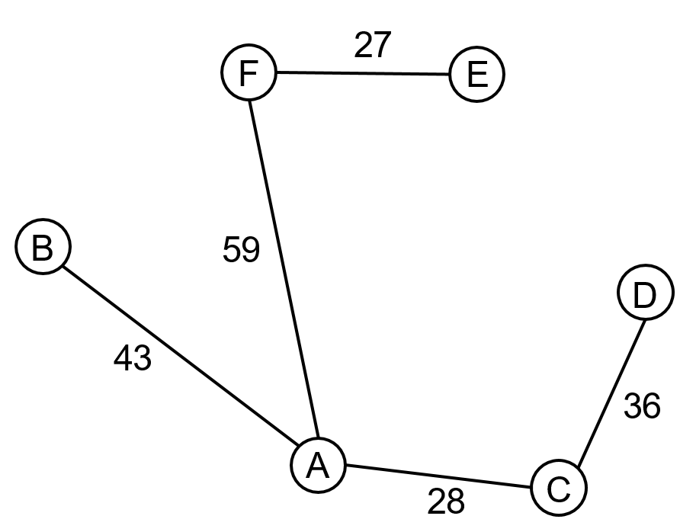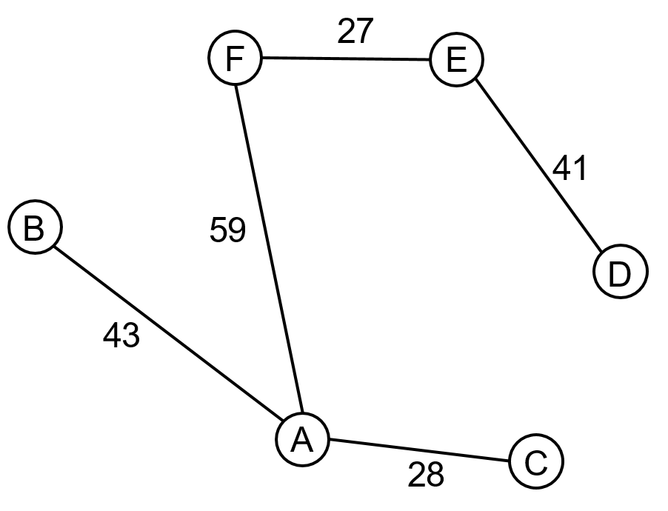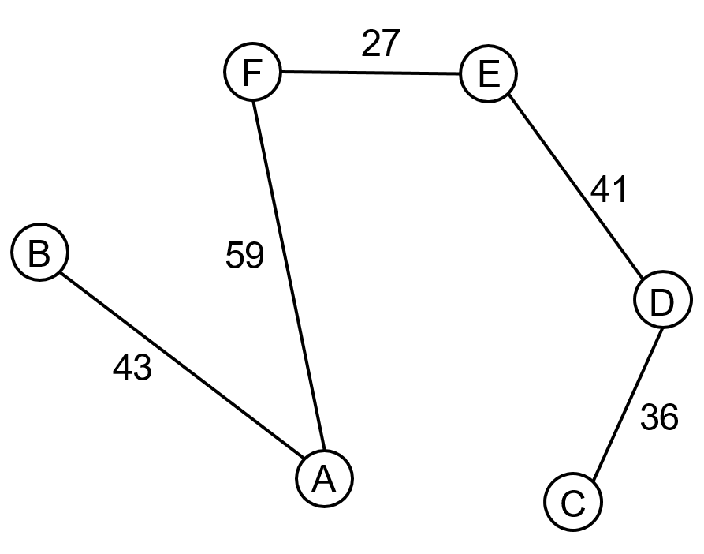

- Which of the spanning trees has the minimum weight?
Solution:
$31+27+41+36+28=163$ units

- Use Prim’s algorithm, starting with vertex $A$, to find the minimum spanning tree.
Solution:
$$AC=28$$
$$DC=36$$
$$ED=41$$
$$FE=27$$
$$BF=31$$

$∴28+36+41+27+31=163$ units

- Show that Kruskal’s algorithm produces the same minimum spanning tree as Prim’s algorithm
Solution:
$$FE=27$$
$$AC=28$$
$$BF=31$$
$$CD=36$$
$ED=41$ Stop here as all vertices have been connected
$$AB=43$$
$$FA=59$$
$∴27+28+31+36+41=163$ units

- Consider the following network:
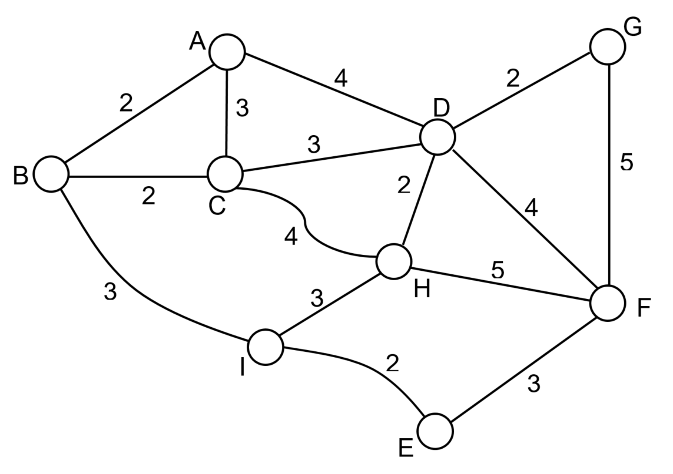
- Find the minimum spanning tree.
Solution:
Note: that this is not the only solution.
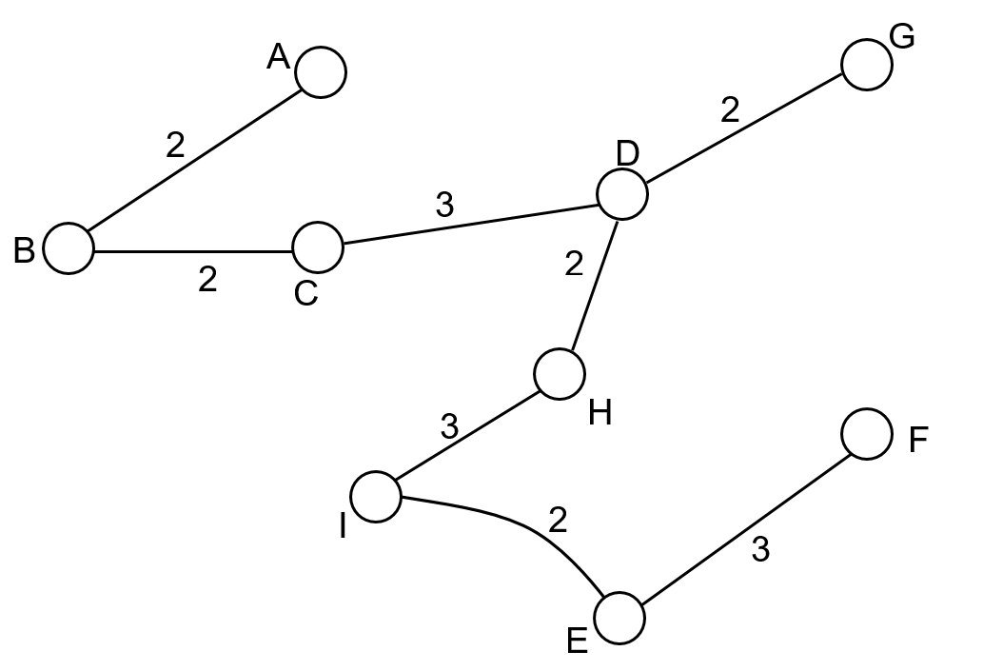
$2+2+3+2+2+3+2+3=19$ units

- Find the length of the shortest path from $A$ to $E$ in the network.
Solution:
$$A-B-I-E=2+3+2$$
$A-B-I-E=7$ units

- The following table shows the travelling times in minutes between towns which are connected directly to each other.
Note: The dash in a box indicates that towns are not connected directly to each other:

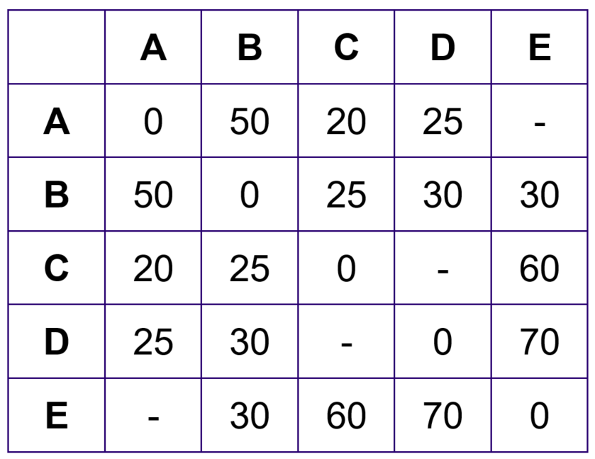

- Draw a network diagram showing the information on this table.
Solution:
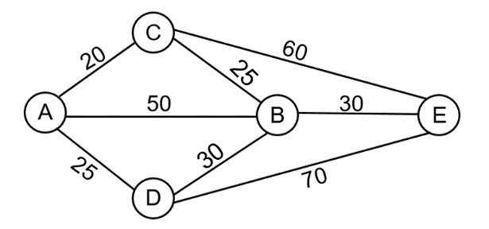

- Find the shortest travelling time between $A$ and $E$

Solution:
$$A-C-B-E=20+25+30$$
$A-C-B-E=75$ units

