Year 12 Mathematics Standard 2
MS-M7 Rates and ratios | Unit duration
Measurement involves the application of knowledge, skills and understanding of numbers and geometry to quantify and solve problems in practical situations. Knowledge of measurement enables an understanding of basic daily situations involving rates and ratios, such as speed and the interpretation of maps and plans, effectively in a variety of situations. Study of measurement is important in developing students’ ability to solve problems related to two and three-dimensional models and representations and to work effectively with a variety of rates and ratios. | 2 weeks

Subtopic focus | Outcomes
The principal focus of this subtopic is the use of rates and ratios to solve problems in practical contexts, including the interpretation of scale drawings. Students develop awareness of the use of rates and ratios and solve problems in everyday situations, such as health sciences, energy and finance.  Within this subtopic, schools have the opportunity to identify areas of Stage 5 content which may need to be reviewed to meet the needs of students. | A student:  - interprets the results of measurements and calculations and makes judgements about their reasonableness, including the degree of accuracy and the conversion of units where appropriate MS2-12-3  - analyses two-dimensional and three-dimensional models to solve practical problems MS2-12-4  - chooses and uses appropriate technology effectively in a range of contexts, and applies critical thinking to recognise appropriate times and methods for such use MS2-12-9  - uses mathematical argument and reasoning to evaluate conclusions, communicating a position clearly to others and justifying a response MS2-12-10  Related Life Skills outcomes: MALS6-3, MALS6-4, MALS6-13, MALS6-14

Prerequisite knowledge | Assessment strategies
Students should be familiar with writing ratios in their simplest form; calculating quantities from a given ratio; writing and converting rates as outlined in the Stage 4 and Stage 5.2 ratios and rates units | How much does it cost to get some peace? is an investigation-style task in which students design a teenage retreat (with minimum requirements), prepare a budget for fit out and use, and calculate its expected energy running costs.
All outcomes referred to in this unit come from Mathematics Standard Stage 6 Syllabus © NSW Education Standards Authority (NESA) for and on behalf of the Crown in right of the State of New South Wales, 2017

Glossary of terms
Terms | Description
Elevation views | Elevation views are scale drawings showing what a building looks like from the front, back and sides.
Energy | Electrical energy usage is measured in watt hours (Wh) which is the amount of electrical energy used by a one watt load drawing power for one hour. The electricity usage for households is measured in kilowatt-hours (kWh).
Fuel consumption rate | The fuel consumption rate of a vehicle measures how much fuel it uses and is usually measured in litres per 100 kilometres  (L/100 km).
Heart rates | Heart rate is the speed of a heartbeat in beats per minute (bpm) and measures the number of contractions of the heart per minute.
Radial surveys | A radial survey can be used to measure the area of an irregular block of land. In a radial survey, a central point is chosen within the block of land and measurements are taken along intervals from this point to each vertex. The angles between these intervals at the central point are also measured and recorded.
Rates | A rate is a particular kind of ratio in which the two quantities are measured in different units. For example the ratio of distance to time, known as speed, is a rate because distance and time are measured in different units (such as kilometres and hours). The value of the rate depends on the units in which the quantities are expressed.
Ratio | A ratio is a quotient or proportion of two numbers, magnitudes or algebraic expressions. It is often used as a measure of the relative size of two objects.
Scale | A ratio of size used in a map, model, drawing, or plan
Scale drawing | A drawing that shows a real object with accurate sizes reduced or enlarged by a certain amount (called the scale).
Targeted heart rate | The target heart rate is defined as the minimum number of heartbeats in a given amount of time in order to reach the level of exertion necessary for cardiovascular fitness and is specific to a person's age, gender or physical fitness. An example of a target heart rate is 150 bpm to burn fat for a woman in her 30s.
Trapezoidal rule | The Trapezoidal rule uses trapezia to approximate the area of an irregular shape, often with a curved boundary. Given a transverse line of length h and two perpendicular offset lengths d_{f} and d_{l}, one application of the Trapezoidal rule is given by: $\text{Area ≈ }\frac{h}{2}(d_{f}+d_{l})$
Watt | International System of Units (SI) derived unit of power and is equal to one joule per second

Lesson sequence | Content | Suggested teaching strategies and resources | Date and initial | Comments, feedback, additional resources used
Investigating different types of rates used in practical problems  (3 lessons) | - use rates to solve and describe practical problems AAM  - use rates to make comparisons, e.g. using unit prices to compare best buys, working with speed, comparing heart rates after exercise and considering target heart rate ranges during training | Converting rates  - Students should be able to make conversions between units for rates over two dimensions, for example length and time, including km/h to m/s.  Comparing best buys  - Student activity: By using online/paper catalogues from supermarkets, check the prices of different items and determine the best buy for similar products.  Resources: Coles, Woolworths, IGA, ALDI  Comparing heart rates  - Student activity: Investigate the resting heart rate, targeted heart rate and heart rate zones for particular age groups.  - Test the resting heart rate of students in your class by asking them to sit/lie still for a few minutes and then measuring their pulse.  - Students then perform some form of exercise for 2 minutes before immediately taking their pulse again.  - Give reasons why the heart rate might be different between students and different depending on the activity.  - Determine their max heart rate: $max=220-age$  - Determine their aerobic and anaerobic thresholds (Heart rate zones)  - After exercise, decrease in heart rate varies due to fitness levels (how fast it decreases). Students could continue to measure their heart rates for 5 – 10 minutes after exercise and then plot their heart rate over time. They can then compare the shape of their graph, to someone else.  Comparing speeds  - Student activity: Introduction to different speed comparisons:  - Show boat vs bike vs car vs public transport – top gear clip.  - Discuss the different speeds involved.  - Investigate/discuss differences between London and Sydney and the impact on speed in Sydney.  - Students could develop the same type of race between Parramatta and the Sydney CBD looking at travel times at different times of the day. Google Maps will allow you to input the day of time of travel and then adjusts the expected travel time accordingly.
Investigating energy consumption and household requirements  (3 lessons) | - use rates to solve and describe practical problems AAM  - know that a watt (W) is the International System of Units (SI) derived unit of power and is equal to one joule per second  - interpret the energy rating of household appliances and compare running costs of different models of the same type of appliance, considering costs of domestic electricity, eg calculate the cost of running a 200-watt television for six hours if the average peak rate for domestic electricity is $0.15/kWh  - investigate local council requirements for energy-efficient housing  - calculate the amount of fuel used on a trip, given the fuel consumption rate, and compare fuel consumption statistics for various vehicles | Introducing standard units for energy and power  - Teacher introduces the prefixes for International System of Units (SI base units), including their origins (historical context of the SI). The difference between the imperial and metric systems should also be considered.  - Quantities and units may be expressed in both decimal form and standard notation, for example  6.8 × 10³ MW or 6 800 000 kW  Investigating energy consumption  - Student activity: Students to research energy rating labels and the energy consumption of common household items (energy rating calculator).  - Energy efficient models are often more expensive. Students to consider:  - Is it worth paying the extra money?  - How long would it take to break-even?  - Students could compare different brands or models of the same appliance and work out the savings by choosing the more efficient model.  - Students to research the requirements for energy-efficient housing in their local council area and compare these to another local council area.  - Conversion of units is to be based on the following table:  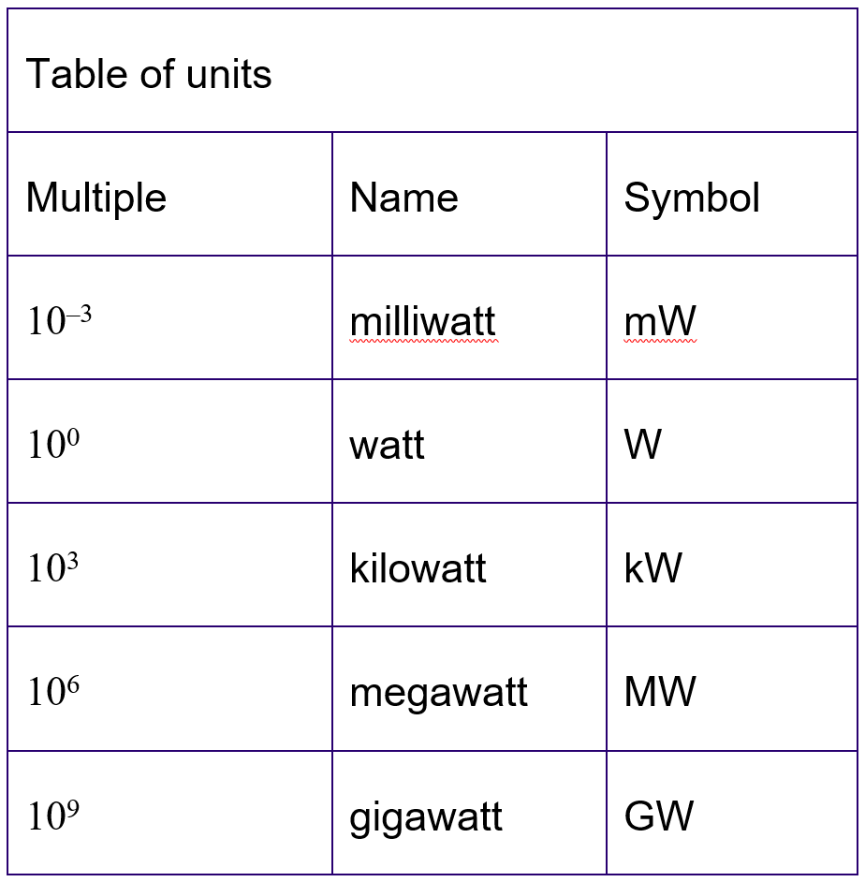  - The following resource contains solutions to the exemplar questions provided within NESA’s topic guidance.  Resource: ms-m7-nesa-exemplar-question-solutions.DOCX  - Students to use the comparison tool on the carsales website (compare cars) to compare the fuel consumption of 2 or more cars.  - Students could then work out how much they would save during an average week driving around town  - Have students choose two locations in NSW and determine the driving distance using Google Maps.  - Using the fuel consumption of the 2 cars that students researched above, determine the amount of fuel that would be used on the trip.
Solving practical problems using ratios  (2 lessons) | - solve practical problems involving ratio, for example capture-recapture, mixtures for building materials or cost per item AAM  - work with ratio to express a ratio in simplest form, to find the ratio of two quantities and to divide a quantity in a given ratio  - use ratio to describe map scales | Solving practical problems using ratios  - Teacher to show the video bad date as a reminder/introduction to ratios  - Possible student investigations could include:  - Students could watch this video tutorial of the Capture-Recapture techniques for estimating unknown populations.  - Using a scale model (such as a toy car or life size Barbie) to determine the actual size of different aspects of the model.  - Students could watch the video about a scale model of the solar system. (To scale: the solar system)  - For a recipe to be cooked for a dinner party, determine the amount needed for each ingredient and then determine the cost per person (based on the cost of the ingredient).  - Determining the cost of painting one or more of the Math’s classrooms.  - Floor space ratio and the golden ratio and how they are used in building  - Investigating different map scales including 1:10000, 1:25000 and 1:50000.  - Students to find examples of each map and determine who would use the map and why.
Using scale diagrams to calculate real life measurements  (2 lessons) | - obtain measurements from scale drawings, including maps (including cultural mappings or models) or building plans, to solve problems AAM  - interpret commonly used symbols and abbreviations on building plans and elevation views  - calculate the perimeter or area of a section of land, using the Trapezoidal rule where appropriate, from a variety of sources, including but not limited to a site plan, an aerial photograph, radial surveys or maps that include a scale | Using building plans  - Student activity: Research building plans and create a list of symbols and abbreviations from building plans on the build.com.au website.  - Students need to be aware that building plan dimensions are given in millimetres.  - Students to use building plans, coral homes, and plans and elevations, students could measure out the actual size of a house on the school oval.  Using maps  - Teacher to revise using the trapezoidal rule for finding the area of irregular shapes.  - Student activity: Students Use Google maps to find an island or country:  - Print the screen out and then use the Trapezoidal rule to determine the area of the land mass. Ensure the scale at the bottom is printed.  - Compare this value with the quoted size.  - This could also be done for a suburb or town boundaries.  - Trapezoidal rule problems involving four strips should be treated through two applications of the rule. The problems addressed could be extended to include the calculation of volume given the relevant dimensions.  - Students to compare the area of Tasmania to the rest of the states in Australia. What is the ratio of Tasmania to the other states?  - Repeat the activity for the island/country above, but with the students’ houses.
Calculating the volume of rainfall for an area  (1 lesson) | - obtain measurements from scale drawings, including maps (including cultural mappings or models) or building plans, to solve problems AAM  - calculate the volume of rainfall over an area, using $V=Ah$, from a variety of sources, including but not limited to a site plan, an aerial photograph, radial surveys or maps that include a scale | Calculating the volume of rainfall  - Students to determine the area of the roof of their house.  - Have the students research the monthly average rainfall (such as the one listed in resources).  - From this the students can determine the amount of rain that their roof will catch each year.  - Students could then research a rain tank that would be able to hold the water that is caught by their roof  - Students could research the capacity of their local water supply using climate data online and its current capacity. They could then calculate how much water it would take to fill it and how long it would take to fill, making assumptions about average daily rainfall etc.

Reflection and evaluation
Please include feedback about the engagement of the students and the difficulty of the content included in this section. You may also refer to the sequencing of the lessons and the placement of the topic within the scope and sequence. All information and communication technologies (ICT), literacy, numeracy and group activities should be recorded in the ‘Comments, feedback, additional resources used’ section.

