Year 12 Mathematics Standard 2

Assessment task
MS-M7 Rates and Ratios

Driving question
How much does it cost to get some peace?

Outcomes
- MS2-12-3 interprets the results of measurements and calculations and makes judgements about reasonableness, including the degree of accuracy and the conversion of units where appropriate
- MS2-12-4 analyses two-dimensional and three-dimensional models to solve practical problems
- MS2-12-9 chooses and uses appropriate technology effectively in a range of contexts, and applies critical thinking to recognise appropriate times and methods for such use
- MS2-12-10 uses mathematical argument and reasoning to evaluate conclusions, communicating a position clearly to others and justifying a response
All outcomes referred to in this unit come from Mathematics Standard Sage 6 Syllabus © NSW Education Standards Authority (NESA) for and on behalf of the Crown in right of the State of New South Wales, 2017

Learning across the curriculum

Cross-curriculum priorities
- Sustainability

General capabilities
- Critical and creative thinking
- Ethical understanding
- Information and communication technology capability
- Literacy
- Numeracy

Task
According to The Urban Development Institute of Australia’s 2018 State of the Land Report, in 2017, Sydney’s median housing lot price was $476,000, Melbourne’s was $281,000, and Adelaide’s was $167,000. Coupled with median housing process in excess of $400,000 many Australians are finding that they cannot afford to build or purchase larger homes for their expanding families. The solution seems to be a granny flat or teenage retreat in the back yard.
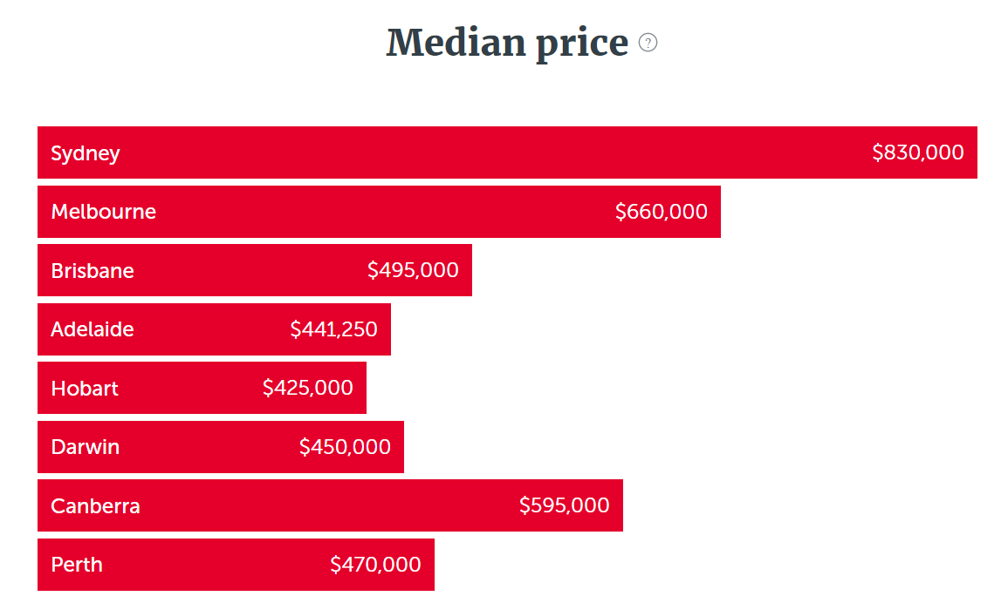

Part 1 – Designing your retreat
You are to design the floor plan for a teenage retreat in your backyard (or grandma’s). It must be drawn to scale and use the recognised symbols and abbreviations of building plans.
The retreat must have the following attributes:
- Area of at least 24m² but no more than 60m² (does not need to be rectangular)
- Identified sleeping area
- Built-in wardrobe/cupboard
- Toilet
- Shower
- Hand basin
- Identified living/study area
- Door into the retreat
- Maximum of 1:4 window to wall area ratio

- Using appropriate mapping technology, produce a map showing a suitable place in your backyard for your retreat and provide evidence that the building will fit in your chosen location and obeys the conditions above.
- Draw your scale diagram, clearly showing the scale used and all of the features above, with appropriate mathematical calculations to demonstrate that you have met the conditions above.

Part 2 – Powering your retreat
You will want to deck your retreat out with some electrical appliances – tv, air-conditioner/heater, mini fridge, toaster, kettle, computer/gaming platform etc. and ensure that you have hot, running water.

Question 1
- Research electricity companies that service your area. Compare and contrast 3 different companies or plans, considering factors such as supply charges and single usage rates vs off peak rates.
- Determine which company you will use, justifying your choice.
Attach your research (screenshots and printouts) and calculations (if any) for each company in Appendix A.

Question 2
  - Choose three different electrical appliances you would like in your retreat. Investigate at least 3 different brands for each item considering the purchasing cost, energy rating and running cost per day in cents. You will need to make some assumptions about how many hours each item will be in use for.
  - Determine which brand/model of each product you will use and justify your answer for each.
Attach your research (screenshots and printouts) and calculations for each of your products in Appendix B.

Question 3
  - Estimate how much hot water you would use in one day. Show calculations and research to support your estimate.
  - Research one of each type of suitable water heater for your hot water needs:
    - Electric instant
    - Electric with tank
    - Instantaneous gas
    - Solar

  - For each type, determine its purchase price and the running cost per day (in cents).

  - Determine which of each product (from question 2 and 3) you will use and justify your answer for each.
Attach your research (Screenshots and printouts) and calculations for each of your products in Appendix C.

Part 3 - Water for the retreat
Determine the size of the rain water tank you will need to attach to the retreat to cater for all of your water needs.

Question 1
Look up the average monthly rainfall of the location of your retreat and determine the yearly rainfall.
Attach your research (screenshots and printouts) in Appendix D.

Question 2
Determine the amount of water that you will capture per year from your roof. Assume that the roof of your retreat will catch 90% of the water that falls on it.

Question 3
  - Revise your water estimate from Part 2 to include cold water use as well – toilet, sink, cooking etc.
  - Determine the size and cost of a rain water tank you would use to capture the water from your roof to supply these needs. Include in your costing, a suitably sized pump for the tank. Justify your choices by showing appropriate calculations.
  - Compare these costs with sourcing water from a mains connection and make a recommendation as to which solution is preferred, justifying your answer.

Attach your research (Screenshots and printouts) and calculations in Appendix D.

Part 4 – How much does it cost for some peace?
  - Investigate the cost of building a dwelling per square metre.
  - Considering set up costs, running costs and any other expenses, answer the driving question “How much does it cost for some peace?”

Show all calculations to justify your answer.

What to submit
- Evidence of an authentic assignment. This may take the form of screenshots of the websites used with annotations.
- All formula, working and calculations required, either written by hand or typed.
- All reasoning and justification, either written by hand or typed.
- Answers should be organised into Appendixes as stated in the body of the assessment.

Success criteria
Fluency, understanding and communication | Problem solving, reasoning and justification

Criteria | Working towards developing | Developing | Developed | Well developed | Highly developed
Part 1  MS2-12-4,  MS2-12-9 | Draws a correct scale diagram of retreat but does not satisfy size requirements. | Draws a scale diagram of a retreat that is at least 24m² and uses the correct symbols. | Draws a scale diagram of retreat and provides evidence that it satisfies all of the size requirements and will fit in the chosen space.
Part 2  Question 1  MS2-12-3,  MS2-12-9,  MS2-12-10 | States 3 different electricity companies quoting either the supply charge or usage rate. | Justifies the chosen electricity company by choosing the lowest rate. | Justifies the chosen electricity company by comparing usage rates and supply charges | Justifies chosen electricity company by comparing usage rates, supply charges and any other conditions.
Part 2  Question 2  MS2-12-3 | States the purchase price and energy rating for three different electrical appliances. | Finds the running cost per kWh. | Makes assumptions about the usage time and uses this to determine the running cost per day for each item. | Justifies choice of product by attempting to consider factors other than purchase price and running costs. | Provides a sophisticated response that justifies choice of products by considering all relevant factors.
Part 2  Question 3  MS2-12-3  MS2-12-9 | Approximates the amount of hot water used each day, without evidence and states the purchase price for each type of hot water heater. | Approximates the amount of hot water each day, providing research or calculations to support their estimate. States the purchase price and running cost per year. | Approximates the amount of hot water each day, providing research or calculations to support their estimate. States the purchase price and running cost for above usage per day in cents. | Justifies choice of hot water heater by attempting to consider factors other than purchase price and running costs. | Provides a sophisticated response that justifies choice of hot water heater by considering all relevant factors.
Part 3  Question 1 & 2  MS2-12-3  MS2-12-9 | Locates average monthly rainfall. | Calculates yearly rainfall and roof area. | Calculates the volume of rain captured from the roof.
Part 3  Question 3  MS2-12-3  MS2-12-9  MS2-12-10 | Approximates the amount of water used each day without evidence. | Approximates the amount of water used each day, providing research or calculations to support their estimate and quotes the size and price of a tank that would store their water needs. | Justifies the size of the water tank by considering rainfall captured and usage needs. | A detailed response that justifies size of rain water tank and makes a recommendation as to whether mains or rainwater would be more suitable. | Provides a sophisticated response that justifies choice of mains or tank water by considering a wide range of relevant factors.
Part 4 | Quotes the cost of building per square metre. | Calculates the cost of the setting up the retreat by considering most of the relevant running costs and set up/building costs. | Attempts to explain the costs associated with building a retreat, supported by calculations, in order to answer the driving question. | Explains in detail the main factors to be considered when setting up a retreat, supported by calculations, in order to answer the driving question. | Justifies the driving question by providing a sophisticated response that considers all relevant costs and issues associated with setting up the retreat.

Notes
- Any non-attempt in a section will be deemed zero. Marks can only be attributed to attempted responses.

Note to staff
Six Maps may be more suitable than Google Maps or Google Earth in producing a map for Part 1, as it provides a clearer image.
If students do not have sufficient room in their own backyards, teachers may like to allow students to use a friend’s or relative’s house.
The success criteria above has been designed for students and staff alike to use. Students should be presented the rubric as part of the assessment task package. Students and staff follow the process of the task downwards through the rubric and the depth of responses, for each element, across the rubric. Students should be encouraged to use the rubric to self-assess their progress as an assessment-as-learning strategy.
The aim of the assessment task is to develop students’ deep content knowledge. This is reflected in the descriptors, working towards developing through to highly developed. The level of skill and understanding required in each part of the task is different; some parts require highly developed or well-developed skills, other parts only capture a developing skill set.
None of the working mathematically elements are distinct and when demonstrating one element, you are invariably demonstrating another. As an example, communication runs concurrently through all the other working mathematically elements. Students cannot respond to this assessment without communicating in some form. However, it is envisaged that there is a general progression through the working mathematically elements, starting with fluency and leading to understanding, problem solving, reasoning and justification, with increasingly higher levels of communication accompanying each element. Careful consideration has been given to the position of the success criteria statements so they reflect the working mathematically elements demonstrated.
This assessment task has been designed to illuminate the style of questions and the types of responses needed to elicit deep content knowledge, however, staff are encouraged to use and adapt the assessment task and the success criteria to their school context. Staff may like to enhance or amend sections of the task. Staff may like to adapt the rubric to assign marks to the descriptors in order to differentiate between responses that address the same statement. All changes are the responsibility of the staff using the assessment.

