MS-S4 Bivariate Data Analysis

Match the correlation coefficient to the scatterplot

Purpose
This task will enable you to match a correlation coefficient to a scatterplot

Task
- Examine each scatterplot on pages 3 and 4.
- Select its correct correlation coefficient from the list and record it in the table below.

Pearson’s Correlation Coefficients (displayed to 2 decimal places):
-1.00 | 0.64 | 0.91 | -0.20 | -0.93 | 0.28 | 1.00 | -0.63

Answer:
Scatterplot | Pearson’s correlation coefficient
A
B
C
D
E
F
G
H

Scatterplots:
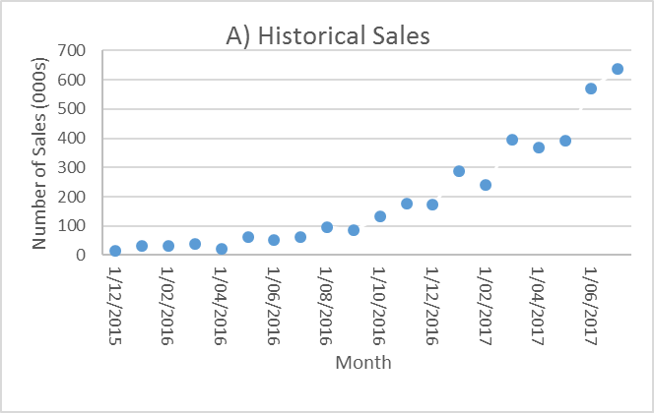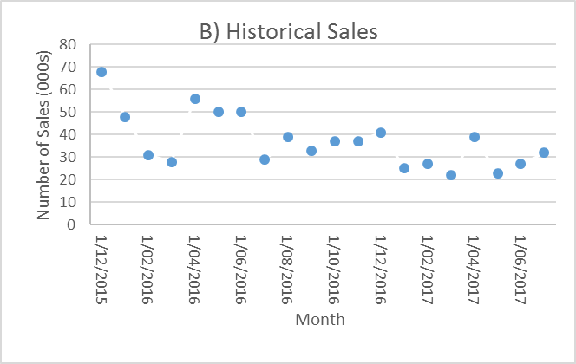
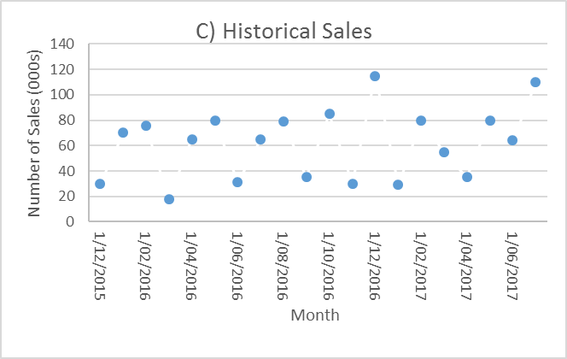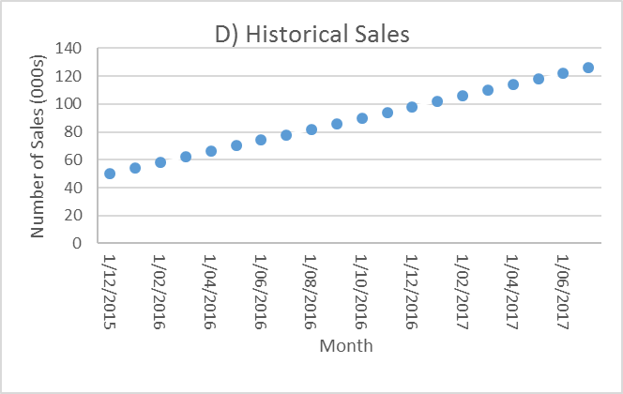
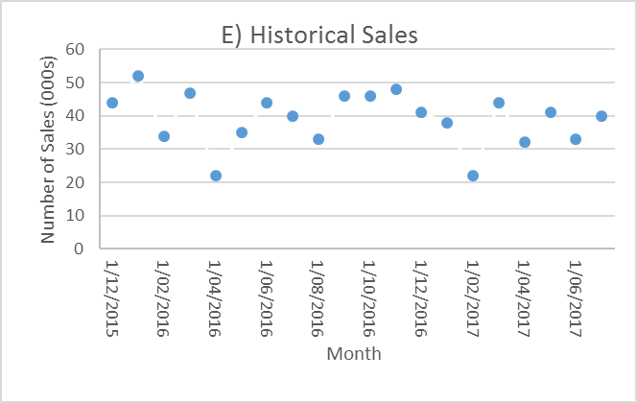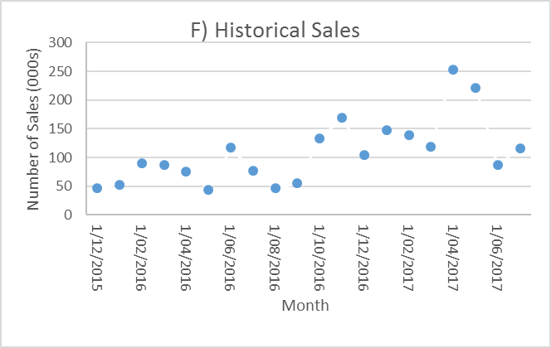
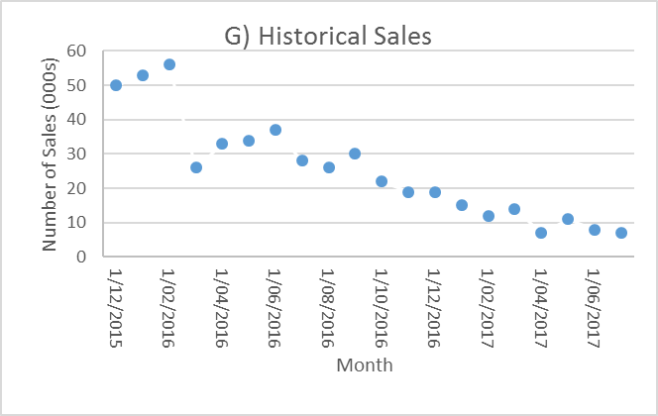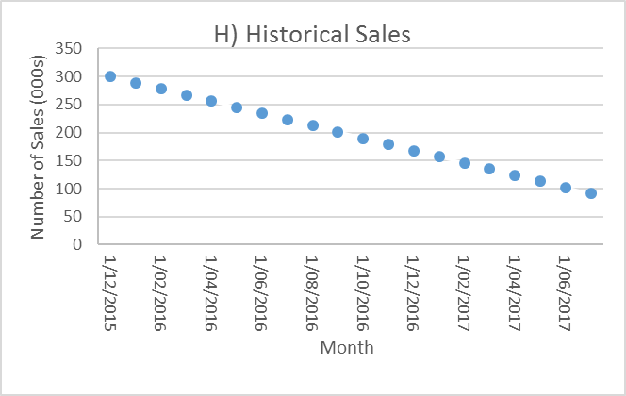

Solution

Scatterplot | Pearson’s correlation coefficient
A | 0.91
B | -0.63
C | 0.28
D | 1.00
E | -0.20
F | 0.64
G | -0.93
H | -1.00

