Sourcing data using google trends

Before you start
- Decide on two variables (search terms) you wish to examine.
- Predict the strength and direction of how they may be associated?
Note: For this file we will consider “ice cream” and “pies”. Are they strongly negatively correlated?

Sourcing data set 1
- Go to google trends: trends.google.com
- Enter a search term for the first variable.
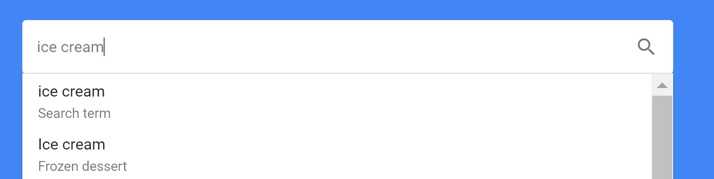
- You can now set a geographic location and time period.
In this demonstration a time period of 5 years is selected.
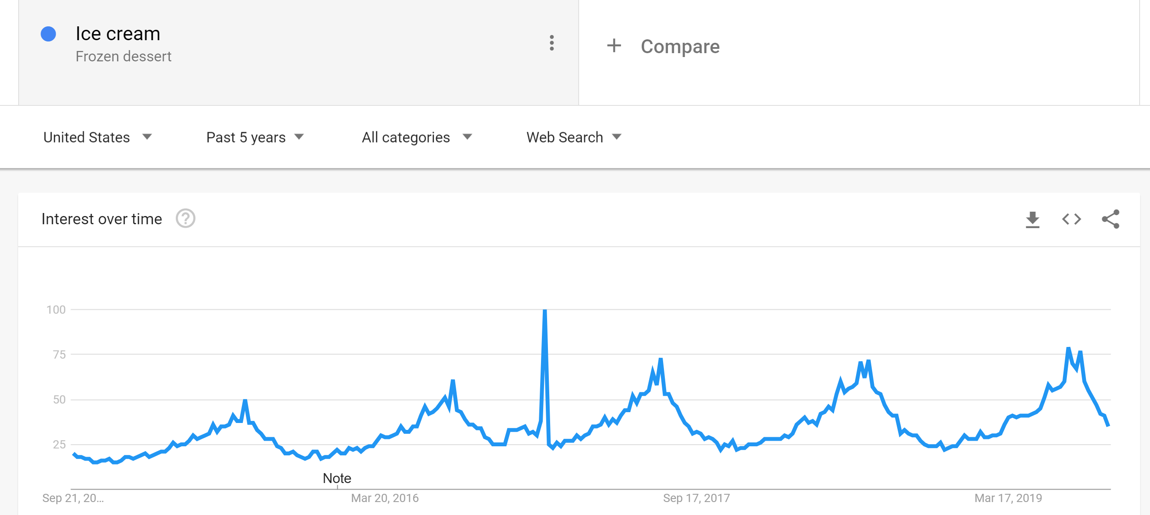
Note: If you add a second item, the scale may be unusable.
- Download the data into MS
- Excel (csv)

Add a second data set
- Go back to google trends
- Click on the search term and type in your second.
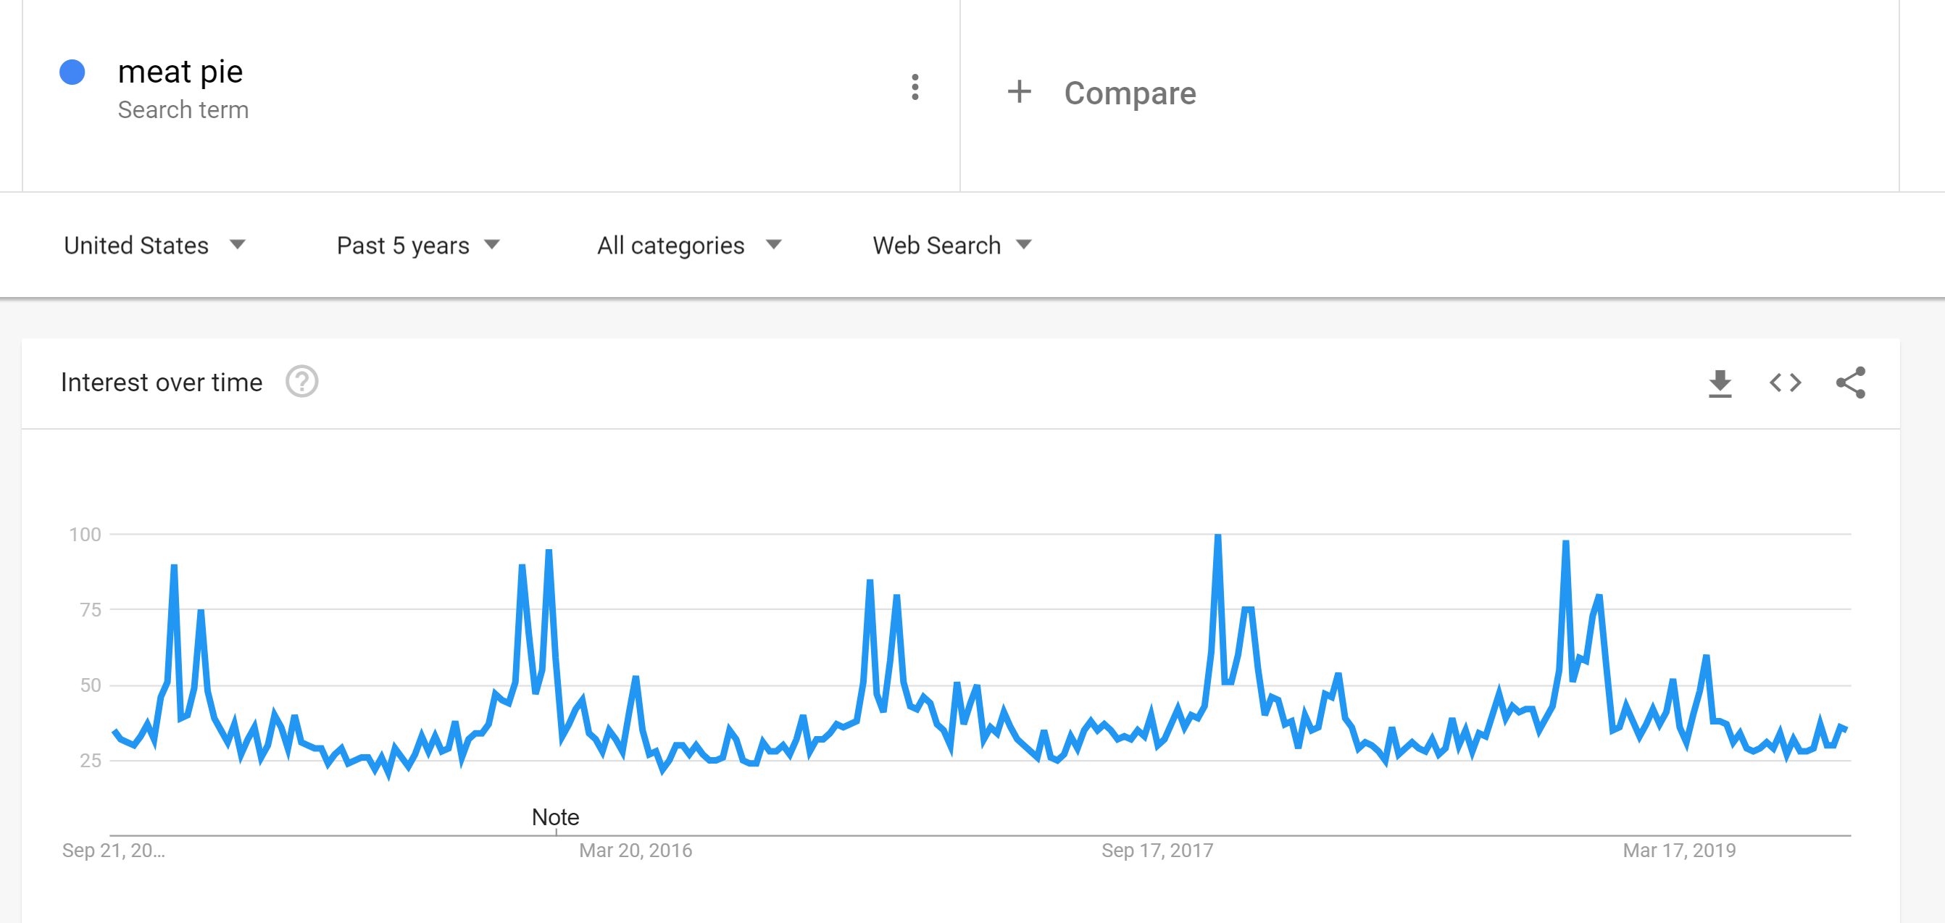
- Download this second data set.
- You now have two MS Excel files. 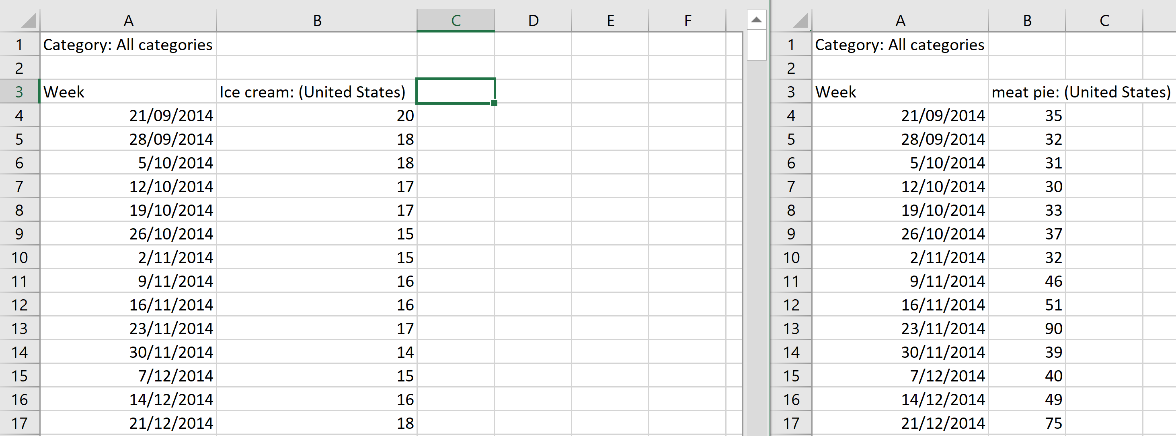
- Check the time periods are identical.
- Copy the data from one file (column B) into column C of the other.
- You now have bivariate data which you can then calculate the correlation coefficient of or a least squares regression line.
