How-to guide: regression analysis in Excel (Office 365)

Part 1 – making a scatterplot
- Ensure your data is in two columns (or rows) in an Excel workbook. The data can be next to each other or separated by other columns.
  - Note: Ensure your independent variable is first (on the left). When Excel constructs a scatterplot, it will automatically put the first (left) variable on the horizontal axis.
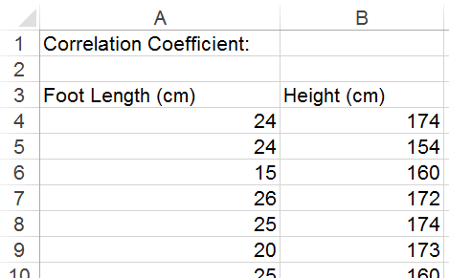
- Highlight your two rows of data.
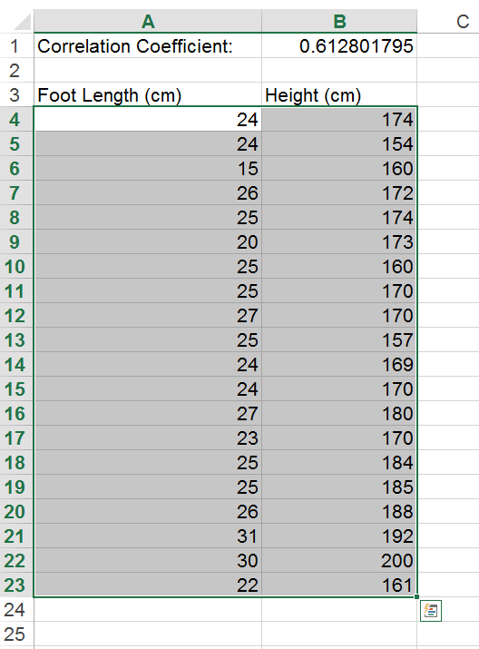

- Select ‘insert’, then ‘scatter’. Click on the first graph type.
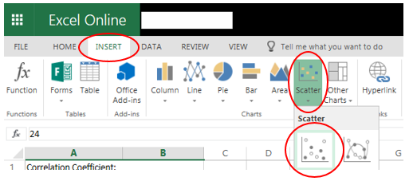
- The scatterplot will be produced.
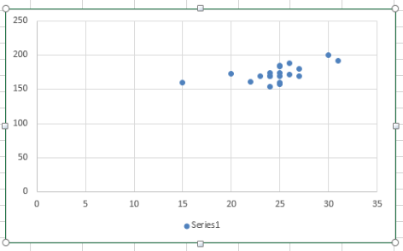
- You can now edit the chart. For example, you can add a chart title, axis labels, and the scale on each axis.
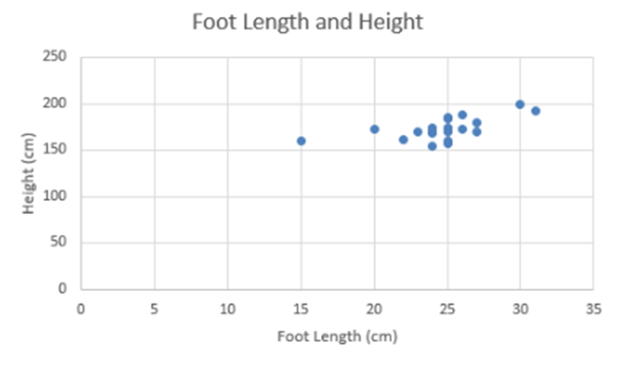

Part 2 – calculating Pearson’s correlation coefficient (r)
- Ensure your data is in two columns (or rows) in an Excel workbook. The data can be next to each other or separated by other columns.
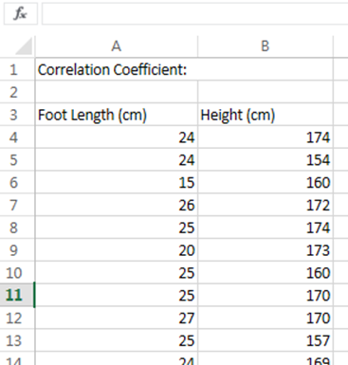
- Click on the cell you want the correlation coefficient to be in. In this case, cell B1 has been selected.
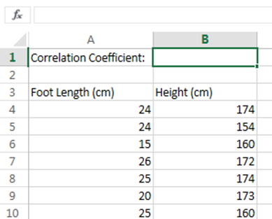
- To start a formula, type “=” then “correl(”
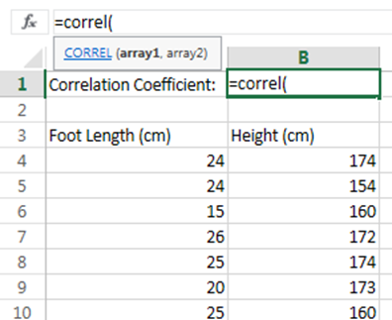

- You will now have to select the data. Select one column, type “,”, then select the second column.
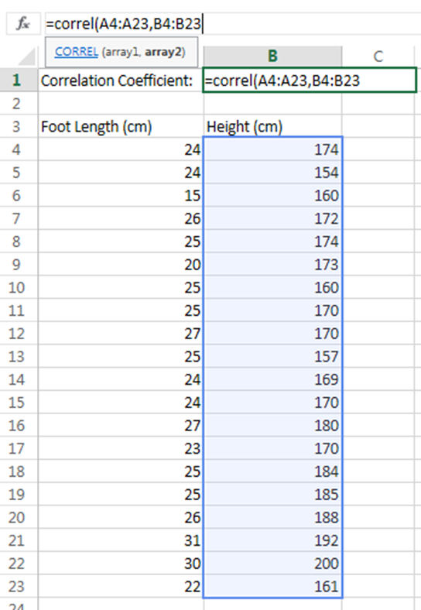
- Close the formula with end brackets “)” before pressing enter to end the formula. Pearson’s correlation coefficient will now be in the selected cell (B1 in this case).
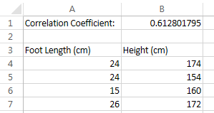

Part 3 – calculating the formula of and adding a least squares regression line
- You will need to edit the Microsoft Excel 365 file in a standard version of Excel.
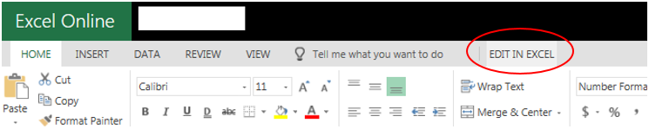

- To add a trendline, right click the scatterplot and select ‘Add Trendline’.
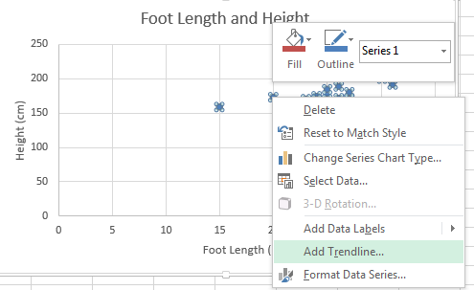
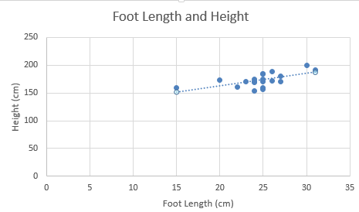

- To obtain the equation of the line, right click the line, select ‘Format Trendline’ and then select ‘Display Equation on Chart’.
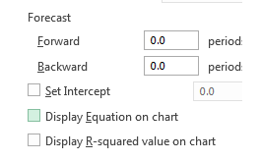
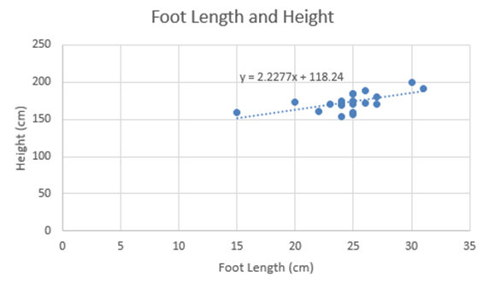

Part 4 – forecasting with Excel
You may need to adjust the data range if you wish to forecast a value outside of the original data range using the graph. For example, in the ‘Foot Length and Height’ graph, we may want to predict the height of a person with a foot length of 40cm.
- To forecast, right click the line, select ‘Format Trendline’, then input the required number of periods. For example, a value of 10 will extend the line past 40 as its maximum value is currently 31.
