NESA exemplar question solutions

MS-S4 Bivariate data analysis
Solutions for questions from the NESA topic guidance related to bivariate data analysis.
- Ahmed collected data on the age ($a$) and the height ($h$) of males aged $11$ to $16$ years. He created a scatterplot of the data and constructed a line of best fit to model the relationship between the ages and height of males.
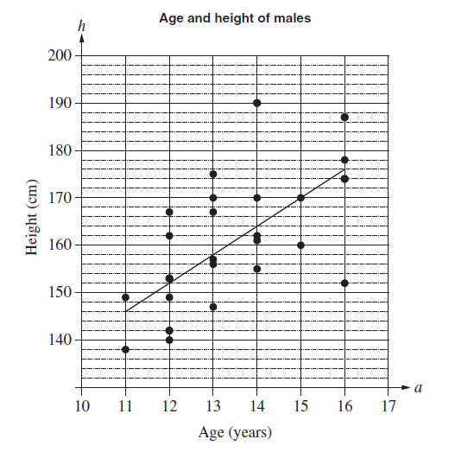
- Determine the gradient of the line of best fit shown on the graph.

Solution: Line of best fit passes through the points ($11,146$) and ($15, 170$)
$$m=\frac{y_{2}-y_{1}}{x_{2}-x_{1}}$$
$$m=\frac{170-146}{15-11}$$
$$m=\frac{24}{4}$$
$$m=6$$

$∴$ The gradient of the line of best fit is $6$

- Explain the meaning of the gradient in the context of the data.

Solution: The gradient is positive which indicates that as age increases the height of the male also increases at a rate of approximately $6$cm per year.

- Determine the equation of the line of best fit shown on the graph.

Solution: $m=6$ passing through the point ($15,170$)
$$y=mx+b$$
$$h=ma+b$$
$$170=6\left(15\right)+b$$
$$170=90+b$$
$$bbb=170-90$$
$$bbb=80$$
$∴$ The equation for the line of best fit is $h=6a+80$

- Use the line of best fit to predict the height of a typical $17$-year-old male.

Solution: when $a=17$
$$h=6\left(17\right)+80$$
$$h=182$$
$∴$ The height of a typical $17$-year-old male is $182$ cm.

- Why would this model not be useful for predicting the height of a typical $45$-year-old male?

Solution: when $a=45$
$$h=6\left(45\right)+80$$
$$h=350$$

Using this model the height of a typical $45$-year-old male would be $350$ cm. This is not a reasonable solution and assumes that males continue to grow at the same rate for the rest of their life. This model is not useful for predicting the height of a typical $45$-year-old male as it is extrapolating the data.

Height (cm) | 165 | 153 | 146 | 138 | 149 | 172 | 170 | 158 | 163 | 154
Right Foot (cm) | 26 | 21 | 20 | 19 | 22 | 24 | 25 | 23 | 22 | 25
- The height and length of the right foot of $10$ high school students were measured. The results were tabulated as follows:

- Using technology, calculate the Pearson correlation coefficient for the data.
Solution: $r=0.7835811345$

- Describe the strength of the association between height and length of the right foot
Solution: the Pearson correlation coefficient of $0.78$ (correct to 2 decimal places) indicates a strong positive linear association between a students height and the length of their right foot.

