Activity charts to network diagrams

Task 1
The local council has decided to build a new garden and picnic area in your town.
The following activity chart identifies the duration and predecessors of each activity or task.
Code | Task | Duration (hours) | Predecessors
A | Project planning | 20 | none
B | Purchasing materials (timber, soil, plants) | 30 | A
C | Excavation work | 70 | A
D | Preparation of materials (e.g. cut timber to length) | 20 | B
E | Install timber | 15 | C, D
F | Fill gardens with soil | 10 | E
G | Plant plants, lay turf. | 25 | F
- Draw a network diagram to reflect this activity table.
- For your network diagram, what is the minimum completion time of the project?

Task 2
You have decided to build a granny flat in your backyard.
The following activity chart identifies the duration and predecessors of each activity or task.
Code | Task | Duration (weeks) | Predecessors
A | Project planning | 10 | none
B | Council approval | 8 | A
C | Order materials | 3 | B
D | Excavation | 1 | B
E | Lay underground plumbing | 1 | D
F | Pour and cure slab | 2 | E
G | Install frames | 3 | C, F
H | Install roof | 3 | G
I | Install internal plumbing | 2 | G
J | Install internal electrical circuits | 1 | H
K | Install plasterboard | 1 | I, J
L | Tiling bathrooms | 2 | K
M | Paint plasterboard | 1 | K
N | Electrical and plumbing fit out | 2 | L, M
O | Lay flooring | 1 | M
P | Finishing touches | 3 | N, O
- Draw a network diagram to reflect this activity table.
- For your network diagram, what is the minimum completion time of the project?

Task 1 solution
The local council has decided to build a new garden and picnic area in your town.
The following activity chart identifies the duration and predecessors of each activity or task.
Code | Task | Duration (hours) | Predecessors
A | Project planning | 20 | none
B | Purchasing materials (timber, soil, plants) | 30 | A
C | Excavation work | 70 | A
D | Preparation of materials (e.g. cut timber to length) | 20 | B
E | Install timber | 15 | C, D
F | Fill gardens with soil | 10 | E
G | Plant plants, lay turf. | 25 | F
- Draw a network diagram to reflect this activity table.
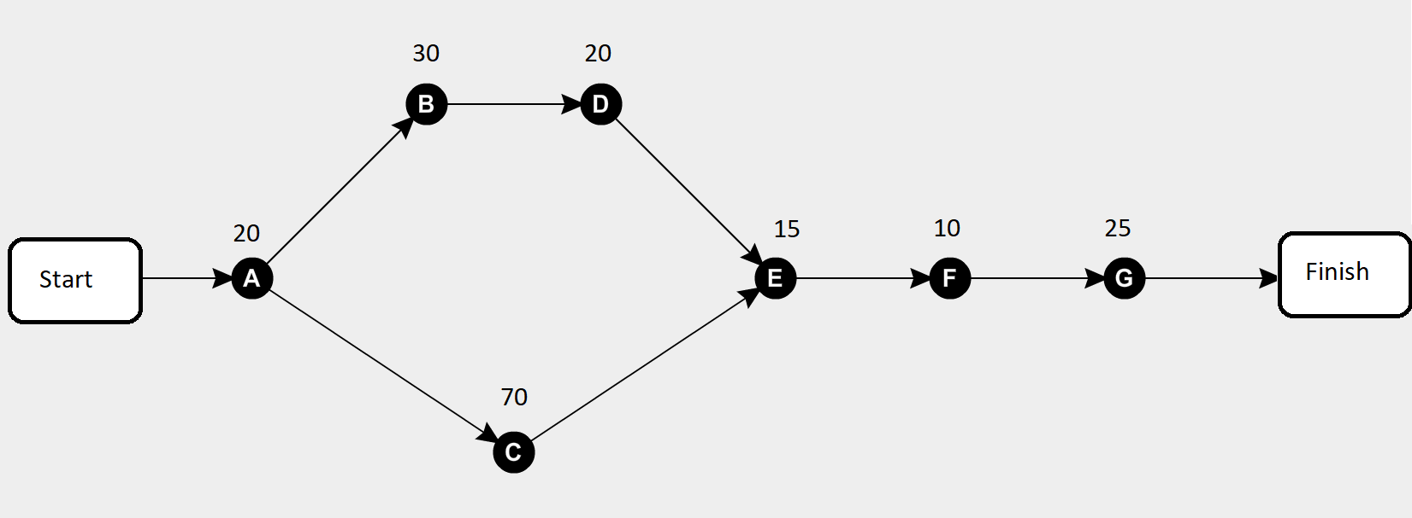
- For your network diagram, what is the minimum completion time of the project?
There are two paths through the network:
$$A-B-D-E-F-G=20+30+20+15+10+25=110 hours$$
$$A-C-E-F-G=20+70+15+10+25=140 hours$$
The minimum completion time of the project is the longest path through the network.
$$Minimum completion time = 20+70+15+10+25=140 hours$$

Task 2 solution
You have decided to build a granny flat in your backyard.
The following activity chart identifies the duration and predecessors of each activity or task.
Code | Task | Duration (weeks) | Predecessors
A | Project planning | 10 | none
B | Council approval | 8 | A
C | Order materials | 3 | B
D | Excavation | 1 | B
E | Lay underground plumbing | 1 | D
F | Pour and cure slab | 2 | E
G | Install frames | 3 | C, F
H | Install roof | 3 | G
I | Install internal plumbing | 2 | G
J | Install internal electrical circuits | 1 | H
K | Install plasterboard | 1 | I, J
L | Tiling bathrooms | 2 | K
M | Paint plasterboard | 1 | K
N | Electrical and plumbing fit out | 2 | L, M
O | Lay flooring | 1 | M
P | Finishing touches | 3 | N, O
- Draw a network diagram to reflect this activity table.
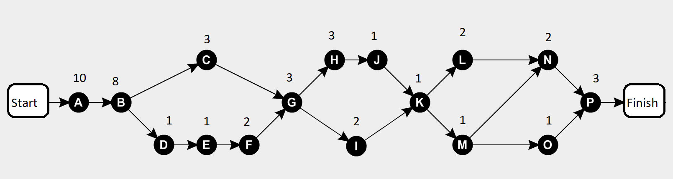
- For your network diagram, what is the minimum completion time of the project?
The minimum completion time is the longest path through the network. The longest path is from the start to A to B to D to E to F to G to H to J to K to L to N to P to finish. Note: The longest option is chosen when there are multiple paths (B to G, G to K and K to P).
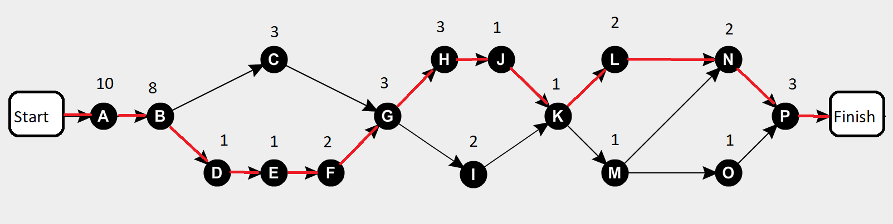
$$Minimum completion time = 10+8+1+1+2+3+3+1+1+2+2+3=37 weeks$$

