Meal and a movie

Meal and a movie
You are going to cook your family dinner tonight and then meet your friends at the movies.
You need to determine:
- What time you will serve dinner
- What time movie session you will attend

Useful Information
- You start cooking when you arrive home at 6:00pm. This will be time 0:00.
- You are going to serve the recipe with garlic bread and grated parmesan cheese.
- The possible film times available are: 7:30pm, 7:45pm, 8:00pm, 8:15pm, 9:00pm or 9:30pm.
- It will take you a total of 45 minutes to eat your dinner and wash up afterwards.
- It will take you 15 minutes to walk to the cinema.
- You want to arrive at the movies at least 10 minutes before it starts so that you can buy your ticket and purchase snacks.

Task 1: Find a recipe
Find a Bolognese pasta sauce recipe. Break the recipe into three components:
- Preparation time: How long will it take you to cut up the ingredients?
- Cooking time: How long will you need to spend cooking / stirring the ingredients?
- Simmering time: How long will the sauce need to simmer for without your input?

Task 2: Complete an activity chart
Complete the following activity chart:
Code | Task | Duration (hours) | Predecessors
Start | Arrive home | - | Nil
A | Sauce preparation |  | Nil
B | Sauce cooking
C | Sauce simmering
D | Boil water for pasta
E | Cook pasta
F | Preheat oven
G | Cook garlic bread in the oven
H | Grate parmesan cheese
I | Serve meal
J | Eat meal and wash up
K | Walk to cinema
Finish | Arrive at the cinema | -

Task 2: Construct a network diagram
Consider what you can run parallel. For example the pasta could be simmering, garlic bread cooking and you could be grating cheese all at the same time.

Task 3: Perform critical pathway analysis
Steps:
- Complete forward scanning
- Complete backward scanning
- Identify the critical path

Task 4: What time…
Determine your answers to the original questions:
- What time you will serve dinner?
- What time movie session you will attend?

Task 5: What if?
What would happen to the serving time of dinner and movie session you attend if:
- the preparation time was 15 minutes longer than expected?
- you took 30 minutes to walk to the movies?
- the pasta took an extra 5 minutes to cook?
Pose additional What if? questions to consider.

Meal and a movie – sample solution

Task 1: Find a recipe
Find a Bolognese pasta sauce recipe. Break the recipe into three components:
- Preparation time: How long will it take you to cut up the ingredients? 30 minutes
- Cooking time: How long will you need to spend cooking / stirring the ingredients? 15 hour
- Simmering time: How long will the sauce need to simmer for without your input? 1 hour

Task 2: Complete an activity chart
Complete the following activity chart:
Code | Task | Duration (hours) | Predecessors
Start | Arrive home | - | Nil
A | Sauce preparation | 0:30 | Nil
B | Sauce cooking | 0:15 | A
C | Sauce simmering | 1:00 | B
D | Boil water for pasta | 0:15 | Nil
E | Cook pasta | 0:10 | D
F | Preheat oven | 0:10 | Nil
G | Cook garlic bread in the oven | 0:25 | F
H | Grate parmesan cheese | 0:05 | Nil
I | Serve meal | 0:10 | H, G, E, C
J | Eat meal and wash up | 0:45 | I
K | Walk to cinema | 0:15 | J
Finish | Arrive at the cinema | -

Task 2: Construct a network diagram
Consider what you can run parallel. For example the pasta could be simmering, garlic bread cooking and you could be grating cheese all at the same time.
Sample 1: Activity on node
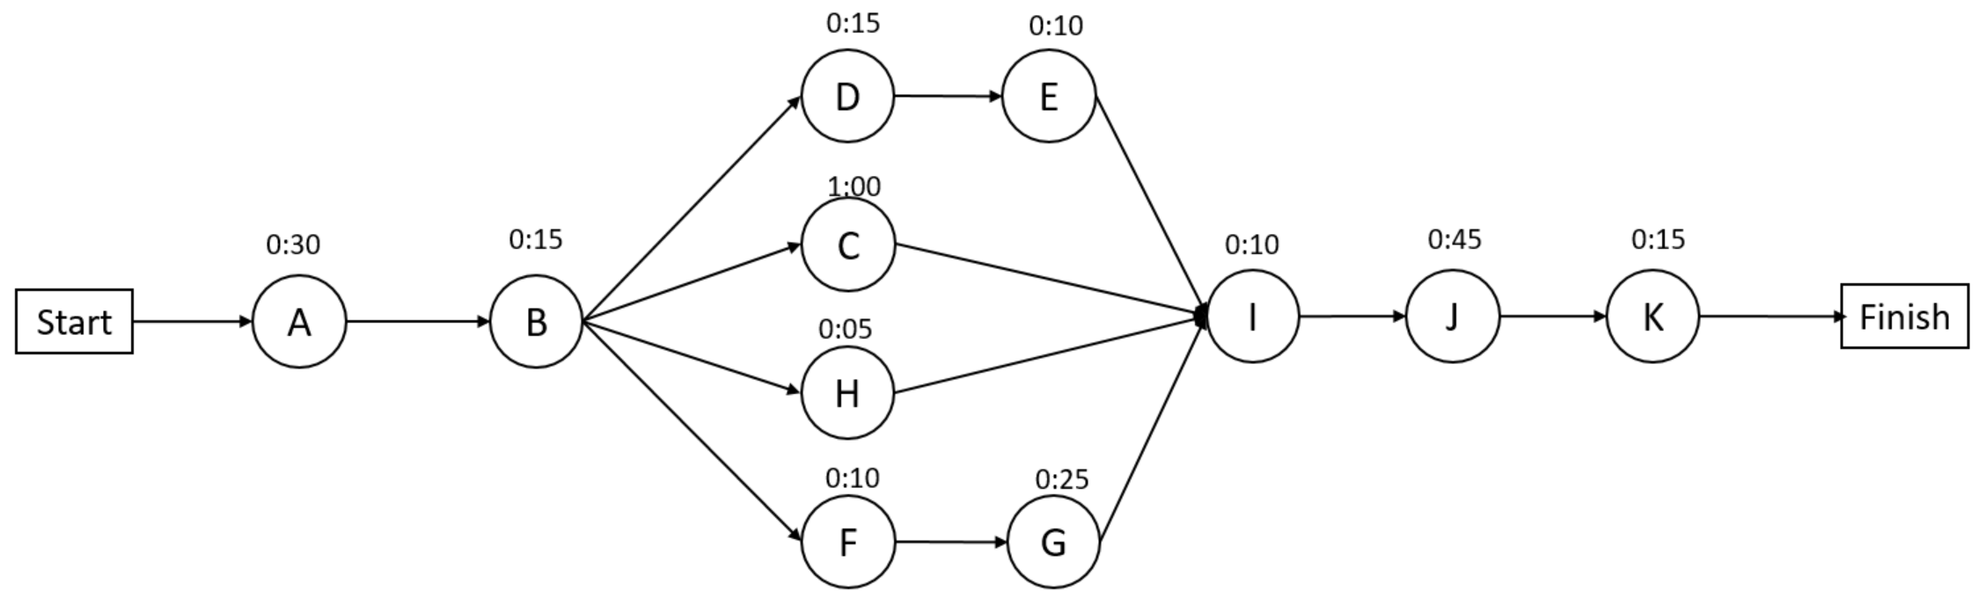
Sample 2: Activity on arrow

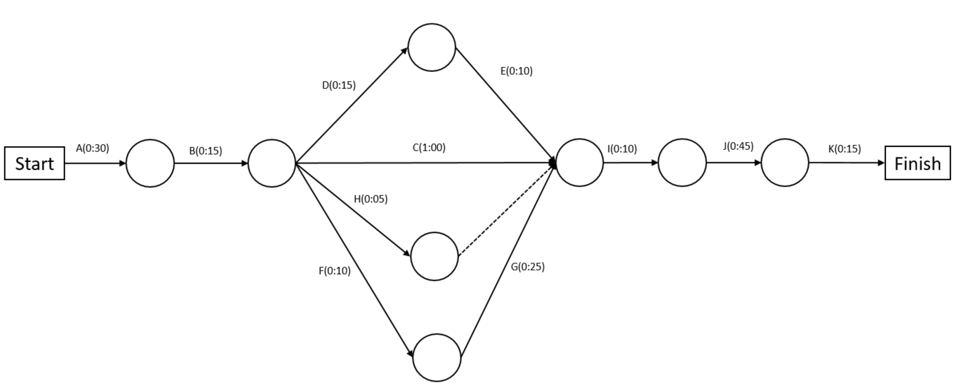

Task 3: Perform critical pathway analysis
Steps:
- Complete forward scanning
- Complete backward scanning
- Identify the critical path
Sample 1: Activity on node (activity box)
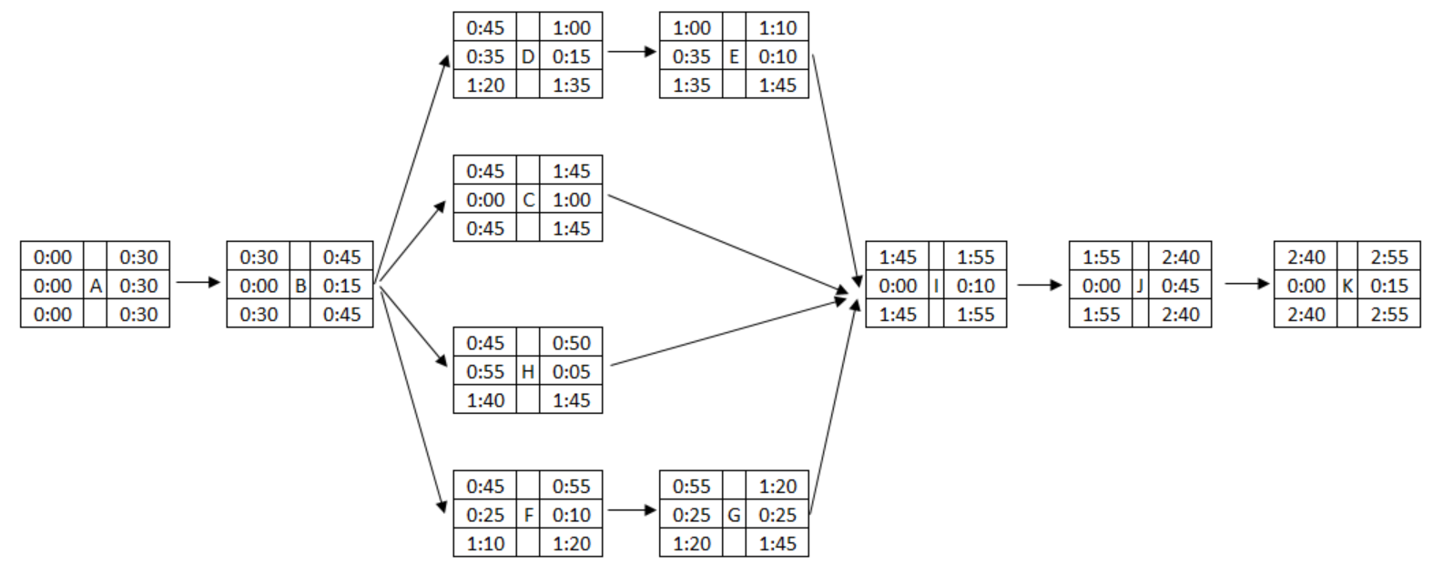
Sample 2: Activity on arrow
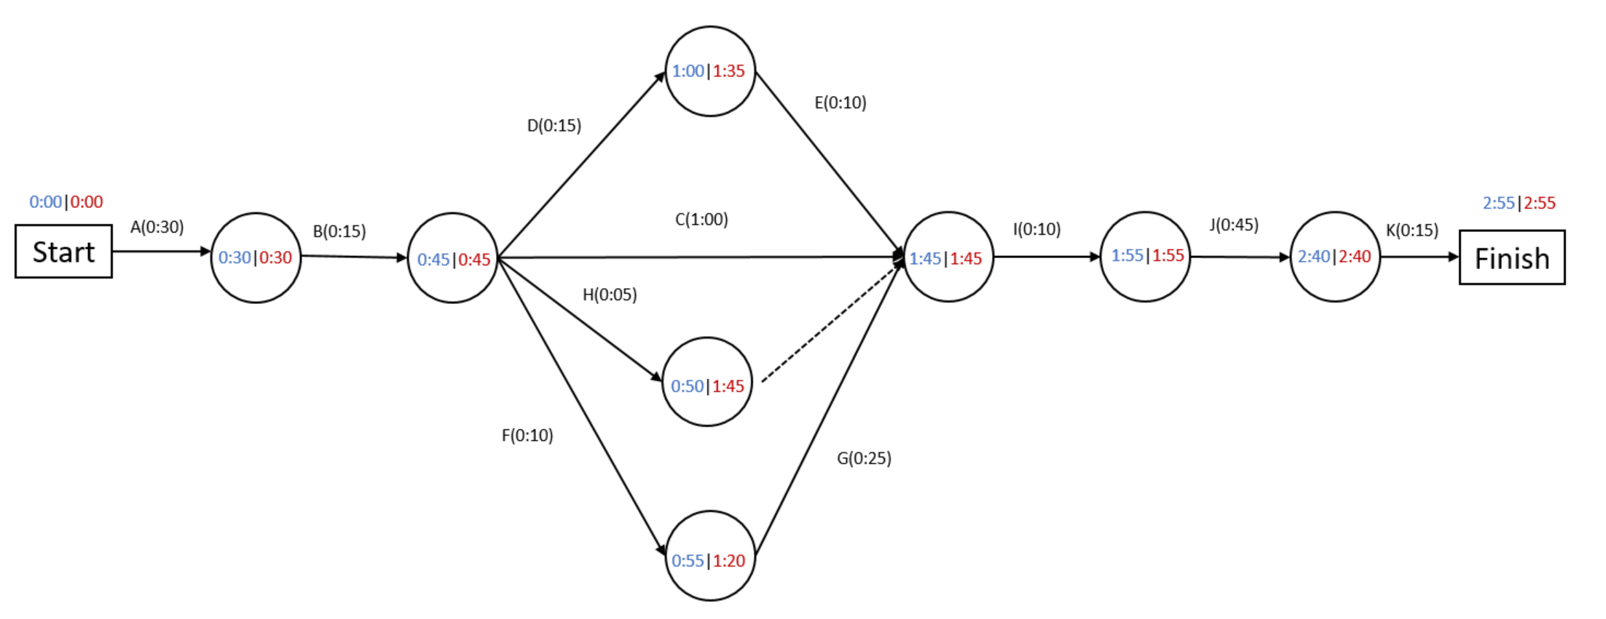

Task 4: What time…
Determine your answers to the original questions:
- What time you will serve dinner?
Dinner will be served 1 hour and 55 minutes after I start cooking, i.e. 7:55pm.
- What time movie session you will attend?
The earliest I can arrive at the movies is 2 hours and 40 minutes after I start cooking, i.e. 8:40pm.
I need to arrive at least 10 minutes before the movie starts to buy a ticket and snacks.
The earliest the movie could start is 8:50pm.
I will be able to attend to 9:00pm session.

Task 5: What if?
What would happen to the serving time of dinner and movie session you attend if:
- the preparation time was 15 minutes longer than expected?
It would increase the serving time of dinner to 8:10pm.
It would increase the earliest time the movie could start to 9:05pm. I could attend the 9:30pm session.
- you took 30 minutes to walk to the movies?
It would increase the earliest time the movie could start to 9:05pm. I could attend the 9:30pm session.
- the pasta took an extra 5 minutes to cook?
This will not affect future times unless I started cooking the pasta after 7:30pm.
Pose additional What if? questions to consider.

