Key terms and concepts
This document contains key terms and concepts for critical path analysis and maximum-flow minimum-cut problems.

Critical path analysis
Each term for critical path analysis starts with the glossary definition followed by other key concepts.
- Critical path
- Definition: The critical path is the sequence of network activities which combine to have the longest overall duration so as to determine the shortest possible time needed to complete a project.
- The longest path from the start to the finish in a project.
- Each activity on the critical path is called a critical step.
- Any delay to a critical step results in a delay of the whole project.
- The critical path is found using a process called forward and backward scanning.
- The length of the critical path is the critical time which gives the minimum time for completion of the project.
- Earliest starting time (EST)
- Definition: The earliest starting time is the earliest time that any activity can be started after all prior activities have been completed.
- Latest starting time (LST
- Definition: The latest starting time is the latest time an activity may be started after all prior activities have been completed and without delaying the project.
- Earliest finish time (EFT)
- Definition: The earliest time an activity can be finished after all the prerequisite activities have also been finished.
- Latest finish time (LFT)
- Definition: The latest time an activity can be finished after all the prerequisite activities have also been finished, and with the project still running on time.
- Float time
- Definition: Float time is the amount of time that a task in a project network can be delayed without causing a delay to subsequent tasks.
- Also known as slack time.
- This represents the maximum delay possible in starting the activity that does not affect the completion time of the entire project.
- The difference between the LST and the EST. time. i.e. $LST=EST$
- All activities on a critical path have no float time.

Maximum-flow minimum-cut
Each term for maximum-flow minimum-cut starts with the key concept followed by an elaboration or visual.
- Source: The start of the network is called the source and is often labelled $s$.
- Sink: The end of the network is called the sink and is often labelled $t$.
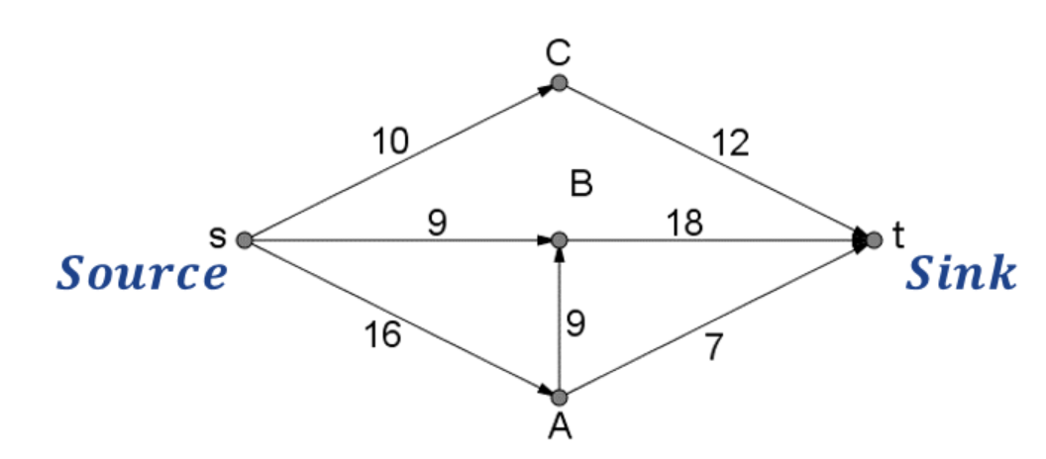

- Flow rules: A flow must obey two rules:
- The flow assigned to an edge must lie between zero and the capacity of the edge.
i.e. In the diagram above, the flow assigned to sB must lie between 0 and 9.
- The inflow of a vertex (total flow of incoming edges) must be equal to the outflow of a vertex (total flow of outgoing edges). This means that vertices cannot ‘store’ flow and are simply where edges meet.
i.e. If 10 flows from s to C, then 10 must leave C and from to t.
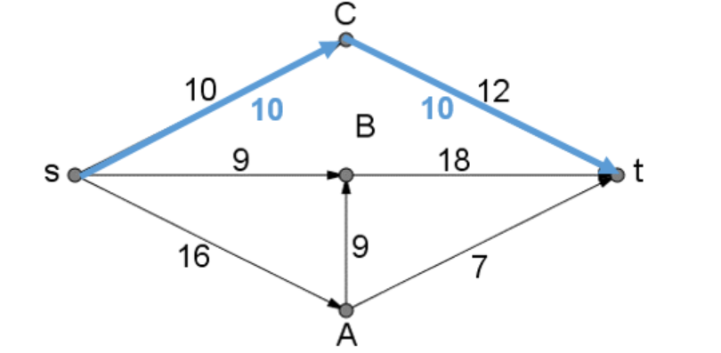
- Excess flow: The excess flow capacity of an edge is the capacity of the edge minus the flow through the edge.
i.e. Ct had a capacity of 12. If the flow through Ct is 10, then the excess capacity is 2.
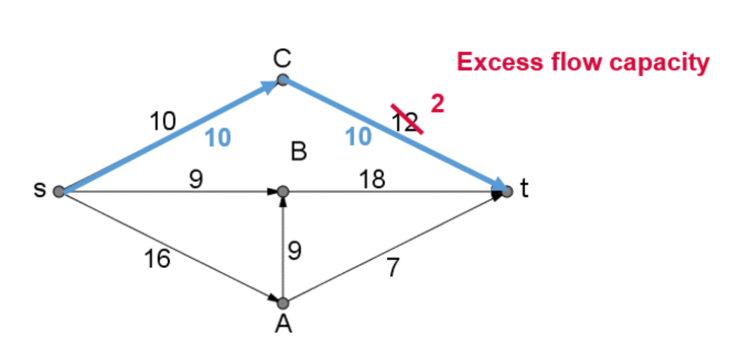
- Saturated edges: Edges with zero excess flow capacity are said to be saturated.
i.e. sC had a capacity of 10. If the flow through sC is 10, then the excess capacity is 0 and sC is said to be saturated.
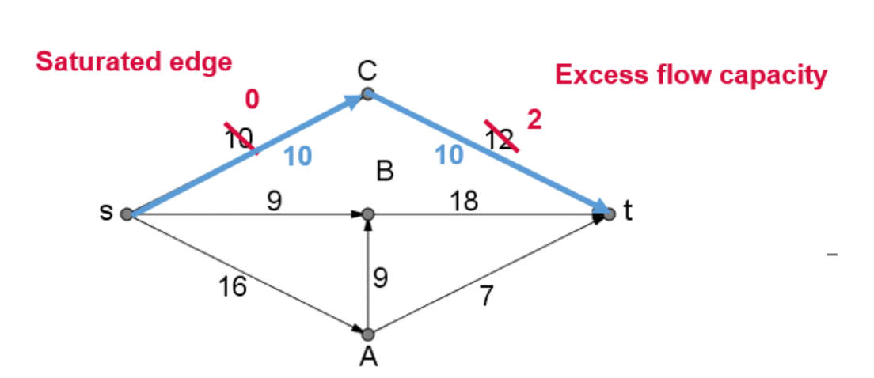
- Cut: A cut is a selection of edges, whose removal completely separates the source from the sink.
- A cut is usually represented as a curve or line across the graph.
- The capacity of the cut is the sum of the weights of the edges cut. Note: Only edges which point from the source side of the cut towards the sink side of the cut are considered part of the cut as the flow along an edge is one directional.
- Not a cut: In the diagram below a line passes through sC and Bt. This is not a cut as it has not completely separated the source from the sink. Flow can still travel from s to A to t.
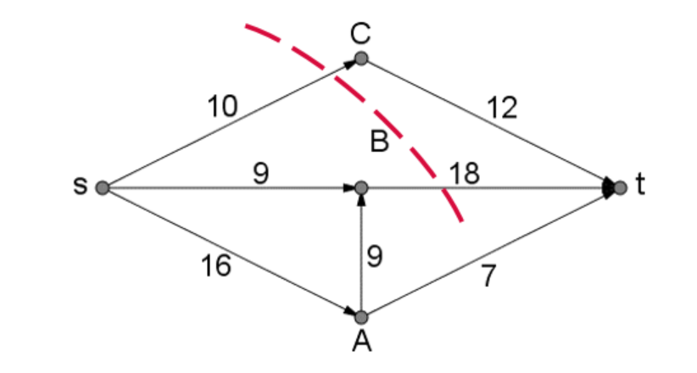
- A cut: In the diagram below a line passes through sC, Bt and At. This is a cut as it completely separates the source from the sink. The capacity of the cut is $10+18+7=35$.
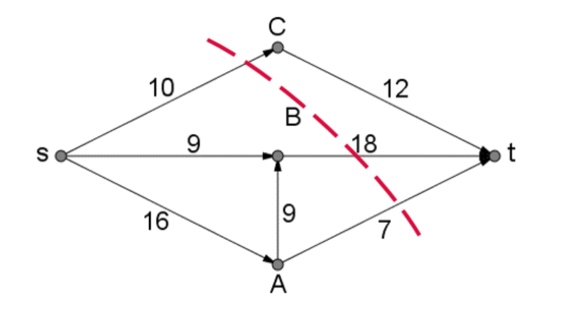
- A cut: In the diagram below a line passes through Ct, Bt, AB and sA. This is a cut as it completely separates the source from the sink. The capacity of the cut is $12+18+16=46$. AB is not considered as part of the cut as it is flowing from the sink side of the cut to the source side of the cut.
