Critical path analysis

Getting ready for school
We all do it every day, and everyone’s journey is different. Some of us crawl out of bed with barely a second to spare, and some of us are early risers and have oodles of spare time. However, there is a “sweet spot” of timing that allows all tasks to be completed with little to no wasted time.
Today, we will look at your daily routine and look for efficiency improvements. This is what businesses do every day in order to deliver their products or services as efficiently as possible, to maximise human resources, and minimise financial spending.

Task 1 – draw a table1
Draw up a table with headers as per the below table. Do this in your book. You may want to write out a list of the tasks first so you know how many rows you’ll need.
Go into as much detail as possible, for example - if you iron your clothes in the morning, you need a task for turning the iron on with a suitable duration for the iron to warm-up.
Using the ironing example again, the concept of prerequisites becomes clear. You can’t iron your shirt without having turned the iron on first, so the task of turning on the iron is a prerequisite for being able to iron.
Below is an example of how your table may look.

Code | Task | Duration | Prerequisites
A | Get out of bed (start) | - | none
B | Have a shower | 10 | A
C | Turn on iron | 2 | A
D | Make breakfast | 10 | A
E | Make coffee | 3 | A
F | Eat breakfast and drink coffee | 10 | D, E
G | Feed the dog | 2 | A
H | Iron warms up | 5 | C
I | Iron shirt | 5 | H
J | Get dressed | 5 | I
K | Leave home (Finish) | - | I

Task 2 – convert your table into a diagram
Diagrams are another way of communicating your morning’s tasks. Usually, a table will be created first to allow the tasks and their prerequisites to be considered, but a diagram is far easier for doing analysis of existing processes. It is far easier to identify inefficient processes when you can see the entire chain as a series of events, flowing into each other.
Consider which activities can be completed by someone else in your house (outsourced). These activities can therefore be run at the same time. For example, if you are showering, your breakfast could be outsourced and made by another family member.
The above table looks like the below diagram. Note: There are multiple ways this could be drawn:

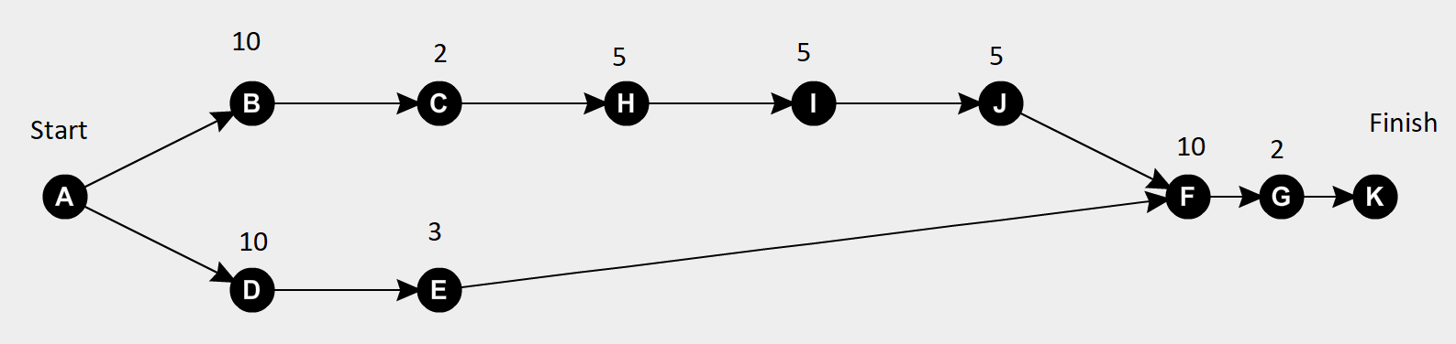
Draw a diagram of your morning’s tasks, making sure you take into account the prerequisites you have specified in your table.

Task 3 – ‘what if’ scenarios
What would happen if your breakfast was spilt / burnt and needed to be made again?
What would happen if your sibling hopped in the shower as you were about to and took 15 minutes?
Consider other scenarios and their implications.

