Prim’s and Kruskal’s algorithms

Prim’s algorithm
Prim’s algorithm is a formalised strategy for finding the minimum spanning tree, T.
- Select any vertex to be the first vertex of T.
- Consider the edges which connect vertex in T to vertices outside T. Pick the one with minimum weight. Add this edge and the extra vertex to T. (If there are two or more edges of minimum weight, choose any one of them.)
- Repeat Step 2 until T contains every vertex of the graph.

Example

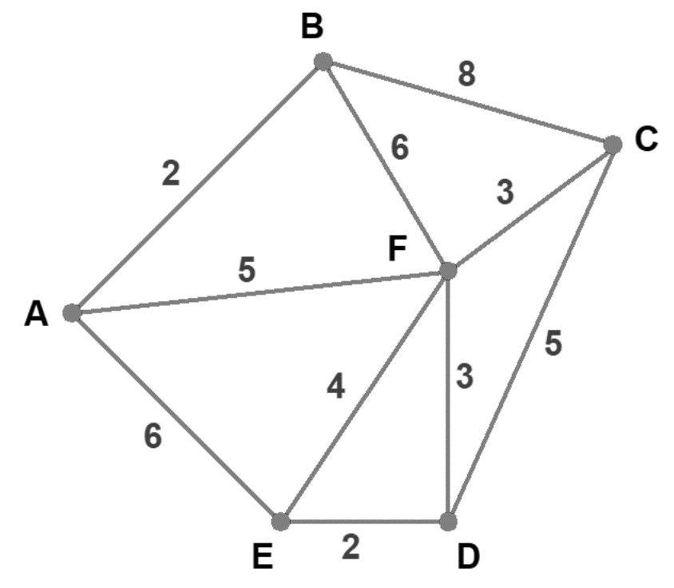

Solution
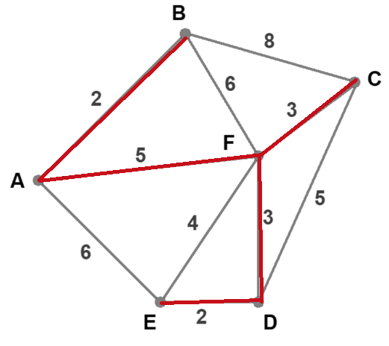
Options:
- Select vertex A or B, join BA, join ED, join FD and FC, join AF
- Select vertex D or E, join ED, join AB, join FD and FC, join AF

Kruskal’s algorithm
Kruskal’s algorithm is a formalised strategy for finding the minimum spanning tree, T.
- Choose the edge of least weight in T.
- From those edges remaining, choose the edge of least weight which does not form a cycle with already chosen edges. (If there are several such edges, choose one arbitrarily.)
- Repeat Step 2 until T contains every vertex of the graph.

Example 1

Solution
Options:
- Select AB, then AF, then FC, then FD, then ED
- Select AB, then AF, then FD, then ED, then FC
- Select ED, then DF, then FC, then FA, then AB

Example 2
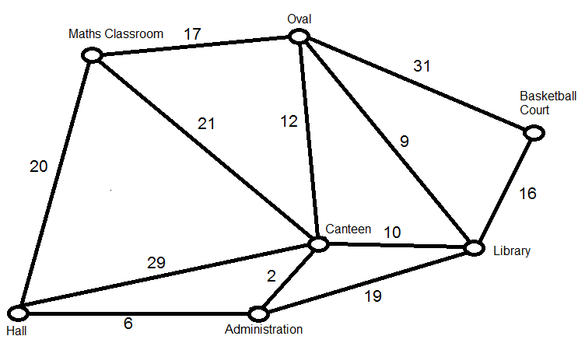

Solution
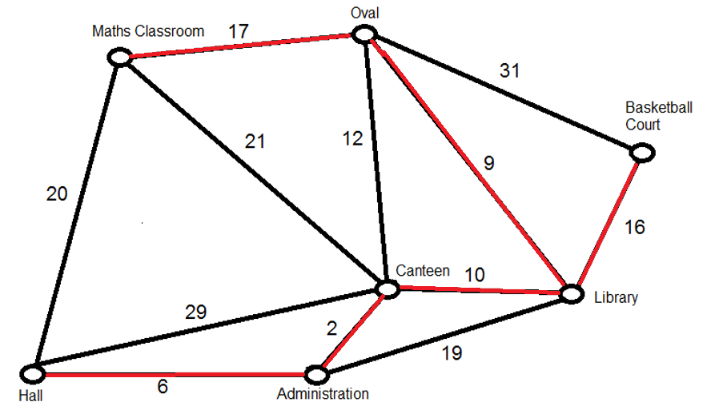

Activities
Use Prim’s algorithm to find the minimum spanning tree for each odd question and Kruskal’s algorithm for each even question:

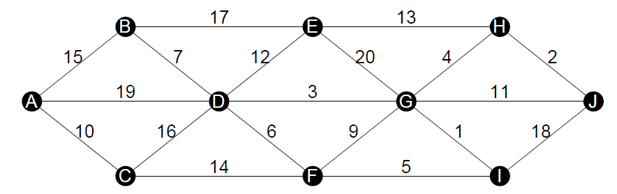

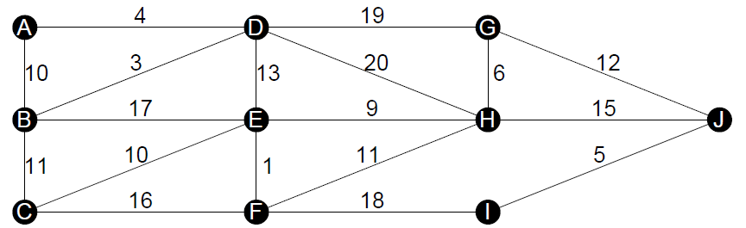

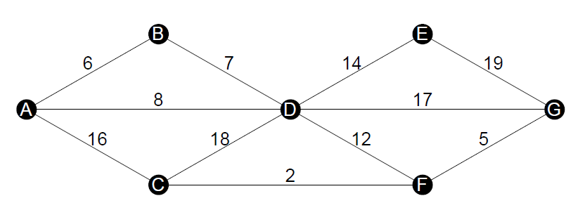

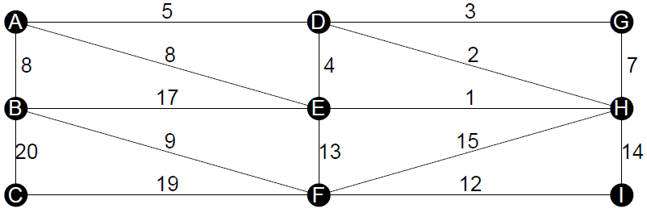

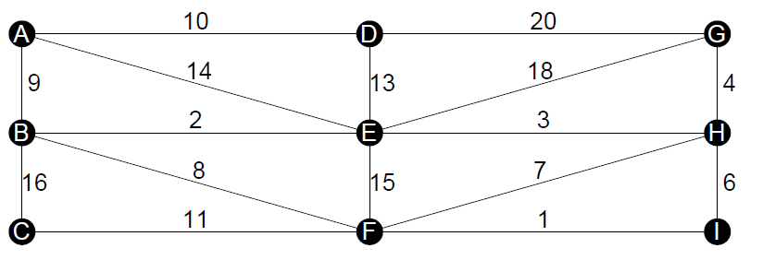

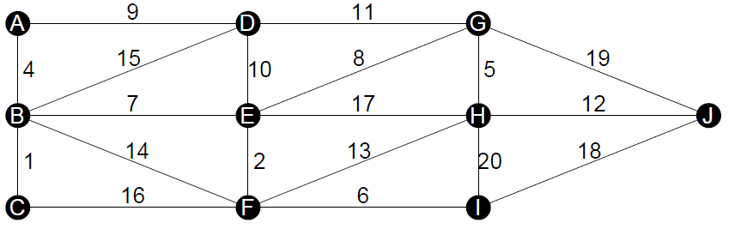

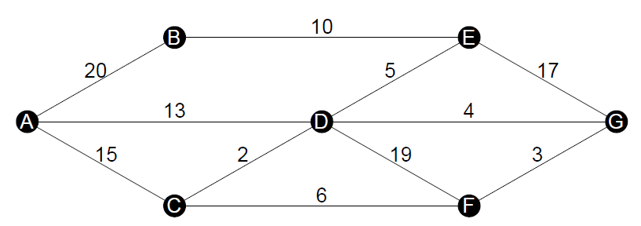

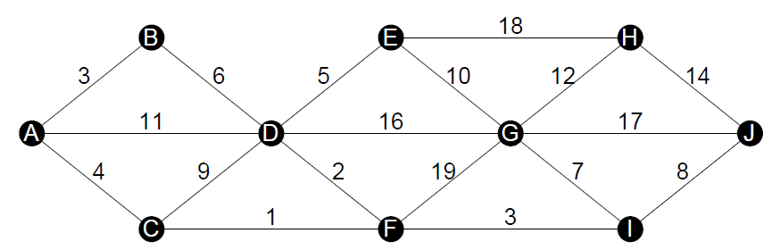

Solutions:
- 
 