Networks formative assessment tool
- How many edges does this graph have?
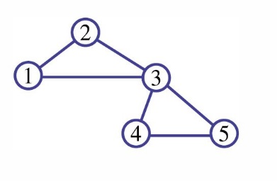
  - 4
  - 5
  - 6
  - Not sure yet

- How many vertices does this graph have?
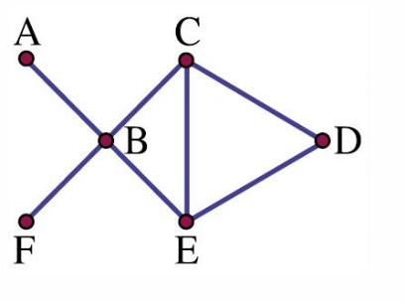
  - 7
  - 6
  - 5
  - Not sure yet
- What is the degree of the vertex labelled E?
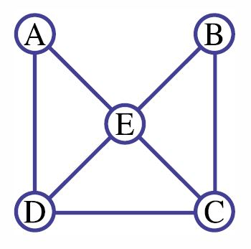
  - 2
  - 3
  - 4
  - Not sure yet

- In which of the following situations could a network be used?
  - Which streets to take on the way to school.
  - Modelling the flow of energy in the ocean food chain.
  - The cost of connecting different towns to a certain power station.
  - All of the above.
  - Not sure yet.
- Using Prim's algorithm, determine the weight of the minimum spanning tree for this network. Enter the number only.
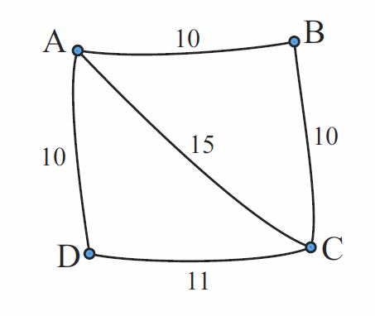
- What is the length of the shortest path to get from Kurri to Woy Woy?
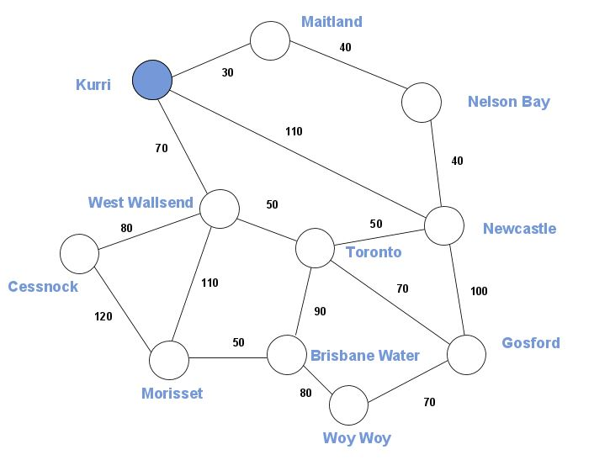

Solutions
- c
- b
- c
- d
- 30 i.e. connect AD, AB, BC
- 260 i.e. Kurri to West Wallsend to Toronto to Gosford to Woy Woy.

