Minimum spanning trees
A network diagram is shown below:
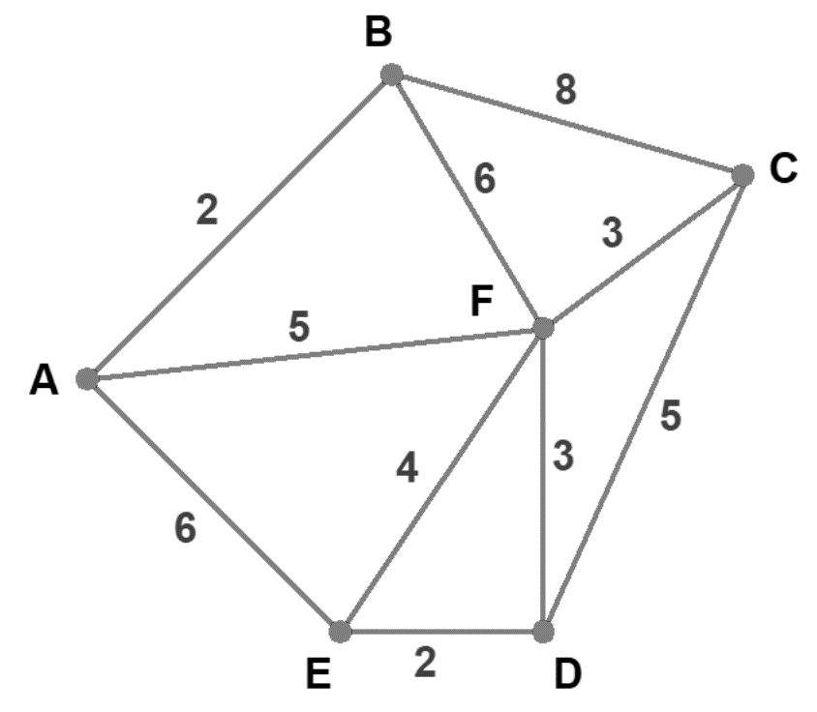

Trees
A tree is an undirected network in which any two vertices are connected by exactly one path.
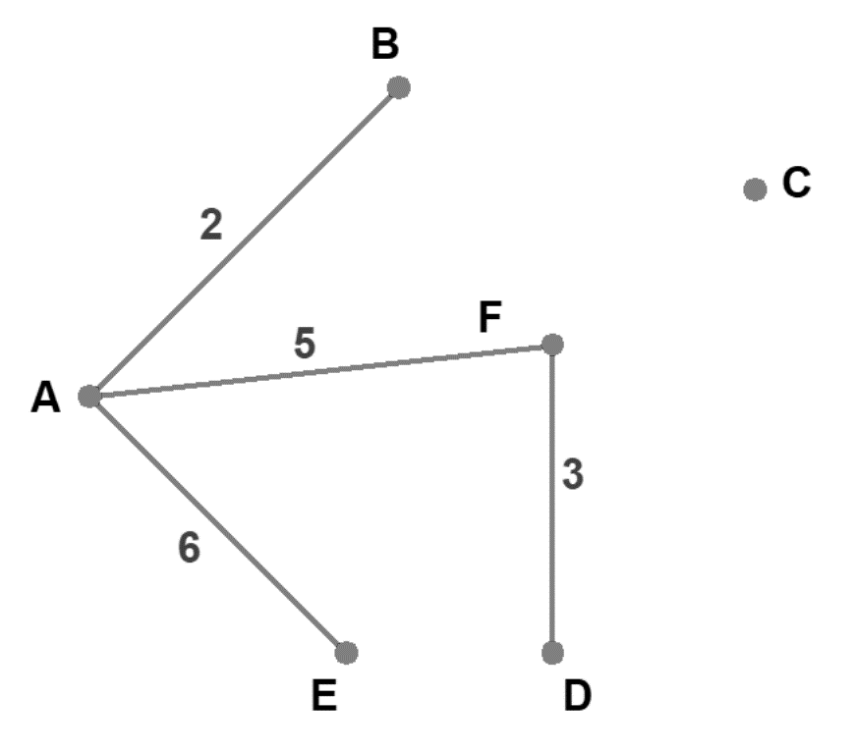

Activities
- Draw either a network with the given specification or explain why no such network exists:
- Network, nine vertices, nine edges
- Network, four vertices, seven edges. What is special about this network?
- Network, five vertices, three edges
- Tree, four vertices, three edges
- Tree, nine vertices, nine edges
- How many edges does a tree with “n” number of vertices have?
- What happens if you delete an edge in a tree?
- In a tree, can vertices be connected by more than one path?
- Can there be ‘cycles’ in a tree?
- What happens if you add an edge to a tree?
- If the total degree of a network is the sum of all the degrees of its vertices, what is the total degree of a tree with ‘n’ vertices?

Spanning trees
A spanning tree in a network is a tree that contains each vertex. There is only one possible path between any two vertices.
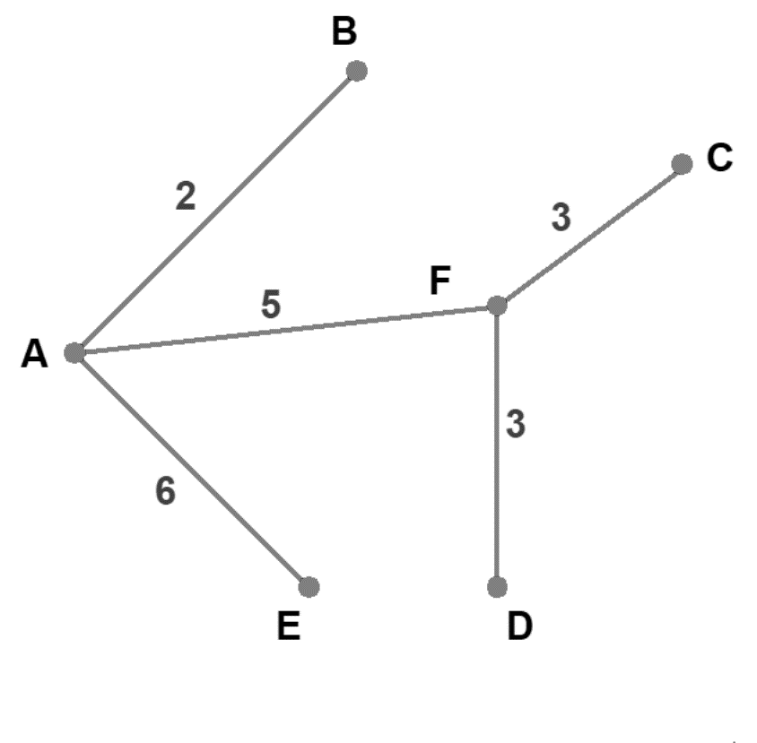
The minimum spanning tree is the spanning tree with the minimum weight.

Minimum spanning trees
- Find the minimum spanning tree for the network diagram below.

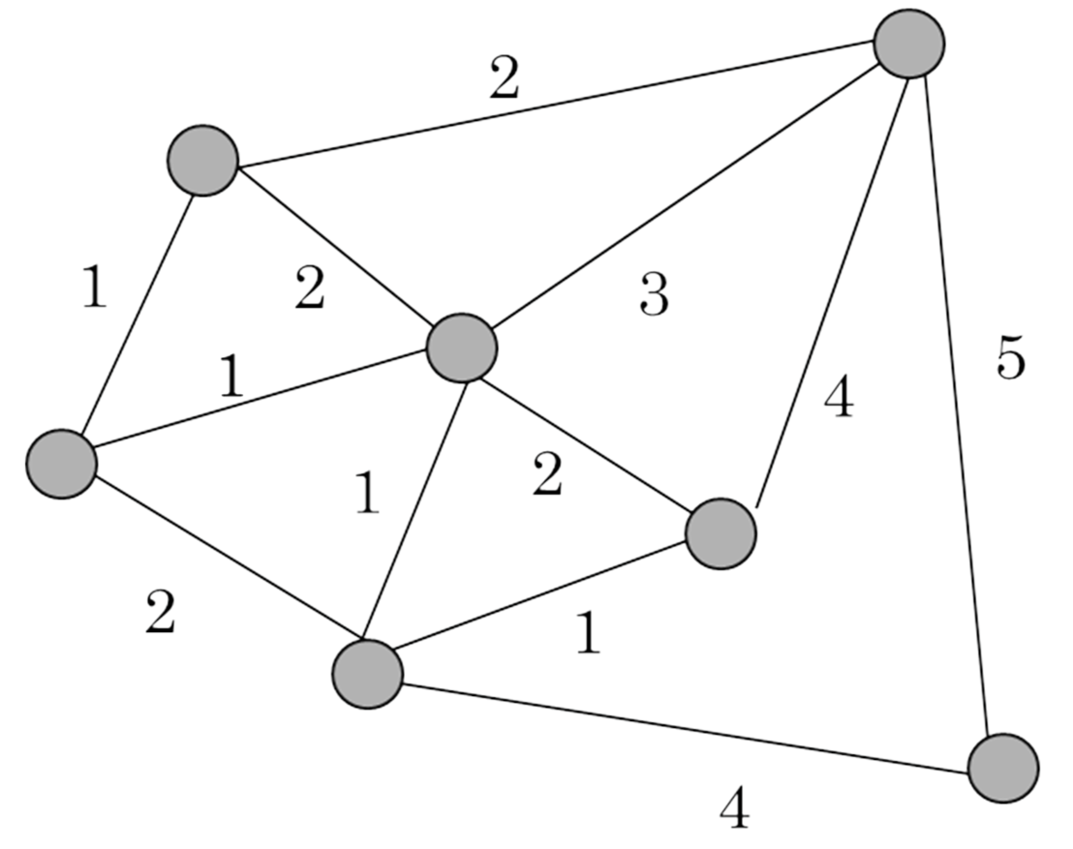
Could you write down a general strategy to solve the problem that works in every case? Would you need more examples to test it?

Activities
Test your strategy/strategies to find the minimum spanning tree in each case below:

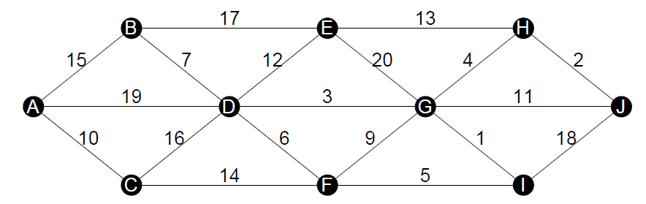

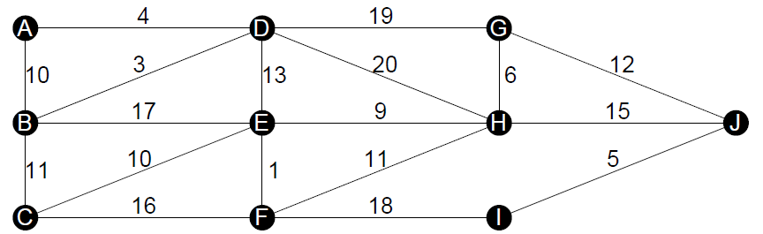

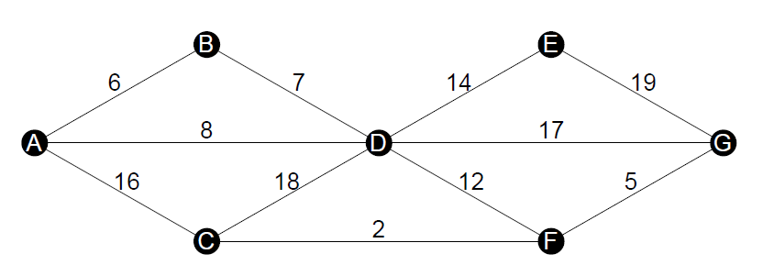

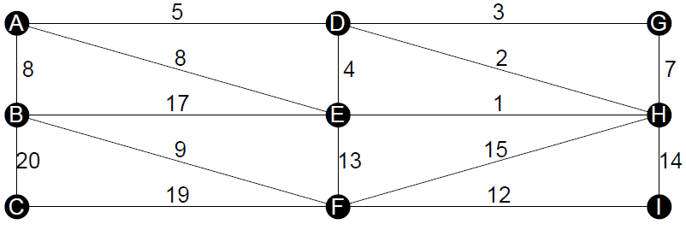

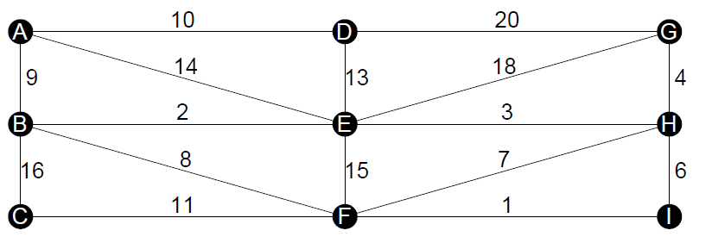

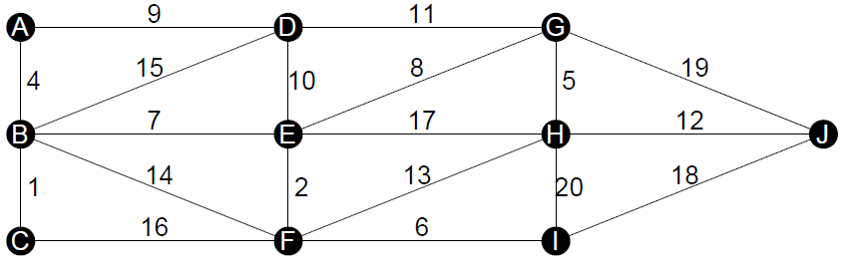

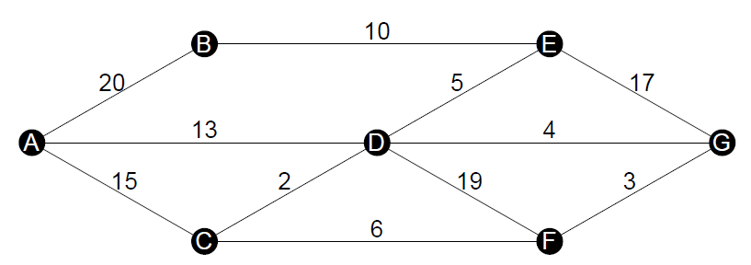

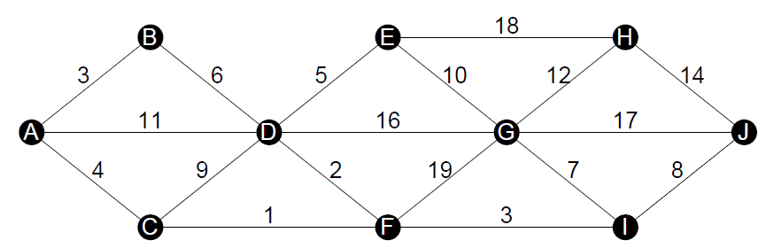

Solutions

Trees

Activities
- Draw either a network with the given specification or explain why no such network exists:
- Network, nine vertices, nine edges
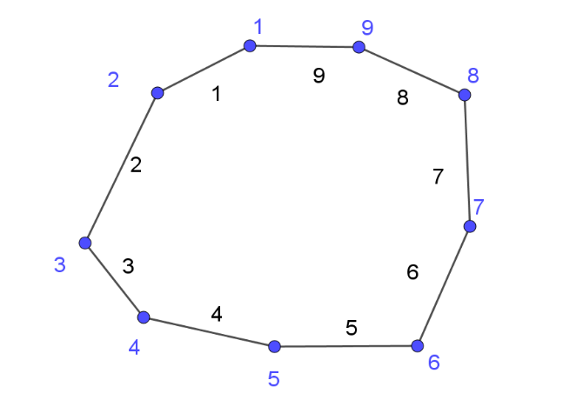
- Network, four vertices, seven edges. What is special about this network?
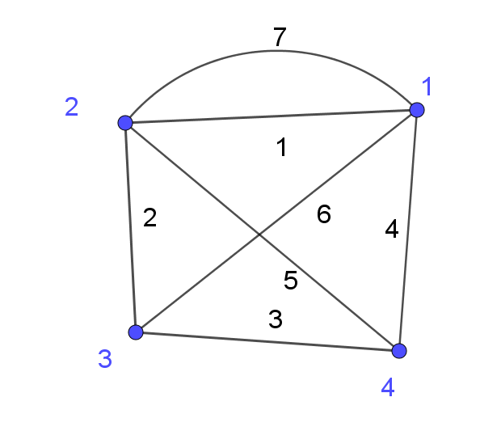
The network must have a loop or two paths joining the same two vertices. The network is not simple.
- Network, five vertices, three edges
This is not possible, a maximum of 4 vertices can be combined into a network with 3 edges.
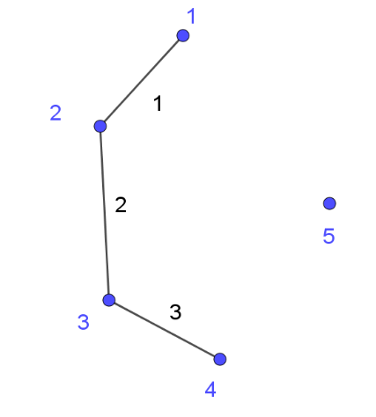

- Tree, four vertices, three edges
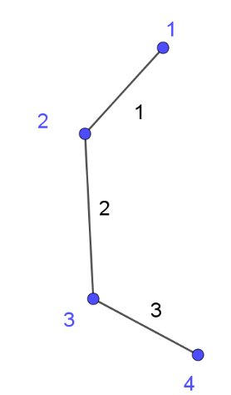
- Tree, nine vertices, nine edges
This is not possible. A tree with 9 vertices will have exactly 8 edges. By adding a 9th edge a cycle or loop is formed and it is therefore not a tree.
- How many edges does a tree with “n” number of vertices have?
(n-1) edges
- What happens if you delete an edge in a tree?
If an edge is deleted from to a tree there are two possibilities.
Option 1: If the edge deleted joined two vertices such as A and F, then it will be split two trees.
Option 2: If the edge deleted joined two vertices such as F and D, then a new tree will be formed with one less vertex.
- In a tree, can vertices be connected by more than one path?
No.
- Can there be ‘cycles’ in a tree?
There cannot be cycles in a tree as then there would be more than one path between two vertices.
- What happens if you add an edge to a tree?
If an edge is added to a tree there are two possibilities.
Option 1: If the edge joins two vertices which are already part of the tree then a cycle will be formed and it will no longer represent a tree. For example, if an edge joining F and B was added to the diagram.
Option 2: If the edge joins to a vertex not previously within the tree a new tree will be formed with an additional vertex. For example, if an edge joining B and C was added to the diagram.
- If the total degree of a network is the sum of all the degrees of its vertices, what is the total degree of a tree with ‘n’ vertices?
$2n-2$.
Explanation: With one vertex there is no degree. When a vertex is added the total degree will increase by two.

Minimum spanning trees
- Find the minimum spanning tree for the network diagram below.

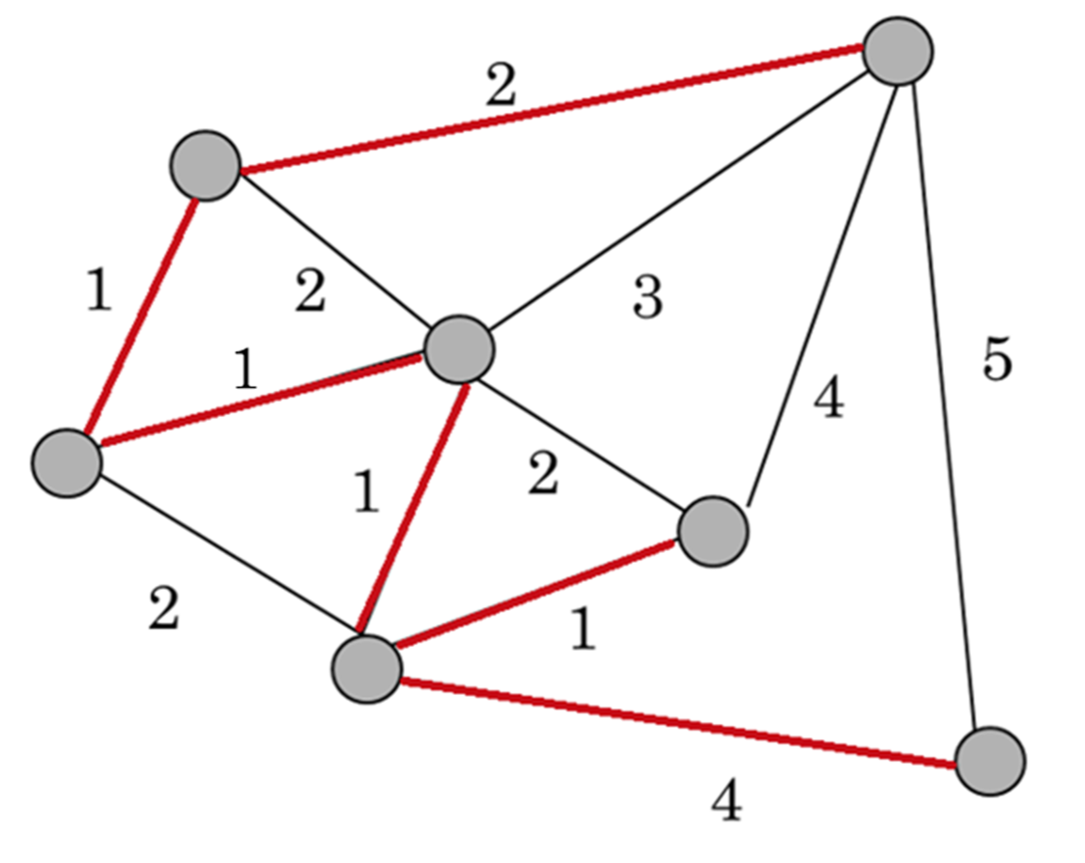
Could you write down a general strategy to solve the problem that works in every case? Would you need more examples to test it?
Solution: Various responses could be given. The students responses may lead to the developments of Prim’s and Kruskal’s algorithms.

Activities
Test your strategy/strategies to find the minimum spanning tree in each case below:
Solution: See sample solutions for the minimum spanning trees in the resource prims-and-kruskals-algorithms.DOCX

