Ambiguous case sine rule
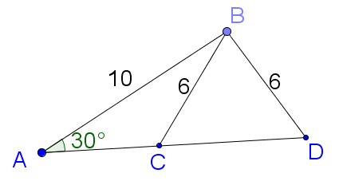

$$\frac{\sin{A}}{a}=\frac{\sin{D}}{d}$$
$$\frac{\sin{30}}{6}=\frac{\sin{D}}{10}$$
$$\sin{D}=\frac{10×\sin{30}}{6}$$
$$D=56°27'$$
However, as
$$\sin{θ}=\sin{(180-θ)}$$
$$∴\sin{56°27'}=\sin{123°33'}$$
Now $∠$ sum of a $∆=180°$
In $∆ABD$,
$$∠ABD=180°-30°-56°27'$$
$$∠ABD=93°33'$$

But in $∆ABC$,
$$∠ACB=180°-30°-123°33'$$
$$∠ACB=26°27'$$
$∴$There are 2 solutions to the following problem.

Calculate the value of $β$.
