NESA exemplar question solutions

M6 non-right-angled trigonometry
Solutions for questions from the NESA topic guidance related to non-right-angled trigonometry.
- The angle of depression from $J$ to $M$ is $75°$. The length of $JK$ is $20$ m and the length of $MK$ is $18$ m.
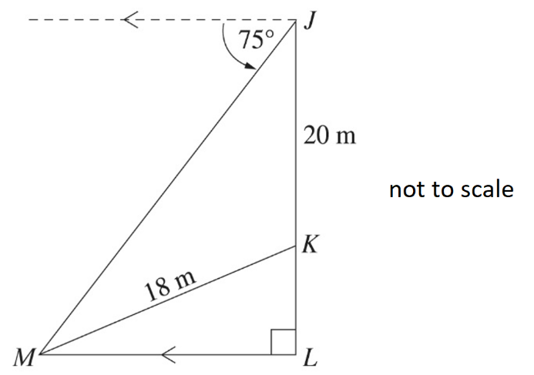
Calculate the angle of elevation from $M$ to $K$. Give your answer to the nearest degree.

Solution:
$$∠KJM=90°-75°=15°$$

In triangle $KJM$
$$\frac{\sin\left(∠JMK\right)}{20}=\frac{\sin{15°}}{18}$$
$$\sin\left(∠JMK\right)= \frac{20×sin15°}{18}$$
$$∠JMK=\sin^{-1}\left(\frac{20×sin15°}{18}\right)$$
$$∠JMK=16°{42}^{'}46.56"$$

Elevation from $M$ to $K=75°-16°{42}^{'}46.56”$ (Alternate angles within parallel lines are equal)
Elevation from $M$ to $K=58°{17}^{'}13.44"$

$∴$The angle of elevation from $M$ to $K$ is $58°$ (correct to the nearest degree)

- The area of the triangle shown is $250$ cm².
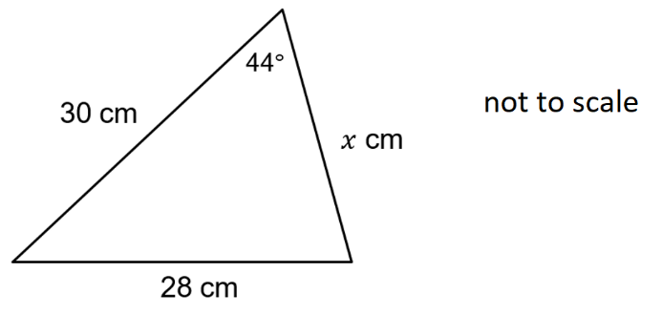
What is the value of $x$, correct to the nearest whole number?
  - 11
  - 18
  - 22
  - 24

Solution:
$$Area=\frac{1}{2}ab\sin{C}$$
$$250=\frac{1}{2}×30×x×\sin{44}°$$
$$250=15×x×\sin{44}°$$
$$x=\frac{250}{15×\sin{44°}}$$
$$x=23.99260899$$
$x=24$ cm (correct to the nearest cm)
$∴$ Correct answer is d

