Year 12 Mathematics Standard 2
MS-F5 Annuities | Unit duration
Financial Mathematics involves the application of knowledge, skills and understanding of numbers to earning, spending, investing, saving and borrowing money. Knowledge of financial mathematics enables students to analyse different financial situations, to calculate the best options for given circumstances, and to solve financial problems. Study of financial mathematics is important in developing students’ ability to make informed financial decisions, to be aware of the consequences of such decisions, and to manage personal financial resources effectively. | 1 week

Subtopic focus | Outcomes
The principal focus of this subtopic is the nature and mathematics of annuities, the processes by which they accrue, and ways of optimising their value as an investment. Students develop awareness of the use of annuities in their lives, for example superannuation and home loans. Within this subtopic, schools have the opportunity to identify areas of Stage 5 content which may need to be reviewed to meet the needs of students. | A student:  - makes informed decisions about financial situations, including annuities and loan repayments MS2-12-5  - chooses and uses appropriate technology effectively in a range of contexts, and applies critical thinking to recognise appropriate times and methods for such use MS2-12-9  - uses mathematical argument and reasoning to evaluate conclusions, communicating a position clearly to others and justifying a response MS2-12-10  Related Life Skills outcomes: MALS6-5, MALS6-6, MALS6-13, MALS6-14

Prerequisite knowledge | Assessment strategies
Students need to have studied the MS-F1 Money matters and MS-F4 Investments and loans topics. This topic also has strong links to the A4.2 Non-linear relationships topic and it would be valuable to discuss these concepts explicitly with students. | During this unit, staff are encouraged to use excel spreadsheets to run simulations to support students’ conceptual understanding. Staff are encouraged to ask lots of “what if” style questions to gauge students’ understanding and direct learning.

All outcomes referred to in this unit come from Mathematics Standard Stage 6 Syllabus © NSW Education Standards Authority (NESA) for and on behalf of the Crown in right of the State of New South Wales, 2017

Glossary of terms
Term | Description
Annuity | An annuity is a compound interest investment from which payments are made or received on a regular basis for a fixed period of time.
Contribution | A payment to an investment (annuity)
Future value | The future value of an investment or annuity is the total value of the investment at the end of the term of the investment, including all contributions and interest earned.
Future value interest factors | Future value interest factors are the values of an investment at a specific date. A table of these factors can be used to calculate the future value of different amounts of money that are invested at a certain interest rate for a specified period of time.
Investment | The action or process of investing money for profit.
Recurrence relation | A recurrence relation occurs when each successive application uses the resultant value of the previous application to generate the next value. Examples include compound interest and annuities.

Lesson sequence | Content | Suggested teaching strategies and resources | Date and initial | Comments, feedback, additional resources used
 |  | - When solving financial problems, students should be encouraged to write a few key words on the left-hand side of the equals sign to identify what is being found in each step of their working, and to conclude with a statement in words.
Introducing annuities as opposed to compound interest or a loan.  (2 lessons) | - solve compound interest related problems involving financial decisions, for example a home loan, a savings account, a car loan or an annuity AAM  - identify an annuity as an investment account with regular, equal contributions and interest compounding at the end of each period, or as a single sum investment from which regular, equal withdrawals are made | Revising compound interest  - Teacher should revise the compound interest formula and graph for investments and loans.  Introducing annuities  - Teacher to discuss with class how an annuity differs from a loan or lump sum investment, in that extra payments are made on a regular basis.  - Annuities can be used as mortgages, loans, savings accounts and superannuation.  - Student activity: Students use the annuity calculator to compare investing a lump sum, with making additional payments (either monthly or annually).  - Students can also compare making payments at the start or end of period.  - Students could use the superannuation calculator to investigate how much money they will have when they retire.  - Students could play around with making extra contributions, different retirement ages etc.
Modelling an annuity as a recurrence relationship  (2 lessons) | - solve compound interest related problems involving financial decisions, for example a home loan, a savings account, a car loan or an annuity AAM  - using technology, model an annuity as a recurrence relation, and investigate (numerically or graphically) the effect of varying the amount and frequency of each contribution, the interest rate or the payment amount on the duration and/or future value of the annuity | Modelling annuities  - Students either create a spreadsheet or use the provided spreadsheet to model the recurrence relation of an annuity  Resource: future-value-of-an-annuity-spreadsheet.XLXS  - Students use annuity calculator again, this time paying particular notice to the different models – namely the graph and the table.  - Students should notice the changes in both when values are altered.  - Students could also complete the financial wizard task to investigate annuities. Spreadsheet and worksheet contained in the link.  Modelling home loans  - Teacher to discuss with students how a home loan works i.e. the interest is calculated on the Principal and then the repayment is subtracted. This way the bank earns the most amount of money.  - Students could investigate, using a spreadsheet, how much extra the bank earns by taking the repayment out after interest is calculated rather than before.  - Students could also complete the financial wizard task to investigate home loans. Spreadsheet and worksheet contained in the link.  - Students use the home loan repayment calculator to investigate the effect of changing the interest rate and/or the amount or frequency of payment on the loan  - Students then use the extra repayments calculator to investigate the effect of making extra contributions
Calculate the future value of an annuity from a table of values  (2 lessons) | - solve compound interest related problems involving financial decisions, for example a home loan, a savings account, a car loan or an annuity AAM  - use a table of interest factors to perform annuity calculations, eg calculating the present or future value of an annuity, the contribution amount required to achieve a given future value or the single sum that would produce the same future value as a given annuity | - Calculations of annuities should be performed using a table of interest factors. Calculation of annuities through the use of a table rather than through the use of formulae, provides for the development of an appropriate understanding of the underlying concepts.  Future value tables  - Teacher to discuss the purpose of future value tables and should point out the important parts of the table; namely the periods and interest rates, and stress that the amounts given in the table are for an investment of $1.  - Students calculate the future value of an annuity (FVA) using a table:  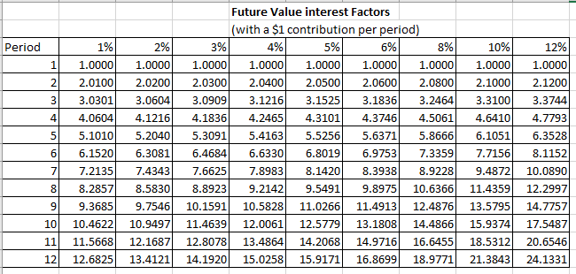  - For example, using the table, the future value of an annuity of $1200 per year for three years at 5% pa is 3.1525 × $1200 = $3783.  - Questions should include varying contribution periods. Sample questions:  - Angie pays $600 a quarter which pays 8% p.a. compounding quarterly. How much will she have at the end of 3 years?  - Kim needs $7500 for her overseas trip. If she is to make payments on a biannual basis into an account which pays 6% p.a. compounding biannually, how much will each payment be?  Resource: future-value-table-spreadsheet.XLSX  Present value tables  - Teacher to introduce students to the present value table and discuss its similarities with the future values table.  - Students calculate the single sum that would produce the same future value given by an annuity:  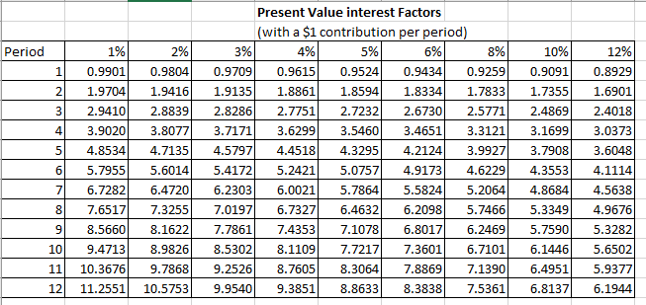  - For example, using the table, calculate the single sum needed to produce the same result as investing $4000 every year at a rate of 5% p.a. for three years is $4000 x 2.7232 = $10892  Resource: future-value-table-spreadsheet.XLSX  - Questions should include varying contribution periods. Sample questions:  - Dillon is saving for a car and deposits $500 into an account at the end of every month for three years. The account pays 12% p.a. interest. Find the single amount he could invest now to produce the same amount at the end of the three years.  - Katia borrows $25000 and pays it back in regular instalments at the end of every half year for 5 years. If the interest rate is 8% p.a., compounded half-yearly, find: the amount of each instalment and the amount that she repays altogether.  - Note: Solutions to all NESA exemplar questions from the topic guidance have been provided in this resource  Resource: ms-f5-nesa-exemplar-question-solutions.DOCX

Reflection and evaluation
Please include feedback about the engagement of the students and the difficulty of the content included in this section. You may also refer to the sequencing of the lessons and the placement of the topic within the scope and sequence. All information and communication technologies (ICT), literacy, numeracy and group activities should be recorded in the ‘Comments, feedback, additional resources used’ section.

