Sample question solutions

F4 Investments
Solutions for questions from the F2 Investments unit of work.
- Table of compounded values of $\$1$
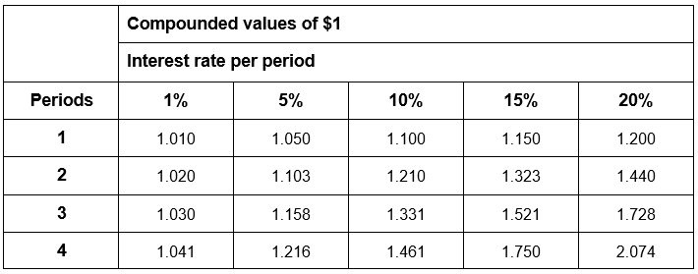

An amount of $\$3000$ is invested and compounded annually at $5\%$. Use the table of compounded values of $\$1$ above to find the value of the investment after three years.

Solution: Value of investment after three years $=\$3000×1.158=\$3474$

- A principal of $\$1000$ is to be invested for three years. Determine which of the following is the best investment option:
- $6\%$ p.a. simple interest,
- $5.9\%$ p.a. compounded annually, or
- $5.85\%$ p.a. compounded half-yearly.

Solution: Calculate the future value of each investment:
Option 1: $6\%$ p.a. simple interest. $P=1000, r=0.06, n=3$
$$I=P×r×n=1000×0.06×3=180$$
$$FV=1000+180=\$1180$$
Option 2: $5.9\%$ p.a. compounded annually. $PV=1000, r=0.059, n=3$
$$FV=PV{\left(1+r\right)}^{n}=1000{\left(1+0.059\right)}^{3}=\$1187.648…$$

Option 3: $5.85\%$ p.a. compounded half-yearly. $PV=1000, r=0.02925, n=6$
$$FV=PV{\left(1+r\right)}^{n}=1000{\left(1+0.02925\right)}^{6}=\$1188.845…$$
$∴$ The best investment is $5.85\%$ p.a. compounded half-yearly.

- Grandparents wish to save $\$10 000$ for their grandchild’s university expenses, and to have this amount available in eight years’ time. Calculate the single sum they need to invest at $5\%$ pa compounded annually.

Solution: When $FV=\$10 000$, $n=8$ and $r=0.05$
$$PV= \frac{FV}{{(1+r)}^{n}}$$
$$PV= \frac{10000}{{(1+0.05)}^{8}}$$
$$PV=6768.39362$$
$$PV=\$6768.39$$

$∴$ The grandparents would have to invest a single lump sum of $\$6768.39$ in order to save $\$10 000$ for their grandchild’s university expenses.

- Determine the single sum to be deposited if $\$10 000$ is required in five years’ time and a rate of $3\%$ pa, compounded quarterly, is available.

Solution:
When $FV=\$10000$, $n=20$ (5 yrs $×4$ quarters $=20$) and $r=0.0075$ ($3\%$ pa $÷4$ quarters $=0.0075$)

$$PV= \frac{FV}{{(1+r)}^{n}}$$
$$PV= \frac{10000}{{(1+0.0075)}^{20}}$$
$$PV=8611.898523$$
$$PV=\$8611.90$$

$∴\$8611.90$ would need to be invested in order for it to grow to a future value of $\$10000$.

- A principal of$\$1000$ is invested for three years at an interest rate of$5.6\%$ pa compounded half-yearly. Determine how much needs to be invested to achieve the same interest if the interest rate was$3.5\%$ pa compounded monthly.

Solution:
When $PV=\$1000$, $n=6$ (3 years $×2=6$) and $r=0.028$ ($5.6\%$ pa $÷2=0.028$)

$$FV= PV{(1+r)}^{n}$$
$$PV= 1000{(1+0.028)}^{6}$$
$$PV=1180.208364$$
$$PV=\$1180.21$$

When $FV=1180.208364$, $n=36$ (3 years $×12$months $=36$) and $r=\frac{0.035}{12}$ ($3.5\%$ pa $÷12$ months)

$$PV= \frac{FV}{{(1+r)}^{n}}$$
$$PV= \frac{1180.208364}{{(1+\frac{0.035}{12})}^{36}}$$
$$PV=1062.732935$$
$$PV=\$1062.73$$

$∴\$1062.73$ would need to be invested in order to achieve the same result.

- A loaf of bread currently costs $\$2.50$. Calculate its cost in 4 years if the inflation rate is $2.7\%$ p.a.

Solution:
$$Inflated value=2.50{\left(1+0.027\right)}^{4}=2.781…=\$2.78 (to the nearest cent)$$

- The current price of a bag of rice is $\$20$. Calculate its price 10 years ago if the average inflation rate over this time was $3.1\%$.

Solution: $$PV= \frac{FV}{{(1+r)}^{n}}=\frac{20}{{\left(1+0.031\right)}^{10}}=14.738…=\$14.74 (to the nearest cent)$$

- A family currently pays $\$320$ for some groceries. Assuming a constant annual inflation rate of $2.9\%$, calculate how much would be paid for the same groceries in 5 years’ time.

Solution:
$$Inflated value=320{\left(1+0.029\right)}^{5}=369.170…=\$369.17 (to the nearest cent)$$

- It is predicted that a particular painting will be appreciated at a rate of $5\%$ per annum. Calculate its predicted value in 2020 if it was purchased in 2010 for $\$48 000$.
Solution: When $PV=\$48000$, $n=10$ and $r=0.05$
$$FV= PV{(1+r)}^{n}$$
$$FV= 48000{(1+0.05)}^{10}$$
$$FV= 78186.94209$$
$$FV=\$78 186.94$$

$∴$ The predicted value in $2020$ is $\$78 186.94$.

