Year 12 Mathematics Standard 2
MS-F4 Investments and loans | Unit duration
Financial Mathematics involves the application of knowledge, skills and understanding of numbers to earning, spending, investing, saving and borrowing money. Knowledge of financial mathematics enables students to analyse different financial situations, to calculate the best options for given circumstances, and to solve financial problems. Study of financial mathematics is important in developing students’ ability to make informed financial decisions, to be aware of the consequences of such decisions, and to manage personal financial resources effectively. | 4 weeks

Subtopic focus | Outcomes
The principal focus of this subtopic is to calculate and compare the value of different types of investments, including shares, over a period of time and to gain an understanding of reducing balance loans and that an asset may depreciate in value over time rather than appreciate. Students develop awareness of mechanisms to optimise their financial position, both now and into the future, justifying their thinking and reasoning mathematically. Within this subtopic, schools have the opportunity to identify areas of Stage 5 content which may need to be reviewed to meet the needs of students. | A student:  - makes informed decisions about financial situations, including annuities and loan repayments MS2-12-5  - chooses and uses appropriate technology effectively in a range of contexts, and applies critical thinking to recognise appropriate times and methods for such use MS2-12-9  - uses mathematical argument and reasoning to evaluate conclusions, communicating a position clearly to others and justifying a response MS2-12-10  Related Life Skills outcomes: MALS6-5, MALS6-6, MALS6-13, MALS6-14

Prerequisite knowledge | Assessment strategies
This unit links to the Stage 5 unit MA5.2-4NA Financial mathematics and the Stage 6 topic MS-F1 Money matters. | - Is buying your own home a dream or reality? Is an investigative style assessment task in which students research and explore the financial implications of purchasing a home.
All outcomes referred to in this unit come from Mathematics Standard Stage 6 Syllabus
© NSW Education Standards Authority (NESA) for and on behalf of the Crown in right of the State of New South Wales, 2017

Glossary of terms
Term | Description
Appreciated Value | Appreciation is an increase in the value of an asset over time. An appreciated value is the value an asset has increased to over that time.
Compound Interest | The interest earned by investing a sum of money (the principal) is compound interest if each successive interest payment is added to the principal for the purpose of calculating the next interest payment.  For example, if the principal $P earns compound interest at the rate of r per period, then after n periods the principal plus interest is $P(1+r)^{n}.
Depreciation | Depreciation is a decrease in the value of an asset over time.
Dividend | A dividend of a share is a sum of money paid by a company to its shareholders out of its profits.
Dividend Yield | A dividend yield is the dividend expressed as a percentage of the current share price.
Exponential Modelling | Creating an exponential model involves fitting an exponential graph and/or function to a practical situation or set of data.
Future Value | The future value of an investment or annuity is the total value of the investment at the end of the term of the investment, including all contributions and interest earned.
Inflation | a general increase in prices and fall in the purchasing value of money.
Present Value | The present value of an investment is the single sum of money (or principal) that could be initially invested to produce a future value over a given period of time.
Reducing Balance Loans | A reducing balance loan is a compound interest loan where the loan is repaid by making regular payments and the interest paid is calculated on the amount still owing (the reducing balance of the loan) after each payment is made.
Salvage Value | Salvage value is the estimated resale value of an asset at the end of its useful life.
Shares | A share is one of the equal parts into which a company's capital is divided, entitling the shareholder to a portion of the company’s profits.
Simple Interest | Simple interest is the interest accumulated when the interest payment in each period is a fixed fraction of the principal.

Lesson sequence | Content | Suggested teaching strategies and resources | Date and initial | Comments, feedback, additional resources used
Comparing simple and compound interest  (2 lessons) | F4.1 Investments  - compare the growth of simple interest and compound interest investments numerically and graphically, linking graphs to linear and exponential modelling using technology  - investigate the effect of varying the interest rate, the term or the compounding period on the future value of an investment, using technology  - compare and contrast different investment strategies, performing appropriate calculations when needed | Comparing simple and compound interest  - The teacher defines the following terminology in the context of an investment: interest rate, term, future value, present value, simple interest, compound interest and compounding period.  - Students investigate the future value or growth of an investment using technology:  - Students compare the growth of investments under simple and compound interest keeping all variables constant.  Students note the shape of the two curves (linear and exponential) and relate the shape of the curve to the position of $n$ in the formulae.  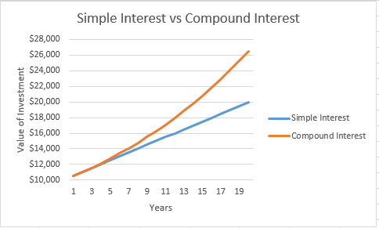  Students discuss which method they would prefer interest to be calculated using if they were borrowing or investing money.  - Students examine the effect of varying the interest rate on the investment’s future value.  - Students examine the effect of varying the term on the investment’s future value.  - Students examine the effect of varying the compounding period on the investment’s future value.  Resources: compound-versus-simple-interest-template.XLSX, compound-versus-simple-interest-completed.XLSX  - The teacher reinforces the students’ findings using an appropriate visual representation such as the interactive Desmos interest graph or the money smart compound interest calculator.
Calculating information using the future value formulae  (2 lessons) | F4.1 Investments  - calculate the future value $(FV)$ or present value $(PV)$ and the interest rate $\left(r\right)$of a compound interest investment using the formula  $FV=PV(1+r)^{n}$  - compare and contrast different investment strategies, performing appropriate calculations when needed | Developing the compound interest formula  - The teacher develops the future value formula  $FV=PV(1+r)^{n}$ by noting in the financial sector, the compound interest formula, $A=P{\left(1+r\right)}^{n}$, is known as the future value formula.  - Future value, $FV$, is used in place of $A$  - Present value, $PV$, is used in place of $P$.  - Class activity: Develop a table of compounded values for $1. Collaboratively determine and model how to use the table to calculate the:  - future value of an investment  - present value of an investment  Resource: compounded-values-table.XLSX  Evaluating the future value of an investment  - The teacher models calculating the future value of an investment by substituting into the future value formula. Calculations should include:  - a range of compounding periods  - a range of interest rates including non-integer percentages  - interest rates expressed other than as ‘per annum’.  NESA exemplar question  - An amount of $3000 is invested and compounded annually at 5%. Use the table of compounded values of $1 to find the value of the investment after three years.  Resource: ms-f4-exemplar-question-solutions.DOCX  Note: This resource contains solutions to NESA exemplar questions referred to throughout the unit.  - Other sample question: A principal of $1000 is to be invested for three years. Determine which of the following is the best investment option:  - 6% p.a. simple interest,  - 5.9% p.a. compounded annually, or  - 5.85% p.a. compounded half-yearly.  Evaluating the present value of an investment  - The teacher initiates conversation by posing the question: You want to have $5000 in 2 years’ time to buy a car. How much do you need to invest today?  - The teacher to lead the students to identify that the single amount that needs to be invested today when the future value is known can be calculated using the formula: $PV=\frac{FV}{{\left(1+r\right)}^{n}}$  - The teacher models calculating the present value of an investment by substituting into the future value formula.  NESA exemplar questions  - Grandparents wish to save $10 000 for their grandchild’s university expenses, which will be available in eight years’ time. Calculate the single sum they need to invest at 5% pa compounded annually.  - Determine the single sum to be deposited if  $10 000 is required in five years’ time and a rate of 3% pa, compounded quarterly.  - A principal of $1000 is invested for three years at an interest rate of 5.6% pa compounded half-yearly. Determine how much needs to be invested now to achieve the same interest if the interest rate was 3.5% pa compounded monthly.  Evaluating the interest rate of an investment  - The teacher models calculating the interest rate of an investment by substituting into the present value formula and solving the resulting equation.  - Ensure students convert the resulting decimal answer into a percentage.
Understanding inflation  (1 lesson) | F4.1 Investments  - solve practical problems involving compounding, for example determine the impact of inflation on prices and wages AAM | Introducing inflation  - The teacher can introduce the concept of inflation to students by showing the explaining inflation video  - The teacher leads a discussion to:  - formalise the meaning and impact of inflation. i.e. the rate at which the general level of prices for goods and services is increasing  - identify examples of the impact of inflation including its effect on prices, wages and the value of money.  Solving problems involving inflation  - The teacher models how to evaluate the future price of an item by applying the future value formula.  - The teacher models how to calculate the average annual rate of inflation by applying the future value formula.  - Students examine the price of canteen items in 1978 and compare them to current prices.  - Students calculate the rate of inflation on each item  - Students determine if all items have inflated at the same rate.  - Students use the RBA’s inflation calculator to compare the price of goods in their year of birth to the present day.  Sample questions  - A loaf of bread currently costs $2.50. Calculate its cost in 5 years if the inflation rate is 2.7% p.a.  - The current price of a bag of rice is $20. Calculate its price 10 years ago if the average inflation rate over this time was 3.1%.
Understanding investing in shares  (2 lessons) | F4.1 Investments  - work with shares and calculate the appreciated value of items, for example antiques AAM  - record and graph the price of a share over time  - calculate the dividend paid on a portfolio of shares, and the dividend yield (excluding franked dividends) | Introducing shares and dividends  - The teacher can introduce the concept of a share by showing the first minute of the what is a share video.  Graphing share prices  - Students record and graph the price of range of shares over time.  - Students compare and contrast trends identified in the share price graphs of companies that operate in the same industry as well as companies that operate on different industries.  - Students can compare their graphs to those from the ASX. Search for the company to view.  Resource: Accessing-share-price-data.DOCX  - Students play the stock market game where they have to make high level decisions about how to invest their money over a 6 day period.  Evaluating dividends  - The teacher can introduce the concept of a dividend by showing the first two minutes of the what is a dividend video.  - The teacher defines a dividend, usually expressed as cents per share and a dividend yield.  - The teacher models calculations involving dividends:  - Dividends paid on a portfolio of shares. For each individual company:  $$dividends paid=number of shares × dividend per share$$  - $dividend yield =\frac{dividend per share}{market price}×100$  The dividend and price will need to be in the same units.  - The teacher explains in a commercial situation, dividend yields are normally calculated on an annual basis and may include multiple dividends. For example, if dividends are paid twice per year, the then dividend per share is the sum of the previous two dividends.  - Students calculate the dividend paid and dividend yield on a share portfolio.  Resource: activity-dividend-calculations.DOCX  NESA exemplar question  - An investor has 2000 shares. The current share price is $1.50 per share. The investor is paid a dividend of $0.30 per share.  - What is the current value of the shares?  - Calculate the dividend yield.
Understanding appreciation  (1 lesson) | F4.1 Investments  - work with shares and calculate the appreciated value of items, for example antiques AAM | Examining appreciation  - The teacher introduces the concept of appreciation by posing a question, how much will a car purchased for $30 000 today be worth in 5 years?  - The teacher leads a discussion to identify that over time an asset may decrease in value (depreciate) or increase in value (appreciate)  - The teacher identifies why items may depreciate - including the wear and tear of items on items like cars; or the emergence of newer technologies making older items more redundant.  - The teacher identifies why items may appreciate - including when the supply of an item is reduced there is increased demand for the item, like artwork. i.e. when an item is rare or becomes collectable.  NESA exemplar question  - It is predicted that a particular painting will appreciate at a rate of 5% per annum. Calculate its predicted value in 2020 if it was purchased in 2010 for $48 000.
Determining depreciation  (2 lessons) | F4.2 Depreciation and loans  - calculate the depreciation of an asset using the declining-balance method using the formula $S={V_{0}\left(1-r\right)}^{n}$, where $S$ is the salvage value of the asset after $n$ periods, $V_{0}$ is the initial value of the asset, $r$ is the depreciation rate per period, expressed as a decimal, and $n$ is the number of periods, as an application of the compound interest formula AAM | Examining depreciation  - The teacher can introduce the concept of depreciation by showing the what is depreciation video  - The teacher leads a discussion on what items commonly depreciates and why.  - Using a basic example such as a car depreciates from $30000 to $20000, the teacher defines  - depreciation  - depreciated value  - amount of depreciation  Note: The concept of depreciation may have been discussed in the introduction to appreciation.  - The teacher describes then compares and contrasts the two methods of depreciation.  - straight line method (examined in MS-F1)  - declining balance method  - Students establish a spreadsheet to show how an item depreciates under each method.  - Students can graph the results and compare the shape of each graph.  - Students can discuss when one method may be better than the other. Consider as asset you own and want to sell compared to claiming depreciation as a tax offset.  Resource: comparing-methods-of-depreciation.XLSX  - There are opportunities to explore the tax implications of the depreciation of business assets.  Applying the declining-balance method  - The teacher develops the formula for declining balance depreciation by considering repeated multiplication by $(1-r)$: $FV=PV(1-r)^{n}$  - Students compare this to the compound interest formula.  - Student activity: Students read the Canstar article top 10 cars that depreciate slowly to find cars that depreciate more slowly than others. Discuss possible reasons for this.  - Students use redbook to find the purchase price and current estimated value of a vehicle and:  - use this information to determine the rate of depreciation and examine the accuracy of the claims made in the Canstar article.  - compare the amount of depreciation of motor vehicles for different ages of the vehicles. Note: The depreciation in the first year of a new car can exceed 35% and often levels out to between 7% and 10% per annum after the first three years.  Sample questions  - James bought a boat for $50 000 which depreciates at a rate of 15% p.a. How much will it be worth after 4 years?  - Geoff bought a tractor for $130 000 which depreciates at 20% p.a. By how much has the tractor depreciated after 8 years?  - Rita purchased a Holden Barina for $14 900. If it depreciates at a rate of 25% p.a., when will the car be worth half of its purchase price?
Calculating loan amounts and repayments  (2 lessons) | F4.2 Depreciation and loans  - solve practical problems involving reducing balance loans, for example determining the total loan amount and monthly repayments AAM | Introducing loans  - The teacher introduces the concept of a loan and could show the what is a loan video.  - The teacher defines terminology used with loans including the amount borrowed, monthly repayments, fees, interest, total repaid and reducing balance loan.  - The teacher discusses a mortgage and other loans such as:  - car loans: these are reducing balance personal loans with a fixed monthly repayment. It may be paid off sooner than the original term by increasing the monthly repayments, or by making additional payments.  Modelling loan scenarios  - Student activity: Students model a reducing balance loan table using a spreadsheet. The minimum repayments can be calculated using the money smart website. Students should:  - compare repayments on loans from a number of lending institutions  - consider both home loans and personal loans  - use a graph of the amount outstanding to determine when the loan will be half paid.  Resource: reducing-balance-loan.XLSX  - Students can use their spreadsheet to examine real life scenarios such as:  - what if you pay interest only?  - what if you pay double the minimum repayment?  - what if the there is an interest rate rise?  - what if more than the minimum monthly repayment is paid?  - what if there is an interest rate rise in the case where more than the minimum monthly repayment is already being paid?  - Note: There are also many online calculators where students can investigate the result of making extra payments, paying more often or paying more than the minimum amount.  - Sample question using NESA sample loan table: Nancy borrowed $50 000. If the interest rate is 10% p.a. and the monthly repayment is $600:  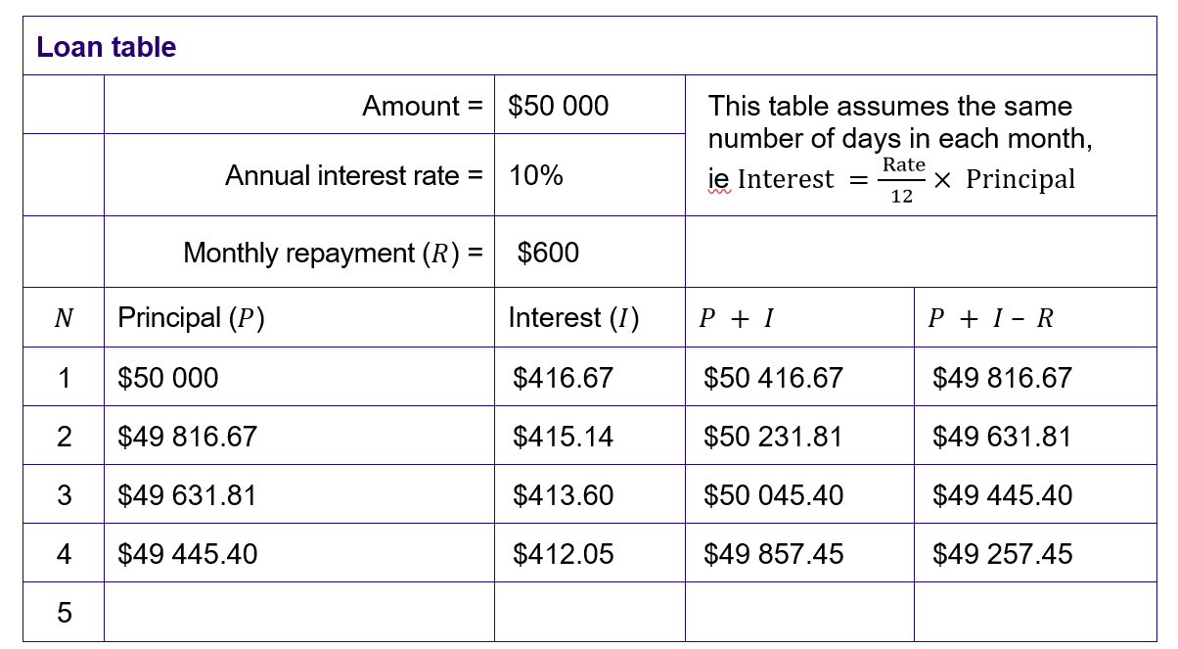  - Calculate the amount owing after 4 months?  - How much interest was paid over the first 4 months?  - Complete the next row and determine how much will be owed after 5 months?  - Student activity: Students to consider “How much do you need to earn to live in different parts of Australia?” using the following assumptions:  - 20% deposit  - the median house price for that area  - a 25 or 30 year loan period
Calculating credit card balances  (3 lessons) | F4.2 Depreciation and loans  - recognise credit cards as an example of a reducing balance loan and solve practical problems relating to credit cards AAM  - identify the various fees and charges associated with credit card usage  - compare credit card interest rates with interest rates for other loan types  - interpret credit card statements, recognising the implications of only making the minimum payment  - understand what is meant by an interest-free period  - calculate the compounding interest charged on a retail purchase, transaction or the outstanding balance for a given number of days, using technology or otherwise | Introducing credit cards  - The teacher introduces students to credit cards by students reading:  - the money smart credit card factsheet  - the money smart website  - The teachers leads a discussion to  - examine the pros and cons of using a credit card.  - identify the consequence of having an interest free card but not paying it off in the interest free period.  - identify the various fees and charges associated with credit card usage. This can include interest, monthly fees, annual fees, reward program fees, surcharge fees at point of purchase.  - Student activity: Students use the credit card simulator game to investigate how long it will take them to pay their purchases back.  - Student activity: Examine credit card use in Australia using credit card statistics. Students can  - Compare the purchase size on debit and credit cards  - examine and graph the number of credit cards, average debt, average debt costing interest, average amount of annual purchases per card.  Examining credit card statements  - Teachers should discuss how to calculate the number of days when interest is charged, paying particular attention to the inclusive dates.  - Students activity: Students look at the AIE sample credit card statement and consider:  - What is the due date for payment?  - What amount needs to be paid to ensure no interest is charged?  - Why is there an overdue fee?  - If only the minimum payment is made, how long will this particular bill (providing no further transactions occur) take to be paid off? Why?  - What is the phone number that should be used if repayments can’t be made?  - What is the credit limit of this card?  - What interest will be charged if this account is paid in full on 20 March that year?  Resources:  How to read a credit card statement (AIE)  How to read a credit card statement (ANZ)  How to read a credit card statement (CommBank)  Calculations involving credit cards  - The teacher defines the assumptions made when completing interest calculations involving credit cards:  - interest is calculated using compound interest.  - interest is calculated on the daily outstanding account balance for each transaction  - interest is applied at the end of the statement period and the daily interest rate is used for this calculation.  - the daily interest rate is the annual percentage rate divided by 365.  Note: Calculations should include both fees and interest free periods.  - Student activity: students create a credit card statement using a spreadsheet.  - Optional: Examine the effect of only making the minimum repayment.  Resource: credit-card-statement.XLSX  - Comparing credit cards and loans:  - Students compare and contrast the rates, fees and interest rate periods of 3 banks “low rate” credit cards using appropriate calculations.  - Students digitally create a graphical representation comparing the use of two credit cards with different interest rates for the same purchases. (NESA)  - Students choose a credit card and compare its rates and fees with a car loan and personal loan from the same bank. Students discuss the advantages and disadvantages of each.  Sample problem  - Shannon bought shoes for her wedding for $150 on 20 June using a credit card. Compound interest was charged at a rate of 19.49% p.a. for purchases on the credit card. No other purchases were made on this account. There was no interest-free period. What amount was paid when Shannon paid the account in full on 6 July?

Reflection and evaluation
Please include feedback about the engagement of the students and the difficulty of the content included in this section. You may also refer to the sequencing of the lessons and the placement of the topic within the scope and sequence. All information and communication technologies (ICT), literacy, numeracy and group activities should be recorded in the ‘Comments, feedback, additional resources used’ section.

