Accessing share price data
This document is a guide to help staff and students access downloadable historical share price data. Existing charts of historical share prices for companies can be accessed on the ASX.
Downloadable data can be obtained from Market Index using the following steps:
- Go to Yahoo finance.
- Enter the company name or company code into the search box.
Ensure you select a company with Equity- ASX
- Select historical data
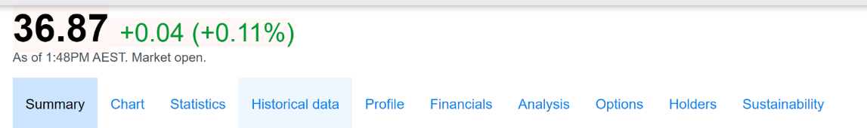
- Choose an appropriate time period then download the data.
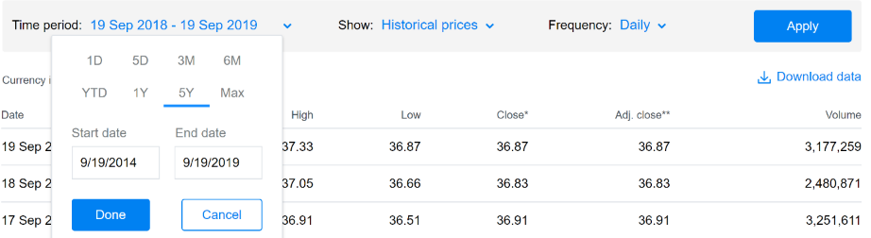
- Column A has the date and column E has the price at the end of the day
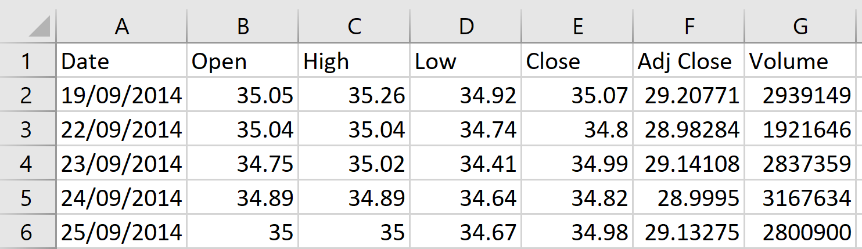
- Columns A and E can be graphed.

