Accessing share price data
This document is a guide to help staff and students access downloadable historical share price data. Existing charts of historical share prices for companies can be accessed on the ASX.
Downloadable data can be obtained from Market Index using the following steps:
- Go to the marketindex.com.au website
Note: copy and paste the address into a web browser.
- Enter the company name or company code into the search box.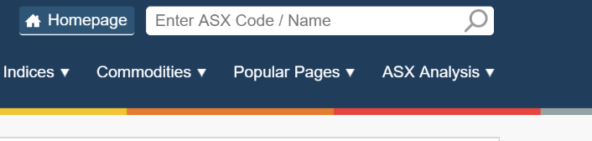
- Scroll to the bottom of the webpage and download the csv file
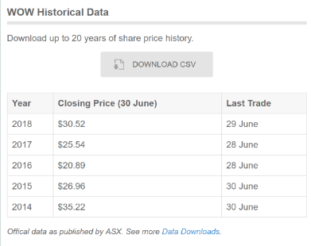
- A range of information is accessed through the download file. Column A has the date and column E has the price at the end of the day
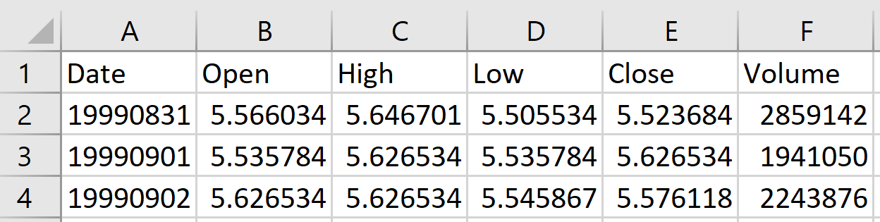
- The date needs to be adjusted so that the close price can be graphed against the date.
  - Right click the E then select insert to add a column to the left of Close.
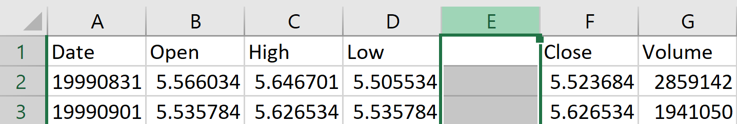
  - In E2, enter the date corresponding to A2 in the format dd/mm/yyyy i.e. 31/08/2019
  - Select E2 and fill down by double clicking the square in the bottom right corner of the cell.
- Column E and F can now be graphed using a scatterplot.

