GeoGebra help

Accessing GeoGebra
Visit the GeoGebra website
Creating an account is optional, but it will make it easier to save work.
Click Sign in
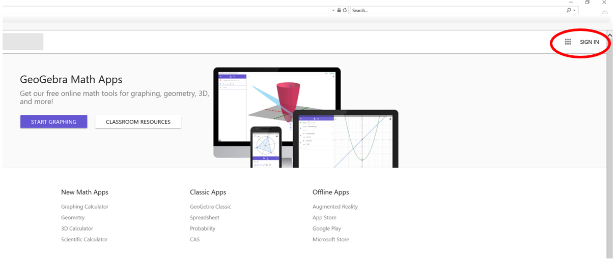
Choose Google and use your Department of Education Google account, which is: first.last@education.nsw.gov.au

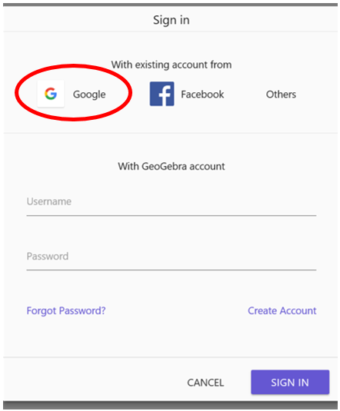

Click on the Start Graphing button.

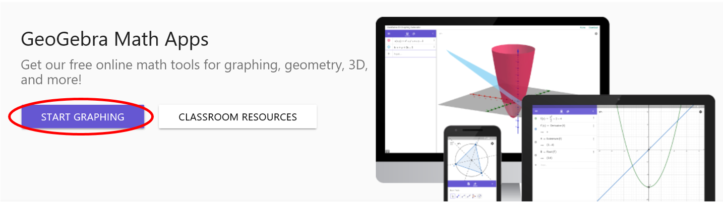

Graphing linear equations
Equations can be entered down the left hand side, as written.
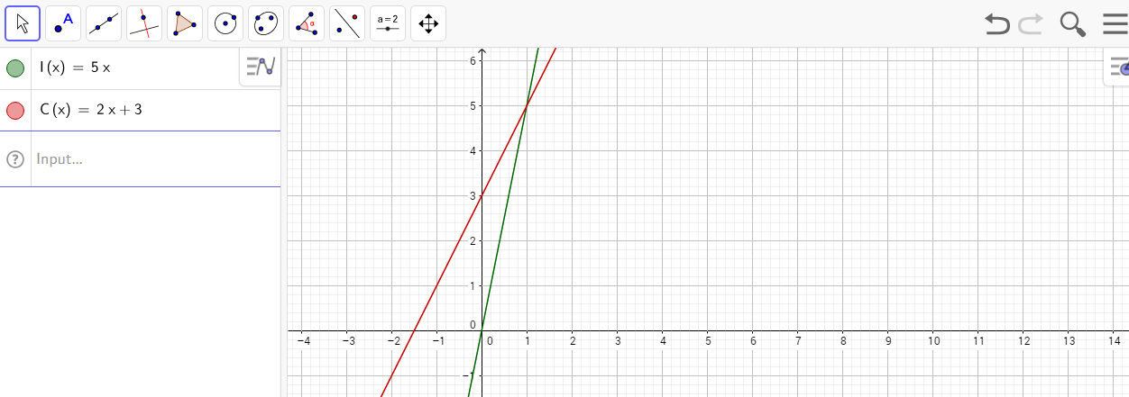
A point of intersection can be determined by choosing the Intersect command from the point menu.
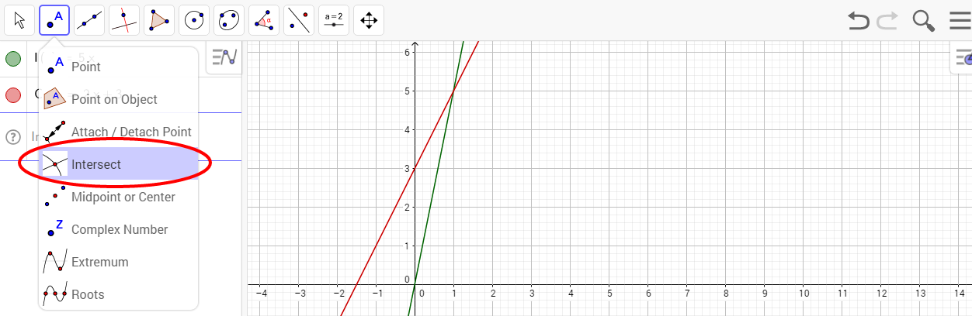
Then, either click both lines, or click the point of intersection.
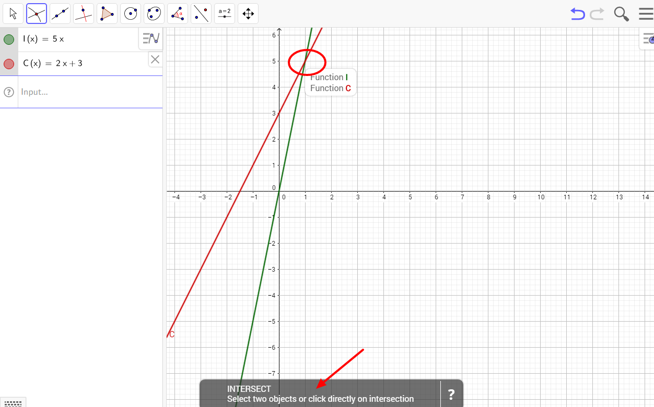

The point of intersection will be shown on the left.

Saving a graph
To save a graph, click the hamburger icon.
Give the graph a meaningful name, for example, the part of the assignment or task you are completing.
Saved graphs can be accessed by clicking the hamburger icon and selecting Open.

Sharing a graph
From the hamburger icon, choose Share.
First, you will be asked to Save the document.
Then, you will be presented with a link that can be copied and pasted for submission to your teacher.
