Year 12 Mathematics Standard 2
MS-A4 Types of relationships | Unit duration
Algebra involves the use of symbols to represent numbers or quantities and to express relationships. It is an essential tool in problem solving through the solution of equations, graphing of relationships and modelling with functions. Knowledge of algebra enables the modelling of a problem conceptually so that it is simpler to solve, before returning the solution to its more complex practical form. Study of algebra is important in developing students’ reasoning skills and logical thought processes, as well as their ability to represent and solve problems. | 4 weeks

Subtopic focus | Outcomes
The principal focus of this subtopic is the graphing and interpretation of relationships, and the use of simultaneous linear equations in solving practical problems. Students develop their ability to communicate concisely, use equations to describe and solve practical problems, and use algebraic or graphical representations of relationships to predict future outcomes. Within this subtopic, schools have the opportunity to identify areas of Stage 5 content which may need to be reviewed to meet the needs of students. | A student:  - uses detailed algebraic and graphical techniques to critically evaluate and construct arguments in a range of familiar and unfamiliar contexts MS2-12-1  - solves problems by representing the relationships between changing quantities in algebraic and graphical forms MS2-12-6  - chooses and uses appropriate technology effectively in a range of contexts, and applies critical thinking to recognise appropriate times and methods for such use MS2-12-9  - uses mathematical argument and reasoning to evaluate conclusions, communicating a position clearly to others and justifying a response MS2-12-10  Related Life Skills outcomes: MALS6-1, MALS6-7, MALS6-8, MALS6-13, MALS6-14

Prerequisite knowledge | Assessment strategies
Students need to be familiar with the skills and concepts from MS-A2 Linear relationships and Stage 5.1 Linear relationships and be able to plot points from a table of values; graph straight lines; and understand the terms slope, intercept and points of intersection. | How well can mathematics be used to model internet sensations? Is an investigation style task that develops non-linear graphing techniques, explores features of non-linear graphs and applies them to the number of hits for internet sensations.
All outcomes referred to in this unit come from Mathematics Standard Stage 6 Syllabus
© NSW Education Standards Authority (NESA) for and on behalf of the Crown in right of the State of New South Wales, 2017

Glossary of terms
Term | Description
Break-even point | The break-even point is the point at which income and cost of production are equal.
Exponential function | An exponential function is a function in which the independent variable occurs as an exponent (or power/index) with a positive base. For example, $y=2^{x}$is an exponential function where $x$ is the independent variable.
Inverse variation | Two variables are in inverse variation (or inverse proportion) if one is a constant multiple of the reciprocal of the other. Hence, as one variable increases, the other variable decreases.  For example, if y is inversely proportional to x, they are connected by the equation $y=\frac{k}{x}$, where k is a constant of variation (or proportion).
Parabola | A parabola is the graph of a quadratic function. The vertex of a parabola is its highest or lowest point (turning point). The parabola has an axis of symmetry through its vertex.  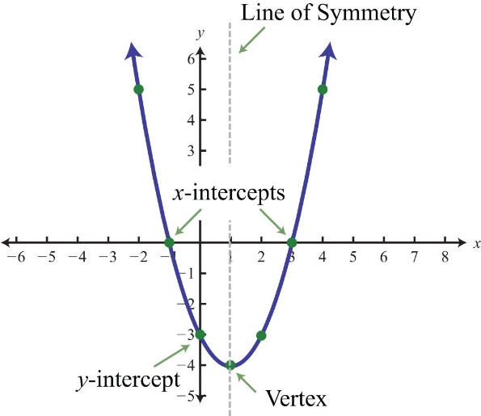
Quadratic function | A quadratic function is a function of the form $y=ax^{2}+bx+c$ where $a≠0$. For example: $y=3x^{2}+7$
Quadratic model | Creating a quadratic model involves fitting a quadratic graph and/or function to a set of data or creating a model to describe a practical situation.
Reciprocal function | A function where the independent variable, x, is the denominator in a fraction. Examples of reciprocal functions include those of the form: $y=\frac{k}{x}$  See also inverse variation.
Reciprocal model | Creating a reciprocal model involves fitting a reciprocal graph and/or a function to a practical situation or set of data.
Rectangular hyperbola | The graph of a reciprocal function is a type of rectangular hyperbola.  A rectangular hyperbola is a hyperbola for which the asymptotes are perpendicular
Simultaneous equations | Two or more equations that share variables.  For example: the following two equations both share the variables $x$ and $y$:  $x+y=6$ and $-3x+y=2$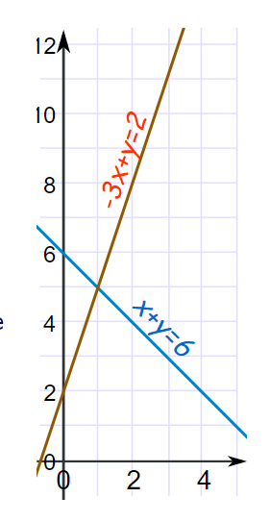  Solving these equations simultaneously involves finding where the two equations intersect. In this example the simultaneous solution is $\left(1,5\right).$

Lesson sequence | Content | Suggested teaching strategies and resources | Date and initial | Comments, feedback, additional resources used
Solve simultaneous equations graphically  (1 or 2 lessons) | A4.1 Simultaneous linear equations  - solve a pair of simultaneous linear equations graphically, by finding the point of intersection between two straight-line graphs, with or without technology | Reviewing graphs of linear equations  - Teachers should revise the features of a straight line and reinforce the skills needed to rearrange equations into the y-intercept form.  - Student activity: Once students feel comfortable being able to identify the y-intercept and gradient of a line given $y=mx+c$ they can investigate how changing these values affects the equation and graph of the line using technology such as Desmos or Geogebra.  - Student activity: Students could investigate the gradient and y-intercept of straight lines using the online resources below:  - Land the plane  - Graph a line from an equation  - Match my line  - Each of the above resources provide students with the opportunity to solve problems requiring knowledge of how to graph and manipulate linear functions.  Solving simultaneous equations graphically  - Teachers may like to run the 360 activity:  - Students are to be divided into 8 groups.  - Graphs are placed around the room. Each group of students spends 2 minutes at each graph and rotates around the room until they have been to all 8 graphs.  - Students are to discuss, then write one observation about the set of simultaneous equations in front of them. After 2 minutes, each group then moves to the next graph, read what has been previously written, discuss and write a different observation.  - After each group has visited each graph, the students are to read and summarise what has been written and report back to the class.  Resource: 360-activity.DOCX  - Students could apply what they know about linear equations to solve problems like negatively triangular
Solve practical problems involving simultaneous equations  (2 lessons) | - develop a pair of simultaneous linear equations to model a practical situation AAM  - solve practical problems that involve determining and interpreting the point of intersection of two straight-line graphs, including the break-even point of a simple business problem where cost and revenue are represented by linear equations AAM | Solving practical simultaneous equation problems  - Students should be able to solve ‘break-even problems’ graphically in questions which emphasise the break-even point, the profit zone and the loss zone, and interpretation of the $y$-intercept.  - In break-even analysis, students learn that the profit or loss can be calculated using the formula: $profit (loss) = income – costs$. They should be able to recognise and interpret the income equation and cost equation drawn on the same graph.  - The income function is a simple linear function of the form $I=mx$, where $x$ is the number of units sold and $m$ is the selling price per unit sold. The cost function is of the form $C=mx+c$, where$x$ is the number of units sold, $m$ is the cost price per unit manufactured, and $c$is the fixed costs of production. The point of intersection of $I$ and $C$ is the ‘break-even point’.  - Students should be able to recognise the limitations of linear models in practical contexts, for example a person’s height as a function of age may be approximated by a straight line for a limited number of years. Students should be aware that models may apply only over a particular domain.  - Desmos or Geogebra may be used to enter equations for straight lines and draw the graphs so that students can simply read off the point of intersection. The activities below provide a practical context for the solution of simultaneous equations.  - Student activity: Students are issued with Fidget Spinner scenario worksheet.  - Step 1: Creating the Income function. Students create a table of values relating number sold to income received.  - Step 2: Creating the Cost function. Students create a table of values relating number sold to the fixed cost and variable cost depending on number sold.  - By considering the resulting simultaneous linear equations, the break-even point is examined.  - The slope and equation of each line can be calculated and related to the scenario.  - Different situations can be modelled by changing fixed cost and/or selling cost students can.  Resources: fidget-spinners.DOCX, fidget-spinners-worked-solutions.DOCX, exit-slips-fidget-spinner.DOCX  - Students watch the stacking cups video and then guess how many cups are required for the stacks to be equal.  - The teacher should discuss with students what information is required to be able to solve the problem. For example, the height of the cups and the width of the lips. The pictures underneath the video in Act 2 show the height of each type of cup and the width of the lip.  - Students should develop an equation for the height of each type of cup based on the number of cups.  - Students then graph each equation to determine the answer. The video in Act 3, shows the correct answer of 7.  - Teacher and students could then brainstorm other questions that could be asked about the cups. For example, how many of each cup is required to reach a certain height? A number of different questions are given at the bottom of the video.  - Teachers can find further problems for students to solve at the math page
Exploring exponential graphs and their features (3 lessons) | A4.2 Non-linear relationships  - use an exponential model to solve problems AAM  - graph and recognise an exponential function in the form $y=a^{x}$ and $y=a^{-x}(a>0)$ with or without technology | Introduction to exponential graphs  - Students are introduced to exponential graphs and the change in gradient from the start of the graph to the end.  - Teacher poses the question to students – ‘Can folding a piece of paper 45 times get you to the moon?’ Ask for their opinions.  - Create a table of values and start with 0 folds giving 1 thickness, 1 fold giving a thickness of 2, and so forth.  - Have students draw the graph either by hand or by using a graphing program such as Desmos or Geogebra to see how quickly the thicknesses increase.  - Have students predict how thick the paper would be after 45 folds.  - Assuming the paper is 0.001mm thick initially, how thick will it be after 45 folds? How close is this to the moon?  - Is this model practical in real life? How many times can students fold a piece of paper? Have students fold a piece of A4 Reflex paper. Can they fold this more or less times than a sheet of tissue paper of the same size?  - Students could then watch the Ted Ed lesson on How folding paper can get you to the moon  - Teacher to tell students the story of The rice and chessboard story  - Students could then discuss how much rice they think the inventor would have once the king had finished completing the chessboard.  - Have students draw up a table of values showing the number of grains of rice on each square and a further column showing the total number of grains.  - Discuss how quickly the numbers grow.  - The students could then count how many grains of rice it takes to fill a small container in order to determine how much room would be required to store the inventor’s rice.  Exploring the features of exponential graphs  - Students should explore the effect of changing the value of $a$ on the graph of the function $y=a^{x}$, including negative values of $a$  - Graphing software can be used to vary coefficients and constants of the various functions addressed in this topic to observe changes to the graphs of the functions.  - The concept of an asymptote should be explored. For example,  - $y=5$ is the asymptote of $y=2^{x}+5$  - Students could complete the suite of Desmos activities looking at the features of exponential graphs found at teacher Desmos  - Students could complete the worksheet on exponential functions that summarises all of the concepts above. Resources: exponential-functions.DOCX, exponential-functions-worked-solutions.DOCX
Interpreting intercepts of exponential graphs (1 lesson) | - use an exponential model to solve problems AAM  - interpret the meaning of the intercepts of an exponential graph in a variety of contexts | Interpreting intercepts of exponential graphs  - Teacher to revise examples of exponential models studied elsewhere in this course.  - Future value of a compound interest investment (MS-F4 F4.1).  - Teacher to show how$FV=PV(1+r)^{n}$, can be simplified to the form $y=a^{x}$. For example, for an investment of $1000 invested at 5% p.a. compounded annually.  $$FV=1000(1+0.05)^{n}$$  $$FV=1000(1.05)^{n}$$  - If you are borrowing between $2000 to $20,000 to purchase your first car. Use Desmos (Modelling compound interest Desmos graph) or Geogebra to model the compound interest for rates of 1% p.a.to 10% p.a. Modelling Compound Interest in Desmos (how to video)  - What can you say about the y-intercept of this exponential graph?  - Depreciation of an asset using the declining-balance method (MS-F4 F4.2).  - Teacher to show how$S=V_{0}(1-r)^{n}$, can be simplified to the form $y=a^{x}$. For example, for a car purchased for $15 000, model the depreciation.  - Use Desmos, or other digital technology, to graph and investigate.  - What can you say about the y-intercept of this exponential graph?
Analysing real life exponential models (3 lessons) | - use an exponential model to solve problems AAM  - construct and analyse an exponential model of the form $y=ka^{x}$ or $y=ka^{-x}$ $\left(a>0\right)$ where $k$ is a constant, to solve a practical growth or decay problem | Analysing real life exponential models  - In modelling physical phenomena, functions and graphs should involve only positive values of the independent variable and zero.  - Student activity: Students use data about the spread of cane toads to create an exponential model of population growth (as measured by area of land occupied).  Resources:  - travelling-cane-toads.DOCX  - Travelling cane toads help  - Travelling cane toads Desmos graph created from this activity  - Students to complete the activity predicting movie ticket prices. Students build a model to describe the relationship between average US movie ticket prices and time. Students then use that model to make predictions about past and future ticket prices. Students also interpret the parameters of their equation in context.  - Students complete the activity game, set, flat Students develop their understanding of the exponential relationship that describes a bouncing tennis ball. They learn to examine successive terms in a sequence to determine if it represents an exponential relationship or not. They also learn how to construct the exponential equation itself.  NESA exemplar questions  - An exponential expression such as $M=1.5{(1.2)}^{x}$ can be used to calculate the mass $M$ kg of a baby orangutan at age $x$ months. This model applies for a limited time, up to $x=6$. Calculate the mass of a baby orangutan at the age of three months.  - In 2010, the city of Thagoras modelled the predicted population of the city using the equation $P=A{(1.04)}^{n}$. That year, the city introduced a policy to slow its population growth. The new predicted population was modelled using the equations $P=A{(b)}^{n}.$ In both equations, $P$ is the predicted population and $n$ is the number of years after 2010. The graph shows the two predicted populations.  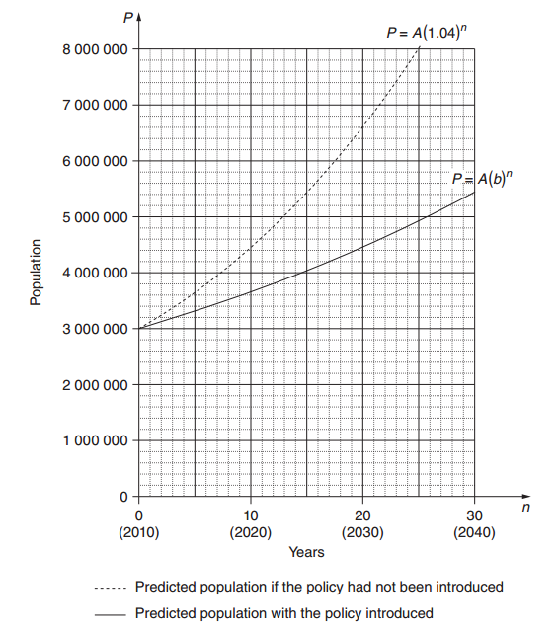  - Use the graph to find the predicted population of Thagoras in 2030 if the population policy had NOT been introduced.  - In each of the two equations given, the value of $A$ is $3 000 000$. What does $A$ represent?  - The guess-and-check method is to be used to find the value of $b$, in $P=A{(b)}^{n}.$ Explain, with or without calculations, why $1.05$ is not a suitable first estimate for $b$. With $n=20$ and $P=4 460 000$, use the guess-and-check method and the equation $P=A{(b)}^{n}$ to estimate the value of $b$ to two decimal places. Show at least TWO estimate values for $b$, including calculations and conclusions.  - The city of Thagoras was aiming to have a population under $7 000 000$ in 2050. Does the model indicate that the city will achieve this aim? Justify your answer with suitable calculations.  Resource: ms-a4-nesa-exemplar-question-solutions.DOCX
Exploring parabolas and their features  (2 lessons) | - construct and analyse a quadratic model to solve practical problems involving quadratic functions or expressions of the form $y=ax^{2}+bx+c$, for example braking distance against speed AAM  - recognise the shape of a parabola and that it always has a turning point and an axis of symmetry  - graph a quadratic function with or without technology | Introducing parabolas  - Student activity: Will it hit the hoop?  - Students complete the ‘Will it hit the hoop?’ activity as an introduction to parabolas. It starts by asking students to fit a straight line through some points that indicate the position of a basketball moments after being thrown.  - It then demonstrates the limitations of this model as it assumes the ball will keep rising.  - Students are introduced to parabolas and are asked to drag points to make the parabola model the path of the basketball.  - Students use these parabolas to predict whether or not the ball will pass through the hoop.  Investigating graphs of quadratic functions  - Graphing software should be used to investigate various quadratic functions and their maximum and minimum values.  - Student activity: Explore the definition of the quadratic function and use the definition and graphs to decide which graphs are parabolas and how the constants a, b and c affect the shape of the graph.  Resources: quadratic-functions.DOCX, quadratic-functions-worked-solution.DOCX  - Student activity: Desmos Quadratic resources. A number of different online activities that introduce the features and terminology of parabolas.  NESA exemplar question  - Sketch at least 10 rectangles that have the same perimeter. Record length versus area in a table. Sketch the resulting function and use the graph to determine the rectangle with maximum area. Describe this rectangle.  Resource: ms-a4-nesa-exemplar-question-solutions.DOCX
Analysing real life quadratic functions  (2 lessons) | - construct and analyse a quadratic model to solve practical problems involving quadratic functions or expressions of the form $y=ax^{2}+bx+c$, for example braking distance against speed AAM  - interpret the turning point and intercepts of a parabola in a practical context  - consider the range of values for $x$ and $y$ for which the quadratic model makes sense in a practical context | Analysing quadratic models  - In modelling physical phenomena, functions and graphs should involve only positive values of the independent variable and zero.  - Student activity: A farmer has a length of fencing in which to enclose the maximum area possible for his sheep.  - Students create a table of values showing the side lengths and the area enclosed.  - Students to plot the table of values either by hand or using technology, and discuss the features of the graph and their meaning in this context i.e. maximum area, largest possible side length  - Students consider the fuel economy versus speed Desmos graph  - The data is approximately modelled by a quadratic function.  - This graph shows that speeds around 60 to 80 km/h, achieve the optimal fuel economy (lowest value of litres per 100 km).  - What does the turning point of this graph represent?  - What does the y-intercept represent? Does the value make sense?  - Do values of $x<0$ make sense in this context?  - Data from Transportation Energy Data Book Edition 35  NESA exemplar questions  - On the Earth, the equation $d=4.9t^{2}$ can be used to express the distance ($d$ metres) that an object falls in $t$ seconds, if air resistance is ignored. Investigate the equations for the moon and for other planets: for example, on the moon the equation is $d=0.8t^{2}$. Create a table of values for the function $d=4.9t^{2}$ either manually or by using a spreadsheet, and use the table to answer questions such as: How long does it take for an object to fall 300 m?  - Anjali is investigating stopping distances for a car travelling at different speeds. To model this she uses the equation $d=0.01s^{2}+0.7s$, where $d$ is the stopping distance in metres and $s$ is the car’s speed in km/h. The graph of this equation is drawn below.  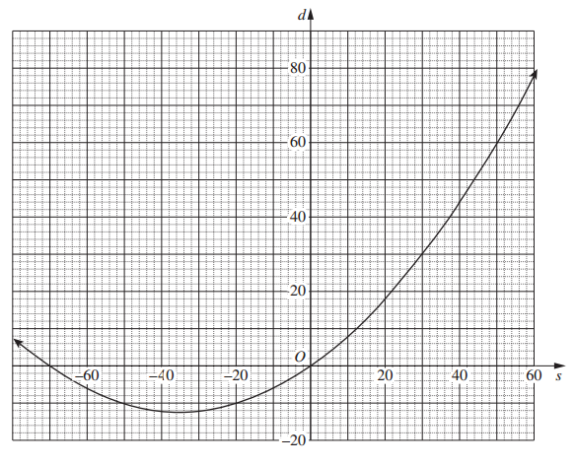  - Anjali knows that only part of the curve applies to her model for stopping distance. In your writing booklet, using a set of axes sketch the part of this curve that applies for stopping distances.  - What is the difference between the stopping distances in a school zone when travelling at a speed of $40$ km/h and when travelling at a speed of $70$ km/h?  Resource: ms-a4-nesa-exemplar-question-solutions.DOCX
Exploring inverse variation and hyperbolas  (1 lesson) | - recognise that reciprocal functions of the form $y=\frac{k}{x}$ , where $k$ is a constant, represent inverse variation, identify the rectangular hyperbolic shape of these graphs and their important features AAM | Exploring hyperbolas and inverse variation  - Graphing software can be used to vary coefficients and constants to observe changes to the graphs of the functions.  - Students should explore the effect of changing the values of$k$ on the graph of the function $y=\frac{k}{x}$  - The concept of an asymptote should be explored with reference to hyperbolas. For example, both $x=0$ and $y=0$ are asymptotes of $y=\frac{4}{x}$  - Students use graphing software to graph examples of reciprocal functions:  - They then explore the definition of the reciprocal function and use the definition and graphs to decide which graphs are hyperbolas and how the constant k affects the shape of the graph.  Resources: reciprocal-functions.DOCX, reciprocal-functions-worked-solution.DOCX
Solving real life inverse variation problems (1 lesson) | - recognise that reciprocal functions of the form $y=\frac{k}{x}$ , where $k$ is a constant, represent inverse variation, identify the rectangular hyperbolic shape of these graphs and their important features AAM  - use a reciprocal model to solve practical inverse variation problems algebraically and graphically, eg the amount of pizza received when sharing a pizza between increasing numbers of people | Solving real life inverse variation problems  - In modelling physical phenomena, functions and graphs should involve only positive values of the independent variable and zero.  - Variation problems should be presented in a number of formats, including in written, tabular and graphical form.  - Teacher to work through the following example with students.  - A section of highway takes 2 hours 20 minutes to drive for a fully licenced driver at 110km/h. Time taken to cover a distance is inversely proportional to the speed. That is$t=\frac{d}{s}$.  - Using the reciprocal function$t=\frac{d}{s}$, determine the distance $(d)$covered on the highway.  $$2h 20 min=\frac{d}{100}$$  $$d=257km$$  The reciprocal model is $t=\frac{257}{s}$  - Determine the time taken for a P1 driver to travel this highway at a speed of 90km/h.  $$t=\frac{257}{90}=2.8\dot{5}=2h 51min$$  - Determine the time taken for a P2 driver to travel this highway at a speed of 100km/h.  $$t=\frac{257}{100}=2.57=2h 34 min$$  - Create a graph using Desmos, or other digital technology, to represent this model.  - Suppose you were to travel this highway by bicycle with an average speed of 25km/h. Use your graph to determine the time taken.  - From the graph, approximately what would be the average speed if the time taken to travel was 5 hours?  - Student activity: Oil Spill - As soon as a quantity of oil is spilled, it starts to spread. If not contained, the resulting slick can cover a very large area. As the oil continues to spread, the depth of the slick decreases. In the following exploration, you investigate the relationship between the depth of a spill and the area it covers.  - Students explore the relationship between the heights of a fixed amount of water poured into cylindrical containers of different sizes as compared to the area of the containers' bases.  NESA exemplar questions  - Inverse variation can be used to find how much each person contributes when a cost is shared. For example, a household has $306 in bills. Create a table and draw a graph to show how much each person pays if there are 2, 3, 4 or 5 people contributing equally to pay bills.  Resource: ms-a4-nesa-exemplar-question-solutions.DOCX
Students compare linear, parabolic, hyperbolic and exponential curves  (1 lesson) |  | Recognising the difference between curves  - Students complete the all-mixed-up worksheet to practise matching graphs with their equations.  Resources: all-mixed-up.DOCX, all-mixed-up-worked-solution.DOCX  - Students to complete activity polygraph: non linear relationships Students try to guess each other’s graph by asking questions using correct mathematical terminology learnt throughout the unit.

Reflection and evaluation
Please include feedback about the engagement of the students and the difficulty of the content included in this section. You may also refer to the sequencing of the lessons and the placement of the topic within the scope and sequence. All information and communication technologies (ICT), literacy, numeracy and group activities should be recorded in the ‘Comments, feedback, additional resources used’ section.

