 Quadratic functions

What do the graphs look like?

Use Desmos or other graphing software to graph the following and look at the shape of the graphs.



$y=x^{2}$

$y=x^{2}+3$

$y=x^{2}-1$

$y=-x^{2}$

$y=-3x^{2}+2$

$y=3x^{2}$

$y=\frac{1}{2}x^{2}$

$y=x^{2}+2x$

$y=x^{2}+2x-3$

$y=-x^{2}-3x-4$

$y=x^{2}-2x+1$

$y=\frac{1}{3}x^{2}-x+2$

$y=2x^{2}+x+1$

$y=4x^{2}-3x-2$

Definition

All of the above graphs are quadratic functions.

A quadratic function is a function in the form: $y=ax^{2}+bx+c (where a≠0)$

These graphs are called parabolas

By looking at the graphs drawn above, complete the statements about the shape of a quadratic function.

If the function is in the form $y=ax^{2}+bx+c$:

* By looking at graphs 1, 6 and 7, the ‘a’ value dictates how       the graph is.
* By looking at graphs 2, 3, 5, 10, 11, 12, 13, 14, 15 the c value shows where the graph crosses the   
        axis.

| If $a>0$ | If $a<0$ |
| --- | --- |
| The shape of the graph is: | The shape of the graph is: |

* Where the graph changes direction (top of the rise or dip at the bottom) is called the vertex and the parabola has an axis of symmetry vertically through the vertex.

Using the Information

Using the definition of the function, choose which of the following are quadratic functions.

$$y=\frac{x}{2}$$

Yes or No

$y=3x^{2}-2x+1$

Yes or No

$y=x^{2}$

Yes or No

$y=1.5^{-x}$

Yes or No

By looking at the shapes of the graphs of the above functions, choose which of the following are quadratic functions.

Graph

Yes or No

Graph

Yes or No

Graph

Yes or No

Graph

Yes or No

Graph

Yes or No

Graph

Yes or No

Match the equation with its graph:

Graph

Graph

Graph

Graph

Complete the following table of values and use the points to graph the parabola.

$$y=\frac{1}{2}x^{2}-1$$

| X | -2 | -1 | 0 | 1 | 2 |
| --- | --- | --- | --- | --- | --- |
| y | 1 |  |  | -1/2 |  |

$y=\frac{1}{2}x^{2}-1$ when $x=-2$

$$y=\frac{1}{2}×(-2)^{2}-1=\frac{1}{2}×4-1=2-1=1$$

$y=\frac{1}{2}x^{2}-1$ when $x = 1$

$y=\frac{1}{2}×1^{2}-1=-\frac{1}{2}$

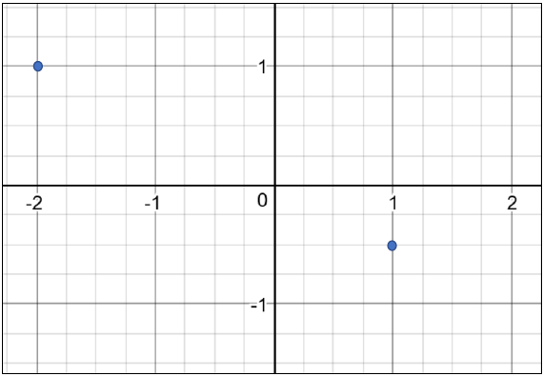

Try graphing these:



$y=x^{2}+x-3$

| X | -2 | -1 | 0 | 1 | 2 |
| --- | --- | --- | --- | --- | --- |
| Y |  |  |  |  |  |

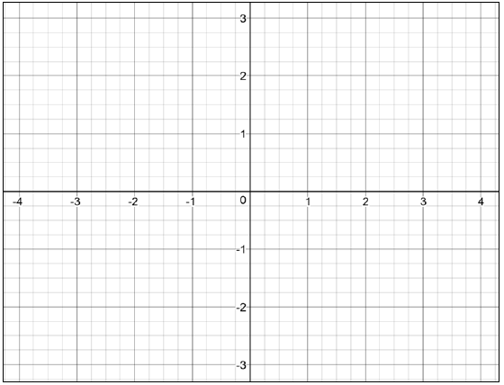

$y=-x^{2}+1$

| X | -2 | -1 | 0 | 1 | 2 |
| --- | --- | --- | --- | --- | --- |
| Y |  |  |  |  |  |

