 Exponential functions

What do the graphs look like?

Use Desmos or other graphing software to graph the following and look at the shape of the graphs.

$y=2^{x}$

$y={10}^{x}$

$y=5^{x}$

$y=3^{-x}$

$y=1.1^{-x}$

$y=8^{-x}$

Definition

All the above graphs are exponential functions.

An exponential function is a function in the form $y=a^{x}$ and $y=a^{-x}$, where $(a>0)$

By looking at the graphs drawn above, complete the statements about the shape of an exponential function.

If the function is in the form $y=a^{x}$:

* The graph goes through the $y$ axis at
* As $x$ values get more negative, the $y$ values
* As $x$ values get more positive, the $y$ values
* As $a$ gets bigger, the graph becomes

If the function is in the form $y=a^{-x}$:

* The graph goes through the $y$ axis at
* As $x$ values get more negative, the $y$ values
* As $x$ values get more positive, the $y$ values
* As $a$ gets bigger, the graph becomes

Using the information

Using the definition of the function, choose which of the following are exponential functions:

$$y=\frac{x}{2}$$

Yes or No

$$y=4^{x}$$

Yes or No

$$y=x^{2}$$

Yes or No

$y=1.5^{-x}$

Yes or No

By looking at the shape of the graphs of the above functions, choose which of the following are exponential functions:

Graph

Yes or No

Graph

Yes or NoGraph

Yes or No

Graph

Yes or NoGraph

Yes or No

Graph

Yes or No

Match the equation with its graph:

Graph

Graph

Graph

Graph

Complete the following table of values and use the points to graph the exponential curve.

$$y=3^{x}$$

| $$x$$ | -3 | -2 | -1 | 0 | 1 | 2 |
| --- | --- | --- | --- | --- | --- | --- |
| $$y$$ | $$\frac{1}{27}≈0.037$$ |  |  |  | 3 |  |

$$y=3^{x} when x=-3 \\ y=3^{-3}=\frac{1}{27}=0.\dot{0}\dot{3}\dot{7}$$

On the calculator:

Image of buttons to press on a calculator to perform the calculation. Press the number three, followed by power of x button, then the negative button, then the number three again, the equal sign, and finally the button to switch from fractions to decimals.

Plot as (-3, 0.037)

On the calculator:

Image of buttons to press on a calculator to perform the calculation. Press the number three, followed by power of x button, then the number one, and finally the equal sign.

1. Plot each point.
2. Join the plotted points with a curved line.
   * Note – To make a smooth curve, place your wrist on the paper on the inside of the curve and use it as a pivot point when drawing.

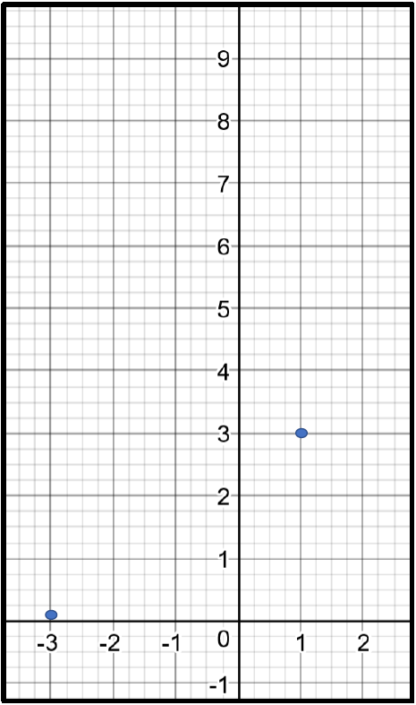

Try graphing these:

|  | -2 | -1 | 0 | 1 | 2 |
| --- | --- | --- | --- | --- | --- |
|  |  |  |  |  |  |

This is an empty graph for students to plot out the function.

|  | -2 | -1 | 0 | 1 | 2 |
| --- | --- | --- | --- | --- | --- |
|  |  |  |  |  |  |

This is an empty graph for students to plot out the function.