Desmos help

Accessing desmos
Visit the desmos website
Click Start Graphing
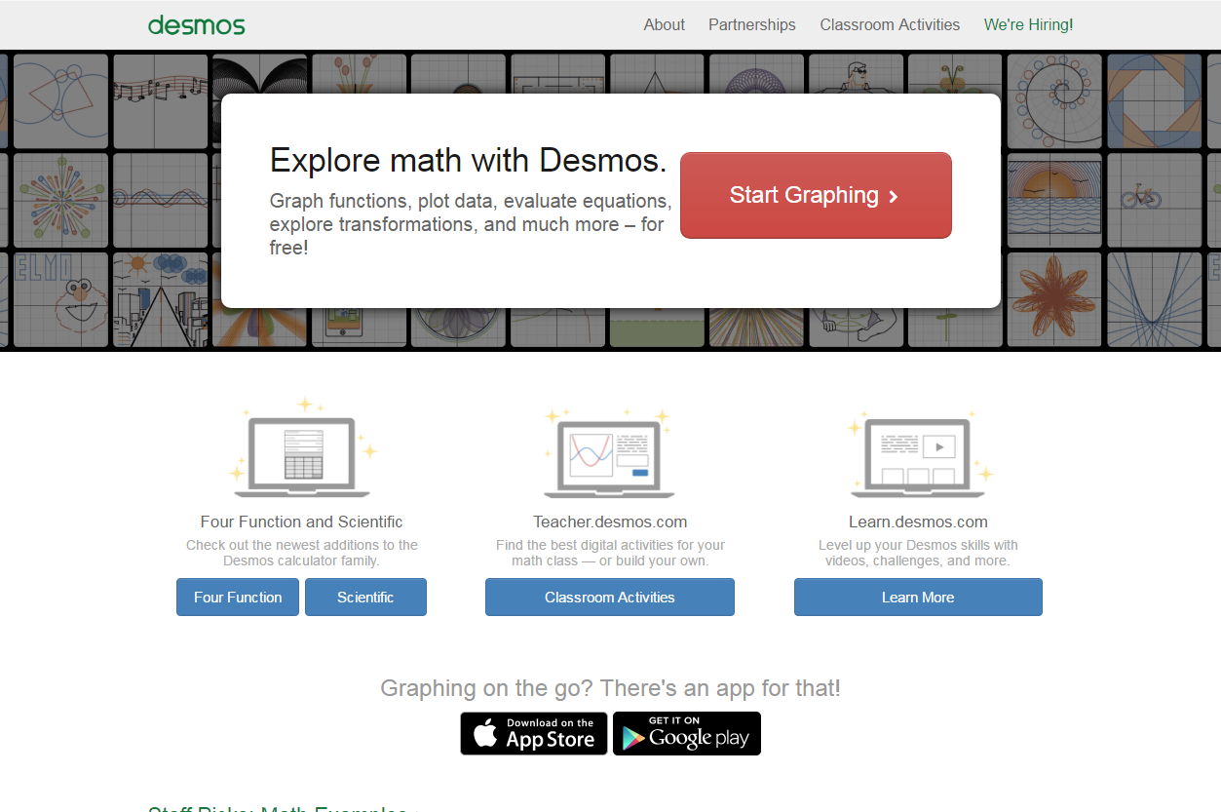
Click Create Account. Creating an account will allow you to save graphs and change them later.
Choose to Sign in with Google. Use your Department of Education Google account, that is: first.last@education.nsw.gov.au
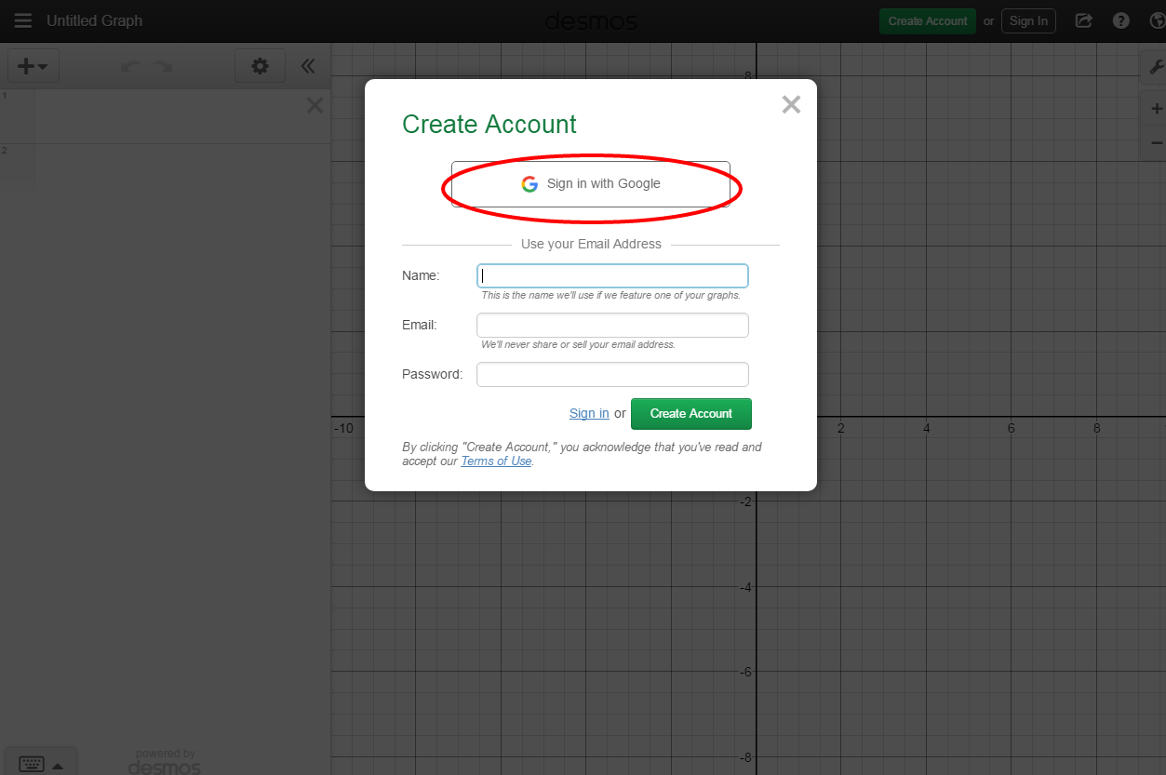

Graphing linear equations
Equations can be entered down the left hand side, as written.
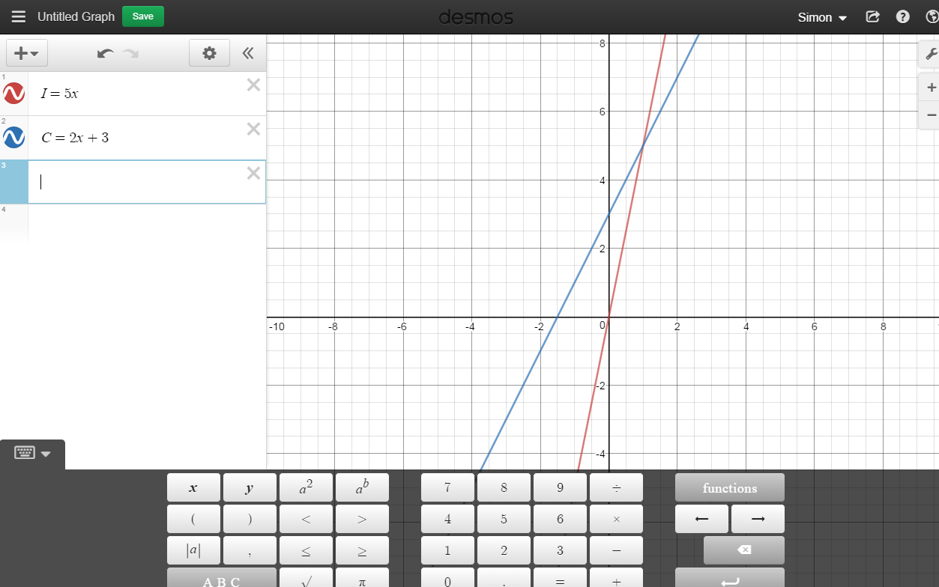
A point of intersection can be determined by clicking the mouse on the point.
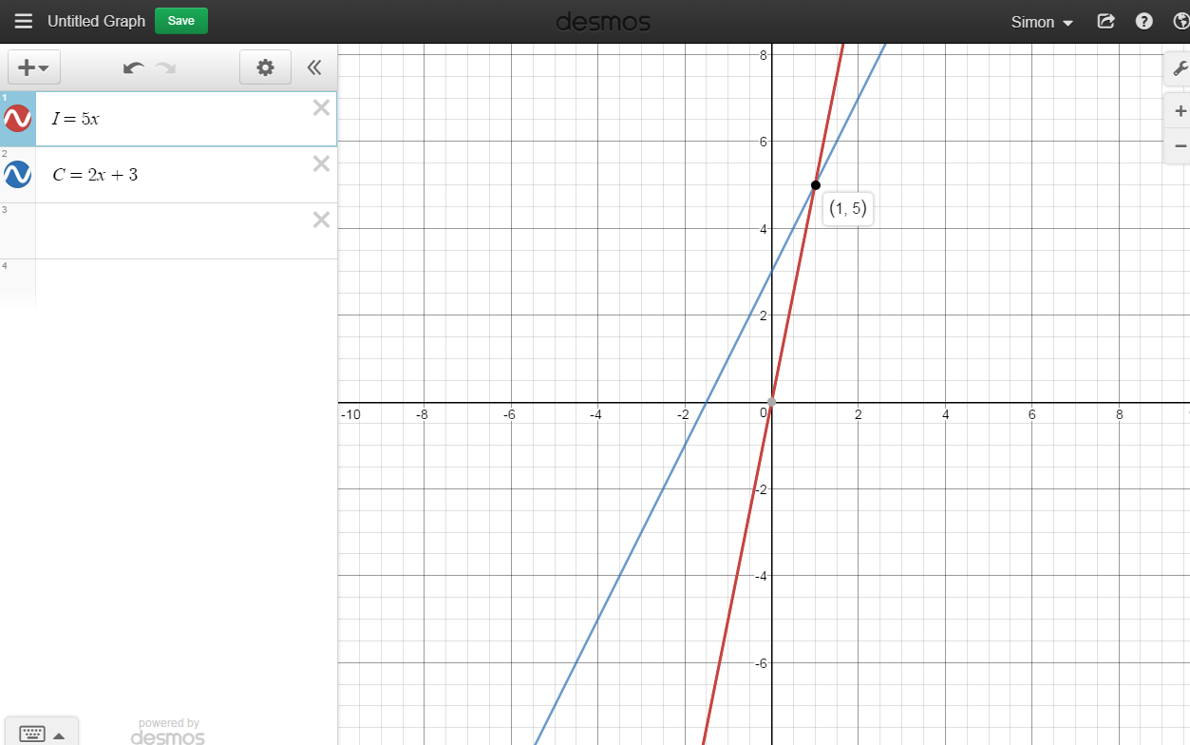

Saving a graph
To save a graph, click Untitled Graph.
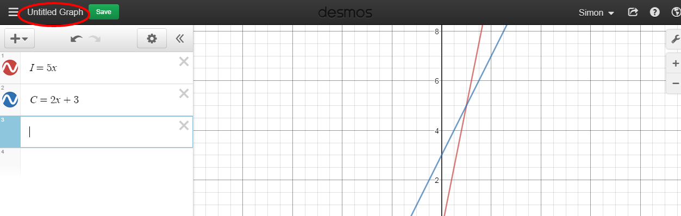
Give the graph a meaningful name, for example, the part of the assignment or task you are completing.
Saved graphs can be accessed by clicking the hamburger icon.
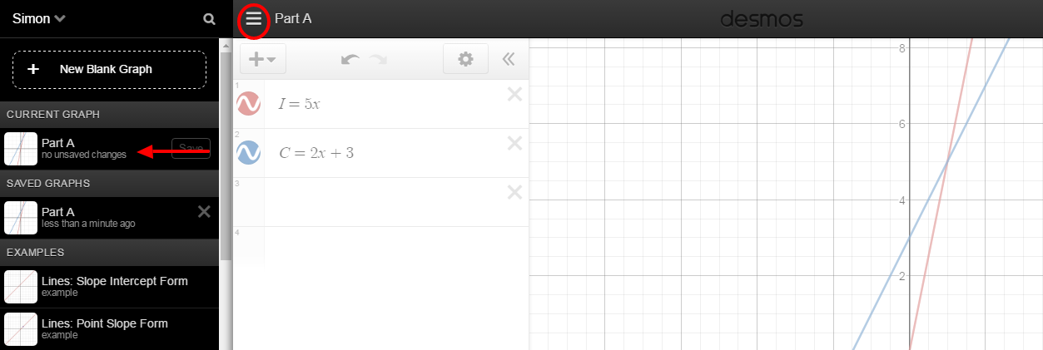

Sharing a graph
Click the share icon, top-right of the screen.
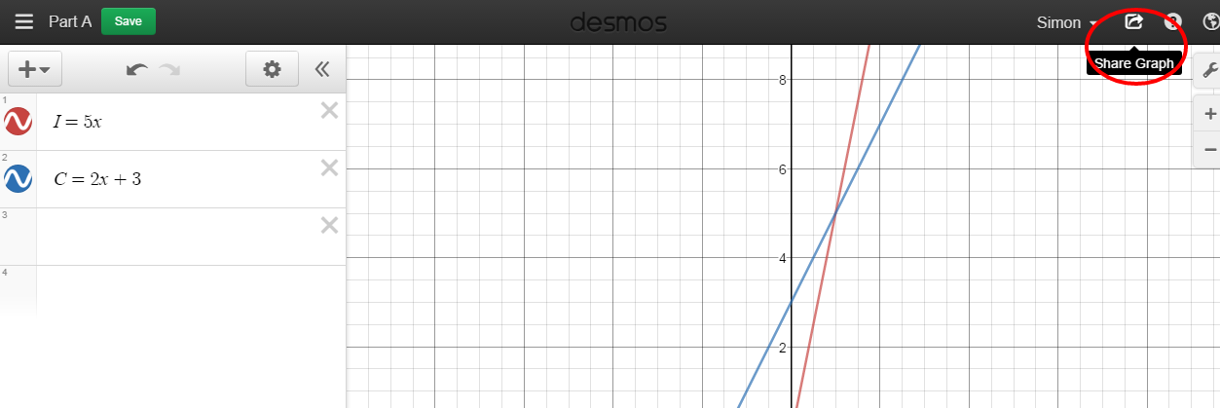
Copy the link. Paste the link where the teacher has asked you to submit the assignment.

