Year 12 Mathematics Standard 2

Assessment task:
MS-S4 Bivariate data analysis and MS-S5 The normal distribution

Driving question
Is mathematical modelling better than guessing?

Outcomes
- MS2-12-2 analyses representations of data in order to make inferences, predictions and draw conclusions
- MS2-12-7 solves problems requiring statistical processes, including the use of the normal distribution, and the correlation of bivariate data
- MS2-12-9 chooses and uses appropriate technology effectively in a range of contexts, and applies critical thinking to recognise appropriate times and methods for such use
- MS2-12-10 uses mathematical argument and reasoning to evaluate conclusions, communicating a position clearly to others and justifying a response
All outcomes referred to in this unit come from Mathematics Standard Sage 6 Syllabus © NSW Education Standards Authority (NESA) for and on behalf of the Crown in right of the State of New South Wales, 2017

Learning across the curriculum

General capabilities
- Critical and creative thinking
- Ethical understanding
- Information and communication technology capability
- Literacy
Numeracy

Other learning across the curriculum areas
- Work and enterprise
Context
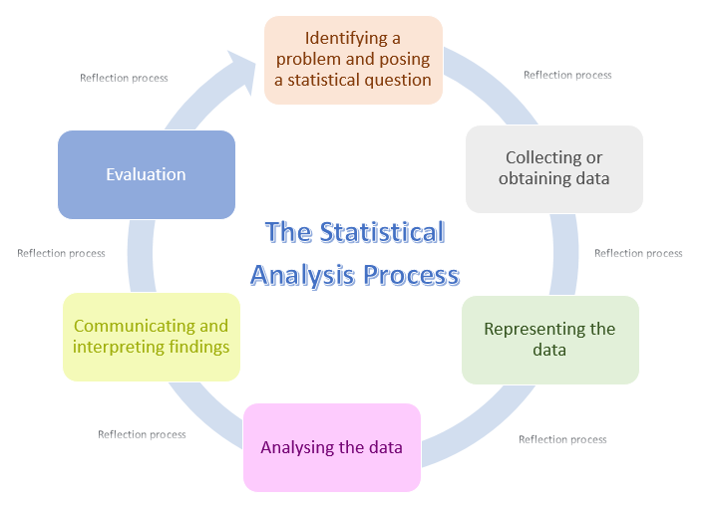
This assessment aims to develop students’ fluency and understanding of applying statistical skills through the Statistical Investigation Process. Students will be challenged to describe and explain any interpretations of the data while justifying their decisions to utilise representations and calculations.
It is envisaged that students will develop connections between the Statistical Analysis process and commercial applications; and empower students to make informed decisions using algebraic modelling techniques.
Background
During this task students will be required to be proficient in and utilise technology such as Microsoft Excel, Geogebra and/or desmos.

Task

Part 1 – Ice cream and shade
Aim: Investigate how data can be modelled and then used to make predictions.
- Students are to source data representing internet interest in the search terms ice cream and shade (shadow) using google trends.
Students are suggested to source and download 5 years of data for each search term individually and then collate the data using a spreadsheet.
- Produce a scatterplot of the internet interest in ice cream and shade using technology.
- Describe the strength and direction of any observable association.
- Provide reason(s) on why you believe you can observe the strength and direction of any observable association.
- Fit a line of best fit by eye.
- Fit a least squares regression line using technology.
- Use the regression model to predict the interest in shade when the interest in ice cream is 15. Complete this prediction both:
  - Graphically and
  - Using the equation of the line of best fit.
- Use the regression model to predict the interest in ice cream when the interest in shade is 80. Complete this prediction both:
  - Graphically and
  - Using the equation of the line of best fit.
- By examining the variation of the ice cream data off the model:
  - Calculate the mean variation.
  - Calculate the standard deviation of the variation.
  - Predict a range of values that will be 95% accurate for the interest in ice cream when the interest in shade is 80.
- Identify and explain any limitations in the model.

Part 2 – Sales forecasting
Aim: Investigate monthly sales history data to predict how many product items to make and for when.
Context: One of the most important challenges for manufacturing businesses is to manufacture the correct amount of their product at the correct time to maximise sales without turning customers away due to shortages.
- Use this Sales History Simulator to generate monthly sales history for your product over the last 20 months, by entering today’s date into the yellow cell.
- Fit a least squares regression line to the data using technology.
- Assuming your product has a lead time of two months, use the model to forecast how many products you predict to sell in two months’ time so that you can plan your inventory needs now.
- Is the forecast in question 3 an example of interpolating or extrapolating? Why?
Context: Another major challenge for manufacturing businesses is to manage their stock levels. Over-investment in stock reduces the company’s cash flow and makes it vulnerable to changes in the market. Additionally, warehousing stock is a costly venture, so minimising the stock levels helps maximise profits by reducing costs. Safety stock is extra stock held by a company to cover a surge in sales which is above the predicted value, i.e. a company may predict sales to be 100 units but may hold a safety stock of 20 units in case 120 units are sold.
- Using the monthly sales data, provide a recommendation on the safety stock levels your company should adopt to ensure that you are 97.5% confident that all sales are met in two month's time.

Part 3 – The statistical analysis process
Aim: Students will complete the statistical analysis process with consideration to commercial applications.
- Identifying a problem and posing a statistical question
  - Students may choose between a correlation investigation and an investigation which compares between two similar populations, using the Normal Distribution, or a mixture of both.
  - Students choosing a correlation investigation need to identify bivariate data. Students may choose to investigate a commercial or biometric relationship, for example, height versus span; height versus foot length; height versus reaction time; height versus stride length, and so on.
  - Students choosing an investigation to compare populations need to identify similar population data in two or more different contexts, for example, comparing the population by age of towns/countries; or comparing the fertility rate by age across different years.
  - After identifying the types of investigation and the data to be collected or obtained, they need to determine a question or problem that their investigation will hope to solve. Some students may require support to determine a question or problem; or staff may provide students who are struggling, with a question or problem.
  - Students may consider setting limits or parameters for the investigation, for example, data will only be collected for adult males aged between 20 to 60 years of age.

Example: I run an ice cream shop and want to predict future ice cream sales. Can temperature forecasts be used to predict future ice cream sales? I sold 500 units last week, how much do I predict to sell next week?
- Collecting or obtaining data
  - Students need to consider whether they design a survey and collect the data themselves or obtain the data from reliable sources. Websites like the World Bank and the Australian Bureau of Statistics may be considered as reliable sources for data. Some students may require support or may be provided with data so that they can progress through this part of the task.

Example: I will source data on daily maximum temperature from the Bureau of Meteorology for my local area and the interest in ice cream using google trends for Australia. I will use 5 years of data so the data I source will be weekly.

- Representing the data
  - Students need to represent the data using appropriate graphs, charts and/or tables, while justifying their use in the given context.
Example: I will produce a scatterplot of ice cream interest verses temperature and use it to develop a least squares regression line.
- Analysing the data
  - Students need to apply appropriate statistical measures and/or calculations to represent characteristics of the data, while justifying their use. For example, students may represent a population by its mean and standard deviation as a measure of the location and consistency of the data; or students may determine the strength of an association between quantities using Pearson’s correlation coefficient, develop a mathematical model and represent the variation of the data (from the model) using the standard deviation.
Example: I will consider the average daily maximum temperature forecast for next week to predict the amount of ice creams sold. I will analyse the variations in the model to establish a range of values which I am 95% confident my ice cream sales will be between.
- Communicating and interpreting findings
  - Students need to interpret the results from the ‘Analysing the data’ stage within the context of the problem or question defined in the ‘Identifying a problem and posing a statistical question’ stage. This may take the form of extrapolating the mathematical model to generate a forecast or make a prediction.
  - It may be possible for students to determine that no connections or relationships exist but they will need to justify their conclusion and provide reasons why.
- Evaluation
  - Students will examine their findings and consider any limitations or opportunities for improvements to their investigation.
  - Students may choose to amend their investigation at this point by restarting the process; however, all work up to this point must be retained and considered in the final mark.

What to submit
- Evidence of an authentic simulation. This may take the form of screenshots of the models with annotations.
- All data collected and generated from the simulation presented using appropriate tables.
- All formula, working and calculations required, either written by hand or typed. If screenshots have been provided, the formulas used need to be clearly annotated.
- All reasoning and justification, either written by hand or typed.

Success criteria
Fluency, understanding and communication | Problem solving, reasoning and justification

Criteria | Working towards developing | Developing | Developed | Well developed | Highly developed
Part 1: Ice cream and shade  MS2-12-2  MS2-12-7  MS2-12-9  MS2-12-10 | Students source data and develops a scatterplot using technology. | Students are able to interpret their scatterplot to describe an association.  Students are able to fit a line of best fit by eye and a least squares regression line using technology. | Students are able to use their model to make predictions both graphically and algebraically. | Students apply the mean, standard deviation and model to make predictions with a given level of confidence.  Students identify and explain limitations in the model.
Part 2: Sales forecasting  MS2-12-2  MS2-12-7  MS2-12-9  MS2-12-10 | Students can produce a scatterplot using technology. | Students are able to fit a least squares regression line using technology and demonstrates a knowledge of extrapolating and/or interpolating. | Students are able to use their model to make predictions. | Students use mathematical reasoning to provide an accurate recommendation with appropriate calculations.
Part 3: The statistical analysis process  MS2-12-7 | Students identify a problem and pose a statistical question. | Students identify, collect or obtain appropriate data.  Students represent data using appropriate displays. | Students analyse their data to establish calculations which can be used to respond to the original question posed. | Students communicate and interpret their findings to answer the original question posed. | Students examine their findings to determine any limitations or opportunities for improvements to their investigation

Notes
- Any non-attempt in a section will be deemed zero. Marks can only be attributed to attempted responses.

Note to staff
The success criteria above has been designed for students and staff alike to use. Students should be presented the rubric as part of the assessment task package. Students and staff follow the process of the task downwards through the rubric and the depth of responses, for each element, across the rubric. Students should be encouraged to use the rubric to self-assess their progress as an assessment-as-learning strategy.
The aim of the assessment task is to develop students’ deep content knowledge. This is reflected in the descriptors, working towards developing through to highly developed. The level of skill and understanding required in each part of the task is different; some parts require highly developed or well-developed skills, other parts only capture a developing skill set.
None of the working mathematically elements are distinct and when demonstrating one element, you are invariably demonstrating another. As an example, communication runs concurrently through all the other working mathematically elements. Students cannot respond to this assessment without communicating in some form. However, it is envisaged that there is a general progression through the working mathematically elements, starting with fluency and leading to understanding, problem solving, reasoning and justification, with increasingly higher levels of communication accompanying each element. Careful consideration has been given to the position of the success criteria statements so they reflect the working mathematically elements demonstrated.
This assessment task has been designed to illuminate the style of questions and the types of responses needed to elicit deep content knowledge, however, staff are encouraged to use and adapt the assessment task and the success criteria to their school context. Staff may like to enhance or amend sections of the task. Staff may like to adapt the rubric to assign marks to the descriptors in order to differentiate between responses that address the same statement. All changes are the responsibility of the staff using the assessment.

