NESA exemplar question solutions

F5 Annuities
Solutions for questions from the NESA topic guidance related to investments and loans.
- Table of future value interest factors

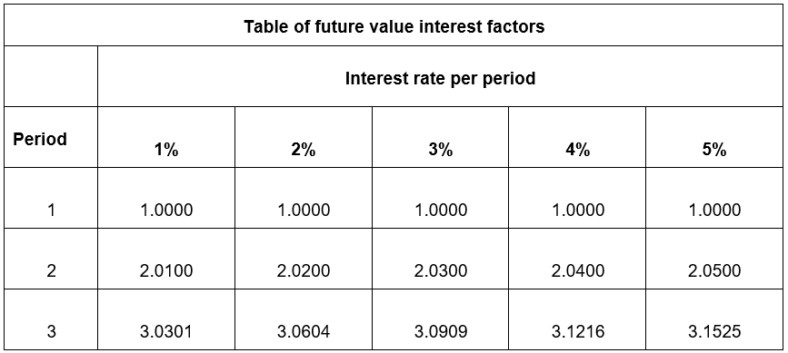
Calculate the future value of an annuity of $\$1200$ per year for three years at $5\%$ pa.

Solution: $3.1525 ×\$1200=\$3783$

- Table of present value interest factors

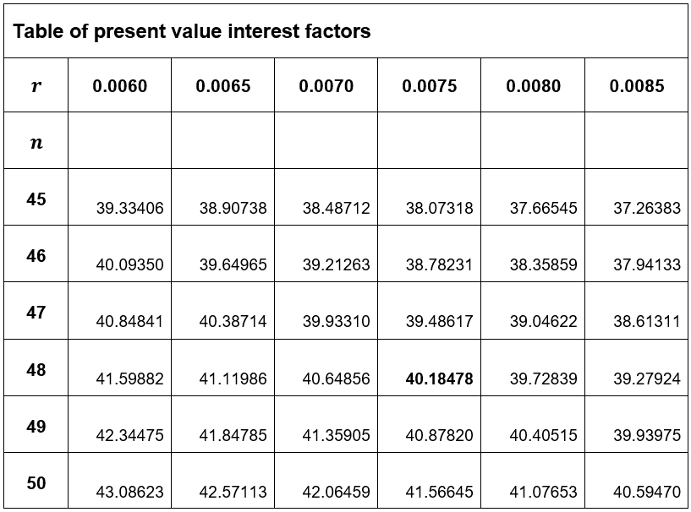
Determine the monthly repayment $a$ for a car loan of $\$8000$ at $9\%$ pa for four years.

Solution: $4$ years $=48$ months and $9\%$ pa $=0.0075$% per month

$$\$8000=a×40.18478$$
$$a=\frac{\$8000}{40.18478}$$
$$a=199.0803483$$
$a=\$199$ (correct to the nearest dollar)

$∴$ The monthly repayment would be$\$199$.

