MEX-V1 Sample questions

V1.1: Introduction to three-dimensional vectors

V1.2: Further operations with 3D vectors

Calculating the Magnitude of a Vector in 3D
- Draw a diagram to illustrate the position vector $3\underset{\sim }{i}-\underset{\sim }{j}+2\underset{\sim }{k}$.
- If $u=(6,-2,4)$ and $v=(-1,3,4)$
  - express the vectors $u+v$ and $v-\frac{1}{2}u$ as ordered triples
$$u+v=\left(6,-2,4\right)+\left(-1,3,4\right)$$
$$=(5, 1, 8)$$

$$v-\frac{1}{2}u=(-1,3,4)-\frac{1}{2}\left(6,-2,4\right)$$
$$=(-4, 4, 2)$$
  - find $\hat{u}$.
$$\hat{u}=\frac{u}{|u|}$$
$$\left|u\right|=\sqrt{6^{2}+{\left(-2\right)}^{2}+4^{2}}$$
$$=\sqrt{56}$$
$$=2\sqrt{14}$$
$$\hat{u}=\left(\frac{6}{2\sqrt{14}}, -\frac{2}{2\sqrt{14}},\frac{4}{2\sqrt{14}}\right)$$
$$=\left(\frac{6\sqrt{14}}{28}, -\frac{2\sqrt{14}}{28},\frac{4\sqrt{14}}{28}\right)$$
$$=\left(\frac{3\sqrt{14}}{14}, -\frac{\sqrt{14}}{14},\frac{\sqrt{14}}{7}\right)$$

- Find all possible values of $c$ if $\left|\vec{AB}\right|=\sqrt{94}$where $A\left(0,3,c\right)$ and $B\left(-3,-1,-6\right).$

$$\sqrt{{\left(0-\left(-3\right)\right)}^{2}+{\left(3-\left(-1\right)\right)}^{2}+{\left(c-\left(-6\right)\right)}^{2}}=\sqrt{94}$$
$$9+16+{\left(c+6\right)}^{2}=94$$
$${\left(c+6\right)}^{2}=69$$
$$c=-6±\sqrt{69}$$

- Use vector methods to locate the midpoint of the interval joining the points $\left(x_{1},y_{1},z_{1}\right)$ and $\left(x_{2},y_{2},z_{2}\right).$

$\underset{\sim }{r}=\left(\begin{matrix}x_{1} \\ y_{1} \\ z_{1}\end{matrix}\right)+\frac{1}{2}\left(\begin{matrix}x_{2}-x_{1} \\ y_{2}-y_{1} \\ z_{2}-z_{1}\end{matrix}\right)$ or $\underset{\sim }{r}=\left(\begin{matrix}x_{2} \\ y_{2} \\ z_{2}\end{matrix}\right)+\frac{1}{2}\left(\begin{matrix}x_{1}-x_{2} \\ y_{1}-y_{2} \\ z_{1}-z_{2}\end{matrix}\right)$
where $\underset{\sim }{r}$ is the position vector of the midpont
Note: the question asks for vector methods (plural)

- Given that $a=\vec{AB}$ and $\frac{2}{3}a=\vec{AC}$, describe the geometric relationship between $A,B$ and $C$.

$C$ is a point that lies on the interval $AB$ such that it splits in interval internally in the ratio $2:1$.

- Use vector methods to find the coordinates of the point that divides the interval joining $A(2,-3,10)$ and $B(-3,12,0)$ in the ratio $2:3$.
$$\underset{\sim }{r}=\left(\begin{matrix}2 \\ -3 \\ 10\end{matrix}\right)+\frac{2}{5}\left(\begin{matrix}-3-2 \\ 12-\left(-3\right) \\ 0-10\end{matrix}\right)$$
$$=\left(\begin{matrix}2 \\ -3 \\ 10\end{matrix}\right)+\frac{2}{5}\left(\begin{matrix}-5 \\ 15 \\ -10\end{matrix}\right)$$
$$=\left(\begin{matrix}0 \\ 3 \\ 6\end{matrix}\right)$$
Or
$$\underset{\sim }{r}=\left(\begin{matrix}-3 \\ 12 \\ 0\end{matrix}\right)+\frac{3}{5}\left(\begin{matrix}2-(-3) \\ \left(-3\right)-12 \\ 10-0\end{matrix}\right)$$
$$=\left(\begin{matrix}-3 \\ 12 \\ 0\end{matrix}\right)+\frac{3}{5}\left(\begin{matrix}5 \\ -15 \\ 10\end{matrix}\right)$$
$$=\left(\begin{matrix}0 \\ 3 \\ 6\end{matrix}\right)$$
- In $PQR, M$ is the midpoint of $PQ$ and $N$ is the midpoint of $PR$. Use vector methods to prove that $MN∥RQ$ and $MN=\frac{1}{2}RQ$.
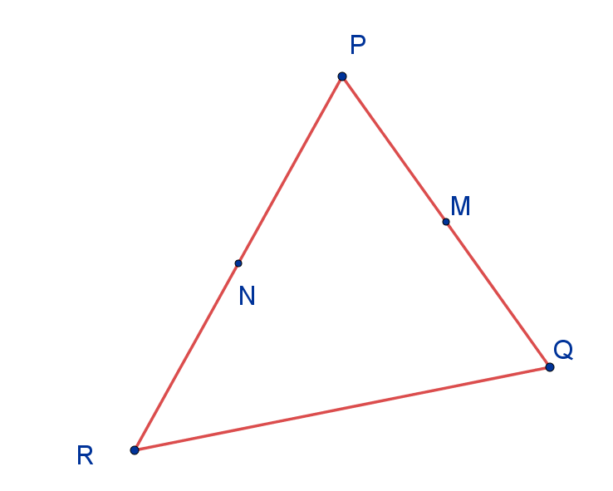
$\overset{⟶}{PQ}+\overset{⟶}{QR}+\overset{⟶}{RP}=0$ end to end vectors with the same start and terminal points.
$$∴\overset{⟶}{QR}=-(\overset{⟶}{PQ}+\overset{⟶}{RP})$$
Following the vector path from M to P to N gives
$$\overset{⟶}{MN}=-\frac{1}{2}(\overset{⟶}{PQ})-\frac{1}{2}(\overset{⟶}{RP)}$$
$$=-\frac{1}{2}(\overset{⟶}{PQ+}\overset{⟶}{RP})$$
$$=\frac{1}{2}\overset{⟶}{QR}$$
If $\underset{\sim }{a}=k\underset{\sim }{b}$, where $k$ is a scalar, then $\underset{\sim }{a} || \underset{\sim }{b}$.
Therefore $\overset{⟶}{MN} || \overset{⟶}{QR}$.
- Classify the triangle formed by joining the points $A(-1,3,3)$, $B(2,5,4)$ and $C(0,3,2)$.
Analysing side lengths:
$$\left|AB\right|=\sqrt{{\left(-1-2\right)}^{2}+{\left(3-5\right)}^{2}+{\left(3-4\right)}^{2}}$$
$$=\sqrt{14}$$
$$\left|BC\right|=\sqrt{{\left(2-0\right)}^{2}+{\left(5-3\right)}^{2}+{\left(4-2\right)}^{2}}$$
$$=\sqrt{12}$$
$$\left|AC\right|=\sqrt{{\left(-1-0\right)}^{2}+{\left(3-3\right)}^{2}+{\left(3-2\right)}^{2}}$$
$$=\sqrt{2}$$
$$∴scalene triangle$$
Analysing angles:
From above ${\left|AB\right|}^{2}={\left|BC\right|}^{2}+{\left|AC\right|}^{2}$, therefore $∠ACB=90°$.
$BC=\left(\begin{matrix}2 \\ 5 \\ 4\end{matrix}\right)+λ\left(\begin{matrix}-2 \\ -2 \\ -2\end{matrix}\right)$ and $AC=\left(\begin{matrix}-1 \\ 3 \\ 3\end{matrix}\right)+μ\left(\begin{matrix}1 \\ 0 \\ -1\end{matrix}\right)$ , use the scalar product of the direction vectors to determine if $BC$ and $AC$ are perpendicular.
$$∴\left(\begin{matrix}-2 \\ -2 \\ -2\end{matrix}\right). \left(\begin{matrix}1 \\ 0 \\ -1\end{matrix}\right)=-2×1+\left(-2\right)×0+\left(-2\right)×\left(-1\right)$$
$$=0$$
Therefore $BC$ and $AC$ are perpendicular. The triangle ABC is a right angled triangle with a right angle at C.

- The four points $A(-1,3,3)$, $B(2,5,4)$, $C(0,3,2)$ and $D(x,y,z)$ form a parallelogram. Use vector methods to find $x, y and z$.
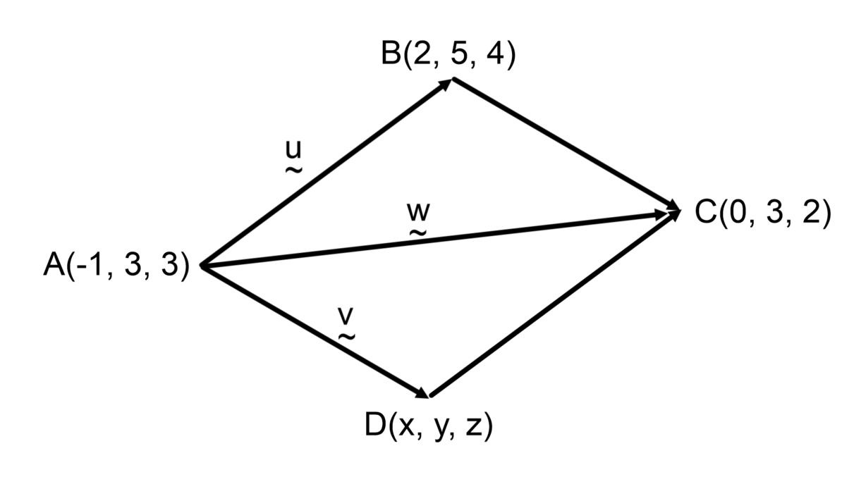
$\underset{\sim }{u}=\left(\begin{matrix}2-\left(-1\right) \\ 5-3 \\ 4-3\end{matrix}\right)=\left(\begin{matrix}3 \\ 2 \\ 1\end{matrix}\right)$ ,$\underset{\sim }{w}=\left(\begin{matrix}0-(-1) \\ 3-3 \\ 2-3\end{matrix}\right)=\left(\begin{matrix}1 \\ 0 \\ -1\end{matrix}\right)$ and $\underset{\sim }{v}=\left(\begin{matrix}x+1 \\ y-3 \\ z-3\end{matrix}\right)$

$$\underset{\sim }{u}+\underset{\sim }{v}=\underset{\sim }{w}$$
$$\left(\begin{matrix}3 \\ 2 \\ 1\end{matrix}\right)+\left(\begin{matrix}x+1 \\ y-3 \\ z-3\end{matrix}\right)=\left(\begin{matrix}1 \\ 0 \\ -1\end{matrix}\right)$$
$$∴3+x+1=1$$
$$x=-3$$
$$∴2+y-3=0$$
$$y=1$$
$$∴1+z-3=-1$$
$$z=1$$
The point D is $(-3, 1, 1)$

Applying the Scalar Product in 3D
- Given $u=(6,-2,4)$ and $v=(-1,3,4),$ verify numerically that $u∙v=|u||v|\cos{θ}=x_{1}x_{2}+y_{1}y_{2}+z_{1}z_{2}$ where $u=\left(x_{1},y_{1},z_{1}\right)$, $v=(x_{2},y_{2},z_{2}$) and $θ$ is the angle between them.
Scalar Product result 1: $u∙v=x_{1}x_{2}+y_{1}y_{2}+z_{1}z_{2}$
$$u.v=6×\left(-1\right)+\left(-2\right)×3+4×4$$
$$=4$$

Scalar Product result 2: $u∙v=|u||v|\cos{θ}$
Connect $u$ and $v$ tip-to-tail as shown.
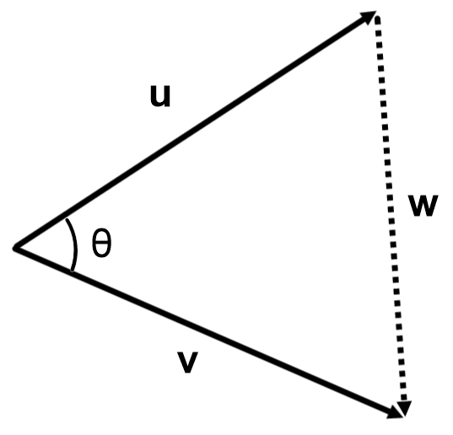
$$w=v-u$$
$$∴w=\left(\begin{matrix}-1 \\ 3 \\ 4\end{matrix}\right)-\left(\begin{matrix}6 \\ -2 \\ 4\end{matrix}\right)=\left(\begin{matrix}-7 \\ 5 \\ 0\end{matrix}\right)$$
$$\left|v\right|=\sqrt{{\left(-1\right)}^{2}+3^{2}+4^{2}}=\sqrt{26}$$
$$\left|u\right|=\sqrt{6^{2}+{(-2)}^{2}+4^{2}}=\sqrt{56}$$
$$\left|w\right|=\sqrt{{\left(-7\right)}^{2}+5^{2}+0^{2}}=\sqrt{74}$$

Cosine rule: $c^{2}=a^{2}+b^{2}-2ab\cos{C}$ which rearranges to $ab\cos{C}=\frac{a^{2}+b^{2}-c^{2}}{2}$

$$u.v=\left|u\right|\left|v\right|\cos{θ}$$
$$=\frac{{\left|u\right|}^{2}+{\left|v\right|}^{2}-{\left|w\right|}^{2}}{2}$$
$$=\frac{56+26-74}{2}$$
$$=4$$
$=$ Scalar Product result 1
$∴u∙v=|u||v|\cos{θ}=x_{1}x_{2}+y_{1}y_{2}+z_{1}z_{2}$ is verified numerically.

Use vectors to prove geometric results in three dimensions
- Find the angle between $u=(6,-2,4)$ and $v=(-1,3,4)$

$$u.v=6×\left(-1\right)+\left(-2\right)×3+4×4=4$$
$$\left|u\right|=\sqrt{6^{2}+{(-2)}^{2}+4^{2}}=\sqrt{56}$$
$$\left|v\right|=\sqrt{{\left(-1\right)}^{2}+3^{2}+4^{2}}=\sqrt{26}$$

$$\cos{θ=\frac{u.v}{\left|u\right|\left|v\right|}}$$
$$=\frac{4}{\sqrt{56}×\sqrt{26}}$$
$$θ=83°59'$$

- Determine if $u=(6,-2,4)$ and $v=\left(-1,3,4\right)$ are perpendicular or parallel.
By inspection $u≠kv$ so $u$ is not parallel to $v$
If $u.v=0$ then $u$ and $v$ are perpendicular.
$$u.v=6×\left(-1\right)+\left(-2\right)×3+4×4=4$$
$u$ and $v$ are not perpendicular.

- If $ABCDEFGH$ is a rectangular prism as illustrated below, and $M$ is the midpoint of $EF$, use vector methods to find the size of $∠BHF$ and $∠BHM$.
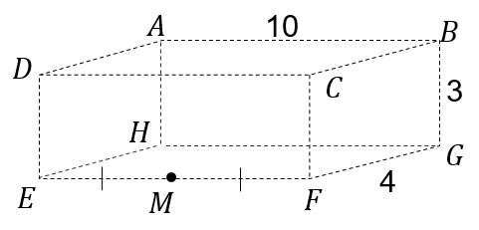
$\overset{⟶}{HB}=\left(\begin{matrix}0 \\ 10 \\ 3\end{matrix}\right)$ , $\overset{⟶}{HF}=\left(\begin{matrix}4 \\ 10 \\ 0\end{matrix}\right)$ , $\left|\overset{⟶}{HB}\right|=\sqrt{0+{10}^{2}+3^{2}}=\sqrt{109}$
and $\left|\overset{⟶}{HF}\right|=\sqrt{4^{2}+{10}^{2}+0}=\sqrt{116}$
$$\cos{∠BHF=}\frac{\overset{⟶}{HB}.\overset{⟶}{HF}}{\overset{⟶}{|BH}|.\overset{⟶}{|HF}|}$$
$$\cos{∠BHF =\frac{0×4+10×10+3×0}{\sqrt{109}×\sqrt{116}}}$$
$$∠BHF =27°13'$$

$\overset{⟶}{HM}=\left(\begin{matrix}4 \\ 5 \\ 0\end{matrix}\right)$ and $\left|\overset{⟶}{HM}\right|=\sqrt{4^{2}+5^{2}+0}=\sqrt{41}$
$$\cos{∠BHM=}\frac{\overset{⟶}{HB}.\overset{⟶}{HM}}{\overset{⟶}{|BH}|.\overset{⟶}{|HM}|}$$
$$\cos{∠BHF =\frac{0×4+10×5+3×0}{\sqrt{109}×\sqrt{41}}}$$
$$∠BHF=41°35'$$

- Use vector methods to prove that the angle in a semicircle is a right angle.
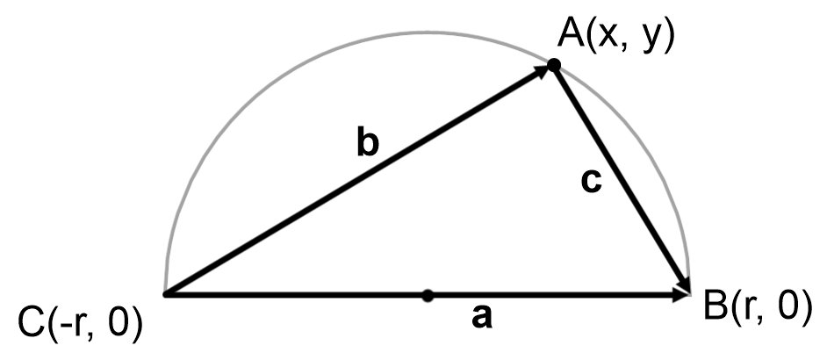
$a=\left(\begin{matrix}2r \\ 0\end{matrix}\right)$, $b=\left(\begin{matrix}x+r \\ y\end{matrix}\right)$, $c=\left(\begin{matrix}r-x \\ -y\end{matrix}\right)$ and $x^{2}+y^{2}=r^{2}$ or $r^{2}-x^{2}-y^{2}=0$
$$b.c=\left(x+r\right)\left(r-x\right)+(y)(-y)$$
$$=r^{2}-x^{2}-y^{2}$$
$$=0$$
$∴b$ and $c$ are perpendicular and the angle in a semi-circle is a right angle.

