NESA exemplar question solution
The circumcentre of a triangle is the centre of the circle that passes through each of the vertices. The centroid is the point of intersection of the angle bisectors of a triangle. Let $O$ be the circumcentre and $G$ the centroid of $∆ABC$. $H$ is the point of $OG$ such that $\vec{OH}=3 \vec{OG}$. Prove that $\vec{AH}⊥\vec{BC}$.
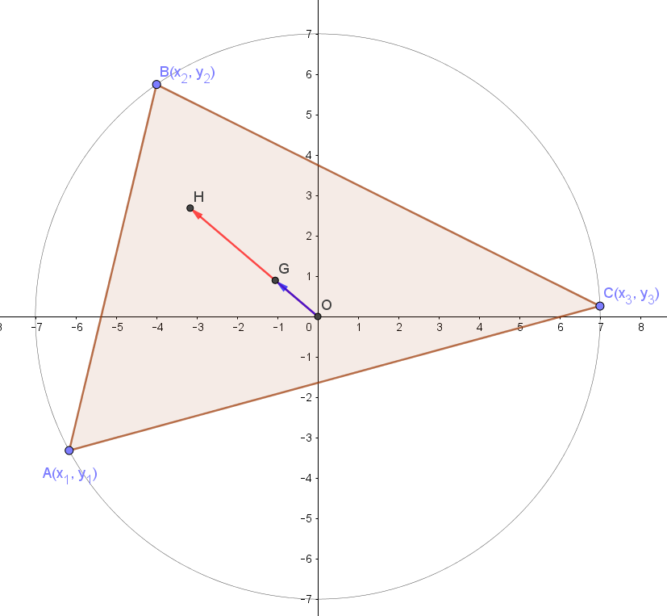
www.geogebra.org/m/byvcmtvd

Centroid $\overset{→}{OG}=\frac{\overset{→}{OA}+\overset{→}{OB}+\overset{→}{OC} }{3}$ and $\overset{→}{OH}=3\overset{→}{OG}$
$$∴\overset{→}{OH}=\overset{→}{OA}+\overset{→}{OB}+\overset{→}{OC}$$
$$\overset{→}{OH}=\left(\begin{matrix}x_{1}+x_{2}+x_{3} \\ y_{1}+y_{2}+y_{3}\end{matrix}\right)$$
$$\overset{→}{AH}=\overset{→}{OH}-\overset{→}{OA}$$
$$=\left(\begin{matrix}x_{1}+x_{2}+x_{3} \\ y_{1}+y_{2}+y_{3}\end{matrix}\right)-\left(\begin{matrix}x_{1} \\ y_{1}\end{matrix}\right)=\left(\begin{matrix}x_{2}+x_{3} \\ y_{2}+y_{3}\end{matrix}\right)$$
and $\overset{→}{BC}=\overset{→}{OC}-\overset{→}{OB}$
$$=\left(\begin{matrix}x_{3} \\ y_{3}\end{matrix}\right)-\left(\begin{matrix}x_{2} \\ y_{2}\end{matrix}\right)$$
$$=\left(\begin{matrix}x_{3}-x_{2} \\ y_{3}-y_{2}\end{matrix}\right)$$
Test $\overset{→}{AH}.\overset{→}{BC}=0$
LHS $=\overset{→}{AH}.\overset{→}{BC}$
$$=\left(x_{2}+x_{3}\right)\left(x_{3}-x_{2}\right)+\left(y_{2}+y_{3}\right)\left(y_{3}-y_{2}\right)$$
$$=(x_{3})^{2}-{\left(x_{2}\right)}^{2}+{(y_{3})}^{2}-{(y_{2})}^{2}$$
$$={\left(x_{3}\right)}^{2}+{\left(y_{3}\right)}^{2}-({\left(x_{2}\right)}^{2}+{\left(y_{2}\right)}^{2})$$
$$={\left|\vec{OC}\right|}^{2}-{\left|\vec{OB}\right|}^{2}$$
$=OC^{2}-OB^{2}$ [$OC=OB$ (radii of circle)]
$$=0$$
$=$ RHS
Therefore $AH$ is perpendicular to $BC$

