Year 12 Mathematics Extension 2
MEX-P1 The nature of proof | Unit duration
The topic Proof involves the communication and justification of an argument for a mathematical statement in a clear, concise and precise manner.  A knowledge of proof enables a level of reasoning, justification and communication that is accurate, concise and precise and lays the foundations for understanding the structure of a mathematical argument.  The study of proof is important in developing students’ ability to reason, justify, communicate and critique mathematical arguments and statements necessary for problem-solving and generalising patterns. | 4 to 5 weeks

Subtopic focus | Outcomes
The principal focus of this subtopic is to develop rigorous mathematical arguments and proofs, specifically in the context of number and algebra.  Students develop an understanding of the necessity for rigorous and robust methods to prove the validity of a variety of concepts related to number and algebra. The level of clear and concise communication developed will be used in further pathways. | A student:  - understands and uses different representations of numbers and functions to model, prove results and find solutions to problems in a variety of contexts MEX12-1  - chooses appropriate strategies to construct arguments and proofs in both practical and abstract settings MEX12-2  - applies various mathematical techniques and concepts to model and solve structured, unstructured and multi-step problems MEX12-7  - communicates and justifies abstract ideas and relationships using appropriate language, notation and logical argument MEX12-8

Prerequisite knowledge | Assessment strategies
The material in this topic builds on content from the Mathematics Extension 1 topic of ME-P1 Proof by mathematical induction. | - Formative assessment strategies will be critical during this unit. Staff are encouraged to adopt activities that enable staff to identify misconceptions early. For example, allow students to use mini-whiteboards to complete truth tables for given statements or to interpret statements using logical notation. Staff may like to adopt pre and post testing methods to gauge progress.
All outcomes referred to in this unit come from Mathematics Extension 2 Syllabus
© NSW Education Standards Authority (NESA) for and on behalf of the Crown in right of the State of New South Wales, 2017

Glossary of terms
Term | Description
Arithmetic mean | The arithmetic mean of the numbers $x_{1}, x_{2}, x_{3},…, x_{n}$ is defined to be: $\frac{x_{1}{+x}_{2}+x_{3}+…+x_{n}}{n}$
Contrapositive | The contrapositive of the statement ‘If $P$ then $Q$’ is ‘If not $Q$ then not $P$’. The contrapositive is true if and only if the statement itself is also true.
Converse | The converse of a statement ‘If $P$ then $Q$’ is ‘If $Q$ then $P$’.  The statements can be represented as: the converse of $P⇒Q$ is $Q⇒P$ or $P⇐Q$.  The converse of a true statement need not be true.
Counter-example | A counter-example is an example that demonstrates that an assertion is not true in general.
Geometric mean | The geometric mean of the positive numbers $x_{1}, x_{2}, x_{3},…, x_{n}$ is defined to be: ${\left(x_{1}x_{2}x_{3}…x_{n}\right)}^{\frac{1}{n}}$
Implication | To say that $P$ implies $Q$ means that if $P$ is true then $Q$ is true.  In shorthand it can be written as ‘If $P$ then $Q'$ and in notation form as $P⇒Q$
Negation | If $P$ is a statement then the statement ‘not $P$’ is the negation of $P$. The negation of $P$ is denoted by $¬P$ or $\sim P$.
Proof by contradiction | Proof by contradiction is when a mathematical proof assumes the opposite (negation) of the original statement being proven and illustrates through a logical chain of arguments that the opposite is demonstrably false. As the reasoning is correct and the conclusion absurd, the only element that could be wrong was the initial assumption. Therefore the original statement is true.
Recursive formulae | A recursive formula defines a sequence in which successive terms are expressed as a function of the preceding terms.
Statement | A statement is an assertion that can be true or false but not both.

Lesson sequence | Content | Suggested teaching strategies and resources | Date and initial | Comments, feedback, additional resources used
The language of proof  (2 lessons) | - use the formal language of proof, including the terms statement, implication, converse, negation and contrapositive (ACMSM024)  - use the symbols for implication $(⇒)$, equivalence $(⇔)$ and equality $(=)$, demonstrating a clear understanding of the difference between them (ACMSM026)  - use the phrases ‘for all’ $(∀)$, ‘if and only if’ $(iff)$ and ‘there exists’ $(∃)$ (ACMSM027)  - understand that a statement is equivalent to its contrapositive but that the converse of a true statement may not be true | Truth Tables  Truth tables are not explicitly referenced within the syllabus but are a useful way to effectively communicate the results of logical statements. A truth table contains the permutations for logical statements, say $P$ and $Q,$ in the first set of columns and the result of a logical statement that links $P$ and $Q$ in the final column. The result of a logical statement is either true, $T$, or false, $F$. A statement is only false if the statement is always false in all cases, else it is true since if it cannot be false it must be true.  - This resource from millerville.edu gives a detailed explanation of truth tables and the logical statements that follow.  The language of proof  Students should explore in depth, and understand the concepts underlying this topic using language before applying them in a mathematical setting.  An introduction to the language of proof is given in the video Introduction to fundamental math proof techniques (duration 14:00)  - Statement: A statement or proposition is an assertion or declarative sentence which is true or false but not both. If a proposition is true, then we say its truth value is true, and if a proposition is false, then we say its truth value is false. Statements are denoted by propositional variables. These are denoted by upper-case letters. E.g. P, Q, R, etc...  Students should practise being able to identify sentences which can be classified as statements, and which are not. In this topic students will only be looking at statements which have a well-defined truth value. Examples:  - “A dog is a mammal.” This is a statement and has a truth value of “true”.  - “Come with me!” This is not a statement and has no truth value.  - “Dogs are lovely.” This does not have a well-defined truth value.  A statement which is true requires a proof. A statement which is false requires a demonstration. There are two main ways to prove a statement.  - Direct proof (includes mathematical induction)  - Indirect proof e.g. counter examples, contradiction, contrapositive  The syllabus also does not mention the term “open statement” but an “open statement” is a statement which is true or false depending on a particular variable. E.g. “The integer $x$ is even.” This statement is either true or false depending on the value of $x$.  - Negation: If $P$ is a statement is true, the negation of $P$ is “not P” or “it is not true that P”. Symbolically this is denoted as $\sim P$.  Truth table:  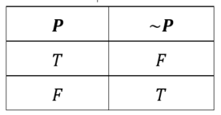  Example: What is the negation of P?  - $P$: It is sunny today. Answer: $\sim P$: It is not sunny today or it is not true that it is sunny today or it is not the case that it is sunny today.  - Implication: If P and Q are statements, the conditional of P is “If P then Q” or “P implies Q”, symbolically $P⇒Q$. P is called the premise or hypothesis and Q is the conclusion. If P is known to be true then Q must also be true.  Truth Table:  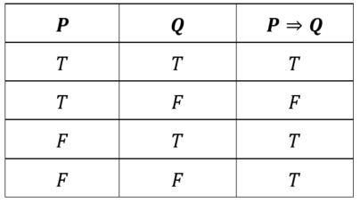  The idea of implication can be written in many different ways:  - If P, then Q  - Q if P  - Q provided that P  - Q whenever P  - Whenever P, then also Q  - P is a sufficient condition for Q  - For Q it is sufficient that P  - Q is a necessary condition for P  - For P, it is necessary that Q  - P only if Q  Sample activity:  - Students should be given sentences in which they have to identify the premise and the conclusion.  - Students practise writing statements out using propositional variables and logical notation.  Exercise: Book of proof p.45  - Converse: The converse of a statement is a result of reversing the hypothesis and the conclusion of a statement. Example:  - The converse of the statement “If today is Saturday then tomorrow is Sunday.” is the statement “If tomorrow is Sunday then today is Saturday”.  The converse is not always true. Example:  - The converse of the statement “If today is Christmas, then tomorrow is Monday.” is “If tomorrow is Monday, then today is Christmas.”  Symbolically: the converse of $P⇒Q$ is $Q⇒P$  - (Logical) Equivalence: If P and Q are statements, the equivalence (or biconditional) of P and Q is “P if, and only if, Q” and this is denoted $P⇔Q.$“if, and only if” is commonly abbreviated to “iff”. It is the case where both the statements $P⇒Q$ and $Q⇒P$ are true simultaneously.  Truth table:  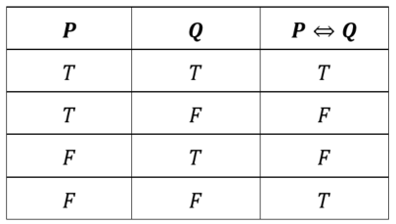  Example:  - Water boils ⇔ Water temperature is over 100°C.  This means that “water will boil if the temperature is over 100°C” and “if the temperature is over 100°C, then the water will boil”  - $n$ is even $⇔$ $∃$ an integer $n$ such that $n = 2k$ where $k$ is an integer  - $n$ is odd $⇔$∃ an integer $n$ such that $n = 2k + 1$ where $k$ is an integer  The idea of equivalence can be written in many different ways:  - P if and only if Q  - P is a necessary and sufficient condition for Q  - For P it is necessary and sufficient that Q  - P is equivalent to Q  - If P, then Q, and conversely  (Logical) Equivalence and equality should not be used interchangeably. Equivalence between two statements, $P⇔Q$, means that each of the propositions of the statements are equal, i.e. when $P$ is true, $Q$ is true and when $P$ is false, $Q$ is false. Logical Equality between two statements, $P=Q$, is an operation or test between the propositions of the statements, i.e.) if $P$ is true and $Q$ is true then $P=Q$ is true also, whereas if $P$ is true and $Q$ is false then $P=Q$ is false. Logical equality if often used within coding as a condition to do something.  Contrapositive: The contrapositive of the conditional statement $P⇒Q$ is $\sim Q⇒\sim P$. Example:  - The contrapositive of the statement “If a bird is a raven then it is black.” is the statement “If a bird is not black then it is not a raven.”  Introduce the idea of logical equivalence and its meaning. The conditional statement is logically equivalent to its contrapositive.  Students must understand that a statement is equivalent to its contrapositive but that the converse of a true statement may not be true. This could be demonstrated through a truth table.  Sample activity:  - Students are given statements where they must write both the converse and the contrapositive and examine if they are true.  Sample question from NESA’s specimen paper:  The sign shown appears on the rear of large vehicles:  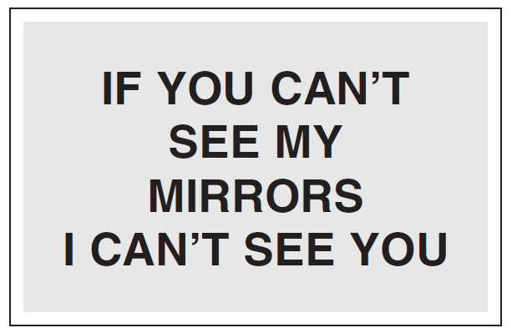  Which of the following statements is logically equivalent to the statement on the sign? (Solution: B)  - If you can see my mirrors then I can see you.  - If I can see you then you can see my mirrors  - If I can’t see you then you can’t see my mirrors  - If I can’t see your mirrors than you can’t see me.  Note: Logically equivalent means the contrapositive.  - Quantifiers: Students should be able to interpret and use the following quantifiers in place of the equivalent phrases.  - $∀$ ‘for all’, ‘ for every’, ‘for each’. This is used to make a statement that pertains to a group of things/numbers.  Example: $∀x∈Z$, $2x$is even. This is equivalent to the phrase “for all $x$, where $x$is an element of the integer set, 2 times $x$ is an even number”  - $∃$ ‘there exists a…’, ‘there is a…’  Example: $∃x∈Z$, $x+3$ is prime number. This is equivalent to the phrase “there exists a value of $x$ where $x$ is an element of the integer set, such that $x$ plus $3$ is a prime number”  Harder examples could include the use of both quantifiers in the same sentence. However, it must be emphasised that the order of the quantifiers is important and that reversing their order creates a different meaning. Example:  - $∀x∈R, ∃y∈R, y^{3}=x$. For all $x$, where $x$ is a real number, there exists a y where y is a real number, such that $y^{3}=x$.  This is a true statement.  - $∃y∈R, ∀x∈R,{ y}^{3}=x$. There exists a y where y is a real number, such that for all x where x is a real number, $y^{3}=x$.  This statement is false.
Proving simple results involving numbers  (1 lesson) | - prove simple results involving numbers (ACMSM061) | Resource: The four basic proof techniques used in mathematics (duration 22:37) direct proof, proof by contradiction, induction and contrapositive  Proving simple results involving numbers  - Method 1: Prove a conditional statement is true by using a direct proof in the form $P⇒Q$:  - Assume the antecedent $P$ is true  - Use a sequence of logical steps to arrive at the conclusion that $Q$ is also true.  It could also be discussed why it is sufficient to just ‘assume’ that the antecedent is true, as opposed to requiring it to be true.  - Method 2: Prove a conditional statement is true by using the contrapositive. The contrapositive of $P⇒Q$ is $\sim Q⇒\sim P$.  - Assume $\sim Q$ is true  - Use a sequence of logical steps to arrive at the conclusion that $\sim P$ is also true.  - Conclude that $P⇒Q$ due to the logical equivalence of a conditional statement and its contrapositive.  - Examples:  - If $x$ is odd then $x^{2}$ is odd. (This is the contrapositive of: if $x^{2}$ is even, then $x$ is even)  - Prove that if $n$ and $m$ are both odd, then $nm$ is odd; otherwise $nm$ is even. (NESA exemplar question)  - The product of two consecutive even counting numbers is a multiple of 4.  Resource: mex-p1-sample-question-solutions.DOCX  See this file for solutions to the sample questions (including exemplar questions from the NESA topic guidance) given throughout the unit.
Proof by contradiction  (1 lesson) | - use proof by contradiction including proving the irrationality for numbers such as $\sqrt{2}$ and $\log_{2}5$ (ACMSM025, ACMSM063) | Proof by contradiction  - The teacher models to students how to set out a proof by contradiction. Students consider the proposition to be proven, and investigate the effect of assuming the opposite is true. If this leads to a contradiction, then it follows that the original proposition is true  Symbolically, if asked to prove a statement $P$, then students assume that $\sim P$ is true and show this leads to a contradiction.  - Examples:  - For all integers $n$, if $n^{2}$ is odd, then $n$ is odd. (This could also be proven using the contrapositive: if $x$ is even, then $x^{2}$ is even)  - Every factor of an odd number is odd.  - The negative of any irrational number is irrational.  - For all integers $n$, if $n^{2}$ is even, then $n$ is even.  - Prove that if $n$ is a positive integer then $\sqrt{4n-2}$ is always irrational.  - There is no greatest even integer.  - Prove that in any group of $n≥2$ people, there are at least two who are acquainted with the same number of people.  - Prove $\sqrt{2}$ is irrational.  - Proof by contradiction is also particularly useful for proving statements of the form $∀x, P(x)$ as the negation of this $\sim (∀x, P\left(x\right))$ is $∃x, \sim P(x)$ i.e. there exists an $x$ such that $P(x)$ is false.  Example:  - Prove that there exist no integers $a$ and $b$ for which $18a+6b=1$.  - Staff may like to reference this resource for Proof by Contradiction from the school of Mathematics and Computer Science at Gordon College.
Using examples and counter-examples  (1 lesson) | - use examples and counter-examples (ACMSM028) | Using examples  - Existence statements involving there exists an $x$ ($∃x)$ can be proven using an example.  A general statement involving for all $x$ ($∀x)$ cannot be proven by using an examples. This only shows it is true for the shown values.  - Examples:  - Prove $∃$ (there exists) a number which is half the sum of its positive factors.  - Prove $∃$ a prime number $p$, such that $p+$2 and $p+6$ are also prime number  - Prove $∃$ a function $f$, such that $f=f'$  Using counter-examples  - All other methods of proof have involved proving that a statement is true, the method of using a counter example is used to prove that a statement is false.  - Sample way of introducing:  - Consider the number of regions formed when $n$ points on a circle are connected.  - Draw a diagram to not the number of regions formed when $n = 2, 3, 4, 5$  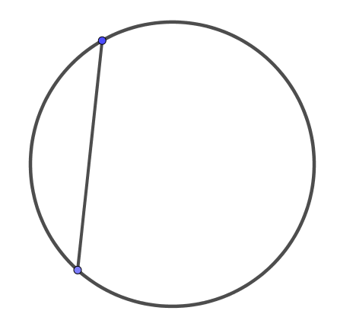2 points, 2 regions or $2^{1}$  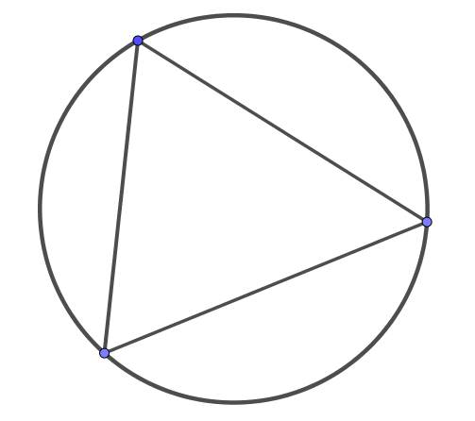3 points, 4 regions or $2^{2}$  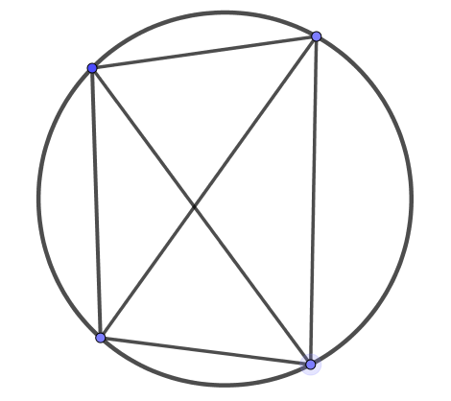4 points, 8 regions or $2^{3}$  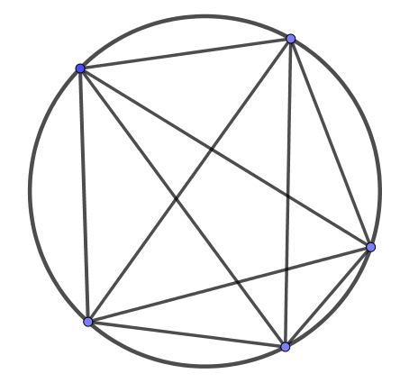5 points, 16 regions or $2^{4}$  - We can make a conjecture based on the pattern we can see. i.e. the number of regions when n points are connected is 2^{n -1}. Note: This is not a proof as general statements involving all values cannot be proved using examples.  - Prove this conjecture is false by finding a counterexample. Based on the formula, we predict a circle with 6 points will have 32 regions, it does not (there are 31 regions) and therefore the conjecture is proven false.  - Examples: Prove each are false by finding a counter-example.  - All prime numbers are odd (NESA topic guidance)  - $∀a,b∈Z, a^{2}=b^{2},$then $a=b$  - A quadrilateral with four congruent sides is a square  - $∀x∈R, ,\frac{x+1}{x}>1$  - $∀x∈R, ,\sqrt{x}≤x$
Proofs involving inequalities  (1 lessons) | - prove results involving inequalities. For example:  - prove inequalities by using the definition of $a>b$ for real $a$ and $b$  - prove inequalities by using the property that squares of real numbers are non-negative | Proofs involving inequalities  - Students define for all real numbers $a$ and $b$  - $a>b$ if and only if $a-b>0$  - $a<b$ if and only if $a-b<0$  - $a^{2}≥0$  - ${\left(a±b\right)}^{2}≥0$  - Students understand other inequality theorems:  If $a>b$ then  - $a+c>b+c$  - $ac>bc$if $c>0$  - $ac<bc$ if $c<0$  - Students establish and know the rules for inequalities involving only positive numbers.  - If $a>b$, $c>d$ ⇒ $ac>bc$  - If $a>b$ ⇒ $a^{2}>b^{2}$  - If $a>0$ then $\sqrt{a}>0$  - If $a>b$ ⇒ $\frac{1}{a}<\frac{1}{b}$  - Examples:  - Prove that if $x, y, z$ are real and not all equal then $x^{2} + y^{2} + z^{2} > yz + zx + xy$. Deduce that if additionally $x + y + z = 1$, then $yz + zx + xy <\frac{1}{3}$. (NESA topic guidance)  - Prove $a^{2}+b^{2}≥2ab$ and hence ${\left(a+b\right)}^{2}≥4ab$  Hint: Start with ${\left(a-b\right)}^{2}≥0$  - If $p,q and r$ are positive real numbers and $p+q≥r$, prove that $\frac{p}{1+p}+\frac{q}{1+q}-\frac{r}{1+r}≥0$ (Extension 2 HSC 2011)  - Prove $x^{4}+x^{2}y+4y^{2}≥5x^{2}y$.
The triangle inequality  (1 lessons) | - prove results involving inequalities. For example:  - prove and use the triangle inequality $\left|x\right|+\left|y\right|≥\left|x+y\right|$ and interpret the inequality geometrically | The triangle inequality  - The teacher can introduce the triangle inequality informally:  - Ask how many triangles can you make from a given perimeter 12cm?  - Consider a triangle with sides of 10cm and 6cm, what value could the third side take? This is examined in a khan academy video (duration 5:51)  A range of other examples are given on math warehouse  - Consider the sum of two vectors $\overset{̰}{x}$ and $\overset{̰}{y}$ on the argand diagram.  - The triangle inequality, $\left|x\right|+\left|y\right|≥\left|x+y\right|,$ can then be formally proved. Sample proof (duration 3:07).  - Examples:  - Prove reverse triangle inequality: Prove that if $a$ and $b$ are real numbers, then $|a - b| ≥ ||a| - |b||.$  reverse triangle inequality (duration 5:03).
The arithmetic and geometric mean  (1 lessons) | - prove results involving inequalities. For example:  - establish and use the relationship between the arithmetic mean and geometric mean for two non-negative numbers | The arithmetic and geometric mean  - The arithmetic mean is the average of a set of numbers  The geometric mean is defined as the $n$th root of the product of $n$ numbers,  - Students derive and define the arithmetic-geometric inequality: For two positive real numbers $x$ and $y$, $\frac{x+y}{2}≥\sqrt{xy}$ where $\frac{x+y}{2}$ is the arithmetic mean and $\sqrt{xy}$ is the geometric mean.  Sample derivation:  $${\left(\sqrt{x}-\sqrt{y}\right)}^{2}≥0$$  $$x-2\sqrt{xy}+y≥0$$  $$x+y≥2\sqrt{xy}$$  $$\frac{x+y}{2}≥\sqrt{xy}$$  $$\sqrt{xy}≤\frac{x+y}{2}$$  Alternate proof starts with ${\left(a-b\right)}^{2}≥0$. This is shown in the first sample question for the arithmetic and geometric mean.  Students can also consider the result geometrically.  - Sample questions:  - Extension 2 HSC 2012  - Prove that $\sqrt{ab}≤\frac{a+b}{2}$ where $a≥0$and $b≥0$  - If $1≤x≤y$, show that $x\left(y-x+1\right)≥y$  - Let $n$ and $j$be positive integers with $1≤j≤n$, prove that $\sqrt{n}≤\sqrt{j\left(n-j+1\right)}≤\frac{n+1}{2}$  - For integers, prove that ${\left(\sqrt{n}\right)}^{n}≤n!≤{\left(\frac{n+1}{2}\right)}^{n}$  - Given that $x+y=p$, prove that, if $x>0$, $y>0$, then $\frac{1}{x}+\frac{1}{y}≥\frac{4}{p}$ and $\frac{1}{x^{2}}+\frac{1}{y^{2}}≥\frac{8}{p^{2}}$ (NESA topic guidance)  - If the product of two positive numbers is 64, what is the minimum value of their sum?  - If $x,y∈R^{+}$ and $x+y=20$, then find the minimum value of $\left(1+\frac{1}{x}\right)\left(1+\frac{1}{y}\right)$.  - Find the minimum value of $\frac{4+9x^{2}\sin^{2}{x}}{x\sin{x}}$ for $0<x<π$.  - Show that the rectangle of the largest possible area, for a given perimeter, is a square.  - For positive reals numbers $a,b$and $c$, prove $\left(a+b\right)\left(b+c\right)\left(c+a\right)≥8abc$  - For positive reals numbers $a,b$and $c$, prove $a^{2}+b^{2}+c^{2}≥ab+bc+ca$  - Extension:  - The result could be extended to include cases with three positive numbers  - Students could prove that this is true for more than two numbers by using induction  - Sample question: A jelly shop sells its products in two different sets: 3 red jelly cubes and 3 green jelly rectangular prisms. The three red cubes are of side lengths $a, b$ and $c,$ where $a<b<c$, while the three green rectangular prisms are identical with dimensions $a×b×c$. Which option would give you more jelly?
Prove further inequalities  (1 lesson) | - prove further results involving inequalities by logical use of previously obtained inequalities | Prove further inequalities  Logically use a previously proven inequality to prove additional results. Sample examples:  - Prove $a+b≥2\sqrt{ab}$. Hence deduce that  - $\left(a+b\right)\left(b+c\right)\left(c+a\right)≥8abc$  - $a^{2}b^{2}+b^{2}c^{2}+c^{2}a^{2}≥abc(a+b+c)$  - $\left(ab+cd\right)\left(ac+bd\right)≥4abcd$  - Prove ${\left(ad+bc\right)}^{2}≤(a^{2}+b^{2})(c^{2}+d^{2})$. Hence deduce that:  - ${\left(a+b\right)}^{2}≤2(a^{2}+b^{2})$  - ${\left(a^{3}+b^{3}\right)}^{2}≤\left(a^{2}+b^{2}\right)\left(a^{4}+b^{4}\right)$  - NESA Example: Let $x$ be a fixed, non-zero number satisfying $x>-1$.  - Use the method of mathematical induction to prove that ${\left(1+x\right)}^{n}>1+nx$ for $n=2,3,…$  - Deduce that ${\left(1-\frac{1}{2n}\right)}^{n}>\frac{1}{2}$ for $n=2,3,…$  - Extension 2 HSC 2007  - Show that $\sin{x}<x$ for $x>0$  - Let $f\left(x\right)=\sin{x}-x+\frac{x^{3}}{6}$. Show that the graph of $y=f(x)$ is concave up for $x>0$  - By considering the first two derivatives of $f(x)$, show that $\sin{x}>x-\frac{x^{3}}{6}$ for $x>0$  - Students may be asked to extend on Extension 1 topics and be asked to solve inequalities graphically. For example this question is referenced in the NESA topic guidance:  Use a graphical method to solve the inequality $3x^{2}-2x-2≤\left|3x\right|$.

Reflection and evaluation
Please include feedback about the engagement of the students and the difficulty of the content included in this section. You may also refer to the sequencing of the lessons and the placement of the topic within the scope and sequence. All ICT, literacy, numeracy and group activities should be recorded in the ‘Comments, feedback, additional resources used’ section.

