Subsets of the complex plane

Modelled solutions
Determine the Cartesian equation, describe and sketch the graph defined by:
- $\left|z\right|=3$
- Finding the Cartesian equation:
  - Geometric interpretation:
$\left|z\right|=3$ is the set of points 3 units from the origin. A circle with centre $(0, 0)$ and radius of $3$.
$$x^{2}+y^{2}=9$$
  - Algebraic interpretation:
Let $z=x+iy$
$$|(x+iy|=3$$
$\sqrt{x^{2}+y^{2}}=3$ (definition of the modulus)
$$x^{2}+y^{2}=9$$
The equation represents a circle with centre $\left(0, 0\right)$ and radius $3$ or the set of all points which are $3$ units from the origin.
- Sketch the graph:

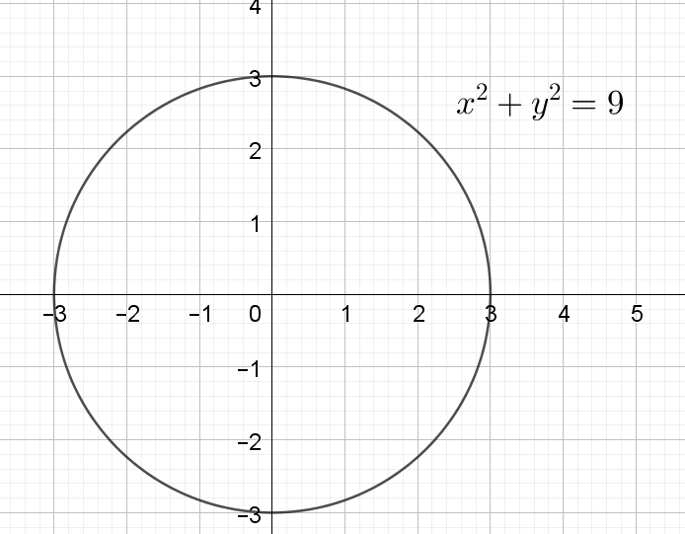

- $|z-3i|≤4$
- Finding the Cartesian equation:
  - Geometric interpretation:
$\left|z-3i\right|≤4$
This is of the form$\left|z-z_{1}\right|,$where $z_{1}=0+3i$
This is the set of points less than or equal to 4 units from the point $(0, 3)$ or the set of all points on or inside the circle with centre $(0, 3)$ and radius of $4$.
$$x^{2}+{(y-3)}^{2}≤16$$
  - Algebraic interpretation:
Let $z=x+iy$
$$|(x+iy)-3i|≤4$$
$$|(x+i(y-3)|≤4$$
$\sqrt{x^{2}+{(y-3)}^{2}}≤4$ (definition of the modulus)
$$x^{2}+{(y-3)}^{2}≤16$$
This is the set of points on or inside the circle with centre $(0, 3)$ and radius of $4$ or the set of all points less than or equal to 4 units from the point $(0, 3)$
- Sketch the graph:

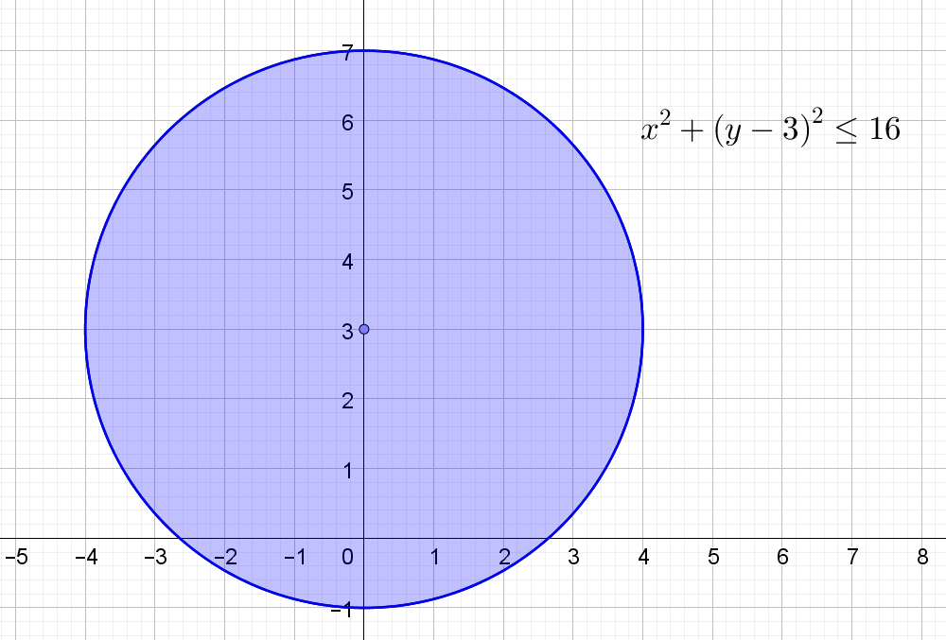

- $|z+3-2i|=5$
- Finding the Cartesian equation:
  - Geometric interpretation:
$\left|z+3-2i\right|=5$
This is of the form$\left|z-z_{1}\right|,$where $z_{1}=-3+2i$
This is the set of points 5 units from the point $(-3, 2)$ or a circle with centre $(-3, 2)$ and radius of 5.
$${(x+3)}^{2}+({y-2)}^{2}=25$$
  - Algebraic interpretation:
Let $z=x+iy$
$$\left|\left(x+iy\right)+3-2i\right|=5$$
$$\left|\left(x+3\right)+i\left(y-2\right)\right|=5$$
$\sqrt{{(x+3}^{2}+{(y-2)}^{2}}=5$ (definition of the modulus)
$$({x+3)}^{2}+{(y-2)}^{2}≤25$$
This is the set of points on the circle with centre $(-3, 2)$ and radius of 5 or the set of all points 5 units from the point $(-3, 2)$
- Sketch the graph:
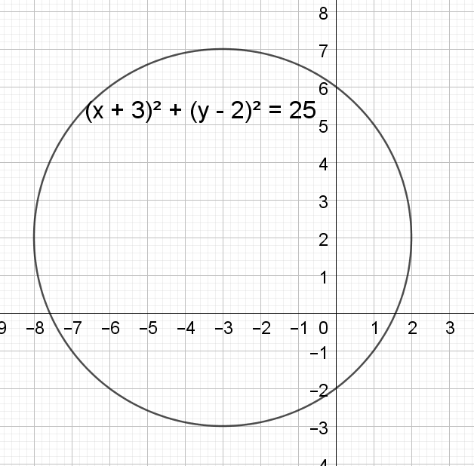

- $\frac{π}{4}≤Arg(z)≤\frac{3π}{4}$
- Geometric interpretation:
$\frac{π}{4}≤Arg(z)≤\frac{3π}{4}$ is the set of all points which have an argument between $\frac{π}{4}$ and $\frac{3π}{4}$ inclusive
- Algebraic interpretation:
Let $z=x+iy$
$Arg\left(z\right)=θ$, where $θ=\tan^{-1}\left(\frac{y}{x}\right)$
$$\frac{π}{4}≤Arg\left(x+iy\right)≤\frac{3π}{4}$$
$$\tan^{-1}\left(\frac{y}{x}\right)≥\frac{π}{4}$$
$$\frac{y}{x}≥1 \\ y≥x$$
$$\tan^{-1}\left(\frac{y}{x}\right)≤\frac{3π}{4}$$
$$\frac{y}{x}≤-1 \\ y≥-x$$
(Change the sign as $x$ is negative as $\frac{3π}{4}$ is in the 2nd quadrant)
This will represent the region which satisfies two conditions or the overlap in two regions. Region 1: $y≥x:$ Area above and including the line $y=x$.
Region 2: $y≥-x:$ Area above and including the line $y=-x$.
- Sketch the graph

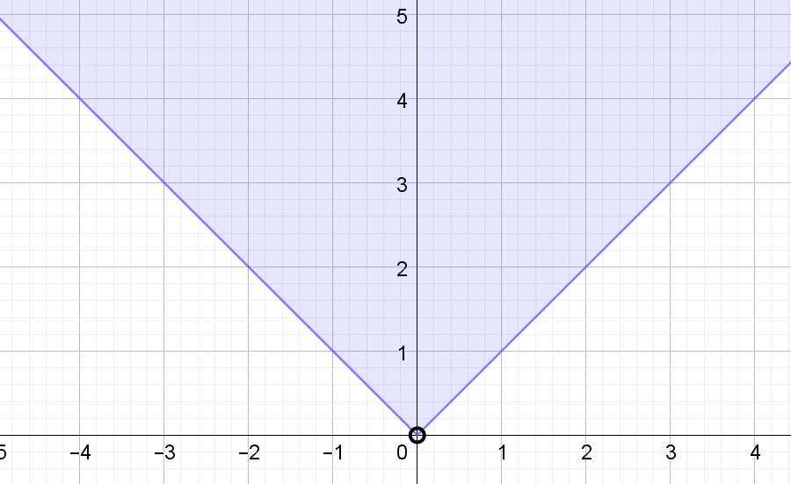

- $Re(z)>Im(z)$

- Algebraic interpretation:
Let $z=x+iy$
$Re\left(z\right)=x$ and $Im\left(z\right)=y$
$$x>y$$
$$y<x$$
This is the region where $y<x$, or the area below the line $y=x$
- Sketch the graph

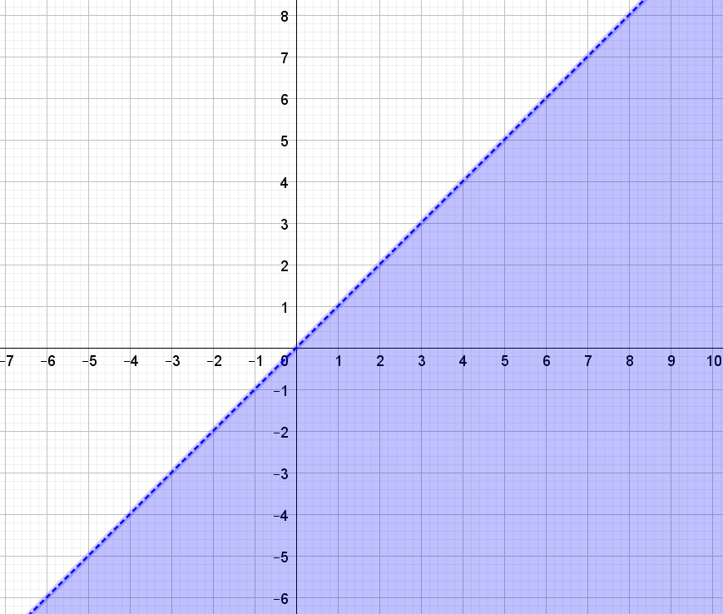

- $|z-1|=2|z-i|$
- Finding the Cartesian equation:
  - Geometric interpretation:
Set of points which are twice as far from $(1, 0)$ as they are from $(0, 1)$
  - Algebraic interpretation:
Let $z=x+iy$
$$|(x+iy)-1|=2|(x+iy)-i|$$
$$|(x-1)+iy|=2|x+i(y-1)|$$
$\sqrt{({x-1)}^{2}+y^{2}}≤2\sqrt{x^{2}+{(y-1)}^{2}}$ (definition of the modulus)
$({x-1)}^{2}+y^{2}≤4\left(x^{2}+{\left(y-1\right)}^{2}\right)$ (squaring both sides)
$$x^{2}-2x+1+y^{2}=4\left(x^{2}+y^{2}-2y+1\right) \\ x^{2}-2x+1+y^{2}=4x^{2}+4y^{2}-8y+4 \\ -3=3x^{2}+2x+3y^{2}-8y \\ 3x^{2}+2x+3y^{2}-8y=-3$$
$$3\left(x^{2}+\frac{2}{3}x\right)+3\left(y^{2}-\frac{8}{3}y\right)=-3$$
$$\left(x^{2}+\frac{2}{3}x\right)+3\left(y^{2}-\frac{8}{3}y\right)=-1$$
$$\left(x^{2}+\frac{2}{3}x+\frac{1}{9}\right)+\left(y^{2}-\frac{8}{3}y+\frac{16}{9}\right)=-1+\frac{1}{9}+\frac{16}{9}$$
$${\left(x+\frac{1}{3}\right)}^{2}+{\left(y-\frac{4}{3}\right)}^{2}=\frac{8}{9}$$
The equation represents a circle with centre $\left(-\frac{1}{3}, \frac{4}{3}\right)$ and radius $3$ or the set of points which are $3$ units from the origin.
- Sketch the graph

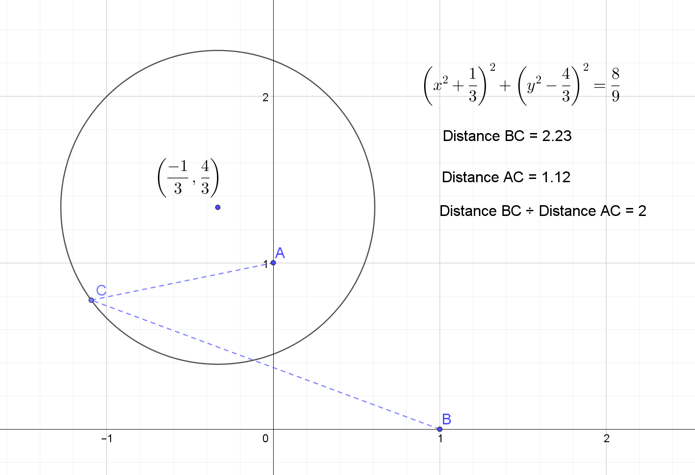
Geogerba applet demonstrating the solution where C is a moveable point and represents the solution.

- $4Re\left(z\right)+3Im\left(z\right)=12$
- Finding the Cartesian equation:
  - Algebraic interpretation:
Let $z=x+iy$
$Re\left(z\right)=x$ and $Im\left(z\right)=y$
$$4x+3y=12$$
Or
$$y=-\frac{4}{3}x+4$$
This is a linear relationship with
  - $y$-intercept of $4$ and $x$-intercept of $3$.
  - Gradient $-4/3$ and $y$-intercept of $4$.
- Sketch the graph

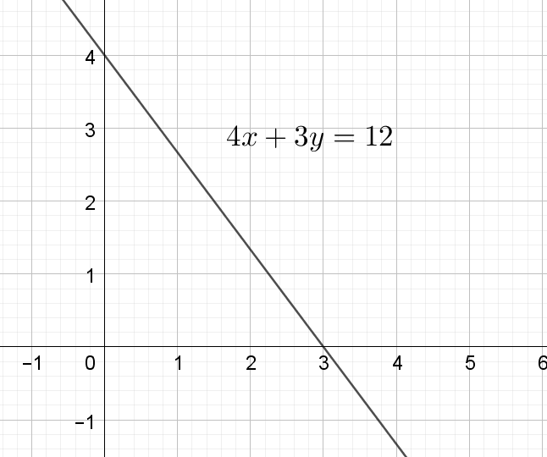

- Arg$\left(z-3+2i\right)=\frac{π}{3}$
- Geometric interpretation:
Arg$\left(z-3+2i\right)=\frac{π}{3}$
This is of the form$Arg(z-z_{1})$where $z_{1}=3-2i$
Arg$\left(z-3+2i\right)=\frac{π}{3}$is the set of all points which lie of the vector from (3, -2) at an angle of $\frac{π}{3}$ from the horizontal.
- Sketch the graph

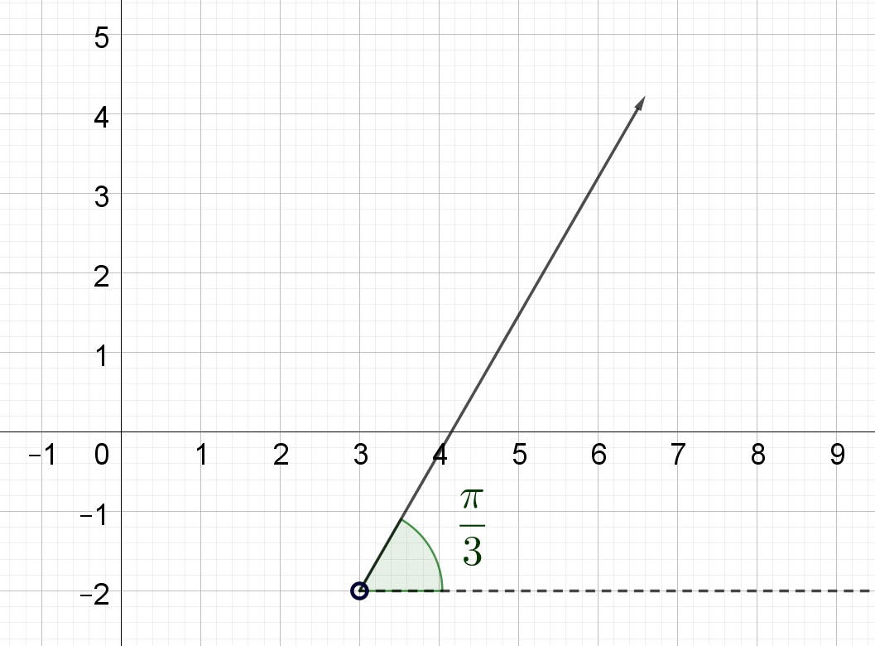

- |$z-2+i|+\left|z-2\right|=3$
- Finding the Cartesian equation:
- Geometric interpretation:
Set of points whose distance from $(2, -1)$ and distance from $(2,0)$ sums to 3.
- Algebraic interpretation:
Let $z=x+iy$
$$\left|\left(x+iy\right)-2+i\right|+\left|\left(x+iy\right)-2\right|=3$$
$$\left|\left(x-2\right)+i\left(y+1\right)\right|+|(x-2)+iy)|=3$$
$\sqrt{({x-2)}^{2}+{(y+1)}^{2}}+\sqrt{{(x-2)}^{2}+y^{2}}=3$ (definition of the modulus)
$$\sqrt{x^{2}-4x+4+y^{2}+2y+1}+\sqrt{x^{2}-4x+4+y^{2}}=3$$
$$\sqrt{x^{2}-4x+y^{2}+2y+5}+\sqrt{x^{2}-4x+y^{2}+4}=3$$
$x^{2}-4x+y^{2}+2y+5+x^{2}-4x+y^{2}+4+2\sqrt{x^{2}-4x+y^{2}+2y+5}\sqrt{x^{2}-4x+y^{2}+4}=9$
(squaring both sides)
${2x}^{2}-8x+2y^{2}+2y+9+2\sqrt{x^{2}-4x+y^{2}+2y+5}\sqrt{x^{2}-4x+y^{2}+4}=9$
$2\sqrt{x^{2}-4x+y^{2}+2y+5}\sqrt{x^{2}-4x+y^{2}+4}=-{2x}^{2}+8x-2y^{2}-2y$
$4\left(x^{2}-4x+y^{2}+2y+5\right)\left(x^{2}-4x+y^{2}+4\right)={\left(-{2x}^{2}+8x-2y^{2}-2y\right)}^{2}$ (squaring both sides)
$$LHS=4x^{4}-32x^{3}+8x^{2}y^{2}+8x^{2}y+100x^{2}-32xy^{2}-32xy-144x+4y^{4}+8y^{3}+36y^{2}+32y+80$$
$RHS=4x^{4}-32x^{3}+8x^{2}y^{2}+8x^{2}y+64x^{2}-32xy^{2}-32xy+4y^{4}+8y^{3}+4y^{2}$
$$100x^{2}-144x+36y^{2}+32y+80=64x^{2}+4y^{2}$$
$$36x^{2}-144x+32y^{2}+32y+80=0$$
$9x^{2}-36x+8y^{2}+8y+20=0$
$$9\left(x^{2}-4x\right)+8\left(y^{2}+y\right)=-20$$
$$9\left(x^{2}-4x+4\right)+8\left(y^{2}+y+\frac{1}{4}\right)=-20+36+2$$
$$9{\left(x-2\right)}^{2}+8{\left(y+\frac{1}{2}\right)}^{2}=18$$
(divide both sides by $8×9=72)$
$$\frac{{\left(x-2\right)}^{2}}{2}+\frac{{\left(y+\frac{1}{2}\right)}^{2}}{9}=\frac{1}{4}$$
$$\frac{{\left(x-2\right)}^{2}}{2}+\frac{{\left(y+\frac{1}{2}\right)}^{2}}{\frac{9}{4}}=1$$
Ellipse with centre $\left(2, -\frac{1}{2}\right)$ with minor axis of $\sqrt{2}$ and major axis of $\frac{3}{2}$

- Sketch the graph

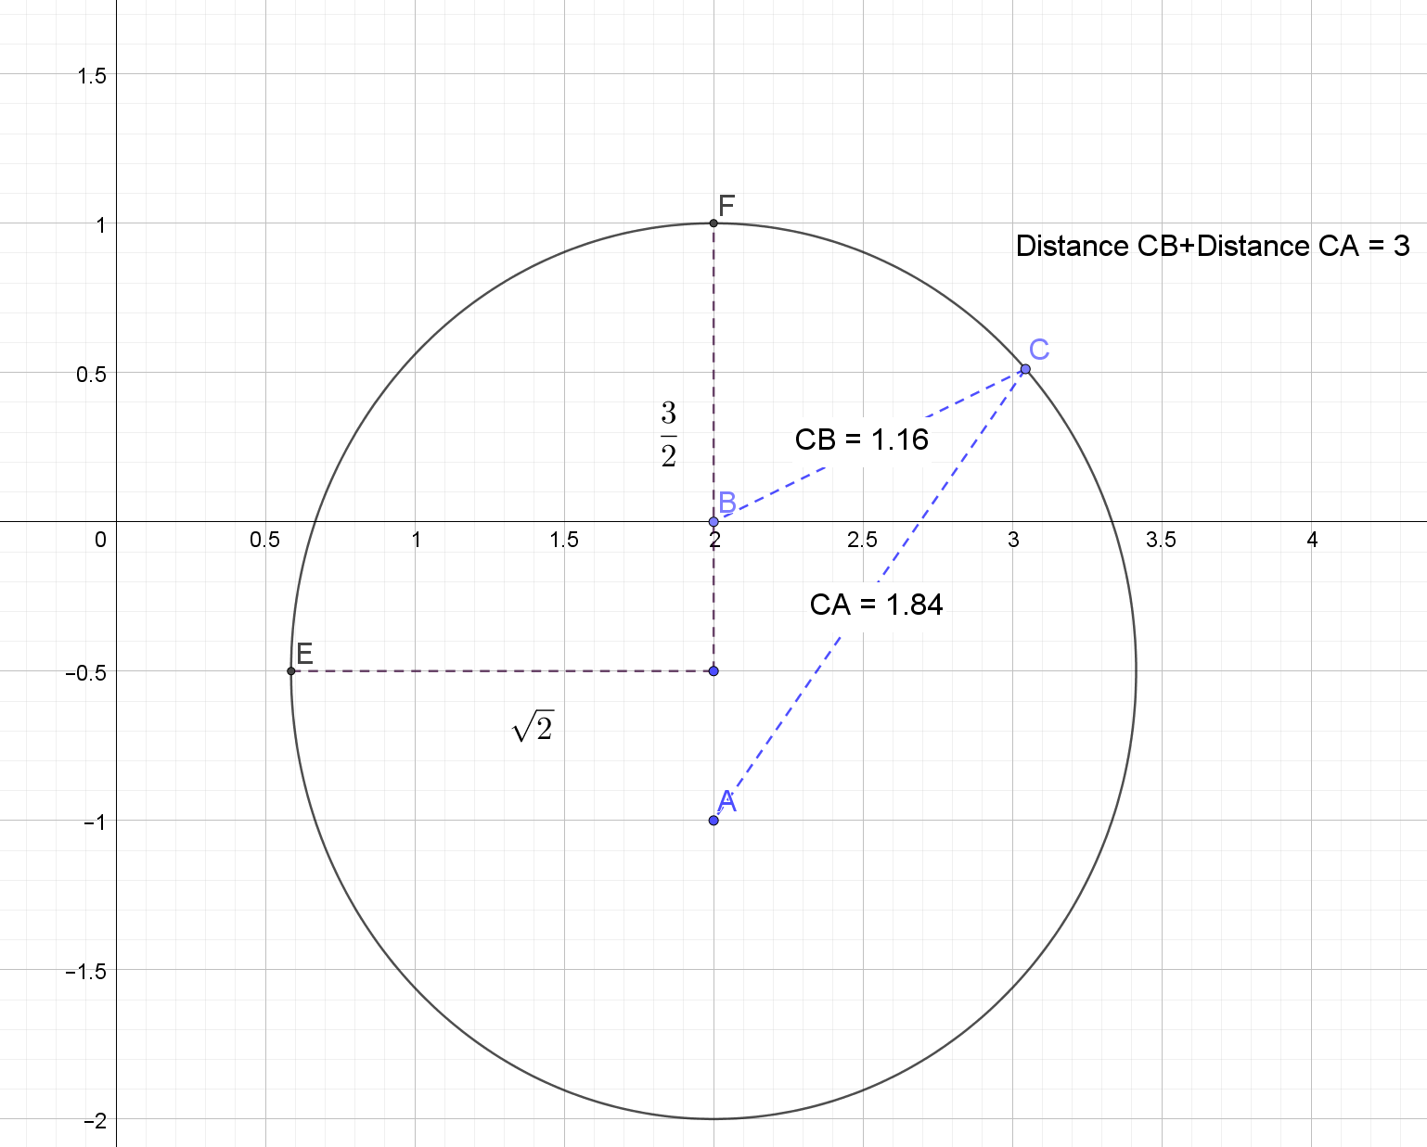
Geogerba applet demonstrating the solution where C is a moveable point and represents the solution.

