Roots of complex numbers

Showing the $n^{th}$ roots of complex numbers are evenly spaced
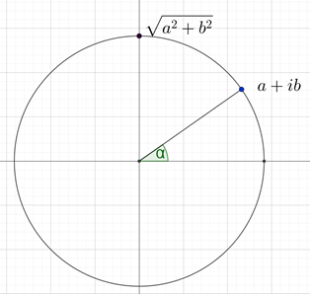
Consider solving ${(a+ib)}^{\frac{1}{n}}$
$$z={(a+ib)}^{\frac{1}{n}}$$
Let $z=r\operatorname{cis}{θ}$
$r\operatorname{cis}{θ}={\left(\sqrt{a^{2}+b^{2}}cis(α+2πk)\right)}^{\frac{1}{n}}$
Where $k=0,1,2,..(n-1)$ and $\tan{α}=\frac{a}{b}$
By De Moivre' s theorem
$$r\operatorname{cis}{θ}=\sqrt[n]{a^{2}+b^{2}} cis\left(\frac{α+2πk}{n}\right)$$
$r=\sqrt[n]{a^{2}+b^{2}}$, $θ=\frac{α}{n}, \frac{α}{n}+\frac{2π}{n}, \frac{α}{n}+\frac{4π}{n},…, \frac{α}{n}+\frac{2(n-1)π}{n}$
The $n^{th}$ roots of a complex number lie on a circle with radius $\sqrt[n]{a^{2}+b^{2}}$ and are evenly spaced by equal length arcs which subtend angles of $\frac{2π}{n}$ at the origin.
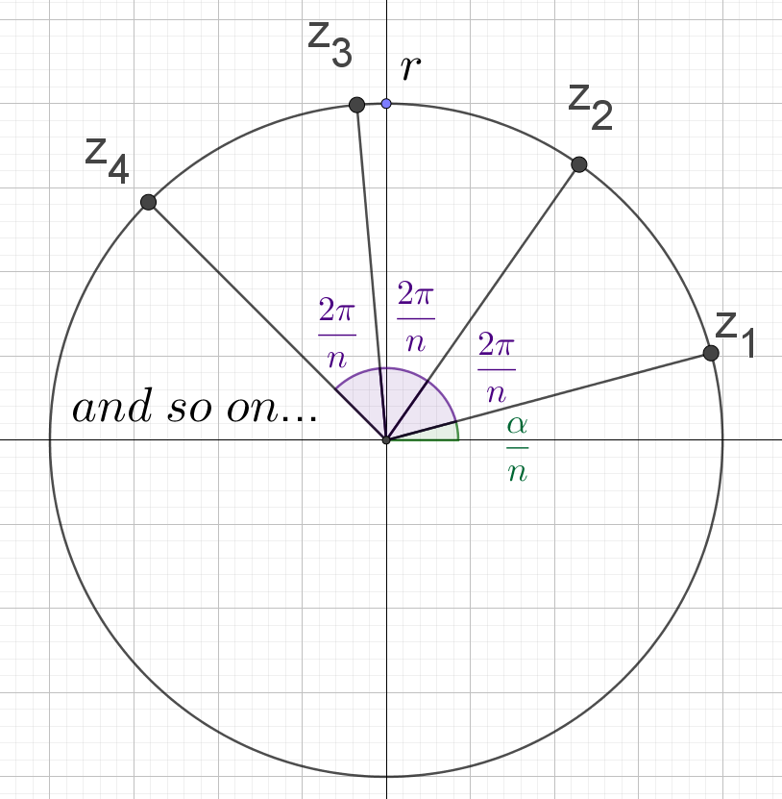
Note: This could be modelled using a numerical example.

Finding the $n^{th}$ root of complex numbers
- Solve ${\left(2i\right)}^{\frac{1}{2}}$
$$z={\left(2i\right)}^{\frac{1}{2}}$$
Let $z=r\operatorname{cis}{θ}$
$r\operatorname{cis}{θ}={\left(2cis\frac{π}{2}\right)}^{\frac{1}{2}}$

By De Moivre' s theorem
$$r\operatorname{cis}{θ}=\sqrt{2}cis\frac{π}{4}$$
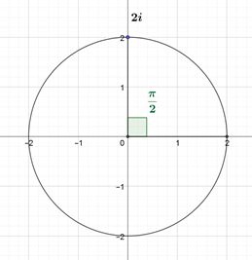
There will be 2 roots which are evenly spread over $2π$(one revolution).
They will be $\frac{2π}{2}=π$ radians apart.
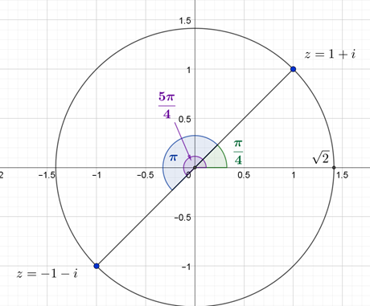

$r=\sqrt{2}$ and $θ=\frac{π}{4}, \frac{5π}{4}$
Polar form:
$z=\sqrt{2}\operatorname{cis}{\frac{π}{4}}$ and $\sqrt{2}\operatorname{cis}{\frac{5π}{4}}$
Cartesian form:

$$z=\sqrt{2}\left(\cos{\frac{π}{4}}+i\sin{\frac{π}{4}}\right)$$
$$=\sqrt{2}\left(\frac{\sqrt{2}}{2}+i\frac{\sqrt{2}}{2}\right)$$
$$=1+i$$
$$z=\sqrt{2}\left(\cos{\frac{5π}{4}}+i\sin{\frac{5π}{4}}\right)$$
$$=\sqrt{2}\left(\frac{-\sqrt{2}}{2}+i\frac{-\sqrt{2}}{2}\right)$$
$$=-1-i$$

- Solve ${\left(\sqrt{3}-i\right)}^{\frac{1}{3}}$
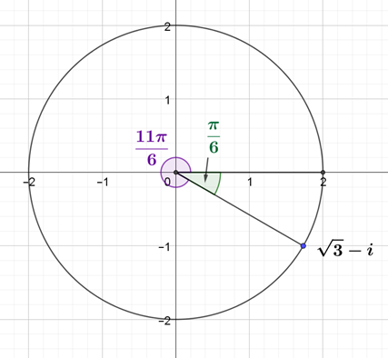
$$z={\left(\sqrt{3}-i\right)}^{\frac{1}{3}}$$
Let $z=r\operatorname{cis}{θ}$
$$r\operatorname{cis}{θ}={\left(2cis\frac{11π}{6}\right)}^{\frac{1}{3}}$$
By De Moivre' s theorem
$$r\operatorname{cis}{θ}=\sqrt[3]{2}cis\frac{11π}{18}$$
There will be 3 roots which are evenly spread over $2π$(one revolution).
They will be $\frac{2π}{3}$ or $\frac{12π}{18}$ radians apart.
$r=\sqrt[3]{2}$ and $θ=\frac{11π}{18}, \frac{23π}{18},\frac{35π}{18}$
Polar form:
$z=\sqrt[3]{2}\operatorname{cis}{\frac{11π}{18}}$ , $\sqrt[3]{2}\operatorname{cis}{\frac{23π}{18}}$ and $\sqrt[3]{2}\operatorname{cis}{\frac{35π}{18}}$
