Year 12 Mathematics Extension 2
MEX-N1 Introduction to complex numbers | Unit duration
The topic Complex Numbers involves investigating and extending understanding of the real number system to include complex numbers. The use of complex numbers is integral to many areas of life and modern-day technology such as electronics. A knowledge of complex numbers enables exploration of the ways different mathematical representations inform each other, and the development of understanding of the relationship between algebra, geometry and the extension of the real number system. The study of complex numbers is important in developing students’ understanding of the interconnectedness of mathematics and the real world. It prepares students for further study in mathematics itself and its applications. | 6 weeks

Subtopic focus | Outcomes
The principal focus of this subtopic is the development of the concept of complex numbers, their associated notations, different representations of complex numbers and the use of complex number operations in order to solve problems.  Students develop a suite of tools to represent and operate with complex numbers in a range of contexts. The skills of algebra, trigonometry and geometry are brought together and developed further, thus preparing students to work effectively with applications of complex numbers. | A student:  - understands and uses different representations of numbers and functions to model, prove results and find solutions to problems in a variety of contexts MEX12-1  - uses the relationship between algebraic and geometric representations of complex numbers and complex number techniques to model and solve problems MEX12-4  - applies various mathematical techniques and concepts to prove results, model and solve structured, unstructured and multi-step problems MEX12-7  - communicates and justifies abstract ideas and relationships using appropriate language, notation and logical argument MEX12-8

Prerequisite knowledge | Assessment strategies
The material in this topic builds on content from the Year 10 Mathematics 5.3 topic of MA5.3-6NA Surds and indices, Year 11 Mathematics Advanced topic of MA-T2 Trigonometric identities and Year 12 Mathematics Advanced topic of MA-C3 Applications of differentiation. | - Formative assessment opportunities through the unit, including matching tasks to link Cartesian, polar and exponential forms of complex numbers and use of applets to link the algebraic solutions with geometric representation.
All outcomes referred to in this unit come from Mathematics Extension 2 Syllabus
© NSW Education Standards Authority (NESA) for and on behalf of the Crown in right of the State of New South Wales, 2017

Glossary of terms
Term | Description
argument and principal argument of a complex number | When a complex number $z$ is represented by a point $P$ in the complex plane then the argument of $z$, denoted $arg z$, is the angle $θ$ that $OP$ (where $O$ denotes the origin) makes with the positive real axis $O_{x}$, with the angle measured from $O_{x}$.  If the argument is restricted to the interval $(-π, π]$, this is called the principal argument and is denoted by $Arg z$.
Cartesian form of a complex number | The Cartesian form of a complex number ($z$) is$z=x+iy$, where $x$ and $y$ are real numbers and $i$ is the imaginary number. Also known as standard or rectangular form.
complex conjugate | The complex conjugate of the number $z=a+ib$ is given by $\overline{z}=a-ib$, where $a$ and $b$ are real numbers. A complex number and its conjugate are called a conjugate pair.
complex plane | A complex plane is a Cartesian plane in which the horizontal axis is the real axis and the vertical axis is the imaginary axis. The complex plane is sometimes called the Argand plane. Geometric plots in the complex plane are known as Argand diagrams.
Euler’s formula | Euler’s formula states that for any real number $θ$: $e^{iθ}=cos θ + i sin θ$
exponential form of a complex number | The complex number $z=a+ib$ can be expressed in exponential form as$z=re^{iθ}$, where $r$ is the modulus of the complex number and $θ$ is the argument expressed in radians.
polar form of a complex number | The complex number $z=a+ib$ can be expressed in polar form as:  $z=r cosθ+ri sinθ=r\left(cosθ+i sinθ\right),$ where $r$ is the modulus of the complex number and $θ$ is its argument expressed in radians. This is also known as modulus-argument form.

Lesson sequence | Content | Suggested teaching strategies and resources | Date and initial | Comments, feedback, additional resource used
Introduction to complex numbers  (1 lesson) | N1.1: Arithmetic of complex numbers  - use the complex number system  - develop an understanding of the classification of numbers and their associated properties, symbols and representations  - define the number, $i$, as a root of the equation $x^{2}= -1$ (ACMSM067)  - use the symbol $i$ to solve quadratic equations that do not have real roots | Introduction to complex numbers  - Develop an understanding of the classification of numbers using the nrich resource vanishing roots. This provides a progression to the classification of numbers i.e. natural numbers, integers, rational numbers, irrational numbers and complex numbers. Students to construct a Venn diagram to display the classification of numbers.  - The acceptance of complex numbers provides a historical context to the discovery of complex numbers.  - Lead discussion that only one new number is required to define the new set of numbers, the complex or imaginary numbers. Define the number, $i$, as a root of the equation $x^{2}= -1$. The teacher uses the result $\sqrt{xy}=\sqrt{x}×\sqrt{y}$ to express the square root of negative numbers in terms of $i.$ Examples: $\sqrt{-3}=\sqrt{3}×\sqrt{-1}=\sqrt{3}i$and $\sqrt{-4}=\sqrt{4}×\sqrt{-1}=2i$  - Review the discriminant to determine the number of roots of a quadratic equation. If $∆<0$ then there are no real roots, but there are complex solutions.  - Students use the methods of completing the square or the quadratic formula to develop solutions for quadratic equations which have no real roots.  Examples:  Solve:  - $x^{2}=-17$  - $x^{2}=-36$  - $x^{2}+5x+8=0$
Complex number arithmetic  (2 lessons) | N1.1: Arithmetic of complex numbers  - represent and use complex numbers in Cartesian form AAM  - use complex numbers in the form $z=a+ib$, where $a$ and $b$ are real numbers and $a$ is the real part $Re(z)$and $b$ is the imaginary part $Im(z)$ of the complex number (ACMSM068, ACMSM077)  - identify the condition for $z_{1}=a+ib$ and $z_{2}=c+id$ to be equal  - define and perform complex number addition, subtraction and multiplication (ACMSM070)  N1.2: Geometric representation of a complex number  - represent and use complex numbers in the complex plane (ACMSM071)  - use the fact that there exists a one-to-one correspondence between the complex number $z=a+ib$ and the ordered pair $(a,b)$  - plot the point corresponding to $z=a+ib$ | Cartesian form of complex numbers  - The teacher defines the Cartesian form of a complex number as  $z=a+ib$, where $a$ and $b$ are real.  - The real part of a complex number is notated as $Re\left(z\right)=a$  - The imaginary part of a complex number is notated as  $Im\left(z\right)=b$.  The complex plane  - Teacher leads the discussion on what students associate with the phrase ‘Cartesian form’. The teacher introduces the concept of a complex plane or Argand diagram, where the $x$-axis is the real axis and the $y$-axis is the imaginary axis.  - The teacher uses the Geogebra applet, complex plane, to established the one-to-one correspondence between the Cartesian form of a complex number and its corresponding Cartesian coordinates in the complex plane, $(a, b)$.  - Students experience plotting points corresponding to $z=a+ib$ on a complex plane by hand and using graphing software.  - Use the Geogebra applet, complex plane, to identify that  $z_{1}=a+ib$ and $z_{2}=c+id$ are equal if and only if $a=c$ and $b=d$.  Addition and subtraction of complex numbers  - The development of the concept of the addition and subtraction of complex numbers can be examined using the following methods or a combination of both:  - The addition and subtraction of surds.  - $3\sqrt{5}+4\sqrt{5}=7\sqrt{5}$  $$3i+4i=3\sqrt{-1}+4\sqrt{-1}=7\sqrt{-1}=7i$$  - $6+3\sqrt{5}+10+4\sqrt{5}=16+7\sqrt{5}$  $$(6+3i)+(10+4i)=6+10+3\sqrt{-1}+4\sqrt{-1}$$  $$(6+3i)+(10+4i)=16+7\sqrt{-1} \\ (6+3i)+(10+4i)=16+7i$$  - The addition and subtraction of algebraic terms.  In an algebraic expression, $x$ represents a number and so does $i$.  - $3x+4x=7x$  $$3i+4i=7i$$  - $6+3x+10+4x=16+7x$  $$(6+3i)+(10+4i)=16+7i$$  - Note: The addition of complex numbers can be examined graphically use the Geogebra applet adding complex numbers.  - Summary: If $z_{1}= a+ib$ and $z_{2}= c+id$ then:  - $z_{1}+z_{2}=\left(a+ib\right)+\left(c+id\right)$  $$z_{1}+z_{2}=a+ib+c+id$$  $$z_{1}+z_{2}=\left(a+c\right)+i(b+d)$$  - $z_{1}-z_{2}=\left(a+ib\right)-\left(c+id\right)$  $$z_{1}-z_{2}=a+ib-c-id$$  $$z_{1}-z_{2}=\left(a-c\right)+i(b-d)$$  - Students practise a variety of addition and subtraction of complex numbers.  - Resources: Khan academy, adding and subtracting complex numbers, Symbolab complex number calculator  Multiplication of complex numbers  - If $z_{1}= a+ib$ and $z_{2}= c+id$ then $z_{1}×z_{2}=\left(a+ib\right)\left(c+id\right)$ Students expand and simplify this expression by considering the method applied to binomial products. Solutions are expressed in the form $a+ib$. Resource: Khan academy, multiplying complex numbers  - Students practice the multiplication of a complex number by:  - A real number  $$3\left(5-4i\right)=15-12i$$  - A purely imaginary number  $$3i\left(2+8i\right)=6i+24i^{2}$$  $$3i\left(2+8i\right)=6i+24×-1$$  $$3i\left(2+8i\right)=6i-24$$  $$3i\left(2+8i\right)=-24+6i$$  - Another complex number  $$\left(5+2i\right)\left(3+6i\right)=5×3+5×6i+2i× \\ \left(5+2i\right)\left(3+6i\right)=15+30i+6i+12i^{2} \\ \left(5+2i\right)\left(3+6i\right)=15+36i-12 \\ \left(5+2i\right)\left(3+6i\right)=3+36i$$
Further complex number arithmetic  (2-3 lessons) | N1.1: Arithmetic of complex numbers  - represent and use complex numbers in Cartesian form AAM  - define, find and use complex conjugates, and denote the complex conjugate of $z$ as $\overline{z}$  - divide one complex number by another complex number and give the result in the form  $$a+ib$$  - find the reciprocal and two square roots of complex numbers in the form $z=a+ib$ | Complex conjugates  - Students solve a range of quadratic equations which have imaginary roots. For example, $z^{2}+4z+7=0$ leads to roots  $z=-2-\sqrt{3}i$ and $z=-2+\sqrt{3}i$. By examining the roots, students will note that they follow the form $a±ib$.  - The teacher defines pairs of complex numbers, $a±ib$, as ‘conjugate pairs’ or ‘complex conjugates’. If $z=a+ib$ then its conjugate is $\overline{z}=a-ib$.  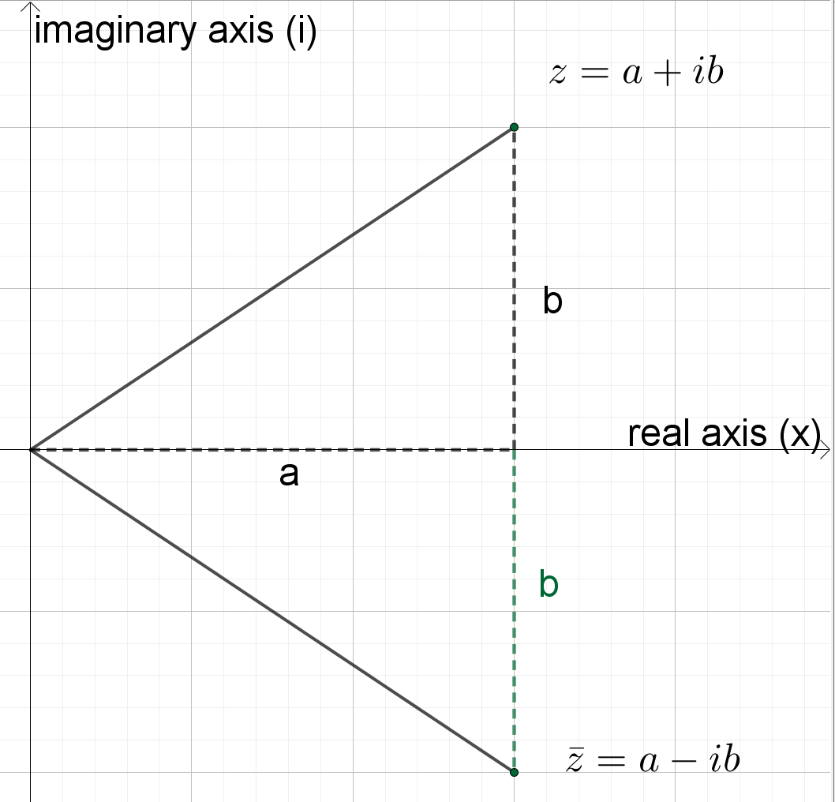  - Teachers should consider multiplying a complex number by its conjugate before introducing the concept of dividing complex numbers. Identify the result as a difference of two squares. Students should identify that $z×\overline{z}$ is a real number.  Division of complex numbers  - When dividing complex numbers, first express the question as a fraction then realise the denominator (make the denominator real) so the result is given in the form $a+ib$.  - The teacher leads the class through a question: Simplify: $\frac{5-3i}{3+2i}$. Pose the question(s):  - How can we make the denominator real?  - What can we multiply $3+2i$ by so that the answer is real?  Alternatively, relate this to rationalising the denominator of a surd, $\frac{a+b\sqrt{k}}{c+d\sqrt{k}}$, by expressing $i$ as the surd, $\sqrt{-1}$.  To realise the denominator, multiply the numerator and denominator by the conjugate of the denominator.  - Students practice the division of a complex number by:  - A real number  $$\frac{5+8i}{2}=\frac{5}{2}+4i$$  - A purely imaginary number  $$\frac{8+5i}{3i}=\frac{8+5i}{3i}×\frac{i}{i}$$  $$\frac{8+5i}{3i}=\frac{-5+8i}{-3}$$  $$\frac{8+5i}{3i}=\frac{5}{3}-\frac{8i}{3}$$  Alternatively, multiply by $\frac{-i}{-i}$  - Another complex number  i.e. multiply by the conjugate  $$\frac{5-3i}{3+2i}=\frac{5-3i}{3+2i}×\frac{3-2i}{3-2i}$$  $$\frac{5-3i}{3+2i}=\frac{15-10i-9i+6i^{2}}{3^{2}-{\left(2i\right)}^{2}}$$  $$\frac{5-3i}{3+2i}=\frac{9-19i}{13}$$  $$\frac{5-3i}{3+2i}=\frac{9}{13}-\frac{19}{13}i$$  - Students should also consider the division of a real number by a complex number.  - NESA sample questions:  Simplify the expressions:  - $\frac{1+3i}{1-2i}$  - $\frac{3+i}{2}$  - $\frac{1}{i}$  - $\frac{1+4i}{2i}$  - $\frac{1+2i}{2+i}$  Reciprocal of a complex number  - If $z=c+id$ then its reciprocal is $\frac{1}{z}=\frac{1}{c+id}$  - The reciprocal of a complex number should be given in the form $a+ib.$  - Students will identify that the method of realising the denominator is required to express the reciprocal of a complex number in the form $a+ib$.  Square roots of a complex number  - Students need to find the two square roots of complex numbers in the form $z=a+ib$  - To find the square root of a complex number, refer to the method in the resource document, square-root-of-a-complex-number.DOCX.
Modulus and argument of a complex number  (2 lessons) | N1.2: Geometric representation of a complex number  - represent and use complex numbers in polar or modulus-argument form, $z=r(\cos{θ}+i\sin{θ})$, where $r$ is the modulus of $z$ and $θ$ is the argument of $z$ AAM  - define and calculate the modulus of a complex number $z=a+ib$ as $\left|z\right|=\sqrt{a^{2}+b^{2}}$  - define and calculate the argument of a non-zero complex number $z=a+ib$ as $\arg{(z)}=θ$, where $\tan{θ=\frac{b}{a}}$  - define, calculate and use the principal argument $Arg(z)$ of a non-zero complex number $z$ as the unique value of the argument in the interval $(-π,π]$ | Modulus and argument of a complex number  - Refer to the diagram on the Argand plane which displays the modulus and argument of a complex number.  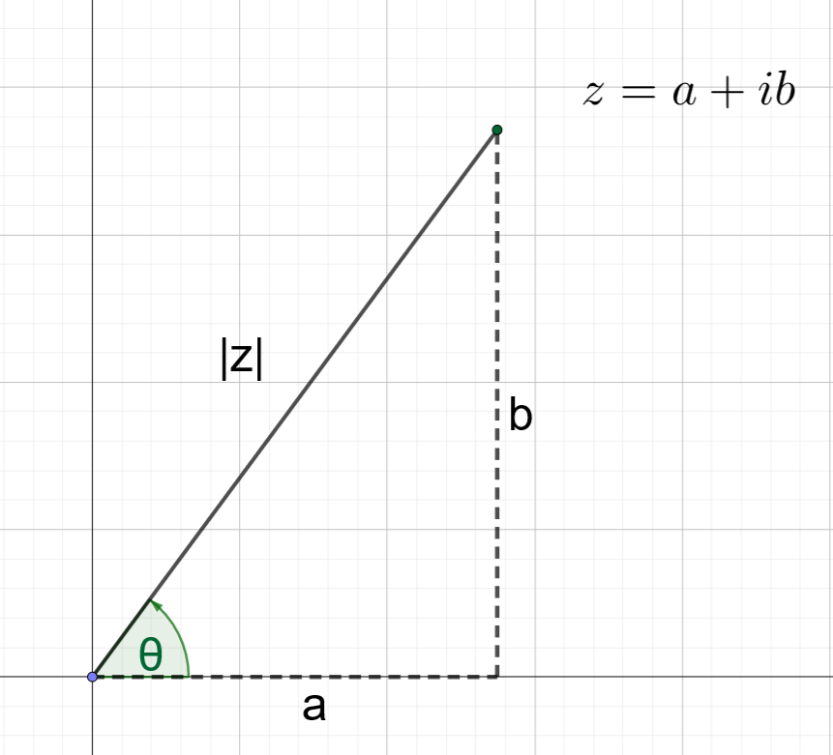  Modulus of $z$  - The teacher defines the modulus of $z,$denoted $\left|z\right|$, as the distance from the origin, $O$, to the point $z$ or the length of $Oz$  - By considering Pythagoras’ theorem, identify that $\left|z\right|=\sqrt{a^{2}+b^{2}}$  Argument of $z$  - The teacher defines the argument of $z,$denoted $\arg\left(z\right)=θ$, as the angle between $Oz$ and the positive $x$ – axis.  - From the diagram, given$z=a+bi$ and $\arg\left(z\right)=θ$ then $\tan{θ}=\frac{b}{a}$  - By examining the diagram, consider the value of $\arg\left(z\right)$ if:  - $a=0, \arg\left(z\right)$ is undefined. $θ$ can be read from the diagram.  - $b=0$, $\tan{θ}=0$. $θ$ can be read from the diagram.  - $z=0$, i.e. $a=0$ and $b=0$. $\tan{θ}=\frac{0}{0}$ which does not exist and so $\arg\left(0\right)$ does not exist.  Argument verse principal argument of z.  - For a given complex number there are infinite possible arguments as each rotation around the argand plane will generate theame complex number.  e.g. $z=\sqrt{3}+i$  $$\tan{θ}=\frac{1}{\sqrt{3}}$$  $$\arg\left(z\right)=θ=\frac{π}{6}, \frac{13π}{6}, \frac{25π}{6},…$$  - The principal argument of $z$, denoted $Arg z=θ$, is the unique value of the argument in the interval $(-π,π]$ i.e. $-π<θ≤π$.  e.g. $z=\sqrt{3}+i$  $$Arg z=\frac{π}{6}$$  - Explicitly teach identifying in which quadrant a complex number lies and the calculation of its modulus and argument. The Geogebra applet, modulus and argument of a complex number, allows the input of values for $a$ and $b$ and the geometric representation and calculation of $|z|$ and $Arg z$.  - Students practise calculating the modulus, argument and principal argument of a range of complex numbers in Cartesian form.
Polar or modulus-argument form  (2 lessons) | N1.2: Geometric representation of a complex number  - represent and use complex numbers in polar or modulus-argument form, $z=r(\cos{θ}+i\sin{θ})$, where $r$ is the modulus of $z$ and $θ$ is the argument of $z$ AAM  N1.3: Other representations of complex numbers  - use multiplication, division and powers of complex numbers in polar form and interpret these geometrically (ACMSM082) AAM | Polar or modulus-argument form  - The teacher leads the derivation of polar or modulus-argument form of complex numbers, $z=r(\cos{θ}+i\sin{θ})$, where $r$ is the modulus of $z$ and $θ$ is the argument of $z$.  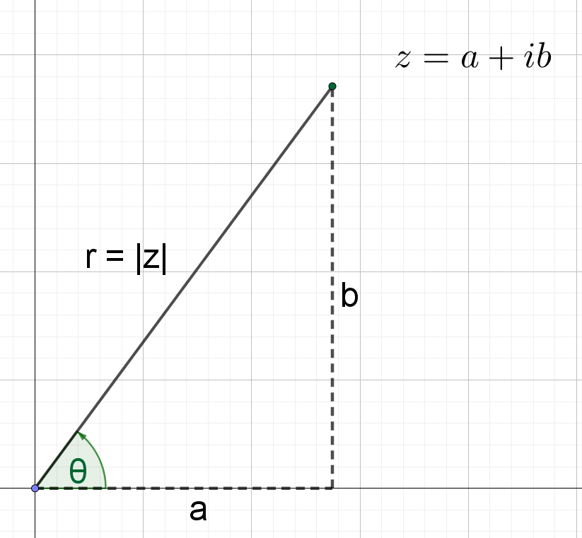  $z=a+ib$ (1)  Define $r$as the modulus of $z$.  $$\sin{θ}=\frac{b}{r}$$  $$b=r\sin{θ}$$  $$\cos{θ}=\frac{a}{r}$$  $$a=r\cos{θ}$$  Substituting $b=r\sin{θ}$ and $a=r\cos{θ}$ into (1)  $$z=r\cos{θ}+ir\sin{θ}$$  $$z=r(\cos{θ}+i\sin{θ})$$  - The teacher explains that polar form can be abbreviated as:  $$z=r\left(\cos{θ}+i\sin{θ}\right)=rcis\left(θ\right)$$  $$\overline{z}=r\left(\cos{θ}-i\sin{θ}\right)=rcis\left(-θ\right)$$  - The teacher demonstrates and students practice converting complex numbers from Cartesian form into modulus-argument form and visa versa.  Arithmetic in polar form  - Note: Arithmetic in polar form could be practiced at this stage or combined with the exponential form.  - Students practice the multiplication, division and powers of complex numbers in polar form and interpret these geometrically. Resource: arithmetic-in-polar-and-exponential-form.DOCX  - The geometric significance of multiplication and division can also be explored using Geogebra applets.
Identities involving modulus and argument  (1 lesson) | N1.2: Geometric representation of a complex number  - prove and use the basic identities involving modulus and argument (ACMSM080) AAM  - $|z_{1}z_{2}|=|z_{1}||z_{2}|$ and $arg (z_{1}z_{2})=arg z_{1}+arg z_{2}$  - $\left|\frac{z_{1}}{z_{2}}\right|=\frac{|z_{1}|}{|z_{2}|}$ and $arg\left(\frac{z_{1}}{z_{2}}\right)=arg z_{1}-arg z_{2}$, $z_{2}≠0$  - $|z^{n}|={|z|}^{n}$ and $arg(z^{n})=n arg z$  - $\left|\frac{1}{z^{n}}\right|=\frac{1}{{|z|}^{n}}$ and $arg\left(\frac{1}{z^{n}}\right)=-n arg z$, $z≠0$  - $\overline{z_{1}}+\overline{z_{2}}=\overline{z_{1}+ z_{2}}$  - $\overline{z_{1}} \overline{z_{2}}=\overline{z_{1} z_{2}}$  - $z\overline{z}={\left|z\right|}^{2}$  - $z+\overline{z}=2Re(z)$  - $z-\overline{z}=2iIm(z)$ | Identities involving modulus and argument  - Students investigate and derive the results of the basic identities involving modulus and argument.  - $|z_{1}z_{2}|=|z_{1}||z_{2}|$ and $arg (z_{1}z_{2})=arg z_{1}+arg z_{2}$  - $\left|\frac{z_{1}}{z_{2}}\right|=\frac{|z_{1}|}{|z_{2}|}$ and $arg\left(\frac{z_{1}}{z_{2}}\right)=arg z_{1}-arg z_{2}$, $z_{2}≠0$  - $\left|z^{n}\right|={\left|z\right|}^{n}$ and $\arg\left(z^{n}\right)=n\arg{z}$  - $\left|\frac{1}{z^{n}}\right|=\frac{1}{{\left|z\right|}^{n}}$ and $arg\left(\frac{1}{z^{n}}\right)=-n\arg{z}$, $z≠0$  - $\overline{z_{1}}+\overline{z_{2}}=\overline{z_{1}+ z_{2}}$  - $\overline{z_{1}} \overline{z_{2}}=\overline{z_{1} z_{2}}$  - $z\overline{z}={\left|z\right|}^{2}$  - $z+\overline{z}=2Re(z)$  - $z-\overline{z}=2iIm\left(z\right)$  For sample proofs of each identity, refer to the resource document, identities-involving-modulus-and-argument.DOCX.  - NESA sample questions  Students practise proving results using complex conjugates. For example:  - If $s=1+2i$, show that $\overline{\left(s^{2}\right)}={\left(\overline{s}\right)}^{2}$  - If $a=2$, $z=1+3i$ and $n=4$, calculate $\overline{\left(az^{n}\right)}$ and $a{\left(\overline{z}\right)}^{n}$, and verify that $\overline{\left(az^{n}\right)}=a{\left(\overline{z}\right)}^{n}$.
Other representations of complex numbers  (2-3 lesson) | N1.3: Other representations of complex numbers  - understand Euler’s formula, $e^{ix}=cos x + i sin x,$ for real $x$  - represent and use complex numbers in exponential form, $z=re^{iθ}$, where $r$ is the modulus of $z$ and $θ$ is the argument of $z$ AAM  - use Euler’s formula to link polar form and exponential form  - convert between Cartesian, polar and exponential forms of complex numbers  - find powers of complex numbers using exponential form  - use multiplication, division and powers of complex numbers in polar form and interpret these geometrically (ACMSM082) AAM  - solve problems involving complex numbers in a variety of forms AAM | Develop an understanding of Euler’s formula  - Students watch Taylor series Essence of calculus (duration 22:19) to understand Taylor series.  - Students develop Euler’s formula, $e^{ix}=cos x + i sin x$ by using the following Taylor series:  - $e^{x}=1+\frac{x}{1!}+\frac{x^{2}}{2!}+\frac{x^{3}}{3!}+\frac{x^{4}}{4!}+…+\frac{x^{n}}{n!}+…$  - $\cos{x}=1-\frac{x^{2}}{2!}+\frac{x^{4}}{4!}-\frac{x^{6}}{6!}+…{\left(-1\right)}^{n}\frac{x^{2n}}{\left(2n\right)!}…$  - $\sin{x}=x-\frac{x^{3}}{3!}+\frac{x^{5}}{5!}-\frac{x^{7}}{7!}+…{\left(-1\right)}^{n}\frac{x^{2n+1}}{\left(2n+1\right)!}…$  Refer to the resource other-representations-of-complex-numbers.DOCX  Notes:  - The teacher could provide these results, lead the derivation as a class or allow students to derive these independently or in groups.  - Following the derivation, students could use graphing software to explore the polynomial expansions (Taylor series) for $e^{ix}$.  Exponential form of a complex number  - Students use Euler’s formula to link polar form and develop exponential form.  - Exponential form, $z=re^{iθ}$, where $r$ is the modulus of $z$ and $θ$ is the argument of $z$.  - Students construct a summary of Cartesian, polar and exponential form of complex numbers.  - Refer to the resource other-representations-of-complex-numbers.DOCX  - Students practise converting between Cartesian, polar and exponential forms of complex numbers. Resource: matching-activity-complex-numbers.DOCX  Arithmetic in polar and exponential form  - Polar form (if not previously completed, see previous lessons)  - Exponential form: Students practise finding powers of complex numbers using exponential form.  - Students use the following result:  Consider $z=re^{iθ}$, raise both sides to the power of $n$ to obtain  $$z^{n}={\left(re^{iθ}\right)}^{n}=r^{n}e^{iθn}$$  - Note: To evaluate powers of complex numbers in polar form, students could also convert the original complex number to exponential form, raise it to the power then convert back to polar form. A Khan Academy video examines the argument using this method. Resource: Arithmetic-in-polar-and-exponential-form.DOCX

Reflection and evaluation
Please include feedback about the engagement of the students and the difficulty of the content included in this section. You may also refer to the sequencing of the lessons and the placement of the topic within the scope and sequence. All ICT, literacy, numeracy and group activities should be recorded in the ‘Comments, feedback, additional resources used’ section.

