****Mathematics Extension 2****

# MEX-V1 Further work with vectors

## Table of contents

Mathematics Extension 2 1

MEX-V1 Further work with vectors 1

Table of contents 2

Outcomes 4

Content 4

Supplementary resources 6

Department of Education resources 6

NESA resources 6

Jonathan Kim Sing videos 6

Examination-style questions 7

Sample question 1 7

Sample question 2 7

Sample question 3 8

Sample question 4 8

Sample question 5 9

Sample question 6 9

Sample question 7 10

Sample question 8 10

Sample question 9 10

Sample question 10 11

Sample question 11 11

Sample question 12 12

Sample question 13 12

Sample question 14 13

Sample question 15 14

Sample question 16 15

Sample question 17 16

Sample question 18 16

Sample question 19 17

Sample question 20 18

Sample question 21 19

Sample question 22 20

Sample question 23 21

Sample question 24 22

Sample question 25 23

Solutions 24

Sample question 1 24

Sample question 2 24

Sample question 3 24

Sample question 4 25

Sample question 5 25

Sample question 6 25

Sample question 7 26

Sample question 8 27

Sample question 9 28

Sample question 10 28

Sample question 11 29

Sample question 12 30

Sample question 13 30

Sample question 14 30

Sample question 15 31

Sample question 16 31

Sample question 17 32

Sample question 18 32

Sample question 19 33

Sample question 20 33

Sample question 21 34

Sample question 22 35

Sample question 23 36

Sample question 24 37

Sample question 25 38

**Disclaimer**

This document is to be used to supplement the support teachers are offering students undertaking HSC Mathematics courses. Questions can be printed off for students individually, with or without solutions, or as an entire booklet. Questions have been sourced from various states across Australia and the source of each question has been referenced. Permission to use these resources was provided in June 2020. Solutions for each of the questions can be found at the end of the document.

**Outcomes**

All outcomes referred to in this booklet are from [Mathematics Extension 2 Syllabus](https://educationstandards.nsw.edu.au/wps/portal/nesa/11-12/stage-6-learning-areas/stage-6-mathematics/mathematics-extension-2-2017) © 2017 NSW Education Standards Authority (NESA) for and on behalf of the Crown in right of the State of New South Wales.

## Outcomes

**A student:**

* uses vectors to model and solve problems in two and three dimensions **MEX12-3**
* applies various mathematical techniques and concepts to model and solve structured, unstructured and multi-step problems **MEX12-7**
* communicates and justifies abstract ideas and relationships using appropriate language, notation and logical argument **MEX12-8**

## Content

**V1.1: Introduction to three-dimensional vectors**

Students:

* understand and use a variety of notations and representations for vectors in three dimensions
  + define the standard unit vectors,  and 
  + express and use a vector in three dimensions in a variety of forms, including component form, ordered triples and column vector notation
* perform addition and subtraction of three-dimensional vectors and multiplication of three-dimensional vectors by a scalar algebraically and geometrically, and interpret these operations in geometric terms

**V1.2: Further operations with three-dimensional vectors**

Students:

* define, calculate and use the magnitude of a vector in three dimensions
  + establish that the magnitude of a vector in three dimensions can be found using:  
    
  + convert a non-zero vector  into a unit vector  by dividing by its length: 
* define and use the scalar (dot) product of two vectors in three dimensions **AAM**
  + define and apply the scalar product  to vectors expressed in component form, where   
    ,  and 
  + extend the formula  for three dimensions and use it to solve problems
* prove geometric results in the plane and construct proofs in three dimensions (ACMSM102)

**V1.3: Vectors and vector equations of lines**

Students:

* use Cartesian coordinates in two and three-dimensional space
* recognise and find the equations of spheres
* use vector equations of curves in two or three dimensions involving a parameter, and determine a corresponding Cartesian equation in the two-dimensional case, where possible (ACMSM104) **AAM**
* understand and use the vector equation  of a straight line through points $A$ and $B$ where $R$ is a point on $AB$, **,** **, $λ$**  is a parameter and 
* make connections in two dimensions between the equation  and $y=mx+c$
* determine a vector equation of a straight line or straight-line segment, given the position of two points or equivalent information, in two and three dimensions (ACMSM105)
* determine when two lines in vector form are parallel
* determine when intersecting lines are perpendicular in a plane or three dimensions
* determine when a given point lies on a given line in vector form

## Supplementary resources

### Department of Education resources

#### Units of work

* [MEX-V1 Further work with vectors](https://education.nsw.gov.au/teaching-and-learning/curriculum/key-learning-areas/mathematics/stage-6/mathematics-extension-2)
* [MEX V1 sample questions](https://education.nsw.gov.au/teaching-and-learning/curriculum/key-learning-areas/mathematics/stage-6/mathematics-extension-1#Year10)

#### HSC Hub videos

* [Determining the intersection of line segments Q10 NESA sample examination](https://hschub.nsw.edu.au/mathematics-items/determining-the-intersection-of-line-segments)
* [Using the scalar product Q15b NESA sample examination](https://hschub.nsw.edu.au/mathematics-items/using-the-scalar-product)

### NESA resources

* [Mathematics Extension 2 – Sample examination materials (2020)](https://educationstandards.nsw.edu.au/wps/portal/nesa/11-12/stage-6-learning-areas/stage-6-mathematics/mathematics-extension-2-2017)

### Jonathan Kim Sing videos

* [Vectors (Y12 Extension 2)](https://www.youtube.com/playlist?list=PLnPz4TGRkQDtUzyZObE1xXHo0yAyEEguF)

## Examination-style questions

### Sample question 1

The position vector of a particle that is moving along a curve at time t is given by

$\underset{\sim }{r}\left(t\right)=3\cos\left(t\right)\underset{\sim }{i}+4sin⁡(t)\underset{\sim }{j}$, $t≥0.$

The **first** time when the speed of the particle is a minimum is

$3$

$\frac{π}{2}$

$\tan^{-1}\left(\frac{4}{3}\right)$

$\frac{3π}{2}$

$9$

Source: **Question 13** [©VCAA 2018 VCE Specialist mathematics written examination 2](https://vcaa.vic.edu.au/assessment/vce-assessment/past-examinations/Pages/Specialist-Mathematics.aspx)

### Sample question 2

The position vectors of two moving particles are given by ${\underset{\sim }{r}}_{1}\left(t\right)=\left(2+4t^{2}\right)\underset{\sim }{i}+(3t+2)\underset{\sim }{j}$ and ${\underset{\sim }{r}}_{2}\left(t\right)=\left(6t\right)\underset{\sim }{i}+(4+t)\underset{\sim }{j}$, where $t ≥ 0$.

The particles will collide at

$3\underset{\sim }{i}+3.5\underset{\sim }{j}$

$6\underset{\sim }{i}+5\underset{\sim }{j}$

$3\underset{\sim }{i}+4.5\underset{\sim }{j}$

$0.5\underset{\sim }{i}+\underset{\sim }{j}$

$5\underset{\sim }{i}+6\underset{\sim }{j}$

Source: **Question 18** [©VCAA 2015 VCE Specialist mathematics written examination 2](https://vcaa.vic.edu.au/assessment/vce-assessment/past-examinations/Pages/Specialist-Mathematics.aspx)

### Sample question 3

Let $\underset{\sim }{a}=3\underset{\sim }{i}+2\underset{\sim }{j}+α\underset{\sim }{k}$ and $\underset{\sim }{b}=4\underset{\sim }{i}-\underset{\sim }{j}+α^{2}\underset{\sim }{k}$, where $α$ is a real constant.

If the scalar projection of $\underset{\sim }{a}$ in the direction of $\underset{\sim }{b}$ is $\frac{74}{\sqrt{273}}$, then $α$ equals

1. 1
2. 2
3. 3
4. 4
5. 5

Source: **Question 11** [©VCAA 2016 VCE Specialist mathematics written examination 2](https://vcaa.vic.edu.au/assessment/vce-assessment/past-examinations/Pages/Specialist-Mathematics.aspx)

### Sample question 4

If $\underset{\sim }{a}=-2\underset{\sim }{i}-\underset{\sim }{j}+3\underset{\sim }{k}$ and $\underset{\sim }{b}=-m\underset{\sim }{i}+\underset{\sim }{j}+2\underset{\sim }{k}$, where $m$ is a real constant, the vector $\underset{\sim }{a}-\underset{\sim }{b}$

will be perpendicular to vector $\underset{\sim }{b}$ where $m$ equals

1. 0 only
2. 2 only
3. 0 or 2
4. 4.5
5. 0 or -2

Source: **Question 12** [©VCAA 2016 VCE Specialist mathematics written examination 2](https://vcaa.vic.edu.au/assessment/vce-assessment/past-examinations/Pages/Specialist-Mathematics.aspx)

### Sample question 5

Points $A$, $B$ and $C$ have position vectors $\underset{\sim }{a}=2\underset{\sim }{i}+\underset{\sim }{j}$, $\underset{\sim }{b}=3\underset{\sim }{i}-\underset{\sim }{j}+\underset{\sim }{k}$ and $\underset{\sim }{c}=-3\underset{\sim }{j}+\underset{\sim }{k}$ respectively.

The cosine of angle ABC is equal to

$\frac{5}{\sqrt{6}\sqrt{10} }$

$\frac{7}{\sqrt{6}\sqrt{13} }$

$-\frac{1}{\sqrt{6}\sqrt{13} }$

$\frac{7}{\sqrt{21}\sqrt{6} }$

$-\frac{2}{\sqrt{6}\sqrt{13} }$

Source: **Question 17** [©VCAA 2015 VCE Specialist mathematics written examination 2](https://vcaa.vic.edu.au/assessment/vce-assessment/past-examinations/Pages/Specialist-Mathematics.aspx)

### Sample question 6

The scalar projection of $\underset{\sim }{a}= 3\underset{\sim }{i}- 2\underset{\sim }{k}$ in the direction of $\underset{\sim }{b}= -\underset{\sim }{i}+2\underset{\sim }{j}+3\underset{\sim }{k}$ is

$-\frac{9\sqrt{13}}{13}$

$-\frac{9}{14}(-\underset{\sim }{i}+2\underset{\sim }{j}+3\underset{\sim }{k})$

$-\frac{9\sqrt{14}}{14}$

$-\frac{9}{13}(3\underset{\sim }{i}-2\underset{\sim }{k})$

$-\frac{\sqrt{14}}{2}$

Source: **Question 14** [©VCAA 2018 VCE Specialist mathematics written examination 2](https://vcaa.vic.edu.au/assessment/vce-assessment/past-examinations/Pages/Specialist-Mathematics.aspx)

### Sample question 7

Given the vectors $\underset{\sim }{a}=3\underset{\sim }{i}-4\underset{\sim }{j}+12\underset{\sim }{k}$ and $\underset{\sim }{b}=2\underset{\sim }{i}+2\underset{\sim }{j}-\underset{\sim }{k}$, the vector projection of $\underset{\sim }{a}$ in the direction of $\underset{\sim }{b}$ is

$-\frac{14}{3}$

$-\frac{14}{3}\left( 2\underset{\sim }{i}+2\underset{\sim }{j}-\underset{\sim }{k}\right)$

$-\frac{14}{9}(2\underset{\sim }{i}+2\underset{\sim }{j}-\underset{\sim }{k})$

$-\frac{14}{13}$

$-\frac{14}{169}(3\underset{\sim }{i}-4\underset{\sim }{j}+12\underset{\sim }{k})$

Source: **Question 13** [©VCAA 2017 VCE Specialist mathematics written examination 2](https://vcaa.vic.edu.au/assessment/vce-assessment/past-examinations/Pages/Specialist-Mathematics.aspx)

### Sample question 8

Relative to a fixed origin, the points $B$, $C$ and $D$ are defined respectively by the position vectors $\underset{\sim }{b}=\underset{\sim }{i}-\underset{\sim }{j}+2\underset{\sim }{k}$, $\underset{\sim }{c}=2\underset{\sim }{i}-\underset{\sim }{j}+\underset{\sim }{k}$ and $\underset{\sim }{d}=a\underset{\sim }{i}-2\underset{\sim }{j}$, where $a$ is a real constant.

Given that the magnitude of angle $BCD$ is $\frac{π}{3}$, find $a$.

**(4 marks)**

Source: **Question 5** [©VCAA 2017 VCE Specialist mathematics written examination 1](https://vcaa.vic.edu.au/assessment/vce-assessment/past-examinations/Pages/Specialist-Mathematics.aspx)

### Sample question 9

Consider the vectors $\underset{\sim }{a}=3\underset{\sim }{i}+5\underset{\sim }{j}-2\underset{\sim }{k}$, $\underset{\sim }{b}=\underset{\sim }{i}-2\underset{\sim }{j}+3\underset{\sim }{k}$ and $\underset{\sim }{c}=\underset{\sim }{i}+d\underset{\sim }{k}$, where d is a real constant.

1. Find the vector projection of $\underset{\sim }{a}$ in the direction of $\underset{\sim }{b}$.

**(2 marks)**

Source: **Question 5** [©VCAA 2016 VCE Specialist mathematics written examination 1](https://vcaa.vic.edu.au/assessment/vce-assessment/past-examinations/Pages/Specialist-Mathematics.aspx)

### Sample question 10

The position vectors of two particles A and B at time t seconds after they have started moving are given by ${\underset{\sim }{r}}_{A}\left(t\right)=\left(t^{2}-1\right)\underset{\sim }{i}+\left(a+\frac{t}{3}\right)\underset{\sim }{j}$ and ${\underset{\sim }{r}}_{B}\left(t\right)=\left(t^{3}-t\right)\underset{\sim }{i}+\left(\cos^{-1}\left(\frac{1}{2}\right)\right)\underset{\sim }{j}$ respectively, where a is a real constant and $0≤ t≤2$.

Find the value of $a$ if the particles collide after they have started moving.

**(3 marks)**

Source: **Question 4** [©VCAA 2019 VCE Specialist mathematics written examination 1](https://vcaa.vic.edu.au/assessment/vce-assessment/past-examinations/Pages/Specialist-Mathematics.aspx)

### Sample question 11

The base of a pyramid is the parallelogram $ABCD$ with vertices at points $A(2, –1, 3)$, $B(4, –2, 1)$, $C(a, b, c)$ and $D(4, 3, –1)$. The apex (top) of the pyramid is located at $P(4, –4, 9)$.

1. Find the values of $a$, $b$ and $c$.

**(2 marks)**

1. Find the cosine of the angle between the vectors $\vec{AB}$ and $\vec{AD}$.

**(2 marks)**

1. Find the area of the base of the pyramid.

**(2 marks)**

1. Show that $6\underset{\sim }{i}+2\underset{\sim }{j}+5\underset{\sim }{k}$ is perpendicular to both $\vec{AB}$ and $\vec{AD}$, and hence find a unit vector that is perpendicular to the base of the pyramid.

**(3 marks)**

1. Find the volume of the pyramid.

**(2 marks)**

Source: **Question 4** [©VCAA 2019 VCE Specialist mathematics written examination 2](https://vcaa.vic.edu.au/assessment/vce-assessment/past-examinations/Pages/Specialist-Mathematics.aspx)

### Sample question 12

A curve is specified parametrically by $\underset{\sim }{r}\left(t\right)=\sec\left(t\right)\underset{\sim }{i}+\frac{\sqrt{2}}{2}\tan{(t)}\underset{\sim }{j}$, $t∈R$.

1. Show that the cartesian equation of the curve is $x^{2}-2y^{2}=1$.

**(2 marks)**

Source: **Question 9** [©VCAA 2018 VCE Specialist mathematics written examination 1](https://vcaa.vic.edu.au/assessment/vce-assessment/past-examinations/Pages/Specialist-Mathematics.aspx)

### Sample question 13

Two yachts, A and B, are competing in a race and their position vectors on a certain section of the race after time $t$ hours are given by

${\underset{\sim }{r}}_{A}\left(t\right)=\left(t+1\right)\underset{\sim }{i}+(t^{2}+2t)\underset{\sim }{j}$ and ${\underset{\sim }{r}}_{B}\left(t\right)=t^{2}\underset{\sim }{i}+(t^{2}+3)\underset{\sim }{j}$, $t≥0$

where displacement components are measured in kilometres from a given reference buoy at origin $O$.

1. Find the cartesian equation of the path for each yacht.

**(2 marks)**

1. Show that the two yachts will not collide if they follow these paths.

**(2 marks)**

1. Find the coordinates of the point where the paths of the two yachts cross.  
   Give your coordinates correct to three decimal places.

**(2 marks)**

One of the rules for the race is that the yachts are not allowed to be within 0.2 km of each other. If this occurs there is a time penalty for the yacht that is travelling faster.

1. For what values of $t$ is yacht A travelling faster than yacht B?

**(2 marks)**

Source: **Question 4** [©VCAA 2018 VCE Specialist mathematics written examination 2](https://vcaa.vic.edu.au/assessment/vce-assessment/past-examinations/Pages/Specialist-Mathematics.aspx)

### Sample question 14

On a particular morning, the position vectors of a boat and a jet ski on a lake $t$ minutes after they have started moving are given by

${\underset{\sim }{r}}_{B}\left(t\right)=\left(1-2\cos{(t)}\right)\underset{\sim }{i}+\left(3+\sin{(t)}\right)\underset{\sim }{j}$ and ${\underset{\sim }{r}}_{J}\left(t\right)=\left(1-sin⁡(t)\right)\underset{\sim }{i}+\left(2-\cos{(t)}\right)\underset{\sim }{j}$

respectively for $t ≥ 0$, where distances are measured in kilometres. The boat and the jet ski start moving at the same time. The graphs of their paths are shown below.

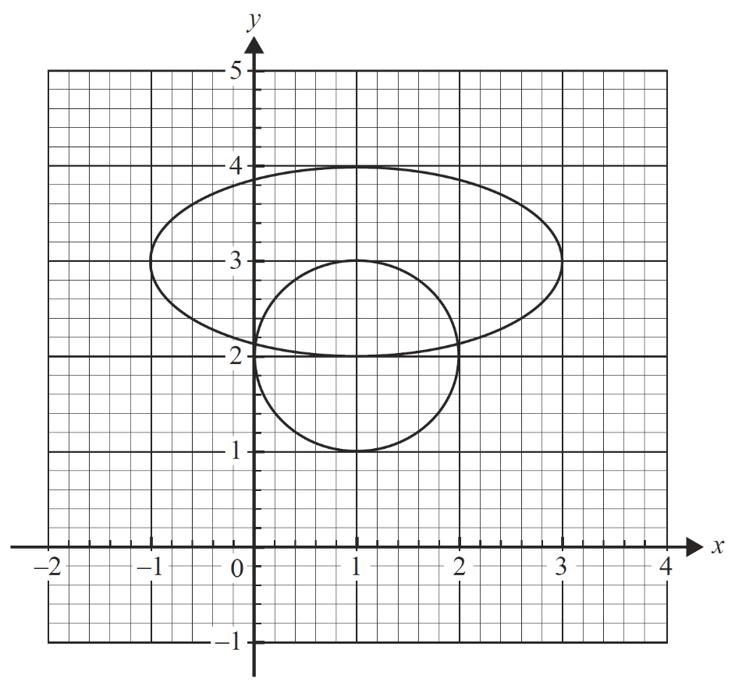

1. On the diagram above, mark the initial positions of the boat and the jet ski, clearly identifying each of them. Use arrows to show the directions in which they move.

**(2 marks)**

1. Find the first time for $t>0$ when the speeds of the boat and the jet ski are the same and state the coordinates of the boat at this time.

**(3 marks)**

1. Write down an expression for the distance between the jet ski and the boat at any time *t* and use it to find the minimum distance separating the boat and the jet ski. Give your answer in kilometres, correct to two decimal places.

**(2 marks)**

1. On another morning, the boat’s position vector remained the same but the jet skier considered starting from a different location with a new position vector given by $\underset{\sim }{r}\left(t\right)=\left(1-sin⁡(t)\right)\underset{\sim }{i}+\left(a-\cos{(t)}\right)\underset{\sim }{j}$, $t ≥ 0$, where $a$ is a real constant. Both vessels are to start at the same time. Assuming the vessels would collide shortly after starting, find the time of the collision and the value of $a$.

**(3 marks)**

Source: **Question 5** [©VCAA 2017 VCE Specialist mathematics written examination 2](https://vcaa.vic.edu.au/assessment/vce-assessment/past-examinations/Pages/Specialist-Mathematics.aspx)

### Sample question 15

The position vector $\underset{\sim }{r}\left(t\right)$ ­ , from origin $O$, of a model helicopter $t$ seconds after leaving the ground is given by

$\underset{\sim }{r}\left(t\right)=\left(50+25\cos\left(\frac{πt}{30}\right)\right)\underset{\sim }{i}+\left(50+25\sin\left(\frac{πt}{30}\right)\right)\underset{\sim }{j}+\frac{2t}{5}\underset{\sim }{k}$

­

where $\underset{\sim }{i}$ is a unit vector to the east, $\underset{\sim }{j}$ is a unit vector to the north and $\underset{\sim }{k}$ is a unit vector vertically up. Displacement components are measured in metres.

1. Find the time, in seconds, required for the helicopter to gain an altitude of 60 m and find the angle of elevation from $O$ of the helicopter when it is at an altitude of 60 m.

Give your answer in degrees, correct to the nearest degree.

**(3 marks)**

1. After how many seconds will the helicopter first be directly above the point of take-off?

**(1 mark)**

1. Show that the velocity of the helicopter is perpendicular to its acceleration.

**(3 marks)**

1. Find the speed of the helicopter in $ms^{–1}$, giving your answer correct to two decimal places.

**(2 marks)**

A treetop has position vector $\underset{\sim }{r}=60\underset{\sim }{i}+40\underset{\sim }{j}+8\underset{\sim }{k}$ ­.

1. Find the distance of the helicopter from the treetop after it has been travelling for 45 seconds. Give your answer in metres, correct to one decimal place.

**(3 marks)**

Source: **Question 4** [©VCAA 2015 VCE Specialist mathematics written examination 2](https://vcaa.vic.edu.au/assessment/vce-assessment/past-examinations/Pages/Specialist-Mathematics.aspx)

### Sample question 16

Two ships, A and B, are observed from a lighthouse at origin O. Relative to O, their position vectors at time t hours after midday are given by

$${\underset{\sim }{r}}_{A}\left(t\right)=5\left(1-t\right)\underset{\sim }{i}+3(1+t)\underset{\sim }{j}$$

$${\underset{\sim }{r}}_{B}\left(t\right)=4\left(t-2\right)\underset{\sim }{i}+(5t-2)\underset{\sim }{j}$$

where displacements are measured in kilometres.

1. Show that the two ships will not collide, clearly stating your reason.

**(2 marks)**

1. Sketch and label the path of each ship on the axes below. Show the direction of motion of each ship with an arrow.

**(3 marks)**

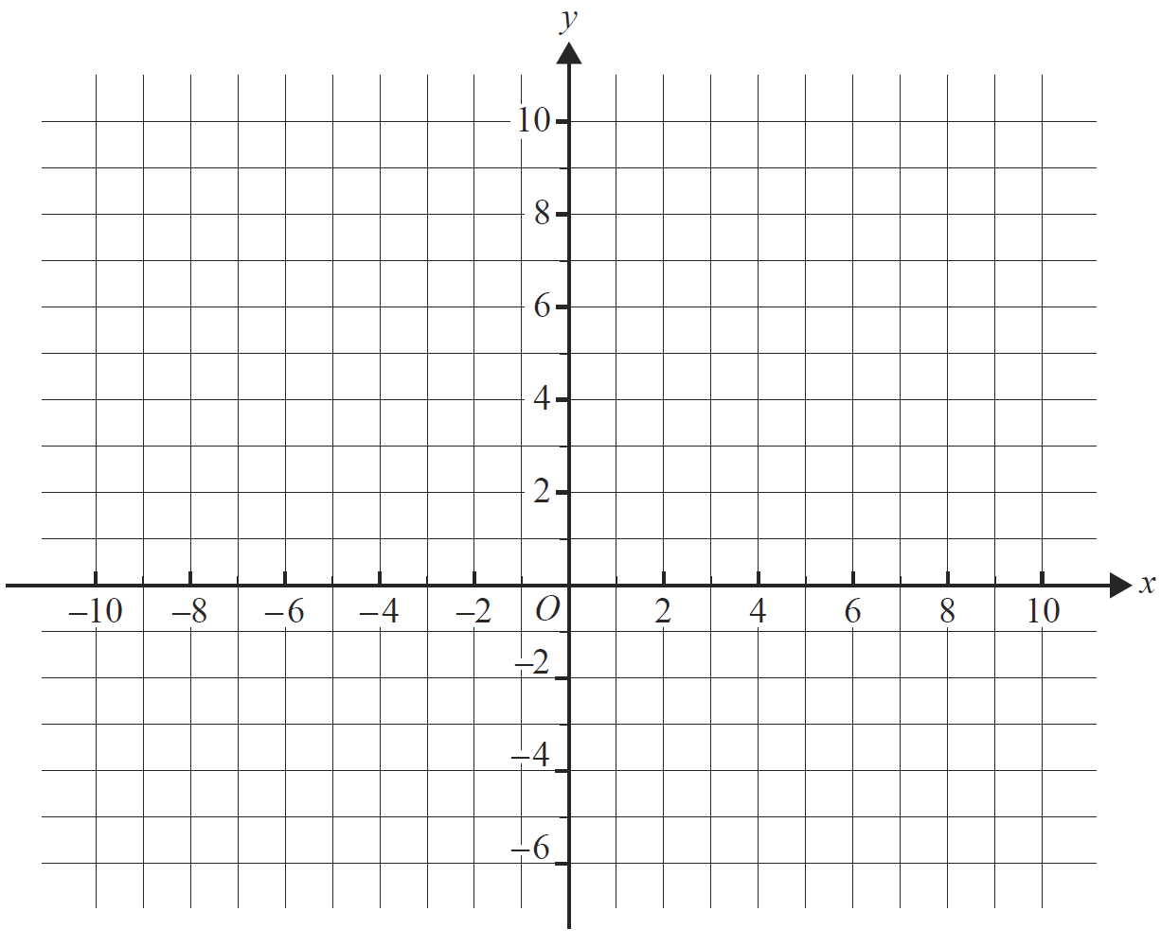

1. Find the obtuse angle between the paths of the two ships. Give your answer in degrees, correct to one decimal place.

**(2 marks)**

1. Find the value of $t$, correct to three decimal places, when the ships are closest. Hence, find the minimum distance between the two ships, in kilometres, correct to two decimal places.

**(3 marks)**

Source: **Question 4** [©VCAA 2016 VCE Specialist mathematics written examination 2](https://vcaa.vic.edu.au/assessment/vce-assessment/past-examinations/Pages/Specialist-Mathematics.aspx)

### Sample question 17

Consider the rhombus $OABC$ shown below, where $\vec{OA}=a\underset{\sim }{i}$ and $\vec{OC}=\underset{\sim }{i}+\underset{\sim }{j}+\underset{\sim }{k}$, and $a$ is a positive real constant.

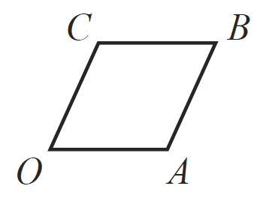

1. Find $a$

**(1 mark)**

1. Show that the diagonals of the rhombus $OABC$ are perpendicular.

**(2 marks)**

Source: **Question 1** [©VCAA 2016 VCE Specialist mathematics written examination 1](https://vcaa.vic.edu.au/assessment/vce-assessment/past-examinations/Pages/Specialist-Mathematics.aspx)

### Sample question 18

The velocity of a particle at time t seconds is given by $\underset{\sim }{\overset{.}{r}}\left(t\right)=\left(4t-3\right)\underset{\sim }{i}+2t\underset{\sim }{j}-5\underset{\sim }{k}$, where components are measured in metres per second.

Find the distance of the particle from the origin in metres when $t=2$, given that

$$\underset{\sim }{r}\left(0\right)=\underset{\sim }{i}-2\underset{\sim }{k}$$

**(4 marks)**

Source: **Question 3** [©VCAA 2015 VCE Specialist mathematics written examination 1](https://vcaa.vic.edu.au/assessment/vce-assessment/past-examinations/Pages/Specialist-Mathematics.aspx)

### Sample question 19

The path of a particle is shown below. This particle moves so that its position vector $\underset{\sim }{r}\left(t\right)$ is given by $\underset{\sim }{r}\left(t\right)=\left(\begin{matrix}-2\cos\left(\frac{t}{2}\right) \\ 1-\sin\left(t\right)\end{matrix}\right)$ metres, where $t$ is the number of seconds the particle has been in motion.

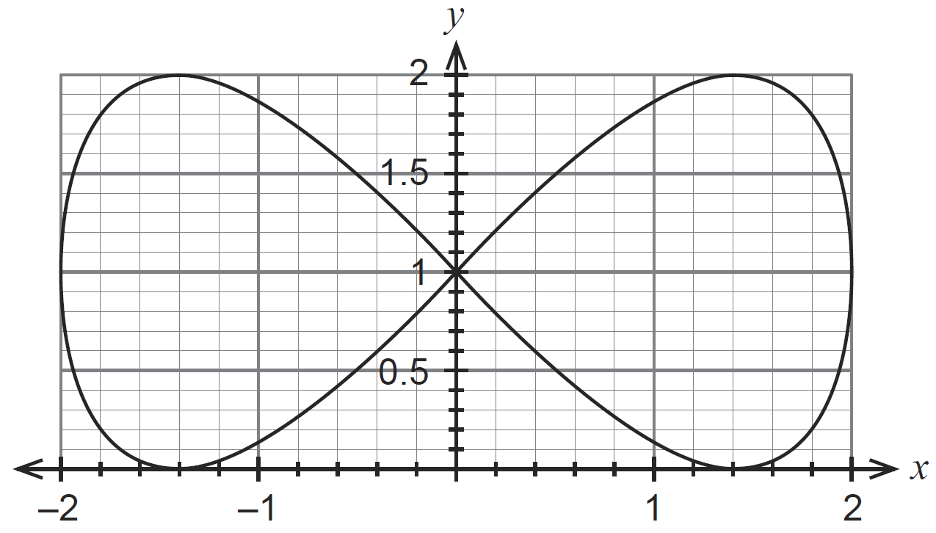

1. Determine the starting position of the particle and mark this as point A on the diagram above.

**(1 mark)**

1. Determine the initial velocity of the particle and illustrate this on the diagram above.

**(3 marks)**

1. Write the expression, in terms of trigonometric functions, for the distance the particle would travel in completing one circuit of the given path. Do not evaluate this expression.

**(3 marks)**

**Part C is not within the scope of this course.**

1. Determine the Cartesian equation for the path of the particle.

**(3 marks)**

Source: **Question 13** [©Western Australian SCSA Specialist mathematics calculator assumed marking key 2019](https://www.scsa.wa.edu.au/publications/past-atar-course-exams/mathematics-specialist-past-atar-course-exams)

### Sample question 20

A small drone is launched and, after hovering in an initial position, it flies in a straight line under the control of its operator. The position of the drone from the operator is given by $\underset{\sim }{r}\left(t\right)=\left(\begin{matrix}100+0.5t \\ 0.6t \\ 50-0.02t\end{matrix}\right)$ metres, where t is the time in seconds it has been flying in a straight line.

The top of a mobile phone tower is positioned at $200\underset{\sim }{i}+150\underset{\sim }{j}+30\underset{\sim }{k}$ relative to the operator, i.e. the mobile phone tower is 30 metres tall.

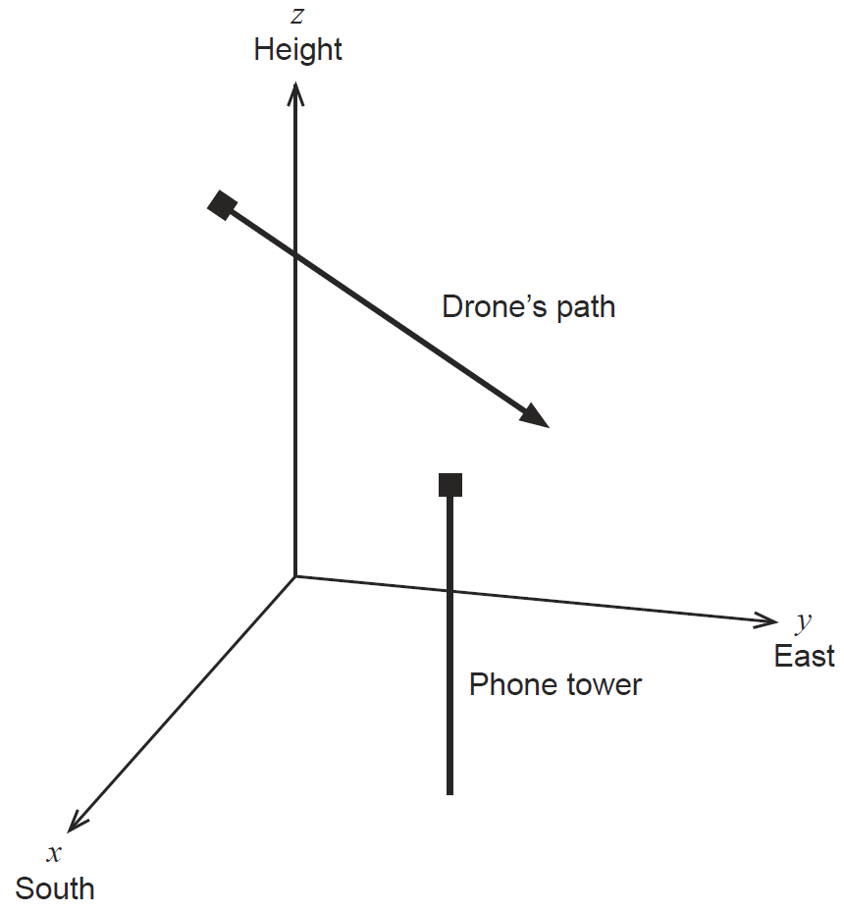

1. After two minutes of flight, how high is the drone above the ground?

**(2 marks)**

1. Write the expression for the position vector of the drone from the top of the phone tower after *t* seconds.

**(1 mark)**

The operator knows that the drone will not strike the mobile phone tower. However, the operator does not know that the drone will cause interference when it is less than 50 metres from the top of the tower.

1. Generate an expression to determine whether the drone will cause interference to the mobile phone tower and, if so, determine for how long will this occur, correct to the nearest second.

**(4 marks)**

Source: **Question 14** [©Western Australian SCSA Specialist mathematics calculator assumed marking key 2017](https://www.scsa.wa.edu.au/publications/past-atar-course-exams/mathematics-specialist-past-atar-course-exams)

### Sample question 21

The following parametric equations describe the motion of a particle moving in a spiral pattern towards the origin:

$\left\{\begin{matrix}x\left(t\right)=e^{-\frac{1}{5}t}\sin{t} \\ y\left(t\right)=e^{-\frac{1}{5}t}\cos{t}\end{matrix}\right.$ for $0≤t≤3π$

where $t$ represents time in seconds, and $x$ and $y$ are distances measured in centimetres.

1. On the axes in Figure 11, sketch the curve defined by these parametric equations.

**(3 marks)**

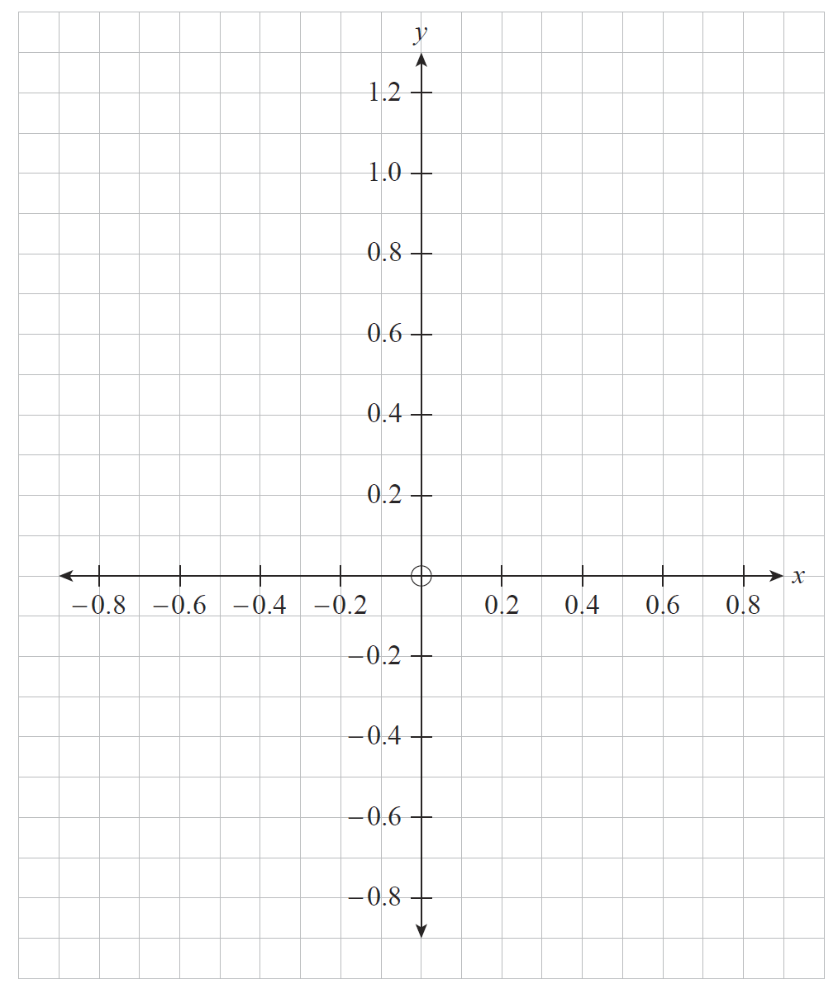

**Figure 11**

1. Show that the velocity vector of the particle is $v=-\frac{1}{5}e^{-\frac{1}{5}t}\left(\begin{matrix}\sin{t}-5\cos{t} \\ \cos{t}+5\sin{t}\end{matrix}\right)$

**(3 marks)**

1. Find the velocity vector of the particle at $t=\frac{π}{2}$.

**(2 marks)**

1. Find the speed of the particle at $t=\frac{π}{2}$.

**(1 mark)**

Source: **Question 12** [©South Australian Certificate of Education Specialist Mathematics 2019](https://www.sace.sa.edu.au/web/specialist-mathematics/stage-2/support-materials/chief-assessors-report-exams)

### Sample question 22

1. Figure 4 shows the points $A(1, 2, -3)$, $B(5, 3, -2)$, $C(6, 7, -3)$ and $D(2, 6, -4)$

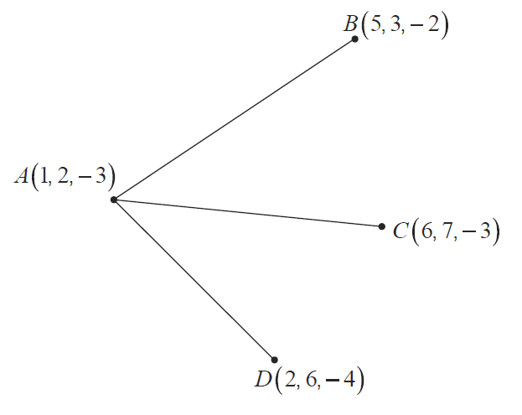

**Figure 4**

* + 1. Find

**(2 marks)**

* + 1. Find

**(1 mark)**

* + 1. Find

**(1 mark)**

1. Let $\vec{OP}=p$ and $\vec{OQ}=q$
2. On Figure 5, clearly show the vector .

**(1 mark)**

Diagram of vectors p and q

**Figure 5**

1. If $\left|p\right|=\left|q\right|$, prove that $\vec{OR}$ bisects $∠POQ$

**(2 marks)**

{Question continues on next page}

1. Figure 6 shows $\vec{OE}=[2, 5, -7]$ and $\vec{OF}=[2, 5, -7]$. Find a vector $\vec{OG}$ that bisects $∠EOF$

**(2 marks)**

Source: **Question 5** [©South Australian Certificate of Education Specialist Mathematics 2018](https://www.sace.sa.edu.au/web/specialist-mathematics/stage-2/support-materials/chief-assessors-report-exams)

### Sample question 23

1. Figure 11 shows the point $E(3, 0, 11)$ on the normal to P through $B(0, 2, 10)$.

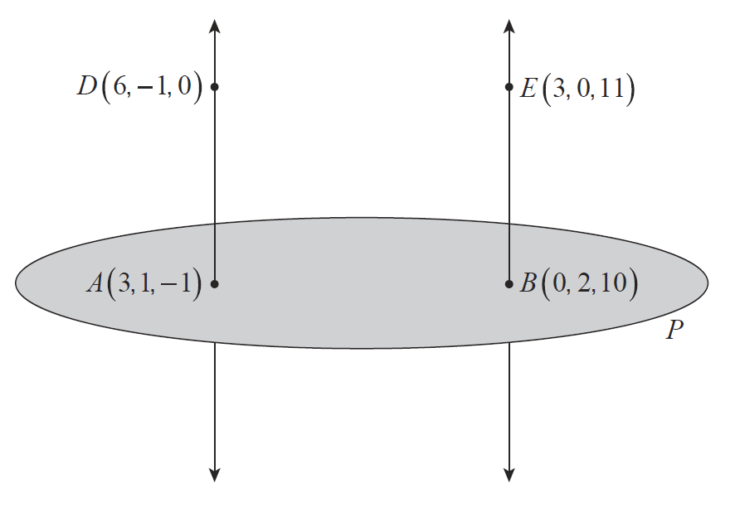

**Figure 11**

1. Show that the line through $D$ and $E$ is parallel to $P$.

**(2 marks)**

1. Find the distance from this line to $P$.

**(1 mark)**

1. Does the point $F(-3, 2, 5)$ lie on the line through $D$ and $E$? Explain your answer.

**(1 mark)**

Source: **Question 11** [©South Australian Certificate of Education Specialist Mathematics 2018](https://www.sace.sa.edu.au/web/specialist-mathematics/stage-2/support-materials/chief-assessors-report-exams)

### Sample question 24

Figure 9 shows points $O\left(0, 0, 0\right)$, $P(1,\sin{θ},\cos{θ})$ and $Q\left(\sqrt{2}, 1, 1\right)$. The vector $a=\vec{OP}$ and the vector .

Diagram of vectors a and b

**Figure 9**

1. On figure 9, draw and label $a+b$.

**(1 mark)**

1. Calculate $\left|a+b\right|$.

**(1 mark)**

1. Show that $\left|a\right|+\left|b\right|=\sqrt{2}+\sqrt{6-2\sqrt{2}-2(\sin{θ}+\cos{θ})}$.

**(3 marks)**

1. State why $2≤\sqrt{2}+\sqrt{6-2\sqrt{2}-2(\sin{θ}+\cos{θ})}$

**(1 mark)**

1. State the relationship between $a$ and $b$ when $2=\sqrt{2}+\sqrt{6-2\sqrt{2}-2(\sin{θ}+\cos{θ})}$ and hence find the exact value for $θ$ when $2=\sqrt{2}+\sqrt{6-2\sqrt{2}-2(\sin{θ}+\cos{θ})}$

**(3 marks)**

Source: **Question 10** [©South Australian Certificate of Education Specialist Mathematics 2017](https://www.sace.sa.edu.au/web/specialist-mathematics/stage-2/support-materials/chief-assessors-report-exams)

### Sample question 25

A small rocket is fired from the ground at an angle of $θ°$ to the horizontal with a speed of $70$ metres per second. The rocket has the assistance of a steady wind that is blowing horizontally at $w$ metres per second.

A coordinate system is set up to track the path of the rocket as shown below.

Let $t =$ the number of seconds elapsed after the rocket is fired

$\underset{\sim }{r}\left(t\right)=$ the position vector (metres)

$\underset{\sim }{v}\left(t\right)=$ the velocity vector ($ms^{-1}$)

$\underset{\sim }{a}\left(t\right)=$ the acceleration vector (due to gravity) ()

An image of a projectile with a following wind.

1. Given , show that $\underset{\sim }{r}\left(t\right)=\left(\begin{matrix}\left(70\cos{θ}+w\right)t \\ \left(70\sin{θ}\right)t-4.9t^{2}\end{matrix}\right)$

**(3 marks)**

1. Obtain the Cartesian equation for the path of the rocket, in terms of $θ$ and $w$.

**(2 marks)**

1. Assuming that the wind speed $w=2$ metres per second, determine the optimum angle $θ$ so that the range of the rocket is maximised, correct to the nearest $0.1$ degree.

**(4 marks)**

Source: **Question 19** [©Western Australia School Curriculum and Standard Authority Mathematics Specialist ATAR course examination, 2018](https://senior-secondary.scsa.wa.edu.au/further-resources/past-atar-course-exams/mathematics-specialist-past-atar-course-exams)

## Solutions

### Sample question 1

$$\underset{\sim }{\overset{.}{r}}=-3\sin{t}\underset{\sim }{i}+4\cos{t}\underset{\sim }{j}$$

$$\left|\underset{\sim }{\overset{.}{r}}\right|=\sqrt{{\left(-3\sin{t}\right)}^{2}+{\left(4\cos{t}\right)}^{2}}=\sqrt{9+7\cos^{2}{t}}$$

$\left|\underset{\sim }{\overset{.}{r}}\right|$ is minimum when $\cos{t}=0$, therefore $t=\frac{π}{2}$

Answer = b) $\frac{π}{2}$

### Sample question 2

Matching $\underset{\sim }{j}$ components: $3t+2=4+t⇒t=1$

${\underset{\sim }{r}}_{1}\left(1\right)=\left(2+4{(1)}^{2}\right)\underset{\sim }{i}+\left(3\left(1\right)+2\right)\underset{\sim }{j}=6\underset{\sim }{i}+5\underset{\sim }{j}$ and ${\underset{\sim }{r}}_{2}\left(1\right)=\left(6(1)\right)\underset{\sim }{i}+\left(4+\left(1\right)\right)\underset{\sim }{j}=6\underset{\sim }{i}+5\underset{\sim }{j}$

Answer = b) $6\underset{\sim }{i}+5\underset{\sim }{j}$

### Sample question 3

$$\frac{\underset{\sim }{a}.\underset{\sim }{b}}{\left|\underset{\sim }{b}\right|}=\frac{74}{\sqrt{273}}$$

$$\frac{3×4+2×\left(-1\right)+α^{3}}{\sqrt{4^{2}+{\left(-1\right)}^{2}+α^{4}}}=\frac{74}{\sqrt{273}}$$

By inspection, $α=4$

Answer = d) 4

### Sample question 4

$$\left(\underset{\sim }{a}-\underset{\sim }{b}\right).\underset{\sim }{b}=0$$

$$\underset{\sim }{a}.\underset{\sim }{b}-\underset{\sim }{b}.\underset{\sim }{b}=0$$

$$2m-1+6-\left(m^{2}+1+4\right)=0$$

$$m\left(2-m\right)=0$$

Answer = c) 0 or 2

### Sample question 5

$\underset{\sim }{a}-\underset{\sim }{b}=-\underset{\sim }{i}+2\underset{\sim }{j}+\underset{\sim }{k}$ and $\underset{\sim }{c}-\underset{\sim }{b}=-3\underset{\sim }{i}-2\underset{\sim }{j}$

$$\cos{∠ABC}=\frac{\left(\underset{\sim }{a}-\underset{\sim }{b}\right).\left(\underset{\sim }{c}-\underset{\sim }{b}\right)}{\left|\underset{\sim }{a}-\underset{\sim }{b}\right|\left|\underset{\sim }{c}-\underset{\sim }{b}\right|}$$

$$=\frac{3-4}{\sqrt{{\left(-1\right)}^{2}+2^{2}+1^{2}}\sqrt{{\left(-3\right)}^{2}+{\left(-2\right)}^{2}}}$$

Answer = c) $-\frac{1}{\sqrt{6}\sqrt{13} }$

### Sample question 6

$\left|\underset{\sim }{b}\right|=\sqrt{{\left(-1\right)}^{2}+2^{2}+3^{2}}=\sqrt{14}$

Scalar projection = $\left|\underset{\sim }{a}\right|\cos{θ=}\frac{\underset{\sim }{a}.\underset{\sim }{b}}{|\underset{\sim }{b}|}$

$$=\frac{-3-6}{\sqrt{14}}=-\frac{9\sqrt{14}}{\sqrt{14}}$$

Answer = c) $-\frac{9\sqrt{14}}{14}$

### Sample question 7

Given the vectors $\underset{\sim }{a}=3\underset{\sim }{i}-4\underset{\sim }{j}+12\underset{\sim }{k}$ and $\underset{\sim }{b}=2\underset{\sim }{i}+2\underset{\sim }{j}-\underset{\sim }{k}$, the vector projection of $\underset{\sim }{a}$ in the direction of $\underset{\sim }{b}$ is

$$\left|\underset{\sim }{b}\right|=\sqrt{2^{2}+2^{2}+{(-1)}^{2}}=3$$

Vector projection $=\frac{\underset{\sim }{a}.\underset{\sim }{b}}{\left|\underset{\sim }{b}\right|}×\frac{\underset{\sim }{b}}{\left|\underset{\sim }{b}\right|}$

$$=\frac{6-8-12}{3}×\frac{2\underset{\sim }{i}+2\underset{\sim }{j}-\underset{\sim }{k}}{3}$$

Answer = c) $-\frac{14}{9}(2\underset{\sim }{i}+2\underset{\sim }{j}-\underset{\sim }{k})$

### Sample question 8

Relative to a fixed origin, the points $B$, $C$ and $D$ are defined respectively by the position vectors $\underset{\sim }{b}=\underset{\sim }{i}-\underset{\sim }{j}+2\underset{\sim }{k}$, $\underset{\sim }{c}=2\underset{\sim }{i}-\underset{\sim }{j}+\underset{\sim }{k}$ and $\underset{\sim }{d}=a\underset{\sim }{i}-2\underset{\sim }{j}$, where $a$ is a real constant.

Given that the magnitude of angle $BCD$ is $\frac{π}{3}$, find a.

$\underset{\sim }{b}-\underset{\sim }{c}=-\underset{\sim }{i}+\underset{\sim }{k}$ and $\underset{\sim }{d}-\underset{\sim }{c}=\left(a-2\right)\underset{\sim }{i}-\underset{\sim }{j}-\underset{\sim }{k}$

$$\left|\underset{\sim }{b}-\underset{\sim }{c}\right|\left|\underset{\sim }{d}-\underset{\sim }{c}\right|\cos{∠BCD}=\left(\underset{\sim }{b}-\underset{\sim }{c}\right).\left(\underset{\sim }{d}-\underset{\sim }{c}\right)$$

$$\frac{\sqrt{2}\sqrt{{\left(a-2\right)}^{2}+{\left(-1\right)}^{2}{+\left(-1\right)}^{2}}}{2}=-\left(a-2\right)-1$$

$$a^{2}-4=0$$

$$a=±2$$

$$\cos{θ}=\frac{\left(\underset{\sim }{b}-\underset{\sim }{c}\right).\left(\underset{\sim }{d}-\underset{\sim }{c}\right)}{\left|\underset{\sim }{b}-\underset{\sim }{c}\right|\left|\underset{\sim }{d}-\underset{\sim }{c}\right|}$$

when $a=2$ $\cos{θ}=\frac{-1}{2}⟹θ=\frac{2π}{3}$

when $a=-2$ $\cos{θ}=\frac{1}{2}⟹θ=\frac{π}{3}$

$$∴a=-2$$

Source: **Question 5** [©VCAA 2017 VCE Specialist mathematics written examination 1 report](https://vcaa.vic.edu.au/assessment/vce-assessment/past-examinations/Pages/Specialist-Mathematics.aspx)

### Sample question 9

Vector projection $=\frac{\underset{\sim }{a}.\underset{\sim }{b}}{{\left|\underset{\sim }{b}\right|}^{2}}×\underset{\sim }{b}$

$$=\frac{3×1+5×\left(-2\right)+(-2)×3}{1^{2}+{\left(-2\right)}^{2}+3^{2}}×\left(\underset{\sim }{i}-2\underset{\sim }{j}+3\underset{\sim }{k}\right)$$

$$=-\frac{13}{14}(\underset{\sim }{i}-2\underset{\sim }{j}+3\underset{\sim }{k})$$

Source: **Question 5** [©VCAA 2016 VCE Specialist mathematics written examination 1 report](https://vcaa.vic.edu.au/assessment/vce-assessment/past-examinations/Pages/Specialist-Mathematics.aspx)

### Sample question 10

Match $\underset{\sim }{i}$-components: $t^{2}-1=t^{3}-t$

$$t^{2}-1=t(t^{2}-1)$$

$$∴t=1$$

Match $\underset{\sim }{j}$-components: $a+\frac{1}{3}=\cos^{-1}{\frac{1}{2}}$ for $t=1$

$$a=\frac{π-1}{3}$$

Source: **Question 4** [©VCAA 2019 VCE Specialist mathematics written examination 1 report](https://vcaa.vic.edu.au/assessment/vce-assessment/past-examinations/Pages/Specialist-Mathematics.aspx)

### Sample question 11

$\vec{AB}=\left(\begin{matrix}4 \\ -2 \\ 1\end{matrix}\right)-\left(\begin{matrix}2 \\ -1 \\ 3\end{matrix}\right)=\left(\begin{matrix}2 \\ -1 \\ -2\end{matrix}\right)$

$$\vec{OC}=\left(\begin{matrix}4 \\ 3 \\ -1\end{matrix}\right)-\left(\begin{matrix}2 \\ -1 \\ -2\end{matrix}\right)=\left(\begin{matrix}2 \\ 4 \\ 1\end{matrix}\right)$$

$a=2$, $b=4$ and $c=1$

$\vec{AD}=\left(\begin{matrix}4 \\ 3 \\ -1\end{matrix}\right)-\left(\begin{matrix}2 \\ -1 \\ 3\end{matrix}\right)=\left(\begin{matrix}2 \\ 4 \\ -4\end{matrix}\right)$

$\left|\vec{AB}\right|=3$ and

units2

1. Let

, therefore $\underset{\sim }{v}⊥ \vec{AB}$

$\underset{\sim }{v}. \vec{AD}=2.6+4.2+\left(-4\right).5=0$, therefore $\underset{\sim }{v}⊥ \vec{AD}$

$$\left|\underset{\sim }{v}\right|=\sqrt{65}$$

$\hat{\underset{\sim }{v}}=\frac{1}{\sqrt{65}}\left(\begin{matrix}6 \\ 2 \\ 5\end{matrix}\right)$

$\vec{AP}=\left(\begin{matrix}4 \\ -4 \\ 9\end{matrix}\right)-\left(\begin{matrix}2 \\ -1 \\ 3\end{matrix}\right)=\left(\begin{matrix}2 \\ -3 \\ 6\end{matrix}\right)$

Perpendicular height of pyramid is equal to the scalar projection of $\vec{AP}$ onto $\hat{\underset{\sim }{v}}$.

Scalar projection of $\vec{AP}$ onto $\hat{\underset{\sim }{v}}$ $=\left(\begin{matrix}2 \\ -3 \\ 6\end{matrix}\right).\frac{1}{\sqrt{65}}\left(\begin{matrix}6 \\ 2 \\ 5\end{matrix}\right)=\frac{36}{\sqrt{65}}$

Volume units3

Source: **Question 4** [©VCAA 2019 VCE Specialist mathematics written examination 2 report](https://vcaa.vic.edu.au/assessment/vce-assessment/past-examinations/Pages/Specialist-Mathematics.aspx)

### Sample question 12

$x^{2}=\sec^{2}{t}$ and $y^{2}=\frac{1}{2}\tan^{2}{t}$

$$x^{2}=1+\tan^{2}{t}$$

$$x^{2}=1+2y^{2}$$

$x^{2}-2y^{2}=1$ as needed

Source: **Question 9** [©VCAA 2018 VCE Specialist mathematics written examination 1 report](https://vcaa.vic.edu.au/assessment/vce-assessment/past-examinations/Pages/Specialist-Mathematics.aspx)

### Sample question 13

1. $A:y=x^{2}-1$ and $B:y=x+3$

$t+1=t^{2}⟹t=\frac{1+\sqrt{5}}{2}, t^{2}+2t=t^{2}+3 ⟹t=\frac{3}{2}, \frac{1+\sqrt{5}}{2}≠\frac{3}{2}$

$\left(2.562, 5.562\right)$

$\sqrt{{\left(2t+2\right)}^{2}+1}>\sqrt{8t^{2}} ⟹0≤t≤\frac{5}{2}$

Source: **Question 4** [©VCAA 2018 VCE Specialist mathematics written examination 2 report](https://vcaa.vic.edu.au/assessment/vce-assessment/past-examinations/Pages/Specialist-Mathematics.aspx)

### Sample question 14

1. Jet ski marked at $(1,1)$ and an indication of clockwise direction.

Boat marked at $(-1,3)$ and an indication of clockwise direction.

1. ${\underset{\sim }{\overset{.}{r}}}_{B}=2\sin\left(t\right)\underset{\sim }{i}+\cos\left(t\right)\underset{\sim }{j}$ and ${\underset{\sim }{\overset{.}{r}}}_{J}=-\cos\left(t\right)\underset{\sim }{i}+\sin\left(t\right)\underset{\sim }{j} ⇒\left| {\underset{\sim }{\overset{.}{r}}}_{B}\right|=\left| {\underset{\sim }{\overset{.}{r}}}_{J}\right|, t=π$ seconds

and the boat is at $(3, 3)$.

1. distance between = $\sqrt{{\left(\sin{t}-2\cos{t}\right)}^{2}+{\left(1+\sin{t}+\cos{t}\right)}^{2}}$, min distance = 0.33 km

$1-\sin\left(t\right)=1-2\cos\left(t\right), a-\cos\left(t\right)=3+\sin\left(t\right)⇒t=\tan^{-1}{2}, a=3+\frac{3}{\sqrt{5}}$

Source: **Question 5** [©VCAA 2017 VCE Specialist mathematics written examination 2 report](https://vcaa.vic.edu.au/assessment/vce-assessment/past-examinations/Pages/Specialist-Mathematics.aspx)

### Sample question 15

1. 50 seconds with an angle of elevation of $47°$
2. 60 seconds

$\underset{\sim }{\overset{.}{r}}=-\frac{5π}{6}\sin\left(\frac{πt}{30}\right)\underset{\sim }{i}+\frac{5π}{6}\cos\left(\frac{πt}{30}\right)\underset{\sim }{j}+\frac{2}{5}\underset{\sim }{k}, \underset{\sim }{\overset{..}{r}}=-\frac{π^{2}}{36}\cos\left(\frac{πt}{30}\right)\underset{\sim }{i}-\frac{π^{2}}{36}\sin\left(\frac{πt}{30}\right)\underset{\sim }{j}$

$$\underset{\sim }{\overset{.}{r}}.\underset{\sim }{\overset{..}{r}}=\frac{5π}{6}\sin\left(\frac{πt}{30}\right).\frac{π^{2}}{36}\cos\left(\frac{πt}{30}\right)-\frac{5π}{6}\cos\left(\frac{πt}{30}\right).\frac{π^{2}}{36}\sin\left(\frac{πt}{30}\right)=0$$

2.65 metres

$\underset{\sim }{r}\left(45\right)=\left(50+25\cos\left(\frac{45π}{30}\right)\right)\underset{\sim }{i}+\left(50+25\sin\left(\frac{45π}{30}\right)\right)\underset{\sim }{j}+\frac{2×45}{5}\underset{\sim }{k}$

$$\underset{\sim }{r}\left(45\right)=50+25\underset{\sim }{j}+18\underset{\sim }{k}$$

1. Distance = $\sqrt{ {10}^{2}+{15}^{2}+{10}^{2}}=20.6$ metres

Source: **Question 4** [©VCAA 2015 VCE Specialist mathematics written examination 2 report](https://vcaa.vic.edu.au/assessment/vce-assessment/past-examinations/Pages/Specialist-Mathematics.aspx)

### Sample question 16

1. $5\left(1-t\right)=4\left(t-2\right) ⇒ t=\frac{13}{9}, 3\left(1+t\right)=5t-2 ⇒t=\frac{5}{2}$ different times so particles do not collide
2. 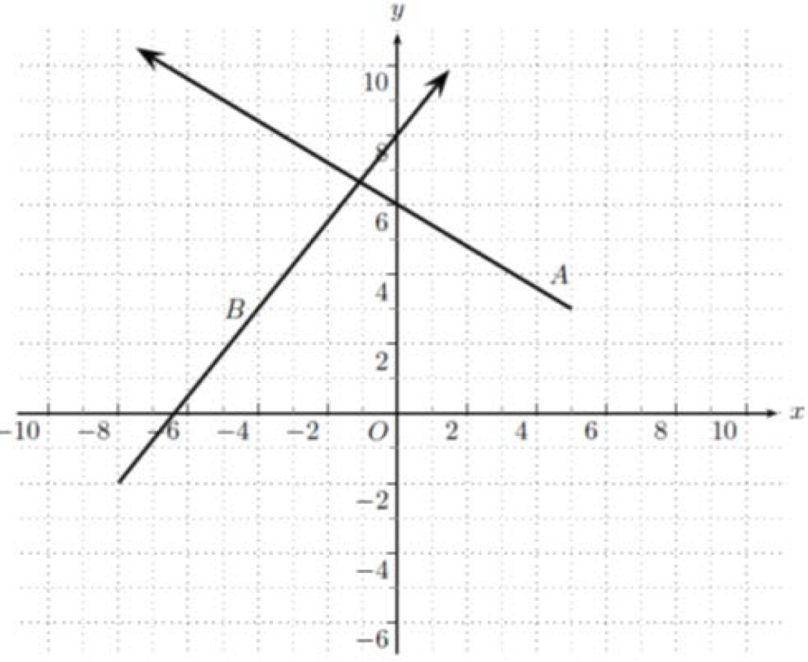
$θ=97.7°$

3. $\underset{\sim }{d}=\left(13-9\right)\underset{\sim }{i}+\left(5-2t\right)\underset{\sim }{j}, {\left|\underset{\sim }{d}\right|}^{2}={\left(13-9t\right)}^{2}+{\left(5-2t\right)}^{2}, t=1.494$ and the minimum distance is 2.06 km.

Source: **Question 4** [©VCAA 2016 VCE Specialist mathematics written examination 2 report](https://vcaa.vic.edu.au/assessment/vce-assessment/past-examinations/Pages/Specialist-Mathematics.aspx)

### Sample question 17

$a=\sqrt{3}$

1. Show $\vec{OB}.\vec{CA}=0$

Source: **Question 1** [©VCAA 2016 VCE Specialist mathematics written examination 1 report](https://vcaa.vic.edu.au/assessment/vce-assessment/past-examinations/Pages/Specialist-Mathematics.aspx)

### Sample question 18

$\underset{\sim }{x}=\int{4t-3.dt}$, $\underset{\sim }{y}=\int{2t.dt}$ and $\underset{\sim }{z}=\int{5.dt}$

$\underset{\sim }{x}=2t^{2}-3t+C_{1}$, $\underset{\sim }{y}=t^{2}+C_{2}$ and $\underset{\sim }{z}=5t+C_{3}$

$\underset{\sim }{x}\left(0\right)=1$, $\underset{\sim }{y}\left(0\right)=0$ and $\underset{\sim }{z}(0)=-2$

$\underset{\sim }{x}=2t^{2}-3t+1$, $\underset{\sim }{y}=t^{2}$ and $\underset{\sim }{z}=-5t-2$

$$∴\underset{\sim }{r}\left(t\right)=(2t^{2}-3t+1)\underset{\sim }{i}+t^{2}\underset{\sim }{j}+(-5t-2)\underset{\sim }{k}$$

$$\underset{\sim }{r}\left(2\right)=3\underset{\sim }{i}+4\underset{\sim }{j}+8\underset{\sim }{k}$$

$$\left|\underset{\sim }{r}\left(2\right)\right|=\sqrt{3^{2}+4^{2}+{(-12)}^{2}}=13$$

13 metres

Source: **Question 3** [©VCAA 2015 VCE Specialist mathematics written examination 1 report](https://vcaa.vic.edu.au/assessment/vce-assessment/past-examinations/Pages/Specialist-Mathematics.aspx)

### Sample question 19

1. 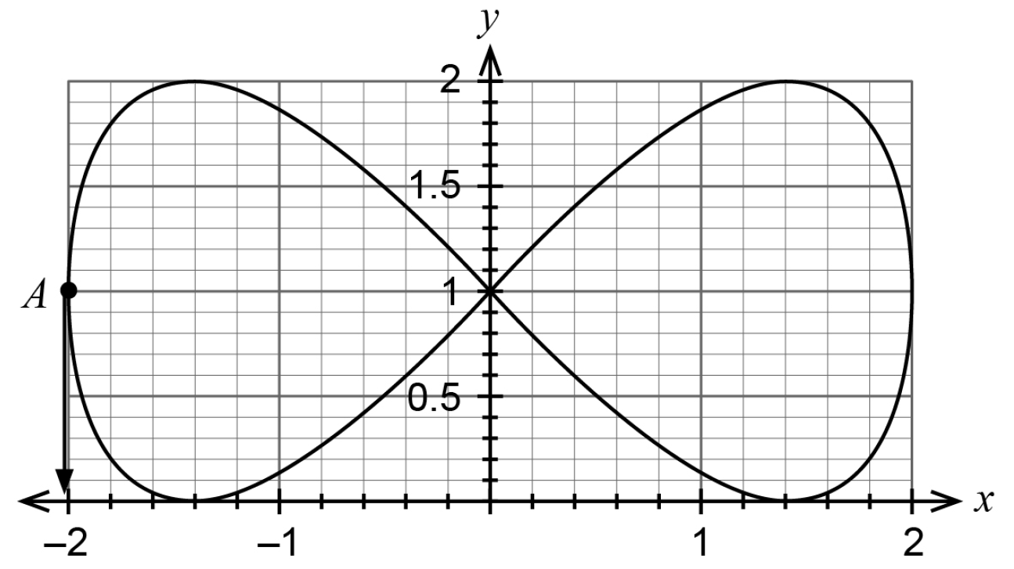
2. $\underset{\sim }{v}\left(t\right)=\left(\begin{matrix}\sin\left(\frac{t}{2}\right) \\ -cos⁡(t)\end{matrix}\right)$ substituting $t=0$ gives $\underset{\sim }{v}\left(0\right)=\left(\begin{matrix}0 \\ -1\end{matrix}\right)$
3. NOT REQUIRED
4. ${\left(1-y\right)}^{2}+{\left(\frac{x^{2}}{2}-1\right)}^{2}=1$ or equivalent.

Source: **Question 13** [©Western Australian SCSA Specialist mathematics calculator assumed marking key 2019](https://www.scsa.wa.edu.au/publications/past-atar-course-exams/mathematics-specialist-past-atar-course-exams)

### Sample question 20

1. $50-0.02\left(120\right)=47.6$ metres
$\vec{TD}\left(t\right)=\left(\begin{matrix}100+0.5t \\ 0.6t \\ 50-0.02t\end{matrix}\right)-\left(\begin{matrix}200 \\ 150 \\ 30\end{matrix}\right)=\left(\begin{matrix}0.5t-100 \\ 0.6t-150 \\ 20-0.02t\end{matrix}\right)$

2. Interference when $\left|\vec{TD}\left(t\right)\right|<50$

$${\left(0.5t-100\right)}^{2}+{\left(0.6t-150\right)}^{2}+{\left(20-0.02t\right)}^{2}<2500$$

$t=174.31$ and $t=185.71$, therefore the drone will cause interference for 111.4s

Source: **Question 14** [©Western Australian SCSA Specialist mathematics calculator assumed marking key 2017](https://www.scsa.wa.edu.au/publications/past-atar-course-exams/mathematics-specialist-past-atar-course-exams)

### Sample question 21

1. 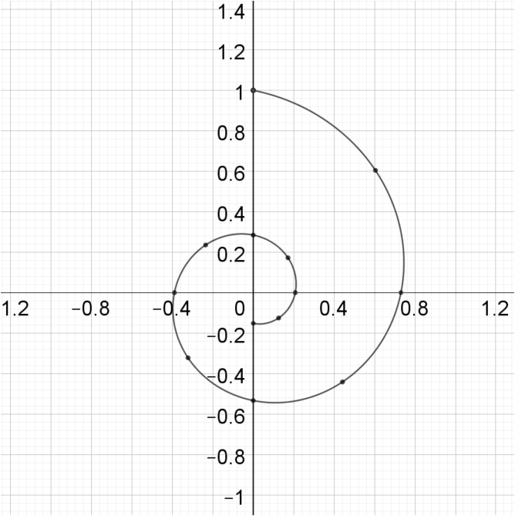
2. $\overset{.}{x}\left(t\right)=-\frac{1}{5}e^{-\frac{1}{5}t}\sin{t}+e^{-\frac{1}{5}t}\cos{t}$ and $\overset{.}{y}\left(t\right)=-\frac{1}{5}e^{-\frac{1}{5}t}\cos{t}-e^{-\frac{1}{5}t}\sin{t}$

Therefore $v=-\frac{1}{5}e^{-\frac{1}{5}t}\left(\begin{matrix}\sin{t}-5\cos{t} \\ \cos{t}+5\sin{t}\end{matrix}\right)$

1. $v=-\frac{1}{5}e^{-\frac{1}{5}×\frac{π}{2}}\left(\begin{matrix}\sin{\frac{π}{2}}-5\cos{\frac{π}{2}} \\ \cos{\frac{π}{2}}+5\sin{\frac{π}{2}}\end{matrix}\right)=-\frac{1}{5}e^{-\frac{π}{10}}\left(\begin{matrix}1 \\ 5\end{matrix}\right)$ cm/s
2. Speed = $\frac{\sqrt{26}}{5}e^{-\frac{π}{10}}$ cm/s

Solutions are not the official set of solutions used by the examiners of the SACE Board of South Australia.

### Sample question 22

1. i. $\vec{AB}=\left(\begin{matrix}4 \\ 1 \\ 1\end{matrix}\right)$ and $\vec{AC}=\left(\begin{matrix}5 \\ 5 \\ 0\end{matrix}\right)$, therefore $\vec{AB}.\vec{AC}=25$
2. $\left|\vec{AB}\right|=3\sqrt{2}$ and $\left|\vec{AC}\right|=5\sqrt{2}$, therefore $\cos{∠BAC}=\frac{25}{3\sqrt{2}×5\sqrt{2}}=\frac{5}{6}$
3. $\vec{AD}=\left(\begin{matrix}4 \\ 1 \\ -1\end{matrix}\right)$, $\left|\vec{AB}\right|=3\sqrt{2}$ and $\vec{AC}.\vec{AD}=25$ therefore $\cos{∠CAD}=\frac{5}{6}$
4. i. 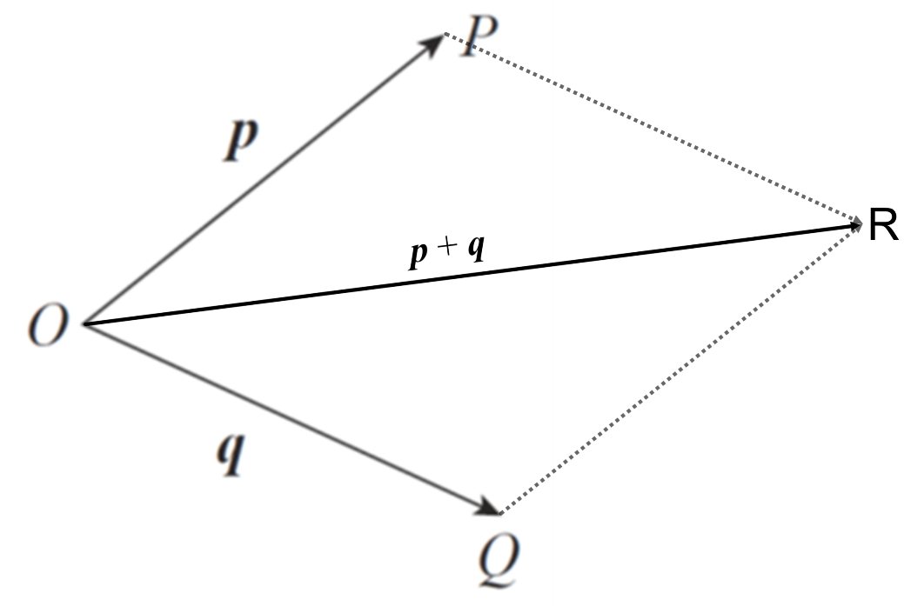
5. $\left|p\right|=\left|q\right|$, therefore $∆OPR≡∆OQR$, as $OP=OQ=PR=QR$ and $OR$ in common.

Therefore $∠POR=∠QOR$ and $\vec{OR}$ bisects $∠POQ$

1. $\left|\vec{OE}\right|=\sqrt{68}$ and $\left|\vec{OF}\right|=\sqrt{312}$

Therefore the unit vectors $\overset{^}{\vec{OE}}=\frac{1}{\sqrt{68}}\left(\begin{matrix}2 \\ 5 \\ -7\end{matrix}\right)$ and $\overset{^}{\vec{OF}}=\frac{1}{\sqrt{312}}\left(\begin{matrix}10 \\ 14 \\ 4\end{matrix}\right)$

$$\vec{OG}=\frac{1}{\sqrt{68}}\left(\begin{matrix}2 \\ 5 \\ -7\end{matrix}\right)+\frac{1}{\sqrt{312}}\left(\begin{matrix}10 \\ 14 \\ 4\end{matrix}\right)$$

Solutions are not the official set of solutions used by the examiners of the SACE Board of South Australia.

### Sample question 23

i. $\vec{AB}$ lies on plane $P$, $\vec{AB}=\left(\begin{matrix}-3 \\ 1 \\ 11\end{matrix}\right)$

$\vec{DE}=\left(\begin{matrix}-3 \\ 1 \\ 11\end{matrix}\right)$ which is equal to $\vec{AB}$, therefore $DE∥AB$ and therefore $DE$ is parallel to the plane $P$

ii. $\left|\vec{EB}\right|=\sqrt{14}$, therefore the perpendicular distance to the plane is $\sqrt{14}$

iii. Equation of line through $D$ and $E$: $\underset{\sim }{r}=\left(\begin{matrix}6 \\ -1 \\ 0\end{matrix}\right)+λ\left(\begin{matrix}-3 \\ 1 \\ 11\end{matrix}\right)$

$6-3λ=-3 ⇒ λ=3$

$-1+λ=2 ⇒ λ=3$

$11λ=5 ⇒ λ=\frac{5}{11}$

Solutions are not the official set of solutions used by the examiners of the SACE Board of South Australia.

### Sample question 24

1. 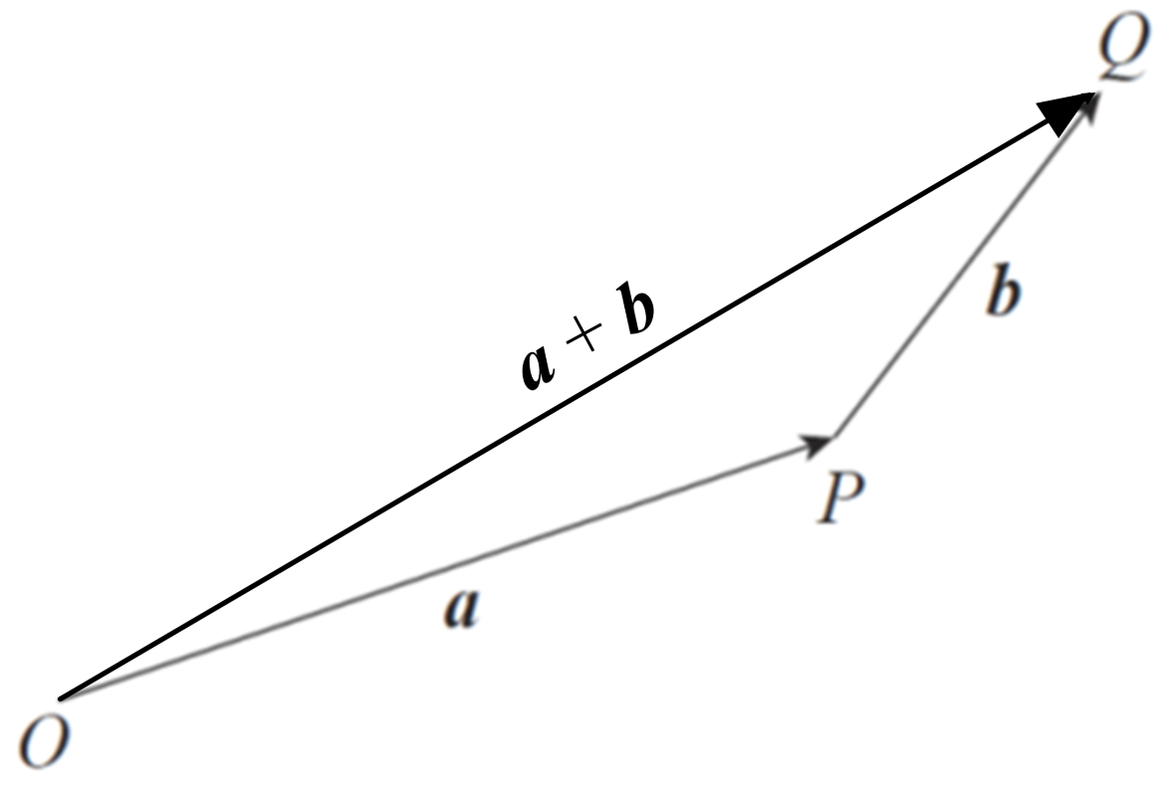
2. $\vec{OQ}=a+b$, $a+b=\left(\begin{matrix}\sqrt{2} \\ 1 \\ 1\end{matrix}\right)$, $\left|a+b\right|=2$
3. $a=\left(\begin{matrix}1 \\ \sin{θ} \\ \cos{θ}\end{matrix}\right)$, $b=\left(\begin{matrix}\sqrt{2}-1 \\ 1-\sin{θ} \\ 1-cos{θ}\end{matrix}\right)$
$$\left|a\right|+\left|b\right|=\sqrt{1+\sin^{2}{θ}+\cos^{2}{θ}}+\sqrt{{\left(\sqrt{2}-1\right)}^{2}+{\left(1-\sin{θ}\right)}^{2}+{\left(1-\cos{θ}\right)}^{2}}$$

$$=\sqrt{2}+\sqrt{3-2\sqrt{2}+1-2\sin{θ}+\sin^{2}{θ}+1-2\cos{θ}+\cos^{2}{θ}}$$

$$=\sqrt{2}+\sqrt{6-2\sqrt{2}+1-2(\sin{θ}+\cos{θ})}$$

4. Triangle inequality $\left|a+b\right|≤\left|a\right|+\left|b\right|$

$$∴2≤\sqrt{2}+\sqrt{6-2\sqrt{2}-2(\sin{θ}+\cos{θ})}$$

$2=\sqrt{2}+\sqrt{6-2\sqrt{2}-2(\sin{θ}+\cos{θ})}$ when $O$, $P$ and Q are collinear.

$\sqrt{6-2\sqrt{2}-2(\sin{θ}+\cos{θ})}=2-\sqrt{2}$

$$6-2\sqrt{2}-2\left(\sin{θ}+\cos{θ}\right)=6-4\sqrt{2}$$

$$\sin{θ}+\cos{θ}=\sqrt{2}$$

$$θ=\frac{π}{4}$$

Solutions are not the official set of solutions used by the examiners of the SACE Board of South Australia.

### Sample question 25

$\underset{\sim }{a}\left(t\right)=\left(\begin{matrix}0 \\ -9.8\end{matrix}\right)⇒ \underset{\sim }{v}\left(t\right)=\int{\underset{\sim }{a}\left(t\right)}.dt=\left(\begin{matrix}k \\ -9.8t+c\end{matrix}\right)$

Using $\underset{\sim }{v}\left(0\right)=\left(\begin{matrix}70\cos{θ}+w \\ 70\sin{θ}\end{matrix}\right)⇒$ $\underset{\sim }{v}\left(t\right)=\left(\begin{matrix}70\cos{θ}+w \\ -9.8t+70\sin{θ}\end{matrix}\right)$

$\underset{\sim }{r}\left(t\right)=\int{\underset{\sim }{v}\left(t\right)}.dt=\left(\begin{matrix}\left(70\cos{θ}+w\right)t \\ -4.9t^{2}+\left(70\sin{θ}\right)t\end{matrix}\right)$ since $\underset{\sim }{r}\left(0\right)=\left(\begin{matrix}0 \\ 0\end{matrix}\right)$

$y=\left(\frac{70\sin{θ}}{70\cos{θ}+w}\right)x-4.9{\left(\frac{x}{70\cos{θ}+w}\right)}^{2}$

1. Time when rocket hits the ground $t=\frac{70\sin{θ}}{4.9}$

Range $R=\left(70\cos{θ}+2\right)\frac{70\sin{θ}}{4.9}$

$$\frac{dR}{dθ}=\frac{-{70}^{2}\sin^{2}{θ}+{70}^{2}\cos^{2}{θ}+140\cos{θ}}{4.9}=\frac{70}{4.9}(140\cos^{2}{θ}+2\cos{θ}-70)$$

$$\cos{θ}=\frac{-2±\sqrt{2^{2}+4×140×70}}{2×140}$$

$\cos{θ}=\frac{7}{10}$, as $0≤θ≤90°$, therefore $θ=45.6°$