ME-V1 Introduction to vectors
This document contains sample questions and solutions from the sample unit ME-V1 Introduction to vectors.

Identifying scalars and vectors
A scalar is a quantity that has magnitude only. A vector is a quantity that has both magnitude and direction.
Identify each quantity as a scalar or vector: length, displacement, area, volume, velocity, acceleration, speed, time, mass, weight, density, force, temperature

Scalar | Vector
Length | Displacement
Area | Velocity
Volume | Acceleration
Speed | Weight
Time | Force
Mass
Density
Temperature

Scalar | Vector
Length | Displacement
Area | Velocity
Volume | Acceleration
Speed | Weight
Time | Force
Mass
Density
Temperature

Vector notation
- Write vector $\overset{→}{OA}$as a column vector, an ordered pair and in component form.
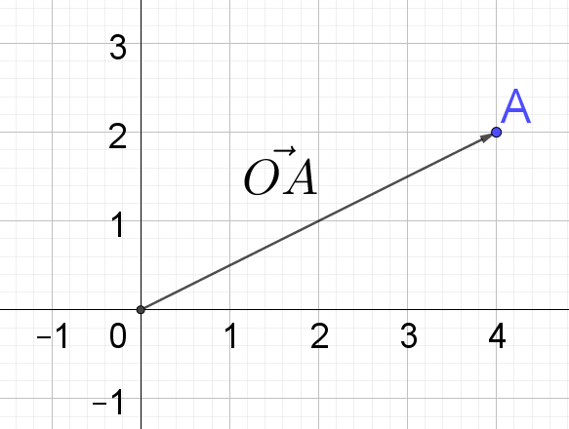
Column vector: $\overset{→}{OA}=\left[\begin{matrix}4 \\ 2\end{matrix}\right]$
Ordered pair: $\overset{→}{OA}=(4, 2)$
Component form: $\overset{→}{OA}=4\underset{\sim }{i}+2\underset{\sim }{j}$

- On a Cartesian plane:
  - Plot two points $A$ and $B$
  - Plot two additional points $C$ and $D$ and draw vectors $\overset{→}{AC}$ and $\overset{→}{DB}$ such that $\overset{→}{AC}=3\underset{\sim }{i}+\underset{\sim }{j}$ and $\overset{→}{DB}=-5\underset{\sim }{i}+3\underset{\sim }{j}$
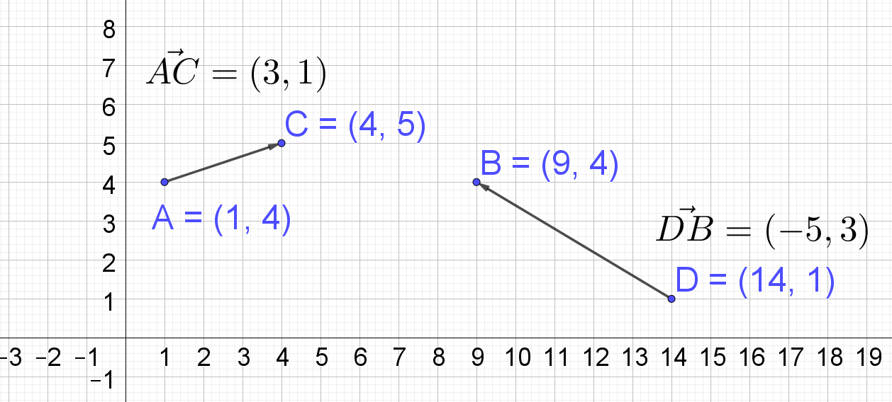

Multiplying a vector by a scalar
- If $\overset{̰}{u}=5\overset{̰}{i}-2\overset{̰}{j}$ calculate $4\overset{̰}{u}$.
$$4\overset{̰}{u}=4\left(5\overset{̰}{i}-2\overset{̰}{j}\right)$$
$$4\overset{̰}{u}=20\overset{̰}{i}-8\overset{̰}{j}$$
Geometrically, this can be shown as:
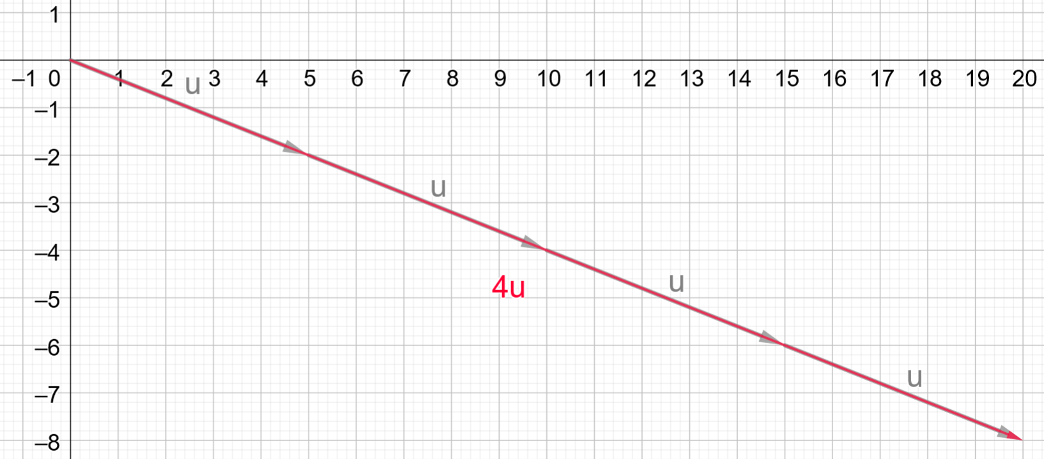

- On a blank page draw a vector $\underset{\sim }{v}$. Use this to draw vectors $3\underset{\sim }{v}, -2\underset{\sim }{v}$and $\frac{1}{2}\underset{\sim }{v}$.
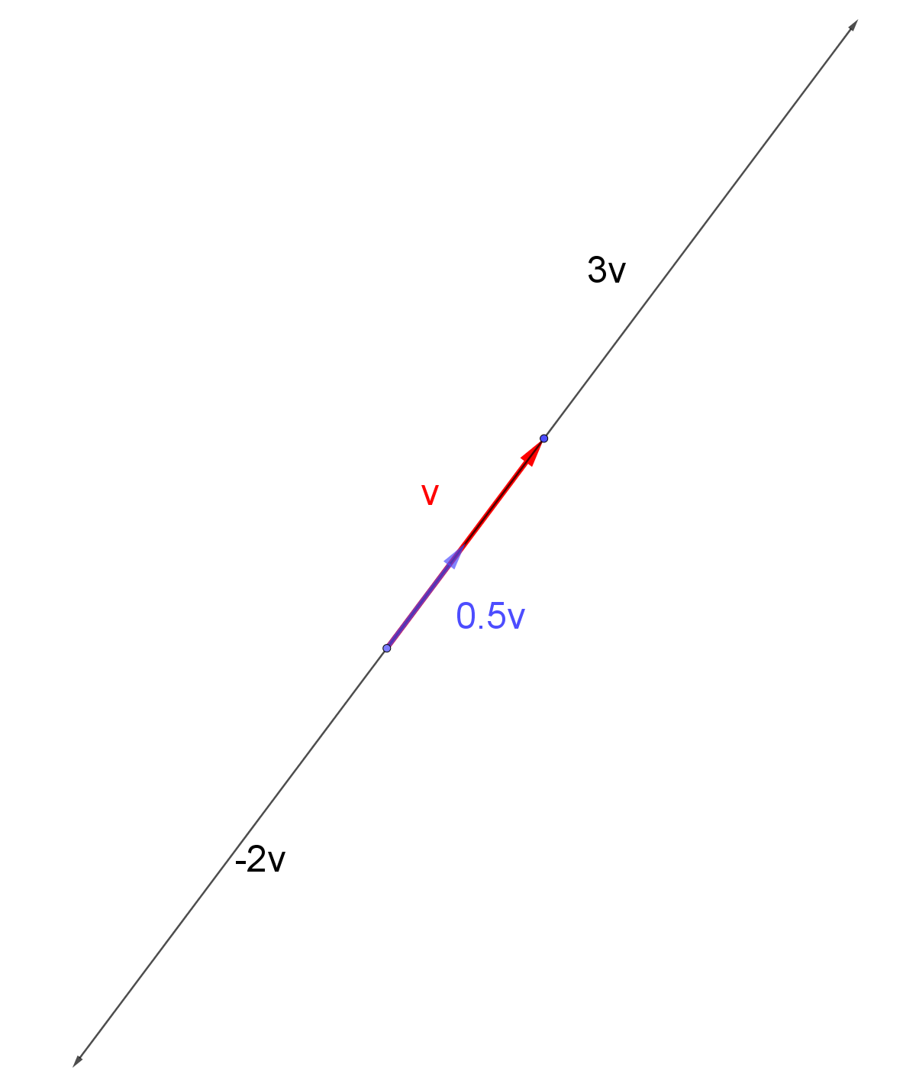
- If $\underset{\sim }{u}=3\underset{\sim }{i}+7\underset{\sim }{j}$, find $3\underset{\sim }{u}, -2\underset{\sim }{u}$and $\frac{1}{2}\underset{\sim }{u}$.
$$3\underset{\sim }{u}=3\left(3\underset{\sim }{i}+7\underset{\sim }{j}\right) \\ =9\underset{\sim }{i}+21\underset{\sim }{j}$$
$$-2\underset{\sim }{u}=-2\left(3\underset{\sim }{i}+7\underset{\sim }{j}\right) \\ =-6\underset{\sim }{i}-14\underset{\sim }{j}$$
$$\frac{1}{2}\underset{\sim }{u}=\frac{1}{2}\left(3\underset{\sim }{i}+7\underset{\sim }{j}\right) \\ =\frac{3}{2}\underset{\sim }{i}+\frac{7}{2}\underset{\sim }{j}$$

Adding and subtracting vectors
- Given $\vec{OA}=$ 8$\underset{\sim }{i}-3\underset{\sim }{j}$and $\vec{OB}=3\underset{\sim }{i}+2\underset{\sim }{j}$:
  - graph vectors $\vec{OA}$ and $\vec{OB}$ on a Cartesian plane
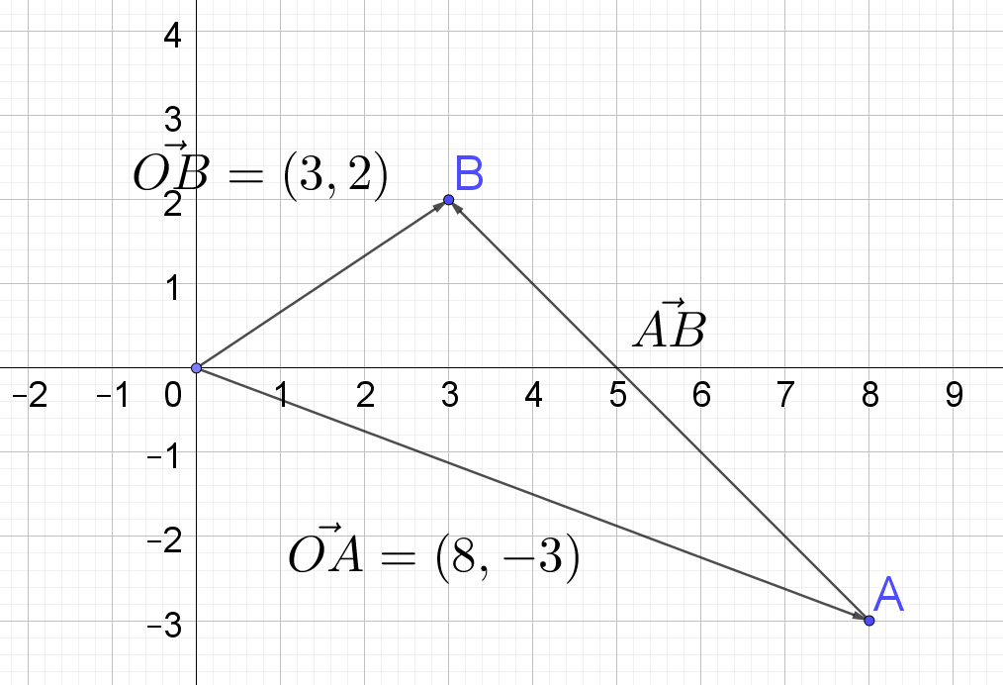
  - Find the vector $\vec{AB}.$
$$\vec{AB}=-5\underset{\sim }{i}+5\underset{\sim }{j}$$
  - Explain the relationship between $\vec{AB}$, $\vec{OA}$and $\vec{OB}.$ $\vec{AB}=?$
$$\vec{AB}=-\left(\vec{OA}\right)+\vec{OB}=\vec{OB}-\vec{OA}$$
  - Confirm the relationship numerically.
$$\vec{OB}-\vec{OA}=3\underset{\sim }{i}+2\underset{\sim }{j}-\left(8\underset{\sim }{i}-3\underset{\sim }{j}\right) \\ =3\underset{\sim }{i}+2\underset{\sim }{j}-8\underset{\sim }{i}+3\underset{\sim }{j} \\ =-5\underset{\sim }{i}+5\underset{\sim }{j} \\ =\vec{AB}$$
- If $\underset{\sim }{v}=3\underset{\sim }{i}+7\underset{\sim }{j}$ and $u=-5\underset{\sim }{i}-3\underset{\sim }{j}$, calculate $\overset{̰}{v} +\overset{̰}{u}$
$$\overset{̰}{v} +\overset{̰}{u}=3\underset{\sim }{i}+7\underset{\sim }{j}+\left(-5\underset{\sim }{i}-3\underset{\sim }{j}\right) \\ =3\underset{\sim }{i}+7\underset{\sim }{j}-5\underset{\sim }{i}-3\underset{\sim }{j} \\ =-2\underset{\sim }{i}+4\underset{\sim }{j}$$
- Consider the vectors $\underset{\sim }{u}=3\underset{\sim }{i}-2\underset{\sim }{j}$ and $\underset{\sim }{v}=\underset{\sim }{i}+4j$. Find:
  - $\underset{\sim }{u}+ \underset{\sim }{v}$
$$\overset{̰}{u} +\overset{̰}{v}=3\underset{\sim }{i}-2\underset{\sim }{j}+\left(\underset{\sim }{i}+4j\right) \\ =4\underset{\sim }{i}+2\underset{\sim }{j}$$
  - $\underset{\sim }{u}- \underset{\sim }{v}$
$$\overset{̰}{u}-\overset{̰}{v}=3\underset{\sim }{i}-2\underset{\sim }{j}-\left(\underset{\sim }{i}+4j\right) \\ =3\underset{\sim }{i}-2\underset{\sim }{j}-\underset{\sim }{i}-4\underset{\sim }{j} \\ =2\underset{\sim }{i}-6\underset{\sim }{j}$$
  - $\underset{\sim }{v}- \underset{\sim }{u}$
$$\overset{̰}{v}-\overset{̰}{u}=\underset{\sim }{i}+4j-\left(3\underset{\sim }{i}-2\underset{\sim }{j}\right) \\ =\underset{\sim }{i}+4j-\underset{\sim }{3i}+2\underset{\sim }{j} \\ =-2\underset{\sim }{i}+6\underset{\sim }{j}$$
  - Confirm the results for a. to c. by geometrically representing these on a Cartesian plane.
$$\underset{\sim }{u}+ \underset{\sim }{v}$$
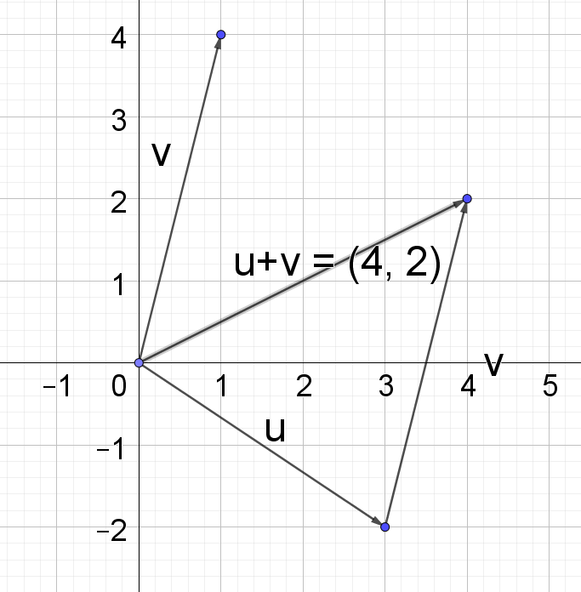
$$\underset{\sim }{u}- \underset{\sim }{v}$$
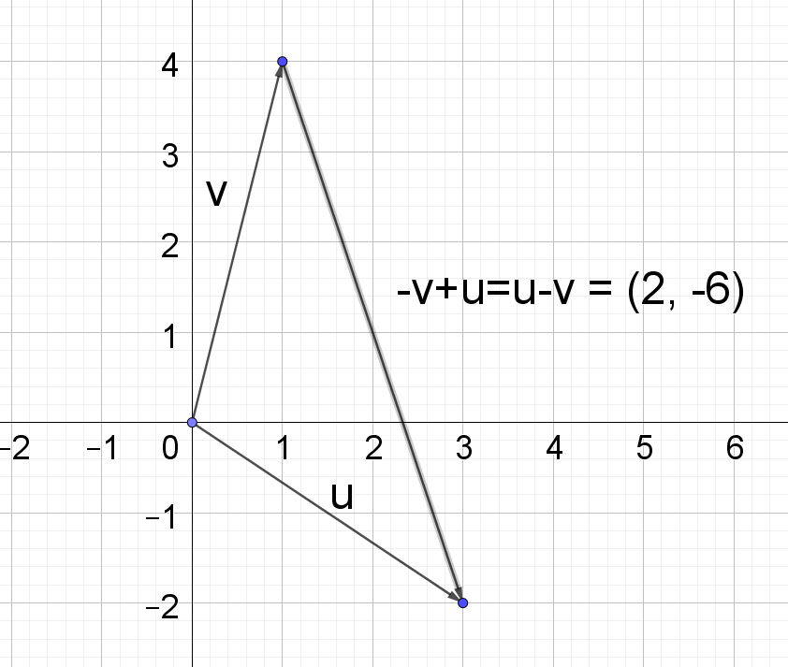
$$\underset{\sim }{v}- \underset{\sim }{u}$$
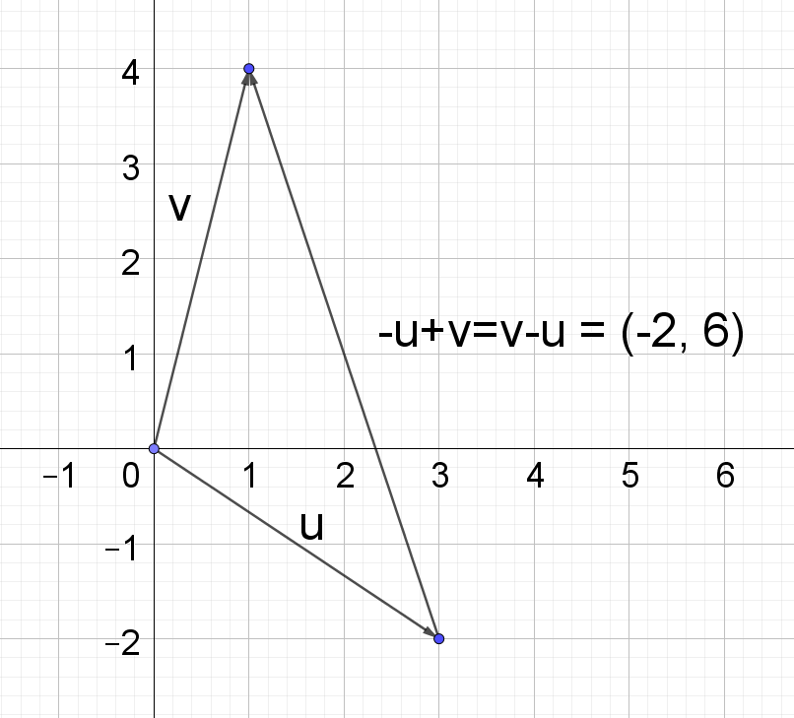

- If $\underset{\sim }{v}=5\underset{\sim }{i}+4\underset{\sim }{j}$, $\underset{\sim }{u}=-3\underset{\sim }{i}-7\underset{\sim }{j}$ and $\underset{\sim }{w}=5\underset{\sim }{i}-4\underset{\sim }{j},$match each statement to its component form.
Statement | Component form expressions
$$\underset{\sim }{u}+\underset{\sim }{v}$$ | $$25\underset{\sim }{i}-20\underset{\sim }{j}$$
$$\underset{\sim }{v}-\underset{\sim }{w}$$ | $$2\underset{\sim }{i}-3\underset{\sim }{j}$$
$$\underset{\sim }{v}+\underset{\sim }{w}-\underset{\sim }{u}$$ | $$13\underset{\sim }{i}+7\underset{\sim }{j}$$
$$5\underset{\sim }{w}$$ | $$0\underset{\sim }{i}+8\underset{\sim }{j}$$
$$-\underset{\sim }{v}$$ | $$15\underset{\sim }{i}+4\underset{\sim }{j}$$
$$2\underset{\sim }{v}+\underset{\sim }{w}$$ | $$-5\underset{\sim }{i}-4\underset{\sim }{j}$$

Statement | Component form expressions – solutions
$$\underset{\sim }{u}+\underset{\sim }{v}$$ | $$2\underset{\sim }{i}-3\underset{\sim }{j}$$
$$\underset{\sim }{v}-\underset{\sim }{w}$$ | $$0\underset{\sim }{i}+8\underset{\sim }{j}$$
$$\underset{\sim }{v}+\underset{\sim }{w}-\underset{\sim }{u}$$ | $$13\underset{\sim }{i}+7\underset{\sim }{j}$$
$$5\underset{\sim }{w}$$ | $$25\underset{\sim }{i}-20\underset{\sim }{j}$$
$$-\underset{\sim }{v}$$ | $$-5\underset{\sim }{i}-4\underset{\sim }{j}$$
$$2\underset{\sim }{v}+\underset{\sim }{w}$$ | $$15\underset{\sim }{i}+4\underset{\sim }{j}$$

Magnitude of a vector
- If $\underset{\sim }{u}=8\underset{\sim }{i}-6\underset{\sim }{j}$, find the:
  - magnitude of the vector $\underset{\sim }{u}$
$$\left|\underset{\sim }{u}\right|=\sqrt{8^{2}+{\left(-6\right)}^{2}} \\ =\sqrt{64+36} \\ =\sqrt{100} \\ =10$$
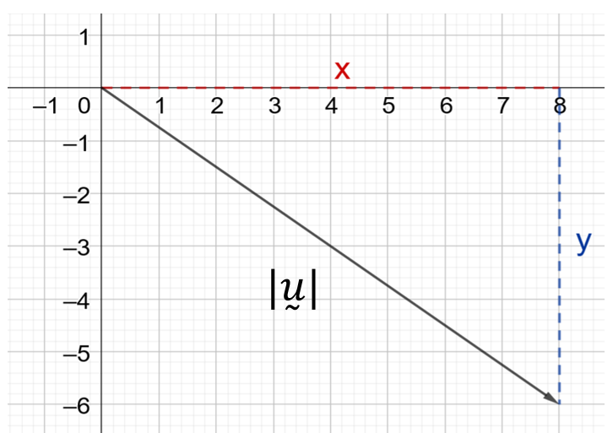
  - unit vector $\overset{̰}{\hat{u}}$
$$\overset{̰}{\hat{u}}=\frac{\underset{\sim }{u}}{\left|\underset{\sim }{u}\right|} \\ =\frac{8\underset{\sim }{i}-6\underset{\sim }{j}}{10} \\ =\frac{8}{10}\underset{\sim }{i}-\frac{6}{10}\underset{\sim }{j} \\ =\frac{4}{5}\underset{\sim }{i}-\frac{3}{5}\underset{\sim }{j}$$
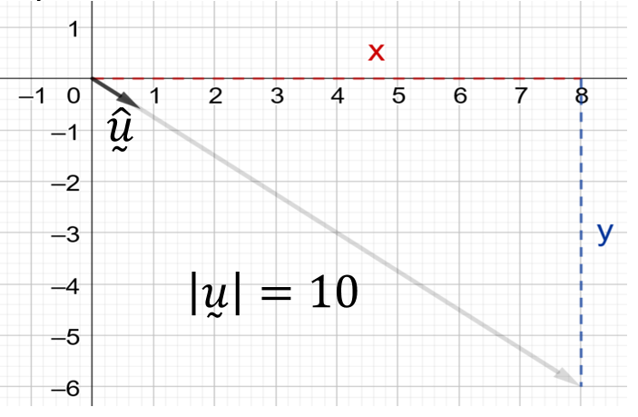

- If $\underset{\sim }{v}=\underset{\sim }{i}+7\underset{\sim }{j}$, find the:
  - magnitude vector $\underset{\sim }{v}$.
$$\left|\underset{\sim }{u}\right|=\sqrt{1+7^{2}} \\ =\sqrt{1+49} \\ =\sqrt{50} \\ =5\sqrt{2}$$
  - unit vector $\overset{̰}{\hat{v}}$
$$\overset{̰}{\hat{v}}=\frac{\underset{\sim }{v}}{\left|\underset{\sim }{v}\right|} \\ =\frac{\underset{\sim }{i}+7\underset{\sim }{j}}{5\sqrt{2}} \\ =\frac{1}{5\sqrt{2}}\underset{\sim }{i}+\frac{7}{5\sqrt{2}}\underset{\sim }{j} \\ =\frac{\sqrt{2}}{10}\underset{\sim }{i}-\frac{7\sqrt{2}}{10}\underset{\sim }{j}$$

- Given $\vec{OA}=$ 4$\underset{\sim }{i}-3\underset{\sim }{j}$and $\vec{OB}=-2\underset{\sim }{i}+3\underset{\sim }{j}$, find the magnitude of $\vec{AB}$
$$\vec{AB}=\vec{OB}-\vec{OA} \\ =-2\underset{\sim }{i}+3\underset{\sim }{j}-\left(4\underset{\sim }{i}-3\underset{\sim }{j}\right) \\ =-2\underset{\sim }{i}+3\underset{\sim }{j}-4\underset{\sim }{i}+3\underset{\sim }{j} \\ =-6\underset{\sim }{i}+6\underset{\sim }{j}$$

Direction of a vector
- A particle is projected from the origin with an initial velocity of $5\underset{\sim }{i}+3\underset{\sim }{j} {ms}^{-1}$. What is the angle of projection?
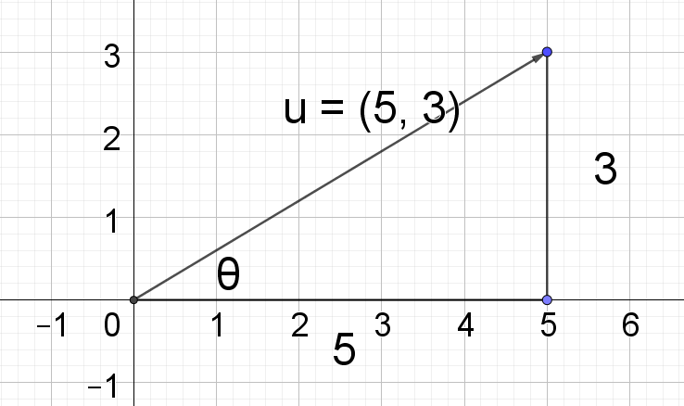
$$\tan{θ}=\frac{3}{5} \\ θ=\tan^{-1}\left(\frac{3}{5}\right) \\ =30.96…°$$

- A particle is projected from the origin with an initial velocity of $-2\underset{\sim }{i}+3\underset{\sim }{j} {ms}^{-1}$. What is the angle of projection?
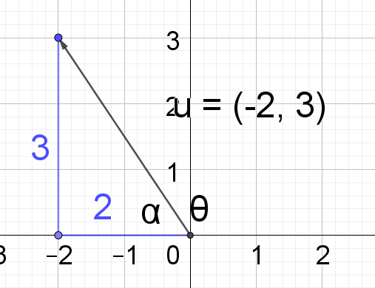
$$\tan{α}=\frac{3}{2} \\ α=\tan^{-1}\left(\frac{3}{2}\right) \\ θ=180-\tan^{-1}\left(\frac{3}{2}\right) \\ =123.69…°$$

Scalar (dot) product
- $\underset{\sim }{u}=-3\underset{\sim }{i}-7\underset{\sim }{j}$, If $\underset{\sim }{v}=5\underset{\sim }{i}+4\underset{\sim }{j}$ and $\underset{\sim }{w}=5\underset{\sim }{i}-4\underset{\sim }{j}:$
  - Calculate $\underset{\sim }{u}⋅\underset{\sim }{v}$
$${\underset{\sim }{u}⋅\underset{\sim }{v}=x}_{1}x_{2}+y_{1}y_{2}$$
$$\underset{\sim }{u}⋅\underset{\sim }{v}=-3⋅5+\left(-7\right)⋅4$$
$$\underset{\sim }{u}⋅\underset{\sim }{v}=-15-28$$
$$\underset{\sim }{u}⋅\underset{\sim }{v}=-43$$

  - Find the angle between $\underset{\sim }{v}$ and $\underset{\sim }{u}$
$\underset{\sim }{u}$.$\underset{\sim }{v}=|\underset{\sim }{u}$||$\underset{\sim }{v}$|$\cos{θ}$

$$\cos{θ}=\frac{\underset{\sim }{u}.\underset{\sim }{v}}{|\underset{\sim }{u}||\underset{\sim }{v}|}$$

$$\left|\underset{\sim }{u}\right|=\sqrt{{\left(-3\right)}^{2}+{(-7)}^{2}} \\ =\sqrt{9+49} \\ =\sqrt{58}$$
$$\left|\underset{\sim }{v}\right|=\sqrt{5^{2}+4^{2}} \\ =\sqrt{25+16} \\ =\sqrt{41}$$

$$\cos{θ}=-\frac{43}{\sqrt{58}⋅\sqrt{41}} \\ θ=\cos^{-1}\left(-\frac{43}{\sqrt{58}⋅\sqrt{41}}\right) \\ =151.85…°$$

  - Show the distributive property holds, i.e. $\underset{\sim }{v}⋅\left(\underset{\sim }{u}+\underset{\sim }{w}\right)=\underset{\sim }{v}⋅\underset{\sim }{u}+\underset{\sim }{v}⋅\underset{\sim }{w}$
$$\underset{\sim }{u}+\underset{\sim }{w}=-3\underset{\sim }{i}-7\underset{\sim }{j}+5\underset{\sim }{i}-4\underset{\sim }{j} \\ =2\underset{\sim }{i}-11\underset{\sim }{j}$$
$$\underset{\sim }{v}⋅\left(\underset{\sim }{u}+\underset{\sim }{w}\right)=5⋅2+4⋅\left(-11\right) \\ =10-44 \\ =-34$$
$$\underset{\sim }{v}⋅\underset{\sim }{u}+\underset{\sim }{v}⋅\underset{\sim }{w}=5⋅\left(-3\right)+4⋅\left(-7\right)+5⋅5+4⋅\left(-4\right) \\ =-15-28+25-16 \\ =-34$$

- A, B and C are points defined by the position vectors $\underset{\sim }{a}=\underset{\sim }{i}+3\underset{\sim }{j}$, $\underset{\sim }{b}=2\underset{\sim }{i}+\underset{\sim }{j}$ and $\underset{\sim }{c}=\underset{\sim }{i}-2\underset{\sim }{j}$ respectively. Find the size of $∠ABC$.
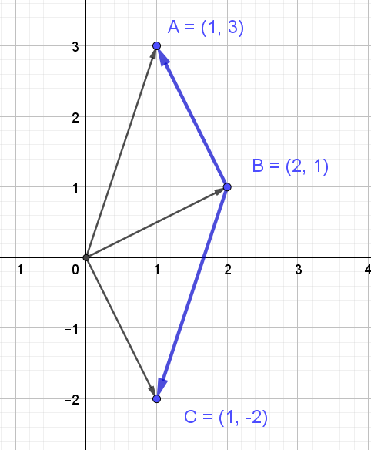
$∠ABC$ is the angle between vectors $\vec{BA}$ and $\vec{BC}$
$\underset{\sim }{u}$.$\underset{\sim }{v}=|\underset{\sim }{u}$||$\underset{\sim }{v}$|$\cos{θ}$
$\cos{θ}=\frac{\underset{\sim }{u}.\underset{\sim }{v}}{|\underset{\sim }{u}||\underset{\sim }{v}|}$, or in our case, letting $∠ABC=θ$, $\cos{θ}=\frac{\vec{BA} .\vec{BC}}{|\vec{BA} ||\vec{BC}|}$

$$\vec{BA}= \underset{\sim }{a}- \underset{\sim }{b} \\ =\underset{\sim }{i}+3\underset{\sim }{j}-\left(2\underset{\sim }{i}+\underset{\sim }{j}\right) \\ =-\underset{\sim }{i}+2\underset{\sim }{j}$$

$$\vec{BC}= \underset{\sim }{c}- \underset{\sim }{b} \\ =\underset{\sim }{i}-2\underset{\sim }{j}-\left(2\underset{\sim }{i}+\underset{\sim }{j}\right) \\ =-\underset{\sim }{i}-3\underset{\sim }{j}$$

$$\vec{BA} .\vec{BC}=-1×-1+2×-3 \\ =-5$$

$$|\vec{BA} |=\sqrt{{\left(-1\right)}^{2}+2^{2}} \\ =\sqrt{5}$$

$$|\vec{BC} |=\sqrt{{\left(-1\right)}^{2}+{(-3)}^{2}} \\ =\sqrt{10}$$

$$\cos{θ}=\frac{\vec{BA} .\vec{BC}}{|\vec{BA} ||\vec{BC}|}$$
$$\cos{θ}=\frac{-5}{\sqrt{5}×\sqrt{10}}$$
$$\cos{θ}=\frac{-5}{\sqrt{5}×\sqrt{5}×\sqrt{2}}$$
$$\cos{θ}=\frac{-5}{5×\sqrt{2}}$$
$$\cos{θ}=-\frac{1}{\sqrt{2}}$$

$$θ=\cos^{-1}\left(-\frac{1}{\sqrt{2}}\right)$$
$$=180°-\cos^{-1}\left(\frac{1}{\sqrt{2}}\right)$$
$$=180°-45°$$
$$=135°$$

$$∴∠ABC=135°$$

- If $\overset{̰}{v}=\underset{\sim }{i}+7\underset{\sim }{j}$ and $\overset{̰}{u}=8\underset{\sim }{i}-6\underset{\sim }{j}$, find $\underset{\sim }{u}⋅\underset{\sim }{v}$ and hence find the angle between $\underset{\sim }{u}$and$\underset{\sim }{v}$ (to the nearest degree).
$$\underset{\sim }{u}⋅\underset{\sim }{v}=x_{1}x_{2}+y_{1}y_{2}$$
$$\underset{\sim }{u}⋅\underset{\sim }{v}=1×8+7×-6 \\ \underset{\sim }{u}⋅\underset{\sim }{v}=-34$$

$$\underset{\sim }{u}⋅\underset{\sim }{v}=\left|\underset{\sim }{u}\right|\left|\underset{\sim }{v}\right|\cos{θ}$$
$$-34=\sqrt{50}×\sqrt{100}cosθ$$
$$-34=50\sqrt{2}cosθ$$

$$\frac{-17}{25\sqrt{2}}=cosθ$$

$$θ={119}^{o}$$

Parallel and perpendicular vectors
- If $\underset{\sim }{v}=6\underset{\sim }{i}+4\underset{\sim }{j}$, $\underset{\sim }{u}=2\underset{\sim }{i}-3\underset{\sim }{j}$, $\underset{\sim }{w}=12\underset{\sim }{i}-18\underset{\sim }{j}$
  - Show $\underset{\sim }{u}$and $\underset{\sim }{v}$are perpendicular
$${\underset{\sim }{u}.\underset{\sim }{v}=x}_{1}x_{2}+y_{1}y_{2} \\ =2×6+\left(-3\right)×4 \\ =12-12 \\ =0$$
$∴\overset{̰}{u}$and $\overset{̰}{v}$ are perpendicular
  - Show $\underset{\sim }{u}$and $\underset{\sim }{w}$are parallel
Show $\underset{\sim }{w}=λ\underset{\sim }{u}$ or if show $\frac{x_{1}}{x_{2}}=\frac{y_{1}}{y_{2}}$
$$\frac{x_{1}}{x_{2}}=\frac{12}{2}=6$$
$$\frac{y_{1}}{y_{2}}=\frac{-18}{-3}=6$$
$∴\underset{\sim }{u}$and $\underset{\sim }{w}$ are parallel.
Alternate method: Show $\underset{\sim }{u}⋅\underset{\sim }{w}=|\underset{\sim }{u}\text{||}\overset{̰}{w}\text{| or} \underset{\sim }{u}⋅\underset{\sim }{w}=-|\underset{\sim }{u}\text{||}\underset{\sim }{w}\text{|}$

- If $\underset{\sim }{a}=x\underset{\sim }{i}+2\underset{\sim }{j}$ is perpendicular to vector $\underset{\sim }{b}=2\underset{\sim }{i}-\underset{\sim }{j}$, find $x$.
$\underset{\sim }{a}⋅\underset{\sim }{b}=0$ as they are perpendicular.
$$x×2+2×-1=0 \\ 2x-2=0 \\ 2x=2 \\ x=1$$

- If $\underset{\sim }{a}=-6\underset{\sim }{i}+y\underset{\sim }{j}$ is parallel to vector $\underset{\sim }{b}=2\underset{\sim }{i}-4\underset{\sim }{j}$, find $y$.
Two vectors are parallel if they are scalar multiples of one another.
$$\frac{y}{-4}=-\frac{6}{2}$$
$$\frac{y}{-4}=-3$$

$$∴y=12$$

Vector projection
- Let $\underset{\sim }{a}=\underset{\sim }{i}+3\underset{\sim }{j}$ and $\underset{\sim }{b}=\underset{\sim }{i}-\underset{\sim }{j}$,
  - find the scalar projection of $\underset{\sim }{a}$ onto $\underset{\sim }{b}$.
Scalar projection of $\underset{\sim }{a}$ onto $\underset{\sim }{b}=|\underset{\sim }{a}|\cos{θ}$
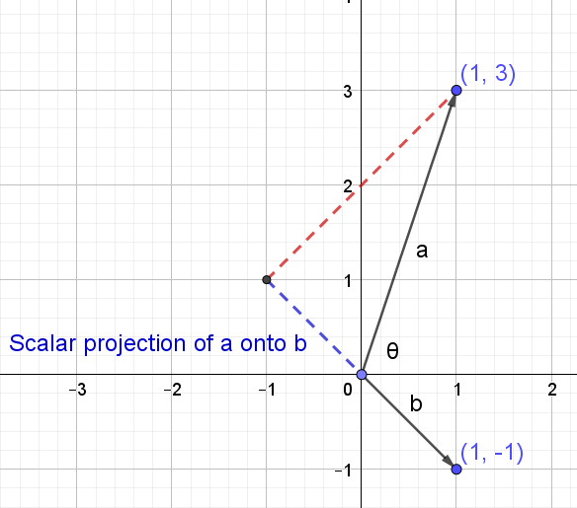
Note: The scalar projection will be negative as $\underset{\sim }{a}$ opposes $\underset{\sim }{b}$
$$\cos{θ}=\frac{\underset{\sim }{a}.\underset{\sim }{b}}{|\underset{\sim }{a}||b|}$$
$$\left|\underset{\sim }{a}\right|\cos{θ}=\frac{\underset{\sim }{a}.\underset{\sim }{b}}{|\underset{\sim }{b}|}$$
$$\left|\underset{\sim }{a}\right|\cos{θ}=\frac{1×1+3×(-1)}{\sqrt{1^{2}+{\left(-1\right)}^{2}}}$$
$$\left|\underset{\sim }{a}\right|\cos{θ}=\frac{-2}{\sqrt{2}}$$
$$\left|\underset{\sim }{a}\right|\cos{θ}=-\sqrt{2}$$
  - find the vector projection of $\underset{\sim }{a}$ in the direction of $\underset{\sim }{b}$.
$${proj}_{\underset{\sim }{b}}\underset{\sim }{a}= scalar projection of \underset{\sim }{a} onto \underset{\sim }{b}×the unit vector of \underset{\sim }{b} \\ =-\sqrt{2}×\frac{\underset{\sim }{i}-\underset{\sim }{j}}{\sqrt{2}} \\ =-\underset{\sim }{i}+\underset{\sim }{j}$$

- Let $\underset{\sim }{a}=\underset{\sim }{i}+3\underset{\sim }{j}$ and $b=\underset{\sim }{i}-\underset{\sim }{j}$, find the vector projection of $\underset{\sim }{a}$ in the direction $\underset{\sim }{b}$.
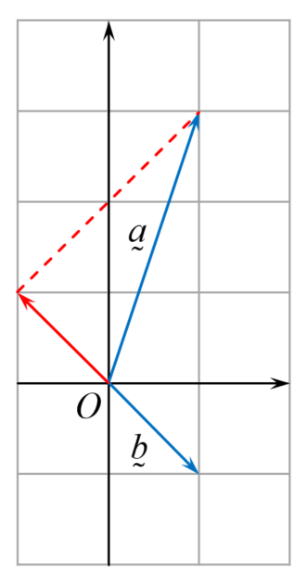
$$\underset{\sim }{a}∙\underset{\sim }{b}=\left(\underset{\sim }{i}+3\underset{\sim }{j}\right)\left( \underset{\sim }{i}-\underset{\sim }{j}\right)$$
$$\underset{\sim }{a}∙\underset{\sim }{b}=1×1+3×\left(-1\right)$$
$$\underset{\sim }{a}∙\underset{\sim }{b}=-2$$

$$\underset{\sim }{b}∙\underset{\sim }{b}=\left( \underset{\sim }{i}-\underset{\sim }{j}\right)\left( \underset{\sim }{i}-\underset{\sim }{j}\right)$$
$$\underset{\sim }{b}∙\underset{\sim }{b}=1×1+(-1)×\left(-1\right)$$
$$\underset{\sim }{b}∙\underset{\sim }{b}=2$$

$${proj}_{\underset{\sim }{b}}\underset{\sim }{a}=\frac{\underset{\sim }{a}∙\underset{\sim }{b}}{\underset{\sim }{b}∙\underset{\sim }{b}}\underset{\sim }{b}$$
$${proj}_{\underset{\sim }{b}}\underset{\sim }{a}=\frac{-2}{2}\left( \underset{\sim }{i}-\underset{\sim }{j}\right)$$
$${proj}_{\underset{\sim }{b}}\underset{\sim }{a}=-\underset{\sim }{i}+\underset{\sim }{j}$$

Proving geometric results
- The diagonals of a parallelogram meet at right angles if and only if it is a rhombus (ACMSM039)
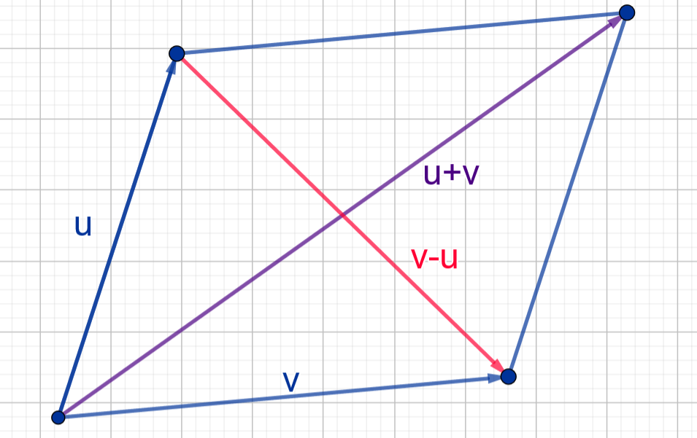
$$\left(\overset{̰}{u}+\overset{̰}{v}\right)∙\left(\overset{̰}{u}-\overset{̰}{v}\right)=\overset{̰}{u}. \overset{̰}{u}-\overset{̰}{v}.\overset{̰}{v} \\ ={\left|\overset{̰}{u}\right|}^{2}-{\left|\overset{̰}{v}\right|}^{2}$$
If the diagonals meet at a right angle then $\left(\overset{̰}{u}+\overset{̰}{v}\right)∙\left(\overset{̰}{u}-\overset{̰}{v}\right)=0$
$$∴{\left|\overset{̰}{u}\right|}^{2}-{\left|\overset{̰}{v}\right|}^{2}=0$$
$${\left|\overset{̰}{u}\right|}^{2}={\left|\overset{̰}{v}\right|}^{2}$$
$$\left|\overset{̰}{u}\right|=\left|\overset{̰}{v}\right|$$
$∴$ The parallelogram is a rhombus

- The midpoints of the sides of a quadrilateral join to form a parallelogram (ACMSM040)
Part 1: First show the line joining the midpoints of two sides of a triangle is parallel to the third side and is half its length.
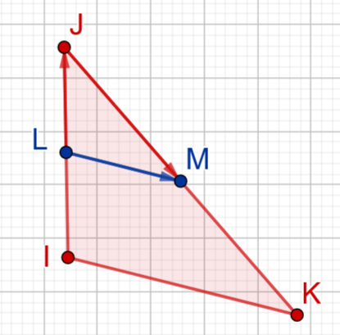
$$\overset{⃑}{LM}=\overset{⃑}{LJ}+\overset{⃑}{JM} \\ =\frac{1}{2}\overset{⃑}{IJ}+\frac{1}{2}\overset{⃑}{JK} \\ =\frac{1}{2}\left(\overset{⃑}{IJ}+\overset{⃑}{JK}\right) \\ =\frac{1}{2}\overset{⃑}{IK}$$
Part 2: Consider quadrilateral ABCD with midpoints F, G, E and H.
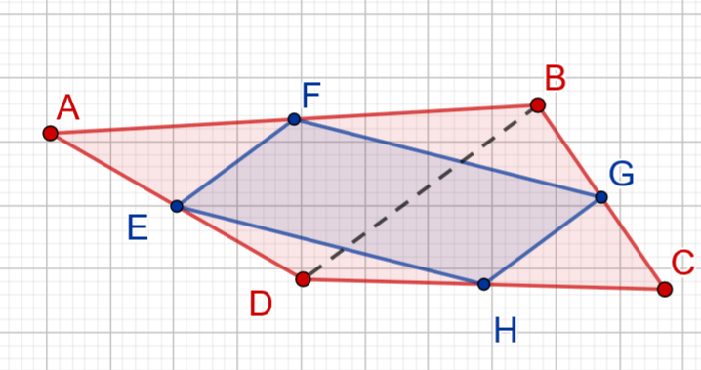
$\overset{⃑}{FE}=\frac{1}{2}\overset{⃑}{BD}$ and $\overset{⃑}{GH}=\frac{1}{2}\overset{⃑}{BD}$
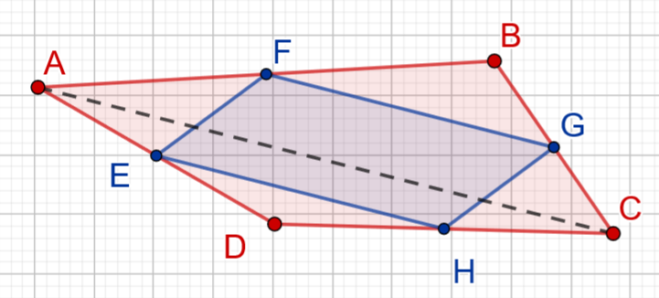
$\overset{⃑}{FG}=\frac{1}{2}\overset{⃑}{AC}$ and $\overset{⃑}{EH}=\frac{1}{2}\overset{⃑}{AC}$
$∴$ $FGHE$ is a parallelogram as opposite sides are equal in length.

- The sum of the squares of the lengths of the diagonals of a parallelogram is equal to the sum of the squares of the lengths of the sides (ACMSM041)

Proof using vectors:
$${\left|\overset{̰}{u}+\overset{̰}{v}\right|}^{2}+{\left|\overset{̰}{u}-\overset{̰}{v}\right|}^{2}=\left(\overset{̰}{u}+\overset{̰}{v}\right)∙\left(\overset{̰}{u}+\overset{̰}{v}\right)+\left(\overset{̰}{u}-\overset{̰}{v}\right)∙\left(\overset{̰}{u}-\overset{̰}{v}\right) \\ =\overset{̰}{u}∙\overset{̰}{u}+\overset{̰}{u}∙\overset{̰}{v}+\overset{̰}{v}∙\overset{̰}{u}+\overset{̰}{v}∙\overset{̰}{v}+\overset{̰}{u}∙\overset{̰}{u}-\overset{̰}{u}∙\overset{̰}{v}-\overset{̰}{v∙}\overset{̰}{u}+\overset{̰}{v}∙\overset{̰}{v} \\ =2\overset{̰}{u}∙\overset{̰}{u}+2\overset{̰}{v}∙\overset{̰}{v}$$${\left|\overset{̰}{u}+\overset{̰}{v}\right|}^{2}+{\left|\overset{̰}{u}-\overset{̰}{v}\right|}^{2}=2{\left|\overset{̰}{u}\right|}^{2}+2{\left|\overset{̰}{v}\right|}^{2}$ i.e. the sum of the squares of the length of the sides

$∴$ The sum of the squares of the lengths of the diagonals of a parallelogram is equal to the sum of the squares of the lengths of the sides

Proof without vectors:
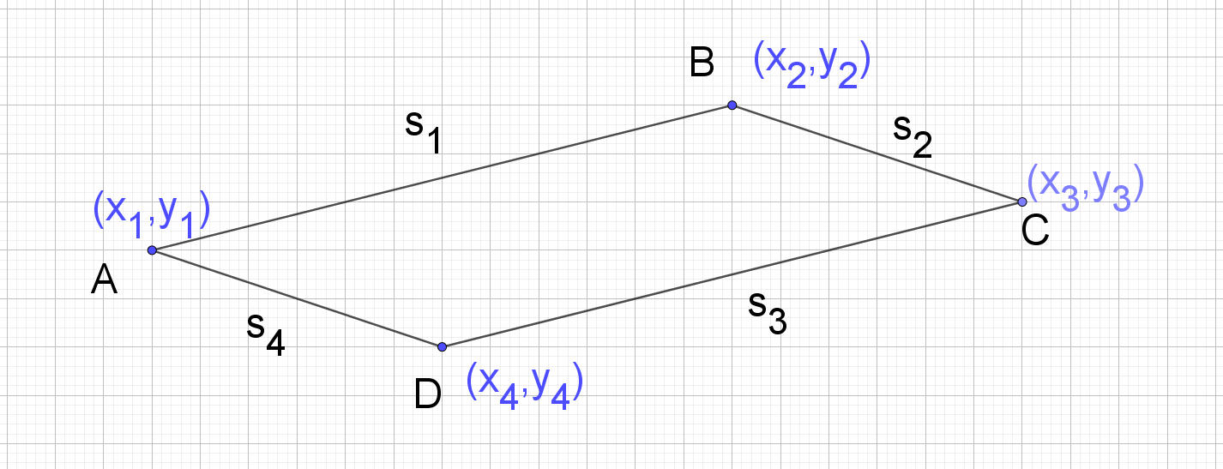

Consider the cosine rule for angle C in triangle DBC:
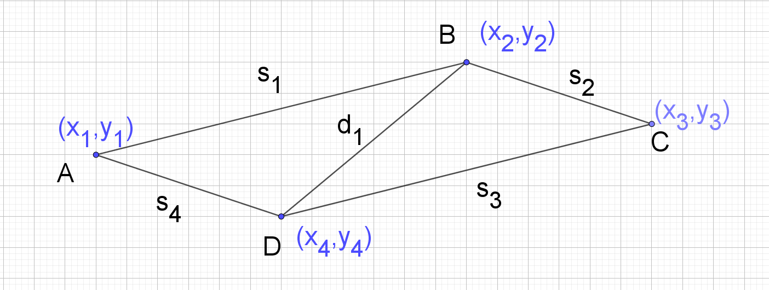
$$\cos{C}=\frac{{s_{2}}^{2}+{s_{3}}^{2}-{d_{1}}^{2}}{2s_{2}s_{3}}$$

Consider the cosine rule for angle D in triangle DAC:
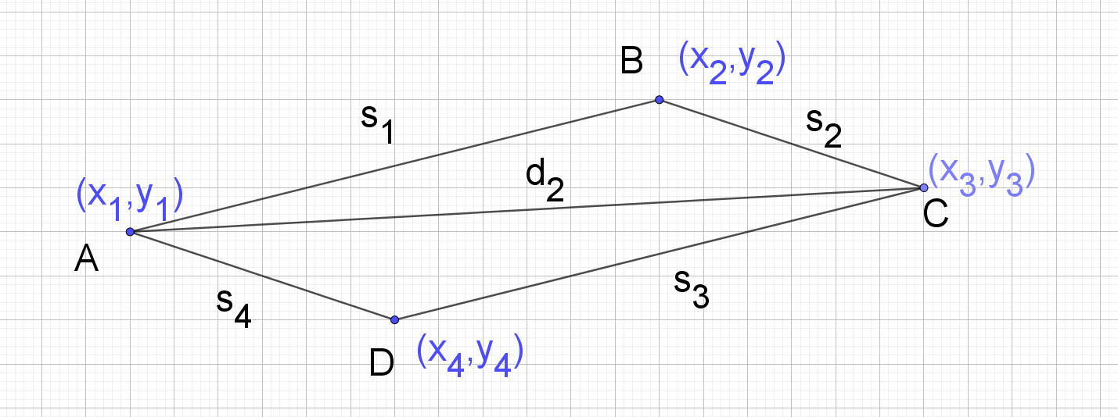
$$\cos{D}=\frac{{s_{3}}^{2}+{s_{4}}^{2}-{d_{2}}^{2}}{2s_{3}s_{4}}$$
$\cos{D}=\cos\left(π-C\right)=-\cos{C}$ (Cointerior angles are supplementary when BC||AB)
$$-\cos{C}=\frac{{s_{3}}^{2}+{s_{4}}^{2}-{d_{2}}^{2}}{2s_{3}s_{4}}$$

$$\cos{C}=\frac{{-s_{3}}^{2}-{s_{4}}^{2}+{d_{2}}^{2}}{2s_{3}s_{4}}$$

$$\frac{{s_{2}}^{2}+{s_{3}}^{2}-{d_{1}}^{2}}{2s_{2}s_{3}}=\frac{{-s_{3}}^{2}-{s_{4}}^{2}+{d_{2}}^{2}}{2s_{3}s_{4}}$$

$sub s_{2}=s_{4}$(Opposite sides of a parallelogram are equal)

$$\frac{{s_{2}}^{2}+{s_{3}}^{2}-{d_{1}}^{2}}{2s_{4}s_{3}}=\frac{{-s_{3}}^{2}-{s_{4}}^{2}+{d_{2}}^{2}}{2s_{3}s_{4}}$$

Multiply both sides by$2s_{3}s_{4}$

$${s_{2}}^{2}+{s_{3}}^{2}-{d_{1}}^{2}={-s_{3}}^{2}-{s_{4}}^{2}+{d_{2}}^{2}$$
$${s_{2}}^{2}+{s_{3}}^{2}+{s_{3}}^{2}+{s_{4}}^{2}={d_{1}}^{2}+{d_{2}}^{2}$$

$sub s_{1}=s_{3}$(Opposite sides of a parallelogram are equal)

$${s_{2}}^{2}+{s_{1}}^{2}+{s_{3}}^{2}+{s_{4}}^{2}={d_{1}}^{2}+{d_{2}}^{2}$$
$${s_{1}}^{2}+{s_{2}}^{2}+{s_{3}}^{2}+{s_{4}}^{2}={d_{1}}^{2}+{d_{2}}^{2}$$

$∴$ The sum of the squares of the lengths of the diagonals of a parallelogram is equal to the sum of the squares of the lengths of the sides.

Modelling motion
- In still water, Jacques can swim at 3 m/s. Jacques is at point A on the edge of a canal, and considers point B directly opposite. A current is flowing from the left at a constant speed of 1 m/s. If Jacques dives in straight towards B, and swims without allowing for the
current, what will his actual speed and direction be? (answers correct to 1 decimal place)
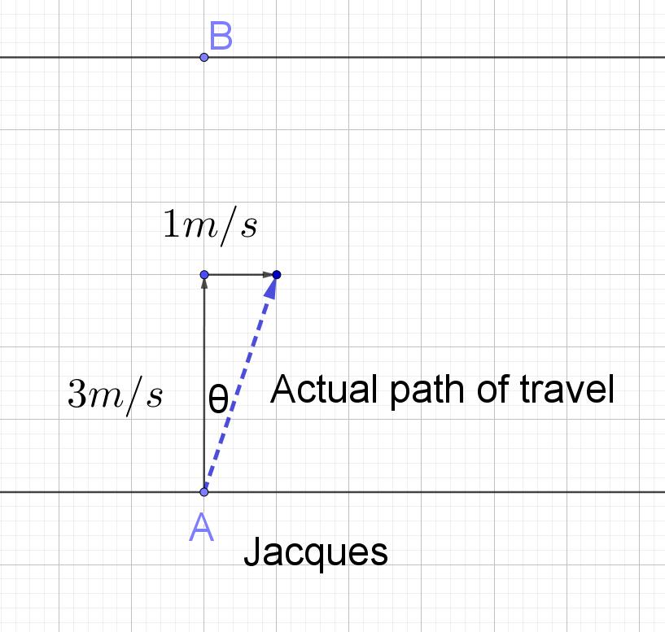
Direction is the deviation of the desired path.
$$\tan{θ}=\frac{1}{3}$$

$$θ=\tan^{-1}\left(\frac{1}{3}\right) \\ =18.4349…° \\ ≈18.4° \left(correct to 1 decimal place\right)$$

Let $S=speed of travel.$Using Pythagoras’ Theorem,

$$S^{2}=3^{2}+1^{2}$$

$$S=\sqrt{10} \\ =3.1622… \\ ≈3.2\frac{m}{s}\left(correct to 1 decimal place\right)$$

- Jacques wants to swim directly across the canal to point B. At what angle should Jacques aim to swim in order that the current will correct his direction? And what will Jacques’ actual speed be? (answers correct to 1 decimal place)
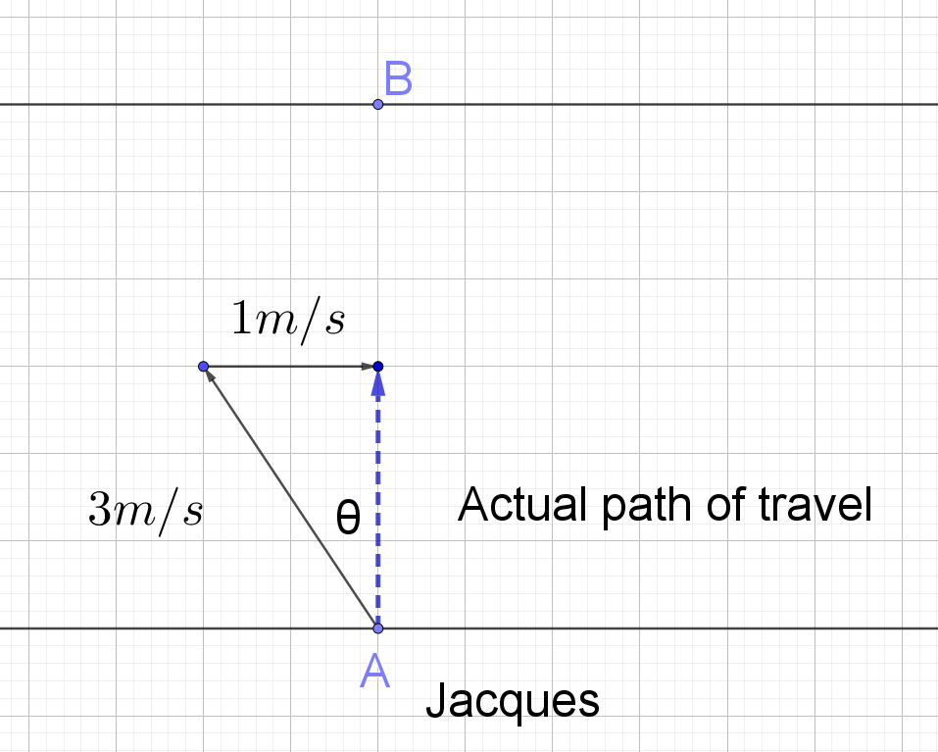
Direction Jacques should aim to swim:
$$\sin{θ}=\frac{1}{3}$$
$$θ=\sin^{-1}\left(\frac{1}{3}\right) \\ θ=19.4712…° \\ θ≈19.4° (correct to 1 decimal place)$$

Let $S=speed of travel.$ Using Pythagoras’ Theorem,

$$3^{2}=S^{2}+1^{2}$$

$$9=S^{2}+1 \\ 8=S^{2}$$

$$S=\sqrt{8}$$
$$=2.824…$$
$$≈2.8 m/s (correct to 1 decimal place)$$

Projectile motion
- A projectile is launched off a cliff 15$m$ above the ground at an angle of $30°$ to the horizontal with an initial velocity of $12 m/s$. Find:
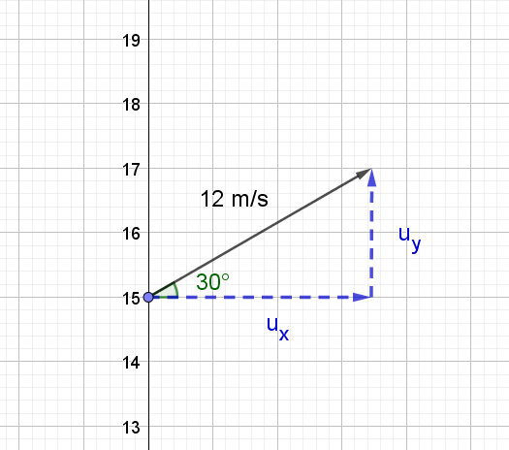

  - Initial velocities
$$\sin{30=}\frac{u_{y}}{12}$$
$$u_{y}=12\sin{30} \\ =6 m/s$$
$$\cos{30}=\frac{u_{x}}{12} \\ u_{x}=12\cos{30} \\ =12×\frac{\sqrt{3}}{2} \\ =6\sqrt{3} m/s$$

  - Horizontal components
$$\ddot{x}=0$$
$$\dot{x}=\int{0⋅}dt \\ =c_{1}$$
When$t=0, \dot{x}=6\sqrt{3}$
$$6\sqrt{3}=c_{1}$$
$$∴\dot{x}=6\sqrt{3}$$
$$x=\int{6\sqrt{3}}⋅dt \\ =6\sqrt{3}t+c_{2}$$
When$t=0, x=0$
$$0=6\sqrt{3}×0+c_{2}$$
$$c_{2}=0$$
$$∴x=6\sqrt{3}t$$

  - Vertical components
$$\ddot{y}=-9.8$$
$$\dot{y}=\int{-9.8⋅}dt \\ =-9.8t+c_{3}$$
When$t=0, \dot{y}=6$
$$6=-9.8×0+c_{3}$$
$$c_{3}=6$$
$$∴\dot{y}=-9.8t+6$$
$$y=\int{\left(-9.8t+6\right)}⋅dt \\ y=-4.9t^{2}+6t+c_{4}$$
When$t=0, y=15$
$$15=-4.9×0^{2}+6×0+c_{4}$$
$$c_{4}=15$$
$$∴y=-4.9t^{2}+6t+15$$

Note: The projectile motion Geogebra applet can be used to check solutions for a, b and c.

  - The time of the flight

The time of the flight is the time taken for the projectile to hit the ground, i.e. the vertical displacement is zero.
Solve $y=-4.9t^{2}+6t+15$for $t$when$y=0$
$$0=-4.9t^{2}+6t+15$$
Use the quadratic formula with $a=-4.9, b=6, c=15$
$$t=\frac{-6±\sqrt{6^{2}-4×\left(-4.9\right)×15}}{2(-4.9)} \\ =\frac{-6±\sqrt{330}}{-9.8}$$
$$t=\frac{-6-\sqrt{330}}{-9.8}, \frac{-6+\sqrt{330}}{-9.8}$$
$$t=-1.2414…, 2.4659…$$
$∴$the time of the flight is $2.47 seconds$ (correct to 2 decimal places)

The solution can be checked by graphing $y=-4.9t^{2}+6t+15$ using graphing software. (use $x$ in place of $t$ in the graphing software)
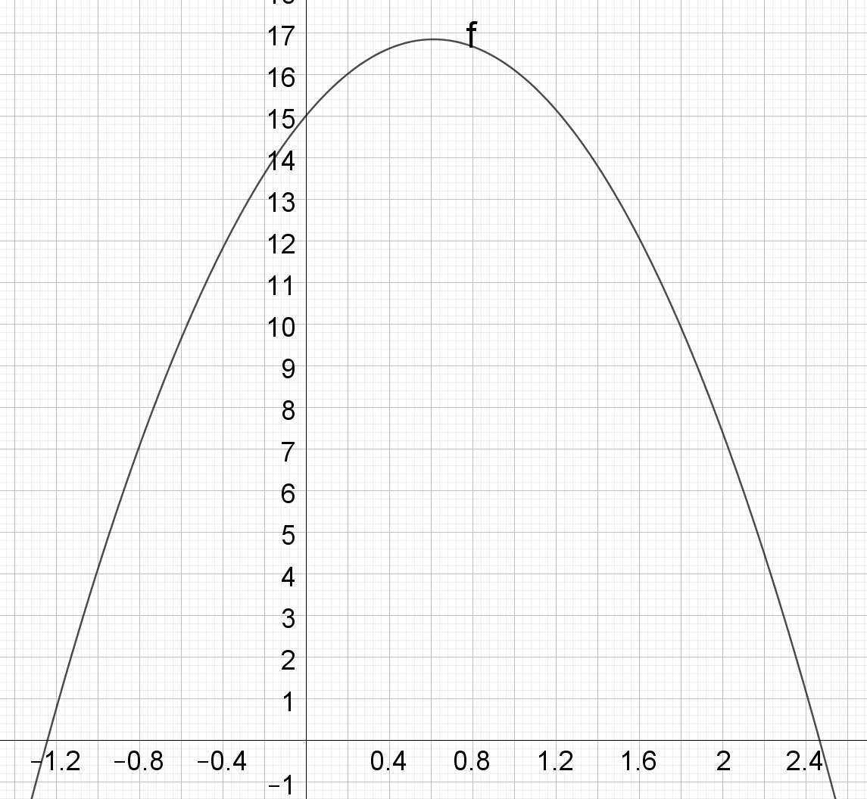

  - The range of the projectile

The range of the projectile is the horizontal displacement when the projectile strikes the ground.
Solve $x=6\sqrt{3}t$ for $x$when$t=\frac{-6-\sqrt{330}}{-9.8}$
$$x=6\sqrt{3}×\frac{-6-\sqrt{330}}{-9.8}$$
$$x=25.6264…$$

$∴$ the range of the projectile is $25.63m$ (correct to 2 decimal places)

  - The final velocity of the projectile
To find the final velocity we need to obtain the x and y velocity components when
$t=\frac{-6-\sqrt{330}}{-9.8}$, the time when the projectile hits the ground.
The $x$ component of the velocity is a constant: $\dot{x}=6\sqrt{3}$.
To find the y component of the final velocity, solve $\dot{y}=-9.8t+6$ for $\dot{y}$ when $t=\frac{-6-\sqrt{330}}{-9.8}$.$$\dot{y}=-9.8×\frac{-6-\sqrt{330}}{-9.8}+6$$$\dot{y}=-\sqrt{330} m/s$ or $-18.1659 m/s$
Note: The negative signifies the object is travelling downwards.

  - Final velocity
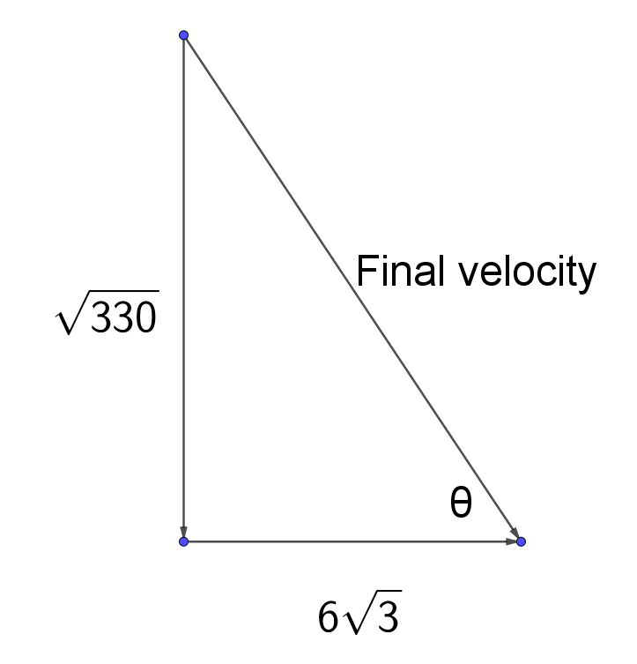
$$v_{final}^{2}={\left(6\sqrt{3}\right)}^{2}+{\left(\sqrt{330}\right)}^{2} \\ =438$$
$$v_{final}=\sqrt{438} \\ =20.9284…$$
$$\tan{θ}=\frac{\sqrt{330}}{6\sqrt{3}} \\ θ=\tan^{-1}\left(\frac{\sqrt{330}}{6\sqrt{3}}\right) \\ =60.2271…$$
$∴$ the final velocity is $20.93m/s$at an angle of $60.23°$ to the horizontal.
(correct to 2 decimal places)

  - The maximum height the projectile reaches

The maximum height of the projectile is the vertical displacement when $\dot{y}=0$

Step 1: Solve $\dot{y}=-9.8t+6$ for $t$ when $\dot{y}=0$.
$$0=-9.8t+6 \\ -6=-9.8t \\ \frac{-6}{-9.8}=t \\ t=\frac{30}{49}or 0.6122…$$
Step 2: Solve $y=-4.9t^{2}+6t+15$ for $y$ when $t=\frac{30}{49}$
$$y=-4.9{\left(\frac{30}{49}\right)}^{2}+6\left(\frac{30}{49}\right)+15 \\ =16.8376… \\ ≈16.84 (correct to the nearest centimetre)$$
Derive the Cartesian equation of the trajectory ($y$ as a function of $x$)
$$x=6\sqrt{3}t$$
$$t=\frac{x}{6\sqrt{3}}$$
Substitute $t=\frac{x}{6\sqrt{3}}$into $y=-4.9t^{2}+6t+15$
$$y=-4.9{\left(\frac{x}{6\sqrt{3}}\right)}^{2}+6\left(\frac{x}{6\sqrt{3}}\right)+15$$
$$y=\frac{-4.9x^{2}}{108}+\frac{\sqrt{3}x}{3}+15$$

- A projectile is launched from the ground at an angle of $θ°$ to the horizontal with an initial velocity of $u m/s$. Assuming no air resistance, show the maximum range is achieved when
$θ=45° or\frac{π}{4}$.

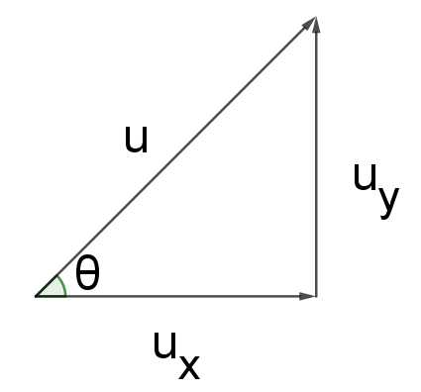
- Initial velocities
$$\sin{θ=}\frac{u_{y}}{u} \\ u_{y}=u\sin{θ}$$
$$\cos{θ}=\frac{u_{x}}{u} \\ u_{x}=u\cos{θ}$$

- Horizontal components
$$\ddot{x}=0$$
$$\dot{x}=\int{0⋅}dt \\ =c_{1}$$
When$t=0, \dot{x}=u\cos{θ}$
$$u\cos{θ}=c_{1}$$
$$∴\dot{x}=u\cos{θ}$$
$$x=\int{u\cos{θ}}⋅dt \\ x=\left(u\cos{θ}\right)t+c_{2}$$
When$t=0, x=0$
$$0=u\cos{θ}×0+c_{2} \\ c_{2}=0$$
$$∴x=ut\cos{θ}$$
$$t=\frac{x}{u\cos{θ}}$$

- Vertical components
$$\ddot{y}=-9.8$$
$$\dot{y}=\int{-9.8⋅}dt \\ =-9.8t+c_{3}$$
When$t=0, \dot{y}=u\sin{θ}$
$$u\sin{θ}=-9.8×0+c_{3}$$
$$c_{3}=u\sin{θ}$$
$$∴\dot{y}=-9.8t+u\sin{θ}$$
$$y=\int{\left(-9.8t+u\sin{θ}\right)}⋅dt \\ y=-4.9t^{2}+\left(u\sin{θ}\right)t+c_{4}$$
When$t=0, y=0$
$$0=-4.9×0^{2}+6×0+c_{4}$$
$$c_{4}=0$$
$$∴y=ut\sin{θ}-4.9t^{2}$$

- Derive the Cartesian equation of the trajectory by substituting $t=\frac{x}{u\cos{θ}}$
$$y=u\left(\frac{x}{u\cos{θ}}\right)\sin{θ}-4.9{\left(\frac{x}{u\cos{θ}}\right)}^{2} \\ =x\tan{θ}-\frac{4.9x^{2}}{u^{2}\cos^{2}{θ}}$$

- The range of the projectile is the horizontal displacement, $x$, when the vertical displacement, $y$, is $0$.
$$0=x\tan{θ}-\frac{4.9x^{2}}{u^{2}\cos^{2}{θ}}$$
$$0=x\left(\tan{θ}-\frac{4.9x}{u^{2}\cos^{2}{θ}}\right)$$
Solve $\tan{θ}-\frac{4.9x}{u^{2}\cos^{2}{θ}}=0$
$$u^{2}\cos^{2}{θ}\tan{θ}-4.9x=0 \\ u^{2}\sin{θ}\cos{θ}-4.9x=0 \\ u^{2}\sin{θ}\cos{θ}=4.9x \\ x=\frac{u^{2}\sin{θ}\cos{θ}}{4.9} \\ x=\frac{u^{2}2sin{θ}\cos{θ}}{9.8} \\ =\frac{u^{2}\sin{2θ}}{9.8}$$

- The maximum value of the functions is when $\sin{2θ}=$1 as $-1≤\sin{2θ}≤1$
$$\sin{2θ}=1$$
$$2θ=90°$$
$$θ=45° or\frac{π}{4}$$

- 2011 Mathematics Extension 1 HSC, question 6, part b
The diagram shows the trajectory of a ball thrown horizontally, at speed v ms^{–1}, from the top of a tower h metres above ground level.
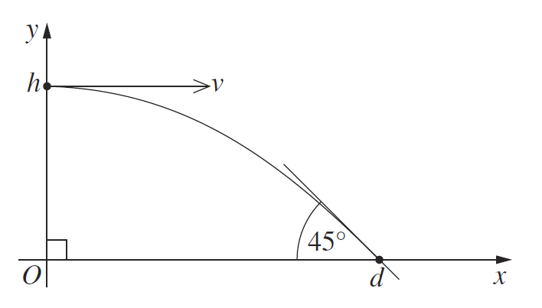
The ball strikes the ground at an angle of $45°$, d metres from the base of the tower, as shown in the diagram. The equations describing the trajectory of the ball are $x=vt$ and $y=h-\frac{1}{2}gt^{2}$, (Do NOT prove this.) where $g$ is the acceleration due to gravity, and $t$ is time in seconds.
  - Prove that the ball strikes the ground at time $t=\sqrt{\frac{2h}{g}}$seconds.
The ball will strike the ground when $y=0$
Solve $y=h-\frac{1}{2}gt^{2}$ for $t$when $y=0$
$$0=h-\frac{1}{2}gt^{2} \\ \frac{1}{2}gt^{2}=h \\ gt^{2}=2h \\ t^{2}=\frac{2h}{g}$$$t=±\sqrt{\frac{2h}{g}}$ $∴$The ball strikes the ground at time,$t=\sqrt{\frac{2h}{g}}$ ($t$ must be positive)

  - Hence, or otherwise, show that $d=2h$.
$d$is the horizontal displacement when ,$t=\sqrt{\frac{2h}{g}}$, $x=vt$
The ball strikes the ground at $45°$ so the horizontal and vertical compoants of velocity are equal in magnitude.
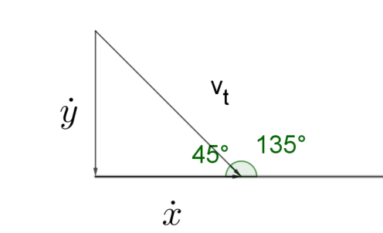
$$\tan{135}=\frac{\dot{y}}{\dot{x}} \\ -1=\frac{\dot{y}}{\dot{x}} \\ \dot{x}=\dot{y}$$
Horizontal component of velocity
$$\dot{x}=\frac{d}{dt}\left(x\right) \\ =\frac{d}{dt}\left(vt\right) \\ =v$$
Vertical component of velocity
$$\dot{y}=\frac{d}{dt}\left(y\right) \\ =\frac{d}{dt}\left(h-\frac{1}{2}gt^{2}\right) \\ =-gt$$

$\dot{x}=-\dot{y}$, $∴v=gt$
Substitute $v=gt$ into $(1)$
$$x=gt^{2}$$
Substitute $t=\sqrt{\frac{2h}{g}}$ to find the horizontal displacement when the ball strikes the ground, $d$.
$$x=g{\left(\sqrt{\frac{2h}{g}}\right)}^{2} \\ =g×\frac{2h}{g}$$$=2h$,
$$∴d=2h$$

