NESA exemplar question solutions

C3.1 Areas and volumes
Solutions for questions from the NESA topic guidance related to areas and volumes.
- Sketch the region bounded by the curve $y=x^{2}$ and the lines $y=4$ and $y=9$. Evaluate the area of this region.

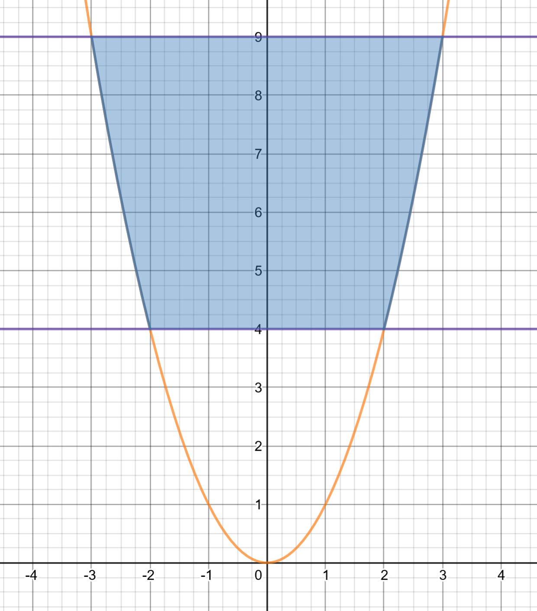
Note: The region in desmos is shaded using $y≥x^{2}\{4≤y≤9\}$

Method 1: The shaded area is twice the area between the curve and the $y$-axis where $x≥0$
$$Area=2\int_{4}^{9}{y^{\frac{1}{2}}dy} \\ =2{\left[{\frac{2y}{3}}^{\frac{3}{2}}\right]}_{4}^{9} \\ =2\left[{\frac{2\left(9\right)}{3}}^{\frac{3}{2}}-{\frac{2\left(4\right)}{3}}^{\frac{3}{2}}\right] \\ =2\left[\frac{2⋅27}{3}-\frac{2⋅8}{3}\right]$$
$$=2\left[\frac{54}{3}-\frac{16}{3}\right]$$
$$=2\left[\frac{38}{3}\right] \\ =\frac{76}{3}=25\frac{1}{3}units^{2}$$
Method 2: The shaded area is twice the area between $x=0 and x=3$
Shaded area between $x=0 and x=2$ is $2⋅5=10 units^{2}$
Shaded area between $x=2 and x=3$ is:
$$A=9-\int_{2}^{3}{x^{2}dx} \\ ={9-\left[{\frac{x}{3}}^{3}\right]}_{2}^{3} \\ =9-\left[{\frac{3}{3}}^{3}-{\frac{2}{3}}^{3}\right] \\ =\frac{8}{3}units^{2}$$

$$Total area =2\left(10+\frac{8}{3}\right) \\ =25\frac{1}{3}units^{2}$$

- The graphs of the curves $y=x^{2}$ and $y={12-2x}^{2}$ are shown in the diagram.
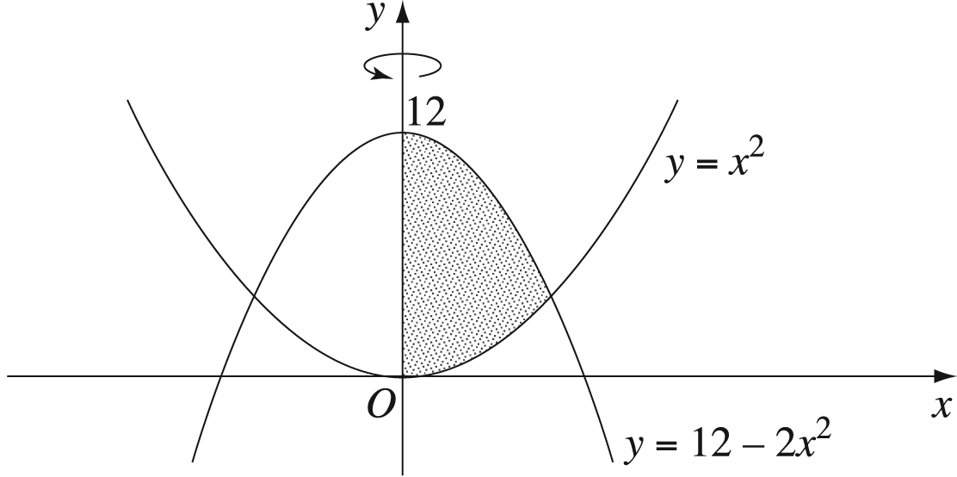
  - Find the points of intersection of the two curves.

Solve $y=x^{2}$and$y=12-2x^{2}$simultaneously.
$$x^{2}=12-2x^{2} \\ 3x^{2}=12 \\ x^{2}=4 \\ x=±2$$
When $x=2, y=2^{2}=4$
When $x=-2, y={\left(-2\right)}^{2}=4$
Points of intersection: $(-2,4)$ and $(2,4)$

  - The shaded region between the curves and the $y$-axis is rotated about the $y$-axis. By splitting the shaded region into two parts, or otherwise, find the volume of the solid formed.
$$V=π\int_{a}^{b}{{\left\{f\left(y\right)\right\}}^{2}.dy}$$
Volume 1: The volume of the curve rotated about the $y$-axis between 4 and 12
$$y=x^{2}$$
$x=±\sqrt{y}=±y^{\frac{1}{2}}$
$$V1=π\int_{4}^{12}{{\left(y^{\frac{1}{2}} \right)}^{2}.dy}$$
$$= π\int_{4}^{12}{y.dy}$$
$$=π{\left[\frac{y^{2}}{2}\right]}_{4}^{12}$$
$$= π\left[\frac{{12}^{2}}{2}-\frac{4^{2}}{2}\right]$$
$$=64π units^{3}$$
Volume 2: The volume of the curve rotated about the $y$-axis between 0 and 4
$$y=12-2x^{2}$$
$$x=±\sqrt{6-\frac{y}{2}}=±{\left(6-\frac{y}{2}\right)}^{\frac{1}{2}}$$
$$V2=π\int_{0}^{4}{{\left({\left(6-\frac{y}{2}\right)}^{\frac{1}{2}} \right)}^{2}.dy} \\ = π\int_{0}^{4}{\left(6-\frac{y}{2}\right).dy} \\ =π{\left[6y-\frac{y^{2}}{4}\right]}_{0}^{4} \\ = π\left[\left(6⋅4-\frac{4^{2}}{4}\right)-\left(6⋅0-\frac{0^{2}}{4}\right)\right] \\ = π\left[\left(24-4\right)-\left(0\right)\right] \\ =20π units^{3}$$

$$Total volume=64π+20π \\ =84π units^{3}$$

- The region bounded by the curve $y=\left(x-1 \right)\left(3-x\right)$ and the $x$-axis is rotated about the line $x=3$ to form a solid. When the region is rotated, the horizontal line segment at height $y$ sweeps out an annulus.
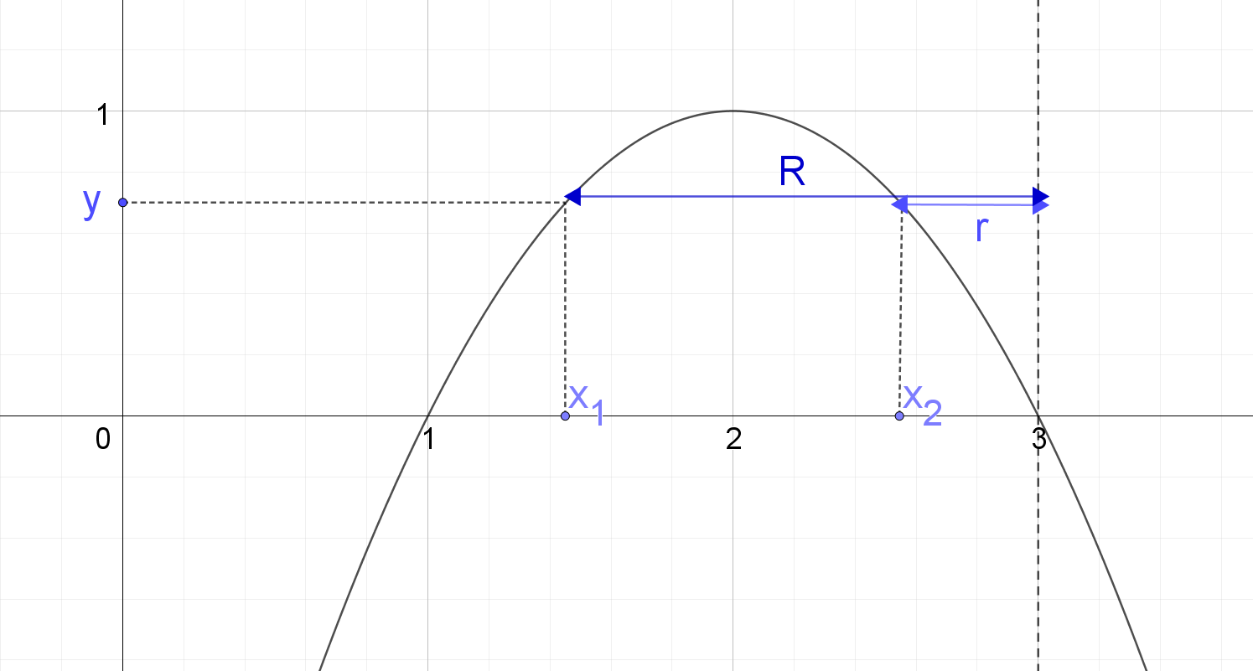
  - Find the area of the annulus as a function of y.
$$Area=π\left(R^{2}-r^{2}\right)$$
$$r=3-x_{2} and R=3-x_{1}$$
Where $x_{1}$ is the smaller $x$ value and $x_{2}$ is the larger $x$ value for a given height y.
$$y=\left(x-1 \right)\left(3-x\right) \\ y=-x^{2}+4x-3 \\ x^{2}-4x=-3-y$$
Complete the square.
$$x^{2}-4x+4=-3-y+4 \\ {\left(x-2\right)}^{2}=1-y \\ x=2±\sqrt{1-y}$$
$x_{1}=2-\sqrt{1-y}$ and $x_{2}=2+\sqrt{1-y}$
$$r=3-\left(2+\sqrt{1-y}\right) \\ =1-\sqrt{1-y}$$
$$R=3-\left(2-\sqrt{1-y}\right) \\ =1+\sqrt{1-y}$$
$$Area=π\left({\left(1+\sqrt{1-y}\right)}^{2}-{\left(1-\sqrt{1-y}\right)}^{2}\right) \\ =π\left(\left(1+2\sqrt{1-y}+(1-y)\right)-\left(1-2\sqrt{1-y}+(1-y)\right)\right) \\ =π\left(\left(2-y+2\sqrt{1-y}\right)-\left(2-y-2\sqrt{1-y}\right)\right) \\ =4π\sqrt{1-y}$$

  - Find the volume of the solid.

Sum of all annuluses from $y=0$ to $y=1$
$$V=\int_{0}^{1}{4π\sqrt{1-y}}dy \\ =4π\int_{0}^{1}{{(1-y)}^{\frac{1}{2}}}dy \\ =4π{\left[\frac{{-2\left(1-y\right)}^{\frac{3}{2}}}{3}\right]}_{0}^{1} \\ =4π\left[\left(\frac{{-2\left(1-1\right)}^{\frac{3}{2}}}{3}\right)-\left(\frac{{-2\left(1-0\right)}^{\frac{3}{2}}}{3}\right)\right] \\ =4π\left[\left(0\right)-\left(\frac{-2}{3}\right)\right] \\ =\frac{8π}{3} units^{3}$$

- The region enclosed by the curve $y=4\sqrt{x}$ and the $x$-axis between $x=0$ and $x=4$ is rotated about the $x$-axis. Find the volume of the solid of revolution.
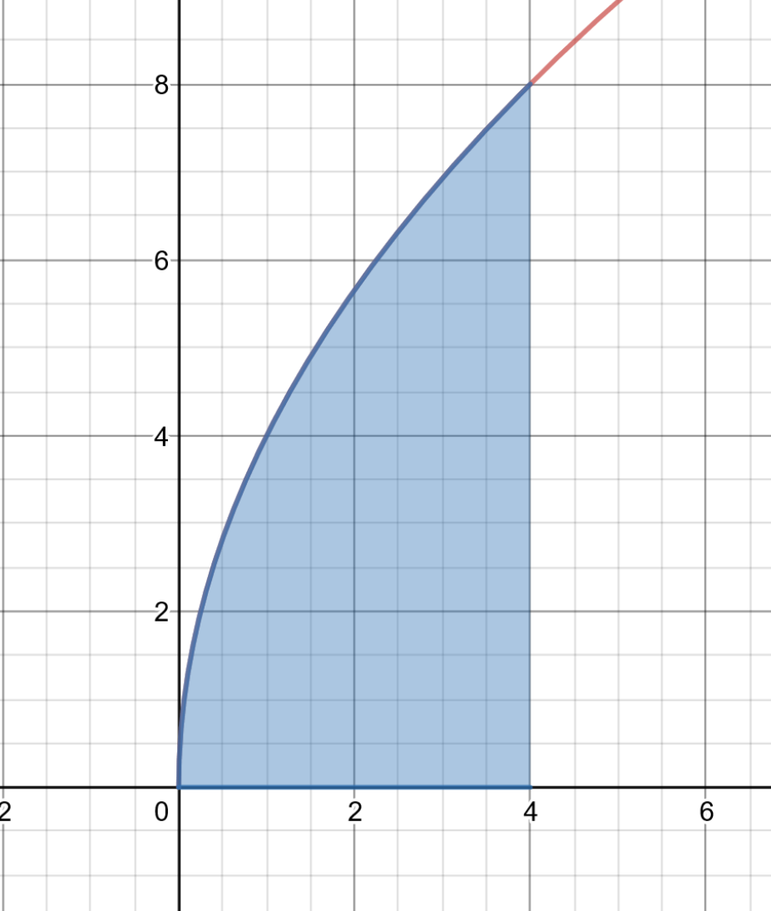
Note: The region in desmos is shaded using $0≤y≤4\sqrt{x} \{0≤x≤4\}$

$$V=π\int_{a}^{b}{{\left\{f\left(x\right)\right\}}^{2}.dx} \\ =π\int_{0}^{4}{{\left(4\sqrt{x}\right)}^{2}.dx} \\ =π\int_{0}^{4}{16x.dx} \\ =π{\left[8x^{2}\right]}_{0}^{4} \\ =π\left[\left(8⋅4^{2}\right)-\left(8⋅0^{2}\right)\right] \\ =π\left[\left(128\right)-\left(0\right)\right] \\ =128π units^{3}$$

- A curved funnel has a shape formed by rotating part of the parabola $y=2\sqrt{x}$ about the $y$-axis, where $x$ and $y$ are given in cm. The funnel is 4 cm deep. Find the volume of liquid which the funnel will hold if it is sealed at the bottom.
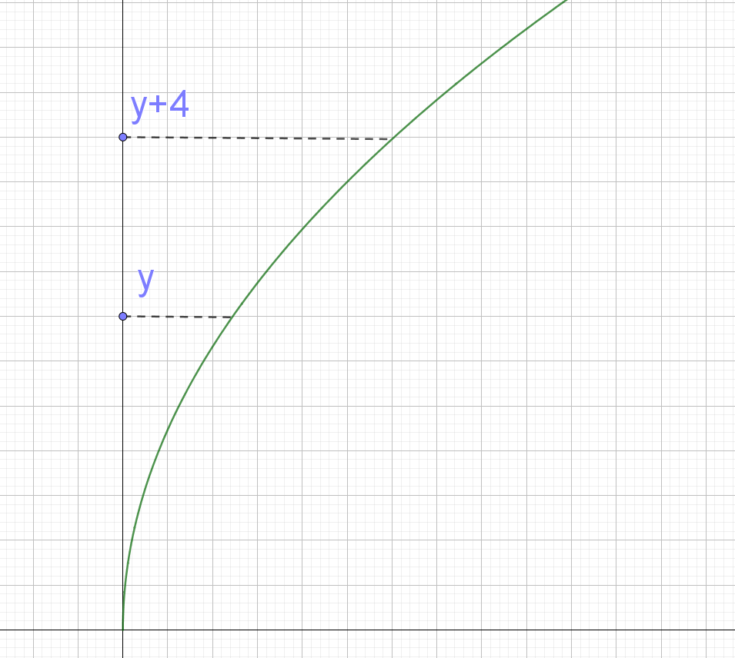
Note: The diagram shows an example of the region to be rotated about the $y$-axis. If the lower bound is $y$, then the upper bound is $y+4$ as the funnel is $4$ cm deep.

$$y=2\sqrt{x}$$
$$x=\frac{y^{2}}{4}$$
$$V=π\int_{a}^{b}{{\left\{f\left(y\right)\right\}}^{2}.dy} \\ =π\int_{y}^{y+4}{{\left(\frac{y^{2}}{4}\right)}^{2}.dy} \\ =π\int_{y}^{y+4}{\left(\frac{y^{4}}{16}\right).dy} \\ =π{\left[\frac{y^{5}}{80}\right]}_{y}^{y+4} \\ =π\left[\left(\frac{{\left(y+4\right)}^{5}}{80}\right)-\left(\frac{y^{5}}{80}\right)\right] \\ =\frac{{\left(y+4\right)}^{5}-y^{5}}{80}π units^{3}$$
If the solution is expanded:
$$=π\left[\frac{{1⋅y}^{5}⋅4^{0}+{5⋅y}^{4}⋅4^{1}+{10⋅y}^{3}⋅4^{2}+{10⋅y}^{2}⋅4^{3}+{5⋅y}^{1}⋅4^{4}+{1⋅y}^{0}⋅4^{5}}{80}-\frac{y^{5}}{80}\right] \\ =π\left[\frac{20y^{4}+160y^{3}+640y^{2}+1280y+1024}{80}\right] \\ =\left(\frac{y^{4}}{4}+2y^{3}+8y^{2}+16y+\frac{64}{5}\right)π units^{3}$$

  - Sketch the region bounded by the curve $y=\sin{x}+\cos{x}$ and the coordinate axes in the first quadrant, taking the upper limit of $x$ as $\frac{3π}{4}$.
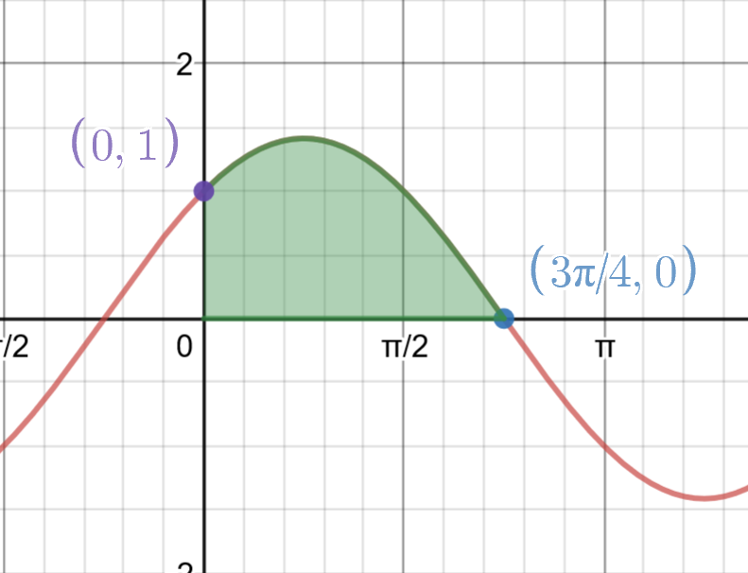
Note: The region in desmos is shaded using $0≤y≤\sin{x}+\cos{x} \{0≤x≤\frac{3π}{4}\}$
  - Show the intercepts on the axes, and calculate the area of the region.
$y$-intercept, substitute $x=0$
$$y=\sin{0}+\cos{0} \\ =0+1 \\ =1$$
$x$-intercept, substitute $y=0$
$$0=\sin{x}+\cos{x} \\ -\cos{x}=\sin{x}$$
$$\frac{-\cos{x}}{\cos{x}}=\frac{\sin{x}}{\cos{x}}$$
$$-1=\tan{x}$$
$x=\frac{3π}{4}$ (limiting the $x$ value to the upper bound of $\frac{3π}{4}$)
$$Area=\int_{0}^{ \frac{3π}{4}}{\left(\sin{x}+\cos{x}\right)dx} \\ ={\left[-\cos{x}+\sin{x}\right]}_{0}^{\frac{3π}{4}} \\ =\left(-\cos{\frac{3π}{4}}+\sin{\frac{3π}{4}}\right)-\left(-\cos{0}+\sin{0}\right) \\ =\left(\frac{\sqrt{2}}{2}+\frac{\sqrt{2}}{2}\right)-\left(-1+0\right) \\ =1+\sqrt{2} units^{2}$$
  - Find the volume of the solid formed if the region is rotated about the $x$-axis to form a solid of revolution.
$$V=π\int_{0}^{ \frac{3π}{4}}{{\left(\sin{x}+\cos{x}\right)}^{2}.dx} \\ =π\int_{0}^{ \frac{3π}{4}}{\left(\sin^{2}{x}+2sin{x}\cos{x}+\cos^{2}{x}\right).dx} \\ =π\int_{0}^{ \frac{3π}{4}}{\left(1+\sin{2x}\right).dx} \\ =π{\left[x-\frac{1}{2}\cos{2x}\right]}_{0}^{\frac{3π}{4}} \\ =π\left[\left(\frac{3π}{4}-\frac{1}{2}\cos\left(2⋅\frac{3π}{4}\right)\right)-\left(0-\frac{1}{2}\cos\left(2⋅0\right)\right)\right] \\ =π\left[\left(\frac{3π}{4}-\frac{1}{2}⋅0\right)-\left(0-\frac{1}{2}\right)\right] \\ =π\left[\frac{3π}{4}+\frac{1}{2}\right] \\ =\frac{3π^{2}}{4}+\frac{π}{2} units^{3}$$
Note: This volume can be check using online calculators such as symbolab. It is entered as volume $y=sinx+cosx,x=0,x=\frac{3π}{4}$

C3.2 Differential equations part 1
Solutions for questions from NESA’s topic guidance related to differential equations.
- If a product which has just been launched is judged by the market to be of poor quality, sales will decline as people try the product but do not continue to buy it. For a certain product, the rate of weekly sales is modelled by $S^{'}\left(t\right)=\frac{400}{{\left(t+1\right)}^{3}}-\frac{200}{{\left(t+1\right)}^{2}},$ where $S$ is the number of sales in millions and $t$ is the number of weeks since the launch of the product.
  - Find the function that describes the weekly sales.
$$S^{'}\left(t\right)=\frac{400}{{\left(t+1\right)}^{3}}-\frac{200}{{\left(t+1\right)}^{2}}$$
$$S(t)=\int{\left(\frac{400}{{\left(t+1\right)}^{3}}-\frac{200}{{\left(t+1\right)}^{2}}\right)dt}$$
$$S(t)=\int{\left(400{\left(t+1\right)}^{-3}-200{\left(t+1\right)}^{-2}\right)dt}$$
$$S\left(t\right)=\frac{400{\left(t+1\right)}^{-2}}{-2}-\frac{200{\left(t+1\right)}^{-1}}{-1}+C$$
$$S\left(t\right)=\frac{-200}{{\left(t+1\right)}^{2}}+\frac{200}{(t+1)}+C$$
$$S\left(0\right)=0 \\ 0=\frac{-200}{{\left(0+1\right)}^{2}}+\frac{200}{(0+1)}+C \\ 0=-200+200+C \\ C=0$$
$$S\left(t\right)=\frac{-200}{{\left(t+1\right)}^{2}}+\frac{200}{(t+1)}$$

  - Find the number of sales for the first week and for the tenth week.
$$S\left(1\right)=\frac{-200}{{\left(1+1\right)}^{2}}+\frac{200}{\left(1+1\right)} \\ =\frac{-200}{4}+\frac{200}{2} \\ =-50+100 \\ =50$$
$$Number of sales in week 1 = 50 000 000$$
$$S\left(10\right)=\frac{-200}{{\left(10+1\right)}^{2}}+\frac{200}{\left(10+1\right)} \\ =\frac{-200}{121}+\frac{200}{11} \\ =\frac{-200}{121}+\frac{2200}{121} \\ =\frac{2000}{121} or 16.528…$$
$$Number of sales in week 10=16 528 925.619…$$

  - Comment on your results in the context of the given information.
Based on the assumption given, this is a poor quality product as sales have declined as people try the product but do not continue to buy.
The model only approximates products sold as only a whole number of products can be sold.

- Which of the following direction fields best represents the differential equation $\frac{dy}{dx}=x-y$?
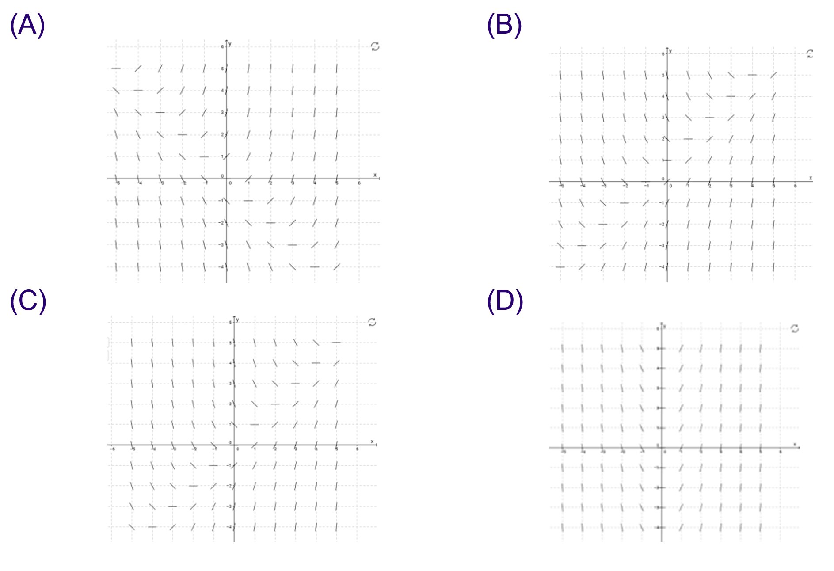
Answer: C. When $x=y$, $\frac{dy}{dx}=x-y=0,$ i.e. the slope of the line segments will be zero.

C3.2 Differential equations part 2
This contains solutions for the questions from the NESA sample unit for the content:
- model and solve differential equations including but not limited to the logistic equation that will arise in situations where rates are involved, for example in chemistry, biology and economics (ACMSM132) AAM

- Gardeners are concerned about the spread of a particular pest. All specimens detected so far lie within a circular region with radius 25 km and it is suggested that the increase of the radius $r$km might be modelled by a differential equation $\frac{dr}{dt}=\frac{1}{6}\sqrt{r}$, where $t$ denotes the time in months. What does this model predict for the radius of the region affected by the pest after $t$ months?
$$\frac{dr}{dt}=\frac{1}{6}\sqrt{r} \\ \frac{6dr}{\sqrt{r}}=1×dt \\ 6r^{\frac{1}{2}}dr=1⋅dt \\ \int{6r^{\frac{1}{2}}dr}=\int{1⋅dt} \\ 4r^{\frac{3}{2}}=t+C$$
$$r=25 when t=0 \\ 4{⋅25}^{\frac{3}{2}}=0+C \\ 4⋅125=C \\ C=500$$
$$4r^{\frac{3}{2}}=t+500 \\ r^{\frac{3}{2}}=\frac{t+500}{4} \\ r={\left(\frac{t+500}{4}\right)}^{\frac{2}{3}}$$
- Water is slowly leaking from a tank. The depth of the water after $t$ hours is $h$ metres and the variables are related by the equation $\frac{dh}{dt}=-ae^{-0.1t}$. Initially the depth of water is 6 metres and after 2 hours it has fallen to 5 metres. At what depth will the level eventually settle?
$$\frac{dh}{dt}=-ae^{-0.1t}$$
$$h=\int{-ae^{-0.1t}dt}$$
$h=10ae^{-0.1t}+C$ where $C$ is the height the water will eventually settle as $\lim_{t→∞}{10ae^{-0.1t}}=0$
$$h=6 when t=0$$
$$6=10ae^{-0.1⋅0}+C$$
$$6=10a+C$$
$$a=\frac{6-c}{10}$$
$$h=5 when t=2$$
$$5=10ae^{-0.1⋅2}+C$$
$$5=10⋅\frac{6-c}{10}⋅e^{-0.2}+C$$
$$5=\frac{6-c}{e^{0.2}}+C$$
$$5=\frac{6}{e^{0.2}}-\frac{c}{e^{0.2}}+C$$
$$5-\frac{6}{e^{0.2}}=C\left(\frac{-1}{e^{0.2}}+1\right)$$
$$\frac{5e^{0.2}-6}{e^{0.2}}=C\left(\frac{e^{0.2}-1}{e^{0.2}}\right)$$
$$C=\frac{\frac{5e^{0.2}-6}{e^{0.2}}}{\frac{e^{0.2-1}}{e^{0.2}}}$$
$$C=\frac{5e^{0.2}-6}{e^{0.2}-1} or 1.0175… m$$

The water will settle at a depth of approximately $1.02$ $m$

- When a ball is dropped from the roof of a tall building the greatest speed that it can reach is $u$ms⁻¹. One model for its speed $v$ ms⁻¹ when it has fallen a distance $x$ m is given by the differential equation $\frac{dv}{dx}=c\frac{u^{2}-v^{2}}{v}$ where $c$ is a positive constant. Find an expression for $v$ in terms of $x$.
$$\frac{dv}{dx}=c\frac{u^{2}-v^{2}}{v} \\ \frac{v}{u^{2}-v^{2}}dv=c⋅dx \\ \int{\frac{v}{u^{2}-v^{2}}dv}=\int{c⋅dx} \\ -\frac{1}{2}\int{\frac{-2v}{u^{2}-v^{2}}dv}=\int{c⋅dx} \\ -\frac{1}{2}\ln\left|u^{2}-v^{2}\right|=cx+C$$
$-\frac{1}{2}\ln\left(u^{2}-v^{2}\right)=cx+C$ as $u≥v$
$$v=0, x=0$$
$$-\frac{1}{2}\ln\left(u^{2}-0^{2}\right)=c⋅0+C$$
$$-\frac{1}{2}\ln\left(u^{2}\right)=C$$
$$-\frac{1}{2}⋅2\ln\left(u\right)=C$$
$$C=-\ln\left(u\right)$$
Substitute $C$ into the function $-\frac{1}{2}\ln\left(u^{2}-v^{2}\right)=cx+C$
$$-\frac{1}{2}\ln\left(u^{2}-v^{2}\right)=cx-\ln\left(u\right) \\ \ln\left(u^{2}-v^{2}\right)=-2cx+2\ln\left(u\right) \\ \ln\left(u^{2}-v^{2}\right)=-2cx+\ln\left(u^{2}\right) \\ u^{2}-v^{2}=e^{-2cx+\ln\left(u^{2}\right)} \\ u^{2}-v^{2}=e^{-2cx}⋅e^{\ln\left(u^{2}\right)} \\ u^{2}-v^{2}=e^{-2cx}⋅u^{2} \\ u^{2}-v^{2}={u^{2}e}^{-2cx} \\ v^{2}=u^{2}-{u^{2}e}^{-2cx} \\ v=±\sqrt{u^{2}-{u^{2}e}^{-2cx}}$$
$v=\sqrt{u^{2}-{u^{2}e}^{-2cx}}$ as $v \left(speed\right)$is positive.
Note: The solution could be expressed in a range of alternate forms such as:
$v=u{\left(1-e^{-2cx}\right)}^{\frac{1}{2}}$. The solution can be checked by finding the derivative.

- The number of cane toads in a colony after $t$ months can be modelled by $\left(t\right)=\frac{40 000}{1+3e^{-t}}$ .
  - Sketch the function $C\left(t\right)=\frac{40 000}{1+3e^{-t}}$.
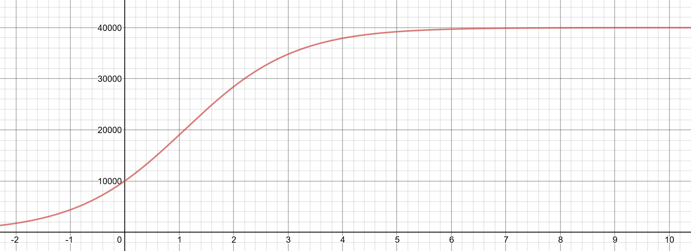
  - What is the initial cane toad population?
Substitute $t=0$
$$C\left(0\right)=\frac{40 000}{1+3e^{-0}} \\ =\frac{40000}{1+3} \\ =10000$$
The initial cane toad population is $10000$.

  - What is the population after 2 months, correct to 3 significant figures?
$$C\left(2\right)=\frac{40 000}{1+3e^{-2}}$$
$$=28449.383…$$
$≈28400$ (correct to 3 significant figures)

The cane toad population after two months is approximately $28400$, correct to 3 significant figures.

  - When does the population reach 30 000?
Substitute $C\left(t\right)=30000$
$$30000=\frac{40 000}{1+3e^{-t}}$$
$$30000\left(1+3e^{-t}\right)=40000$$
$$1+3e^{-t}=\frac{4}{3}$$
$$3e^{-t}=\frac{4}{3}-1$$
$$3e^{-t}=\frac{1}{3}$$
$$e^{-t}=\frac{1}{9}$$
$$-t=\ln{\frac{1}{9}}$$
$$t=-\ln{\frac{1}{9}}$$
$$=\ln{9}$$
$$=2.1972…months$$

The population will reach $30000$ after approximately $2.2 months or$ $2 months and 6 days$

  - Show that $C'\left(t\right)=\frac{120 000e^{t}}{{\left(e^{t}+3\right)}^{2}}$
$$C\left(t\right)=\frac{40 000}{1+3e^{-t}}$$
$$=40000{\left(1+3e^{-t}\right)}^{-1}$$
$$C^{'\left(t\right)}=-1⋅-1⋅3e^{-t}⋅40000{\left(1+3e^{-t}\right)}^{-2}$$
$$=\frac{120000}{e^{t}{\left(1+3e^{-t}\right)}^{2}}$$
$$=\frac{120000}{e^{t}{\left(1+\frac{3}{e^{t}} \right)}^{2}}$$
$$=\frac{120000}{e^{t}{\left(\frac{e^{t}+3}{e^{t}} \right)}^{2}}$$
$$=\frac{120000}{\frac{e^{t}}{{\left(e^{t}\right)}^{2}}{\left(e^{t}+3\right)}^{2}}$$
$$=\frac{120000}{\frac{1}{e^{t}}{\left(e^{t}+3\right)}^{2}}$$
$$=\frac{120000e^{t}}{{\left(e^{t}+3\right)}^{2}} as required.$$

  - Find the maximum growth rate of the cane toad population.
The maximum growth rate of the population is at the time corresponding to the maximum value of the derivative. i.e. Solve $C''\left(t\right)=0$
This corresponds to the point of inflexion in the graph of the original function, which is the $C\left(t\right)$ value halfway between the asymptotes. i.e. Solve $C\left(t\right)=20000$
Find the time of the maximum growth rate of the population:
Option 1: Solve $C''\left(t\right)=0$
$$C'(t)=\frac{120000e^{t}}{{\left(e^{t}+3\right)}^{2}}$$
$$C'(t)=120000e^{t}{\left(e^{t}+3\right)}^{-2}$$
Apply the product rule:
$$u=120000e^{t}, u^{'}=120000e^{t}$$
$$v={\left(e^{t}+3\right)}^{-2}, v^{'}=-2e^{t}{\left(e^{t}+3\right)}^{-3}$$
$$C^{''}\left(t\right)=u^{'}v+v'u$$
$$C^{''}\left(t\right)=120000e^{t}{\left(e^{t}+3\right)}^{-2}-2e^{t}{\left(e^{t}+3\right)}^{-3}⋅120000e^{t}$$
$$=120000e^{t}\left(\frac{1}{{\left(e^{t}+3\right)}^{2}}-\frac{2e^{t}}{{\left(e^{t}+3\right)}^{3}}\right)$$
$$=120000e^{t}\left(\frac{\left(e^{t}+3\right)-2e^{t}}{{\left(e^{t}+3\right)}^{3}}\right)$$
$$=120000e^{t}\left(\frac{3-e^{t}}{{\left(e^{t}+3\right)}^{3}}\right)$$
$$Solve C^{''}\left(t\right)=0$$
$$0=120000e^{t}\left(\frac{3-e^{t}}{{\left(e^{t}+3\right)}^{3}}\right)$$
$$0=3-e^{t}$$
$$e^{t}=3$$
$$t=\ln{3}$$
$$=1.098…$$
Check for change in concavity either side of $t$.
$$C^{''}\left(1\right)=491.466…$$
$$C^{''}\left(1.2\right)=-505.205…$$
$∴$ $t=\ln{3}=1.098…$ is time of the maximum growth rate in the cane toad population.
Option 2: Solve $C\left(t\right)=20000$
$$20000=\frac{40 000}{1+3e^{-t}}$$
$$20000\left(1+3e^{-t}\right)=40000$$
$$1+3e^{-t}=2$$
$$3e^{-t}=2-1$$
$$3e^{-t}=1$$
$$e^{-t}=\frac{1}{3}$$
$$-t=\ln{\frac{1}{3}}$$
$$t=-\ln{\frac{1}{3}}$$
$$=\ln{3}$$
$$=1.098…$$
Find the maximum growth rate of the population:
$C^{'}\left(\ln{3}\right)$is the maximum value of the derivative and the maximum growth rate in the cane toad population.
$$C^{'}\left(\ln{3}\right)=\frac{120 000e^{t}}{{\left(e^{t}+3\right)}^{2}}$$
$$=\frac{120 000e^{\ln{3}}}{{\left(e^{\ln{3}}+3\right)}^{2}}$$
$$=\frac{120 000⋅3}{{\left(3+3\right)}^{2}}$$
$$=\frac{360 000}{36}$$
$$=10000$$
The maximum growth rate in the cane toad population is 10000 toads per month.

- The population of a town is decreasing at a rate proportional to the square root of the population at that time.
  - Write a differential equation to describe the situation.
Let $P^{'}(t)$ be the rate of change in the population at time $t.$
$$P'\left(t\right)∝\sqrt{t}$$
$P'\left(t\right)=k\sqrt{t}$ where k is a constant.
  - If the population was initially $2500$ and decreased to $2025$ after $10$ years, find the population after $20$ years.
$$P'\left(t\right)=k\sqrt{t}$$
$$P\left(t\right)=\int{k\sqrt{t}⋅dt}$$
$$P\left(t\right)=\int{kt^{\frac{1}{2}}⋅dt}$$
$$P\left(t\right)=\frac{2kt^{\frac{3}{2}}}{3}+C$$
Use the initial conditions to find $C$ and $k$:
$$P\left(0\right)=2500$$
$$2500=\frac{2k{⋅0}^{\frac{3}{2}}}{3}+C$$
$$2500=C$$
$$P\left(t\right)=\frac{2kt^{\frac{3}{2}}}{3}+2500$$
$$P\left(10\right)=2025$$
$$2025=\frac{2k{⋅10}^{\frac{3}{2}}}{3}+2500$$
$$-475=\frac{2k{⋅10}^{\frac{3}{2}}}{3}$$
$$-1425=2k{⋅10}^{\frac{3}{2}}$$
$$\frac{-1425}{2{⋅10}^{\frac{3}{2}}}=k$$
$$k=\frac{-1425}{2\sqrt{1000}}$$
$$P\left(t\right)=\frac{2⋅\frac{-1425}{2\sqrt{1000}}⋅t^{\frac{3}{2}}}{3}+2500$$
$$P\left(t\right)=\frac{-1425⋅t^{\frac{3}{2}}}{3\sqrt{1000}}+2500$$
Find the population after 20 years:
$$P\left(20\right)=\frac{-1425⋅{20}^{\frac{3}{2}}}{3\sqrt{1000}}+2500 \\ =1156.497…$$

The population of the town after 20 years is $1156.497…$

