Year 12 Mathematics Extension 1

Assessment task
ME-C3 Applications of calculus

Driving question
How can mathematics help predict the latest trends?

Outcomes
- ME12-1 applies techniques involving proof or calculus to model and solve problems
- ME12-4 uses calculus in the solution of applied problems, including differential equations and volumes of solids of revolution
- ME12-6 chooses and uses appropriate technology to solve problems in a range of contexts
- ME12 7 evaluates and justifies conclusions, communicating a position clearly in appropriate mathematical forms
All outcomes referred to in this unit come from Mathematics Extension 1 Syllabus © NSW Education Standards Authority (NESA) for and on behalf of the Crown in right of the State of New South Wales, 2017

Learning across the curriculum

General capabilities
- Critical and creative thinking
- Ethical understanding
- Information and communication technology capability
- Literacy
- Numeracy
- Work and enterprise

Task
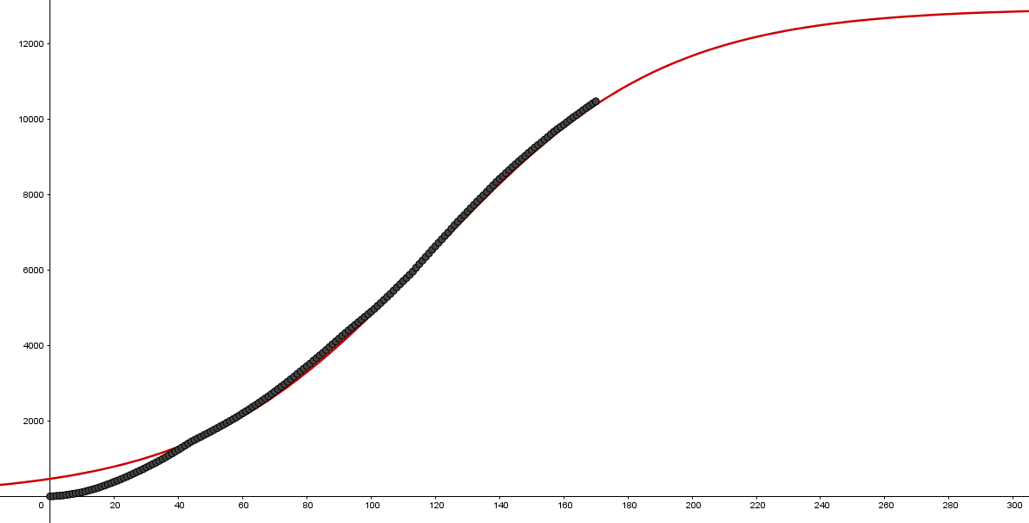
During this task, students will investigate methods of mathematical modelling of different internet trends and use the models to problem solve, make informed decisions and make comparisons and predictions, while justifying conclusions.
Students will develop skills to analyse, model and interpret first order differential equations. This assessment task concentrates on establishing logistic and exponential models from first order differential equations.

Students are to investigate the levels of interest for online trends through Google Trends. The level of interest is a relative score calculated as a percentage of the number hits per day against the peak number of hits per day, i.e.) the peak number of hits per day will receive a level of interest equal to 100.

Further information regarding Google Trends may be found at support.google.com/trends/?hl=en-GB#topic=6248052

Part A: Finding, modifying and displaying the data
- Finding and downloading the data:
  - Go to Google Trends
  - Search for the topic, “Making slime”
  - Specify the location as worldwide; the date range as 1/4/2016 to present; and the source of information as YouTube.
  - Download the data to a Microsoft Excel Comma Delimited CSV file by clicking the download icon
  - Modifying the data in preparation for modelling:
  - Open the data file in Microsoft Excel
  - The data contains two columns. Column A contains the date and Column B contains the relative number of hits. If $t$ represents time and $N$ represent the total number of hits, then Column B represents the derivative $\frac{dN}{dt}$, the number of hits per day. Label the data in Column B as dN/dt.
  - Insert two new columns between Columns A and B.
  - Label Column B as $t$, which represents the number of periods from the start. Fill this column with values 0, 1, 2…, where $t=0$ represents the start date.
  - Label column D as $N$, as it will represent the total number of hits. The data in this column will be a cumulative total of the number of hits per day, dN/dt.
  - Calculate the values for N in column D.
- Display the data:
  - Choose an appropriate graph or chart to display the total number of hits against time.
  - Describe the display in part 2a.

Part B: Modelling with the logistic equation
- Logistic equation modelling of the data:
  - Using the Logistic equation $N=\frac{C}{1+Ae^{-kt}}$, show that $\frac{dN}{dt}=kN(1-\frac{N}{C})$
  - Show that the differential equation for the logistic curve is $\frac{dN}{dt}=kN(1-\frac{N}{C})$ and can be rearranged into $\frac{1}{N}×\frac{dN}{dt}=k(1-\frac{N}{C})$, which has a linear expression for N on the right-hand side of the equation (Consider the coefficient of N and the constant term in this linear expression, as connections will need to be established later).
  - Insert a new column, at column D, and fill it with calculated values for 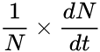.
  - Generate a scatterplot of $N$ against . This display should show a linear pattern; although some of the data, when $N$ is close to zero, may not appear linear. Eliminating this data will improve the accuracy of the model.
  - Add a trendline to the scatterplot and identify its gradient and y-intercept.
  - By comparing the gradient and y-intercept with the right-hand side of the model $\frac{1}{N}×\frac{dN}{dt}=k(1-\frac{N}{C})$, determine the parameters $k$ and $C$ in the model.

  - Use calculus to show that the point of inflexion for the logistic model $N=\frac{C}{1+Ae^{-kt}}$ occurs when $N=\frac{C}{2}$ and interpret this result.
  - Using the result from part f, show that $A=e^{kt_{0}}$ where $t_{0}$ is the time at the point of inflexion.
  - Analyse the data, to determine an approximate value for $t_{0}$ and use it to approximate $A$.
  - Use your values for $k$, $C$ and $A$ to develop the Logistic model $N=\frac{C}{1+Ae^{-kt}}$
  - Show the data and the Logistic model on the same display. Explain if this an appropriate model for the “Making slime” trend?

Part C: Modelling using exponential equations
- Developing an exponential growth model:
  - In a new spreadsheet, repeat all the steps in part A but search for the topic “Minecraft” and set the date range from 1/4/2016 to present.
  - From the display of $N$ against $t$, identify the section of the data that shows signs of exponential growth. This will be during the initial stages of the data.
  - Using the Exponential model $N=C+Ae^{kt}$, show that $\frac{dN}{dt}=k(N-C)$. (Note that this is a linear relationship between $\frac{dN}{dt}$ and $N$. Consider the coefficient of $N$ and the constant term in this linear equation)
  - For the data identified in question 1b only, plot a scatterplot of $\frac{dN}{dt}$ and $N$ and generate a trendline for the relationship.
  - By comparing the gradient and y-intercept with the model $\frac{dN}{dt}=k(N-C)$, determine the parameters $k$ and $C$.
  - For the model $N=C+Ae^{kt}$, the parameters $C$ and $k$ have been established. To find $A$, identify the value of $N$ when $t=0$ from the data. Substitute the values for $N$, $C$, $k$ and $t$ into the model to find $A$. Show the completed model.
  - Show the data and the exponential growth model on the same display. Explain if this an appropriate model for the initial growth of Minecraft?
- Developing an inverted exponential decay model:
  - From the display of $N$ against $t$, identify the section of the data that shows signs of deterioration as an inverted exponential decay. This will be during the latter stages of the data.
  - Using the data identified in question 2a, repeat questions 1d to 1g to develop an exponential model to describe the deterioration of Minecraft.

Part D:
Students need to
- Research the level of interest for at least one significant trend, e.g. Snapchat, Instagram, Gmail, Fidget Spinners, Ice Bucket Challenge, Fortnite, Gangnam Style. A significant trend has a significant lifetime and a large number of hits. Reducing these factors jeopardises its ability to be modelled.
- Download the data for the trend(s).
- Develop logistic and exponential models for the trends using differential equations.
- Draw inferences from the models, such as making predictions and/or making comparisons regarding the levels of interest across the trends.

Success criteria
Fluency, understanding and communication | Problem solving, reasoning and justification

Criteria | Working towards developing | Developing | Developed | Well developed | Highly developed
Part A  ME12-6 | The student accesses the data and but is unable to accurately follow the scaffolded technique to prepare the data. | The students follows the scaffolded technique to prepare the data for graphical modelling. | The student chooses appropriate graph and observed features are described
Part B  ME12-4, ME12-1, ME12-6 |  | The students follows the scaffolded technique to further manipulate the data. (c-e) | The student applies calculus methods to determine $\frac{dN}{dt}$, a point of inflexion and modifies equations involving $\frac{dN}{dt}$ (a,b,g,h).  AND/OR  The student deduces values for some parameters $k$, $C$ and $A$, to develop and graph the logistic model (f,I,j,k) | The student deduces values for $k$, $C$ and $A$, to develop and graph the logistic model and explains its appropriateness. (f,I,j,k)
Part C, Question 1.  ME12-4, ME12-1, ME12-6 | The student accesses the data and repeats the steps in part A. (a) | The student identifies data which follows a trend of exponential growth, (b) and produces a scatterplot and trendline for the relationship. (d) | The student applies calculus methods to determine $\frac{dN}{dt}$. (c)  AND/OR  The student deduces values for some parameters $N, C, k$and $A$, to develop and graph the exponential decay model. (e,f,g) | The student deduces values for $N, C, k$and $A$, to develop and graph the exponential growth model and explains its appropriateness. (e,f,g)
Part C, Question 2.  ME12-4, ME12-1, ME12-6 |  | The student identifies data which follows a trend of exponential decay. (a) | The student deduces values for some parameters $N, C, k$and $A$, to develop and graph the exponential decay model. (b) | The student deduces values for $N, C, k$and $A$, to develop and graph the exponential decay model and explains its appropriateness. (b)
Part D  ME12-4, ME12-1, ME12-6, ME12-7 |  | The student collects and identifies data which follows the desired trend. (1,2) | The student deduces values for some parameters to develop and graph the logistic and exponential models. (3) | The student deduces values for $N, C, k$and $A$, to develop and graph the logistic and exponential models and explains its appropriateness. (3) | The student draws appropriate inferences from the model, such as making predictions and/or comparisons regarding levels of interest across the trends. (4)

Notes
- Any non-attempt in a section will be deemed zero. Marks can only be attributed to attempted responses.
- Corresponding question numbers are shown in brackets.

Note to staff
The success criteria above has been designed for students and staff alike to use. Students should be presented the rubric as part of the assessment task package. Students and staff follow the process of the task downwards through the rubric and the depth of responses, for each element, across the rubric. Students should be encouraged to use the rubric to self-assess their progress as an assessment-as-learning strategy.
The aim of the assessment task is to develop students’ deep content knowledge. This is reflected in the descriptors, working towards developing through to highly developed. The level of skill and understanding required in each part of the task is different; some parts require highly developed or well-developed skills, other parts only capture a developing skill set.
None of the working mathematically elements are distinct and when demonstrating one element, you are invariably demonstrating another. As an example, communication runs concurrently through all the other working mathematically elements. Students cannot respond to this assessment without communicating in some form. However, it is envisaged that there is a general progression through the working mathematically elements, starting with fluency and leading to understanding, problem solving, reasoning and justification, with increasingly higher levels of communication accompanying each element. Careful consideration has been given to the position of the success criteria statements so they reflect the working mathematically elements demonstrated.
This assessment task has been designed to illuminate the style of questions and the types of responses needed to elicit deep content knowledge, however, staff are encouraged to use and adapt the assessment task and the success criteria to their school context. Staff may like to enhance or amend sections of the task. Staff may like to adapt the rubric to assign marks to the descriptors in order to differentiate between responses that address the same statement. All changes are the responsibility of the staff using the assessment.

