Discovering binomial probability

Student activity
- Complete the probability tree diagram to represent the number of sixes when a die is rolled 4 times.
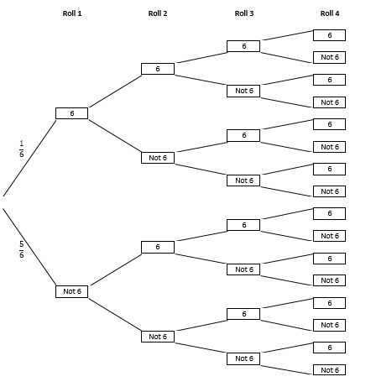
- Use the tree diagram to complete the first 4 rows of the following table with expressions to represent the probability of rolling r sixes.
One expression has been done for you.
There are 3 ways (branches) of obtaining 2 sixes from 3 throws. This is multiplied by the probability of each branch in the tree diagram.

Number of Rolls | $$r=0$$ | $$r=1$$ | $$r=2$$ | $$r=3$$ | $$r=4$$ | $$r=5$$
1 |  |  | N/A | N/A | N/A | N/A
2 |  |  |  | N/A | N/A | N/A
3 |  |  | $$3×{\left(\frac{1}{6}\right)}^{2}×{\left(\frac{5}{6}\right)}^{1}$$ |  | N/A | N/A
4 |  |  |  |  |  | N/A
5

- Examine the first 4 rows. By observing a pattern, complete the last two rows of the table.
- Examine the coefficients of the expressions. What pattern do you observe?
- Relate the pattern to your knowledge of combinations.
- Use your observations to write an expression for the following:
A die is rolled 12 times, what is the probability that you will obtain 5 sixes?
- Can you generalise your result? Write an expression for: What is the probability of $r$ successes in $n$ trials if the probability of success in each trial is p?
$$P\left(X=r\right)=___________________________________$$
- With teacher guidance as necessary, students link the expressions for the probabilities with the terms of the expansion of ${\left(p+q\right)}^{n}$. This result is then generalised to$P\left(X=r\right)= ^{n}C_{r}p^{r}{(1-p)}^{n-r}$.

Worked solutions (questions 2-7)
- Use the tree diagram to complete the first 4 rows of following table with expressions to represent each probability:
One expression has been done for you.
There are 3 ways (branches) of obtaining 2 sixes from 3 throws. This is multiplied by the probability of each branch in the tree diagram.

Number of Rolls | $$r=0$$ | $$r=1$$ | $$r=2$$ | $$r=3$$ | $$r=4$$ | $$r=5$$
1 | $$1×{\left(\frac{1}{6}\right)}^{0}×{\left(\frac{5}{6}\right)}^{1}$$ | $$1×{\left(\frac{1}{6}\right)}^{1}×{\left(\frac{5}{6}\right)}^{0}$$ | N/A | N/A | N/A | N/A
2 | $$1×{\left(\frac{1}{6}\right)}^{0}×{\left(\frac{5}{6}\right)}^{2}$$ | $$2×{\left(\frac{1}{6}\right)}^{1}×{\left(\frac{5}{6}\right)}^{1}$$ | $$1×{\left(\frac{1}{6}\right)}^{2}×{\left(\frac{5}{6}\right)}^{0}$$ | N/A | N/A | N/A
3 | $$1×{\left(\frac{1}{6}\right)}^{0}×{\left(\frac{5}{6}\right)}^{3}$$ | $$3×{\left(\frac{1}{6}\right)}^{1}×{\left(\frac{5}{6}\right)}^{2}$$ | $$3×{\left(\frac{1}{6}\right)}^{2}×{\left(\frac{5}{6}\right)}^{1}$$ | $$1×{\left(\frac{1}{6}\right)}^{3}×{\left(\frac{5}{6}\right)}^{0}$$ | N/A | N/A
4 | $$1×{\left(\frac{1}{6}\right)}^{0}×{\left(\frac{5}{6}\right)}^{4}$$ | $$4×{\left(\frac{1}{6}\right)}^{1}×{\left(\frac{5}{6}\right)}^{3}$$ | $$6×{\left(\frac{1}{6}\right)}^{2}×{\left(\frac{5}{6}\right)}^{2}$$ | $$4×{\left(\frac{1}{6}\right)}^{3}×{\left(\frac{5}{6}\right)}^{1}$$ | $$1×{\left(\frac{1}{6}\right)}^{4}×{\left(\frac{5}{6}\right)}^{0}$$ | N/A
5 | $$1×{\left(\frac{1}{6}\right)}^{0}×{\left(\frac{5}{6}\right)}^{5}$$ | $$5×{\left(\frac{1}{6}\right)}^{1}×{\left(\frac{5}{6}\right)}^{4}$$ | $$10×{\left(\frac{1}{6}\right)}^{2}×{\left(\frac{5}{6}\right)}^{3}$$ | $$10×{\left(\frac{1}{6}\right)}^{3}×{\left(\frac{5}{6}\right)}^{2}$$ | $$5×{\left(\frac{1}{6}\right)}^{4}×{\left(\frac{5}{6}\right)}^{1}$$ | $$1×{\left(\frac{1}{6}\right)}^{5}×{\left(\frac{5}{6}\right)}^{0}$$

- Examine the first 4 rows. By observing a pattern, complete the last two rows of the table.
- Examine the coefficients of the expressions. What pattern do you observe?
Hint: Rewrite the coefficient aligning each term in between coefficients from the row above.
They follow the rows of Pascal’s triangle.
- Relate the pattern to your knowledge of combinations.
Example: The coefficient to obtain 2 sixes from 5 rolls is $^{5}C_{2}$
- Use your observations to write an expression for the following:
A die is rolled 12 times, write an expression for the probability that you will obtain 5 sixes?
$$^{12}C_{5}×{\left(\frac{1}{6}\right)}^{5}×{\left(\frac{5}{6}\right)}^{7}$$
- Can you generalise your result? Write an expression for: What is the probability of $r$ successes in $n$ trials if the probability of success in each trial is p?
$$P\left(X=r\right)= ^{n}C_{r}p^{r}{(1-p)}^{n-r}$$

