Triominoes worksheet
A Triomino is a ‘piece’ that is made of three squares put together. They can take either of the orientations below, or rotations of these.

Proposition
Any grid of $2^{n}× 2^{n}$ squares can be covered by triominoes, leaving just one empty square in the corner, for positive integral values of $n.$
For $n=1$, the grid is $2 ×2$ and the proof is simple.
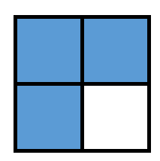
Using different colours, shade in triominoes in these grids to prove this statement for larger values of $n.$
$n=2, 4×4$ grid.
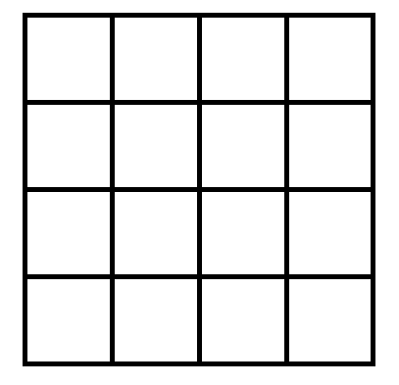
$n=3, 8×8$ grid
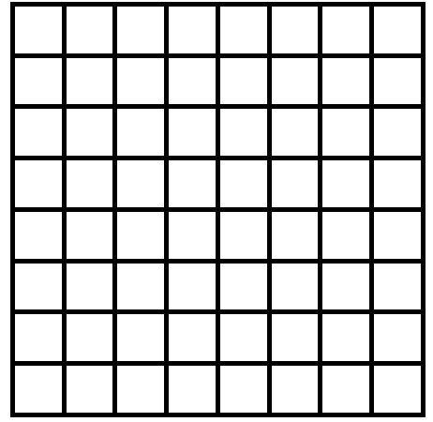
$n=4, 16×16$ grid

Proof
What we are trying to prove is that the number of squares in each of these grids ($2^{n}×2^{n}$) when divided by 3 has a remainder of 1.
i.e. Prove by mathematical induction that $2^{n}×2^{n}-1$ is divisible by 3 for all integral values of $n$ such that $n≥1$.
Extension – review the practical proof at Underground mathematics

