Intersecting lines

Part 1 – Investigation
Consider the number of enclosed regions formed by intersecting lines, with the rules that:
- There are no parallel lines
- There are no sets of three or more concurrent lines
In Figure 1, we can see 2 intersecting lines which clearly have no enclosed regions.
In Figure 2, we can see 3 intersecting lines which clearly have one enclosed region (shaded).
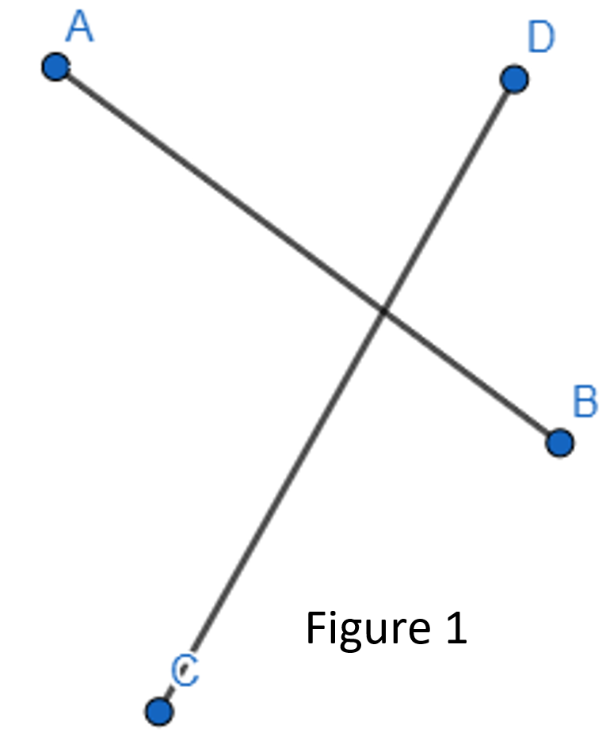
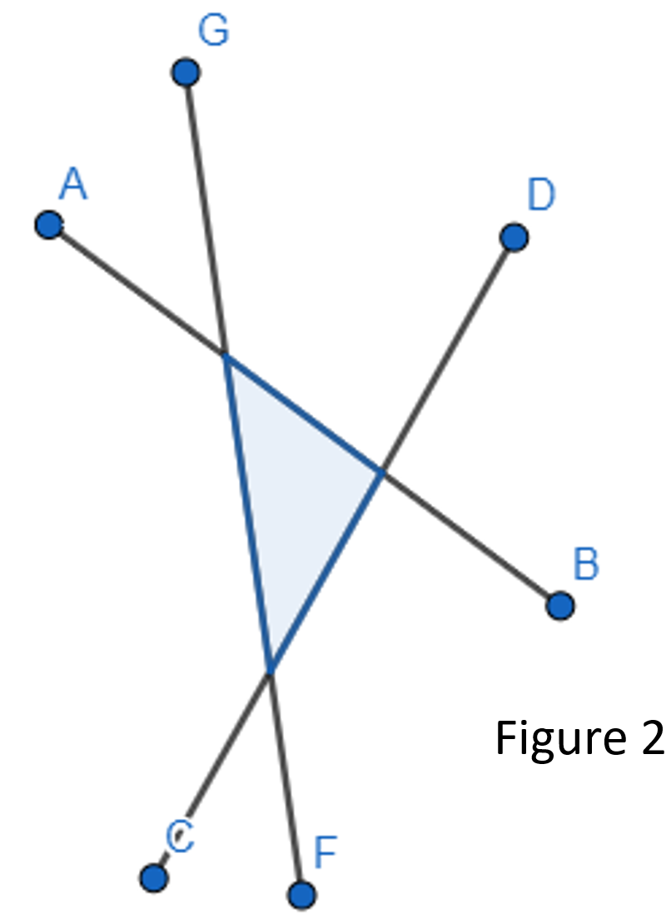

Investigate this pattern by constructing similar diagrams for n intersecting lines and complete the table below.

Intersecting lines | Number of enclosed regions
2 | 0
3 | 1
4
5
6
7
8
How would you calculate the number enclosed regions formed by 10 intersecting lines.

How would you calculate the number enclosed regions formed by n intersecting lines?

Part 2 – Proof of formula
There are two ways to find the number of enclosed regions formed by n intersecting lines.
Series – If we choose to draw the additional line outside the existing intersections as in Figure 3, we can see that when we add the 4th line, it intersects 3 existing lines, forming 2 additional regions.
This gives rise to the idea that three lines form 1 regions,
Four lines form 1 + 2 regions,
Five lines form 1 + 2 + 3 regions and so forth.
Hence the series that gives the numbers of enclosed regions formed by n intersecting lines is
1 + 2 + 3 + …. + (n – 2)
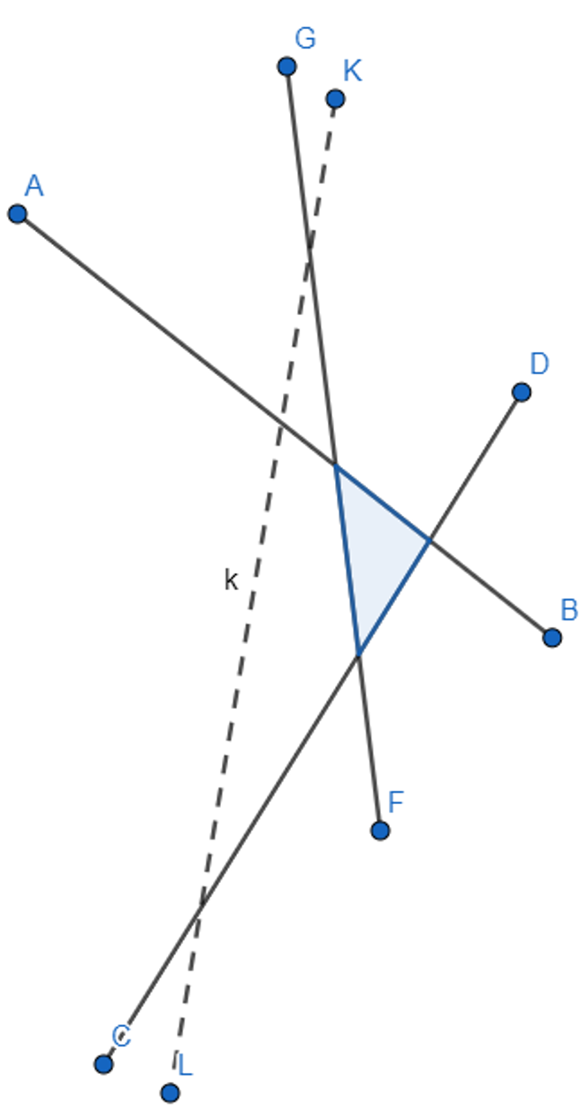
Formula – The formula $\frac{(n-2)(n-1)}{2}$ will also give the total number of enclosed regions formed by n intersecting lines, and is a much simpler way of calculating solutions for large numbers of lines.
Proof – Prove by Mathematical Induction that
1 + 2 + 3 + … + (n – 2) = $\frac{(n-2)(n-1)}{2}$ for integral values of n with n ≥ 2

