Diagonals of polygons

Part 1 – investigation
Consider the number of diagonals that exist within an n sided convex polygon.
We know that a triangle has no diagonals, and in Figure 1 we can see that a quadrilateral has 2 diagonals. Complete the table below to identify the number of diagonals in each n sided polygon
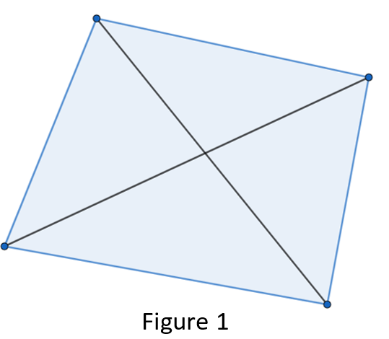
n – Number of sides | Number of diagonals
3 | 0
4 | 2
5
6
7
8
9
How would you calculate the number diagonals existing in a polygon of 10 side?

How would you calculate the number diagonals existing in a polygon of n sides?

Part 2 – proof of formula
There are two ways to find the number of diagonals existing in a polygon n sides.
Series – Consider the tree shapes below:
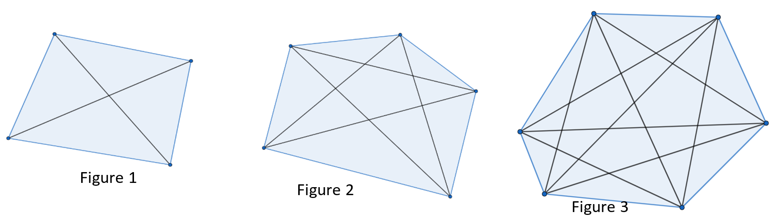
The number of diagonals for these three figures are 2, 5 and 9.
To get from one to the next, we add the next natural number. So a three sided polygon has 0 diagonals,
- A four sided polygon has 0 + 2 = 2 diagonals
- A five sided polygon has 0 + 2 + 3 = 5 diagonals
- A six sided polygon has 0 + 2 + 3 + 4 = 9 diagonals and continuing this we would see that
- A seven sided polygon will have 0 + 2 + 3 + 4 + 5 = 14 diagonals.
Hence an n sided polygon will have 2 + 3 + 4 + 5 + … + (n – 2) diagonals.
Formula – Notice that Figure 1 has 4 vertices, and each vertex connects to one diagonal. This would suggest 4 diagonals, but as each diagonal has a beginning and an end, we need to divide by 2 to get 2 diagonals.
In Figure 2, we have 5 vertices with each vertex connecting to two diagonals. This would be 5 x 2 = 10 diagonals, but similarly we divide by 2 to get 5 diagonals.
In Figure 3, we have 6 vertices, each connecting to 3 diagonals, so 6 x 3 ÷ 2 = 9 diagonals.
A seven sided figure would have 7 vertices with each connecting to 4 diagonals, so 7 x 4 ÷ 2 = 14 diagonals.
Hence a formula should be $\frac{n(n-3)}{2}$.
Proof – Prove by Mathematical Induction that
2 + 3 + 4 + 5 + … + (n – 2) = $\frac{n(n-3)}{2}.$

