The life and times of the humble CD
During this activity, students will gain experience in developing exponential models to explain certain stages in the lifetime of a technological product, for example the compact disc (CD). These stages are the emergence and subsequent demise of the product, due to advancements in technology.
Students will utilise an understanding of calculus techniques and logarithmic equations to determine the model generated from the annual sales of CDs in the United States of America https://www.statista.com/chart/12950/cd-sales-in-the-us/
This task is broken up into two parts. In part A, students will develop an exponential model in the form $P=C+Ae^{kt}$ to describe the various stages of the lifetime of the CD. In part B, students will use the logistic model in the form $P=\frac{C}{1+Ae^{-kt}}$ to describe the entire lifetime.
Background information about compact discs can be accessed at these websites:
https://www.digitaltrends.com/features/the-history-of-the-cds-rise-and-fall/
https://www.theguardian.com/music/2015/may/28/how-the-compact-disc-lost-its-shine

Part A
- Open the file sales-history-for-cds.xlsx
- Insert two new columns between columns A and B. Label column B as time period, t and column C as total sales, P
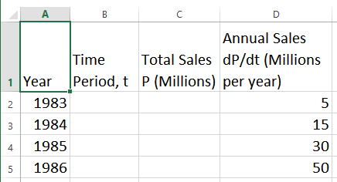

- Populate the time period column with values 0, 1, 2 …
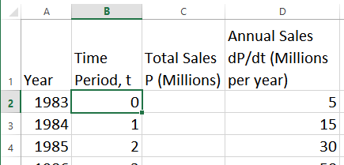

- Populate the total sales column by taking a cumulative total of the annual sales
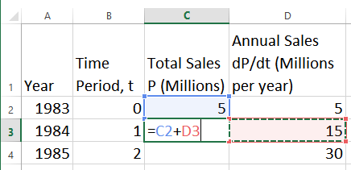

- Plot a scatterplot of the total sales over time
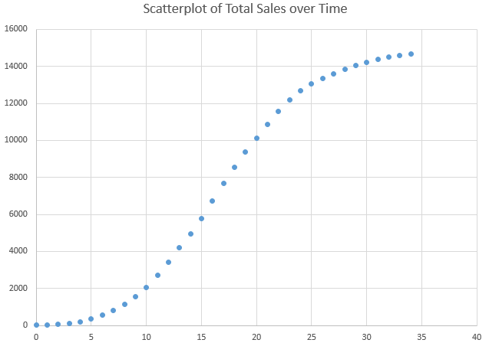

- Analyse the graph to identify areas of potential exponential growth and decay.
- Using the differential equation for an exponential model, $\frac{dP}{dt}=k(P-C)$ where $C$ is the carrying capacity, analyse the relationship between $\frac{dP}{dt}$ and $P$ by plotting a scatterplot of $\frac{dP}{dt}$ and $P$ by using the data in columns C and D.
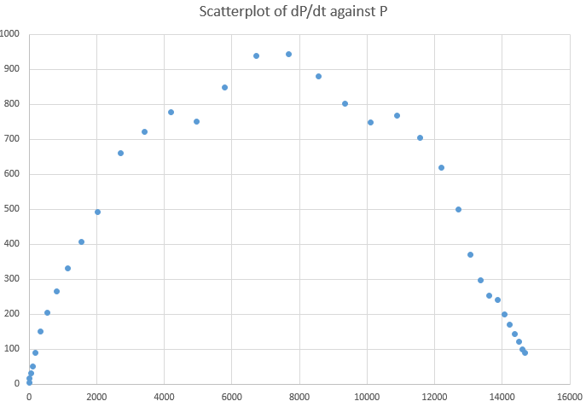

- Analyse the graph, looking for linear patterns, ie) for $0≤P≤3000$ and $11000≤P≤15000$ there are suggestions of linear patterns.
The section $0≤P≤3000$ refers to a stage of exponential growth, whereas the section $11000≤P≤15000$ refers to a stage of exponential decay.
- Generate another scatterplot of $\frac{dP}{dt}$ and $P$ for the $0≤P≤3000$
- Right-click on a data point and Add Trendline and select Display Equation from the format options.
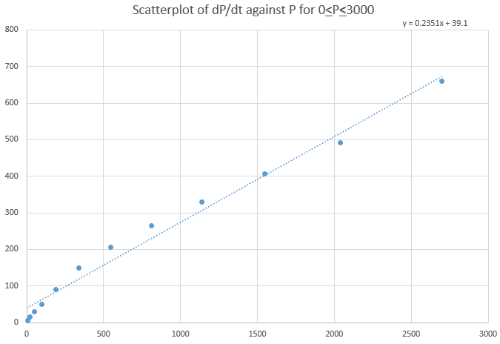
- The trendline shows a linear relationship between $\frac{dP}{dt}$ and $P$ for $0≤P≤3000$. The gradient of this relationship can be matched to the $k$ value in the exponential model, i.e. $k = 0.2351$ (this value for $k$ is an estimate at this stage). The $y$-intercept value can be matched to the expression $–kC$ from the differential equation shown earlier. Therefore $$C = 39.1/(-0.2351) = -166.3$$
- By applying logarithm rules, show that the exponential model $P=C+Ae^{kt}$ can be rearranged in the form $\log_{e}\left(P-C\right)=kt+\log_{e}A$

- For $0≤P≤3000$, create columns for the values of $t$ and $\log_{e}\left(P-C\right)$ in columns E and F.
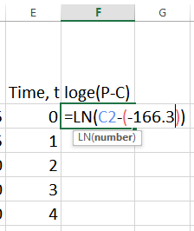
- Create a scatterplot of these values, add a trendline to the data and display the equation
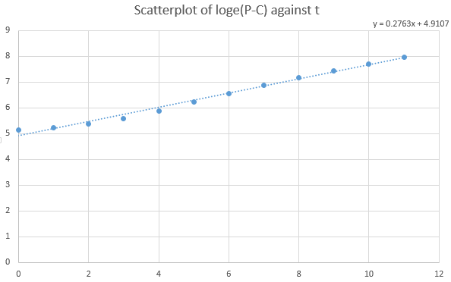

- By matching the gradient and y-intercept values, $k=0.2763$ , $\log_{e}A=4.9107$ and therefore $A=e^{4.9107}≈135.7$

- Completing the exponential model gives $P=135.7e^{0.2763t}-166.3$ for $0≤P≤3000$

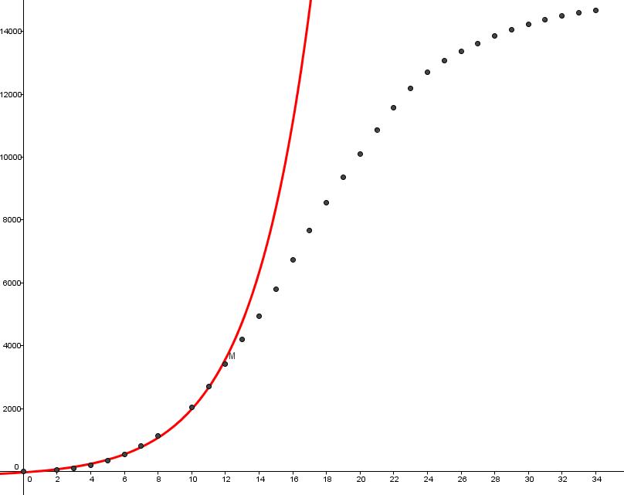
- From $e^{k}=1+r$ where r is the percentage increase per annum, this model above relates to a 31.8% increase in sales per annum for the first 12 years of the lifetime of the CD.
- Repeat steps 9 to 16 for $11000≤P≤15000$, which relates to the later stages of the lifetime of the CD in which sales are in decline.

Part B
- Using the differential equation for an exponential model, $\frac{dP}{dt}=kP(1-\frac{P}{C})$ where $C$ is the carrying capacity, show that $\frac{1}{P}×\frac{dP}{dt}=k(1-\frac{P}{C})$ which forms a linear expression on the right hand side of the equation.
- Insert a column D alongside Total Sales, P, with header 1/P*dP/dt to represent the left hand side of the rearranged differential equation above.
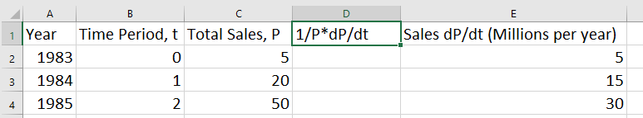
- Calculate the values of the left hand side of the rearranged differential equation above using the formula “=E2/C2”
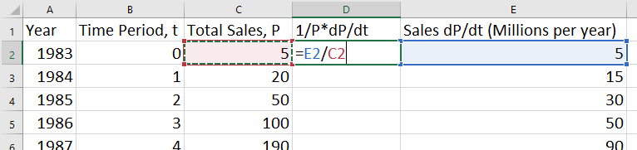
- Calculate for all values of $P$ by copying the formula down to every cell in column D
- Generate a scatterplot of $\frac{1}{P}×\frac{dP}{dt}$ against $P$ by selecting the cells in columns C and D and inserting a scatterplot
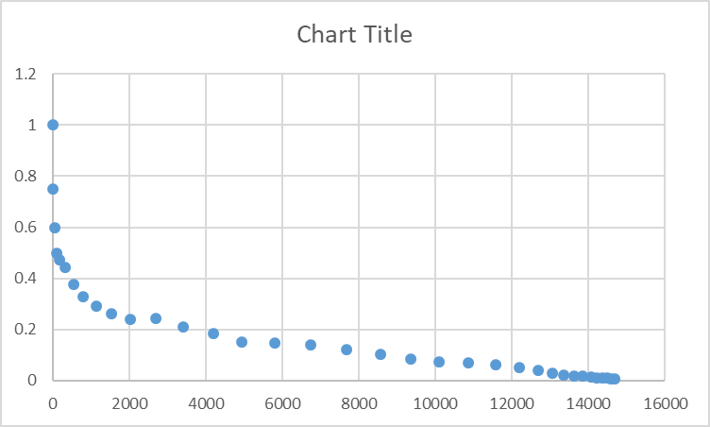
- Inspecting the scatterplot shows a signs of a linear pattern for $P>2000$. Regenerate this scatterplot for values of $P>2000$.
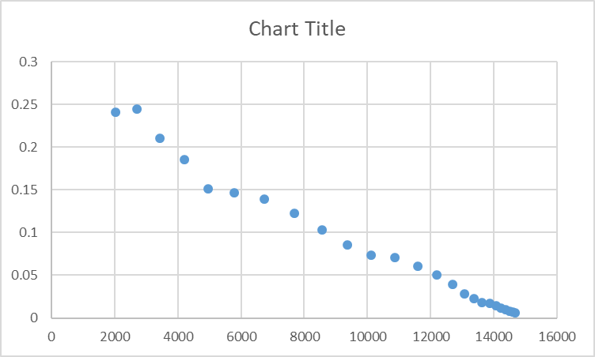
- Right click on a data point to generate a trend line and show the equation by checking the Display Equation on Chart checkbox. The coefficients for the linear model may be small. Use the Excel functions SLOPE and INTERCEPT to generate more accurate values.
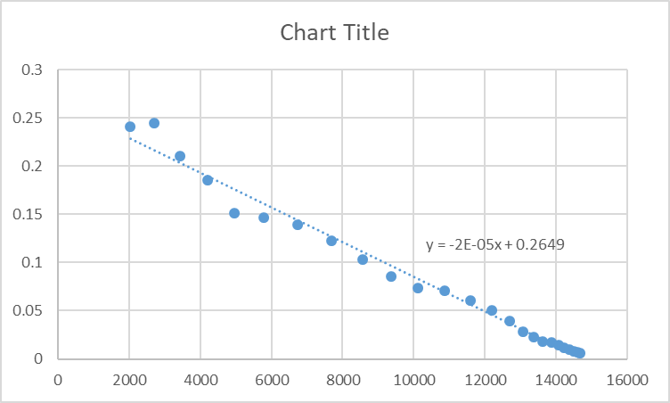
- Matching the coefficients from the trend line to the rearranged differential equation from earlier gives $k=0.2649$ and $\frac{k}{C}=1.8×{10}^{-5}$, which gives $C=14717$
- Using these values in the logistic equation $P=\frac{C}{1+Ae^{-kt}}$ gives $P=\frac{14717}{1+Ae^{-0.2649t}}$ which is a partially complete logistic model.
- Use the logistic equation to show that $A=e^{kt_{0}}$ where $t_{0}$ is the time at the point of inflection where $P=\frac{C}{2}$.
- Hence estimate $t_{0}$ from the table of values and use it to show the value of $A≈e^{0.2649×17}≈90$.
- Show the complete logistic model as $P=\frac{14717}{1+90e^{-0.2649t}}$
