Solving first order differential equations

Example 1
Solve: $\frac{ⅆy}{ⅆx}=3x$ given that when $x = 1$, $y = 2$

Example 1 solution - indefinite integral technique
$$\frac{dy}{dx}=3x$$

$$1.dy=3x.dx$$

$$\int{1.dy}=\int{3x.}dx$$

$$y=\frac{3}{2}x^{2}+c$$

Substitute $x = 1$, $y = 2$

$$2=\frac{3}{2}×1^{2}+c$$

$$2=\frac{3}{2}+c$$

$$c=\frac{1}{2}$$

$$y=\frac{3}{2}x^{2}+\frac{1}{2}$$

Example 1 slope field

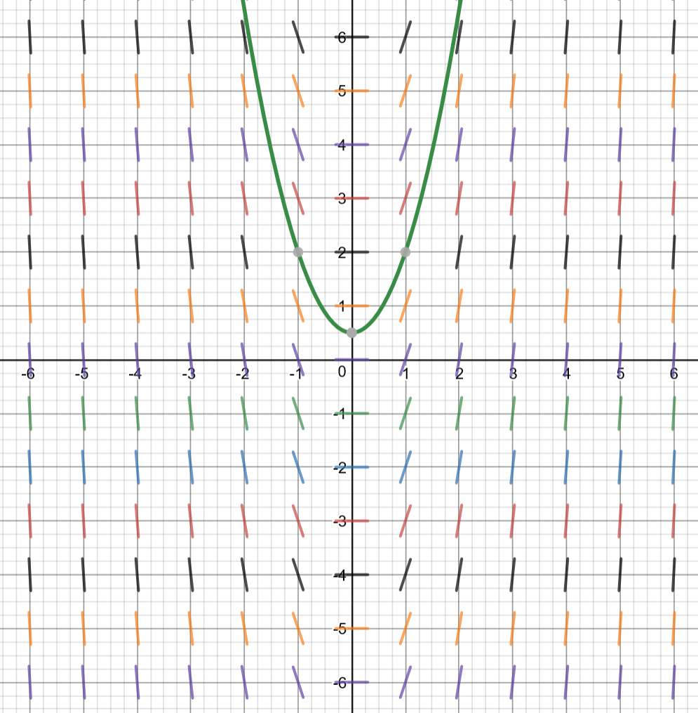

Example 2
Solve $\frac{ⅆy}{ⅆx}=y^{2}$, given that when $x = -3$, $y = 1$.

Example 2 solution - indefinite integral technique
$$\frac{dy}{dx}=y^{2}$$

$$\frac{dx}{dy}=\frac{1}{y^{2}}$$

$$1.dx=\frac{1}{y^{2}}.dy$$

$$\int{1.dx}=\int{\frac{1}{y^{2}}}dy$$
$$x=-\frac{1}{y}+c$$
Substitute $x = -3$, $y = 1$. (or make y the subject at this stage)
$$-3=-\frac{1}{1}+c$$
$$c=-2$$
$$x=-\frac{1}{y}-2$$

$$x+2=-\frac{1}{y}$$
$$\frac{1}{x+2}=-y$$

$$y=\frac{-1}{x+2}$$

Example 2 solution - definite integral technique
$$\frac{dy}{dx}=y^{2}$$

$$\frac{dx}{dy}=\frac{1}{y^{2}}$$

$$1.dx=\frac{1}{y^{2}}.dy$$

$$\int_{-3}^{x}{1 dx}=\int_{1}^{y}{\frac{1}{y^{2}} dy}$$

$${\left[x\right]}_{-3}^{x}={\left[-\frac{1}{y}\right]}_{1}^{y}$$

$$x-\left(-3\right)=-\frac{1}{y}-\left(-\frac{1}{1}\right)$$

$$x+3=-\frac{1}{y}+1$$
$$x+2=-\frac{1}{y}$$

$$y=-\frac{1}{x+2}$$

Example 2 slope field
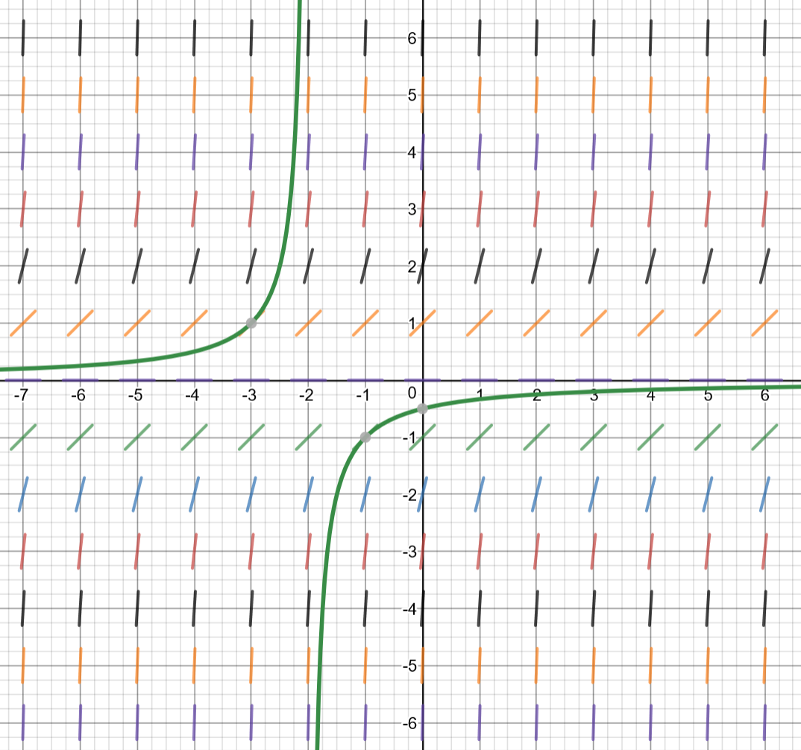

Example 3
Solve $\frac{ⅆy}{ⅆx}=xy$ given that when $x = 3$, $y = 2$

Example 3 solution – indefinite integral technique
$$\frac{dy}{dx}=xy$$

$$\frac{1}{y}dy=x dx$$

$$\int{\frac{1}{y}dy}=\int{x dx}$$

$$\ln{|y|}=\frac{x^{2}}{2}+c$$

Substitute $x = 3$, $y = 2$

$$\ln{|2}|=\frac{3^{2}}{2}+c$$

$$\ln{2}=\frac{9}{2}+c$$

$$c=ln{2}-\frac{9}{2}$$

$$\ln{|y|}=\frac{x^{2}}{2}+\ln{2}-\frac{9}{2}$$

$$\ln{|y|}-\ln{2}=\frac{x^{2}}{2}-\frac{9}{2}$$

$$\ln{\frac{|y|}{2}}=\frac{x^{2}-9}{2}$$

$$\frac{|y|}{2}=e^{\frac{x^{2}-9}{2}}$$

$\left|y\right|={2e}^{\frac{x^{2}-9}{2}}$

$y={±2e}^{\frac{x^{2}-9}{2}}$

Determine the function by substituting the values $x=3$ and $y=2$ into the positive and negative functions and testing which holds true.
$∴y={2e}^{\frac{x^{2}-9}{2}}$ as the point (3,2) lies on this curve.

Example 3 slope field

